DNA & Proteins Unit – Week 4
Score
□ Above & Beyond
□ Fully Complete
□ Mostly Complete
□ Incomplete – fix the following pages:
Name: Hour Date:
Date Packet is due: after Part 5 Why late?
If your work was late, describe why
Semester Schedule
Traits & Genes
Week 1 - What determines the traits of an organism?
Week 2 - How are traits inherited from parents?
Week 3 – Can we predict traits?
Week 4 - Assessment

DNA & Proteins
Week 1: What is DNA and how does it work?
Week 2: How does DNA affect protein assembly?
Week 3: How does a protein determine traits?
Week 4 - Assessment

Mutations & Change
Week 1: How do mutations change genes & proteins?
Week 2: How can mutations result in new traits?
Week 3: How can mutations lead to new species?
Week 4 - Assessment

Biodiversity & Extinctions
Week 1: How does biodiversity affect ecosystems?
Week 2: Why do some species go extinct?
Week 3: How can human activity cause extinctions?
Week 4 - Assessment

Driving Question: What is DNA, how does it enable protein assembly, and how does it determine traits?

Anchoring Phenomenon: Throughout this unit, we have explored DNA – what it is and how it functions. In this final week, we will put all the pieces together to develop sophisticated explanations for the phenomena we have encountered in this unit.

Weekly Schedule

Part 1: Introduction
- Comparative Data Dives.

Part 2: Critiquing Responses
- Evaluating Sample Responses
- Writing a “Level 3” Response

Part 3: Investigation
- Woolly Mammoths

Part 4: Review
- Jeopardy Review Game

Part 5: Final Review
- Review of Driving Questions
- Final Q&A

Deeper Questions
- What is DNA made from?
- How does DNA store information?
- How does DNA determine protein assembly?
- How does a protein determine traits?
- How can we move genes from one organism to another?

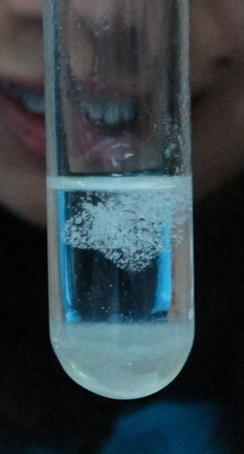
NGSS Standards: HS-LS1-4. Use a model to illustrate the role of cellular division (mitosis) and differentiation in producing and maintaining complex organisms.
HS-LS3-1 - Role of DNA/chromosomes as instructions for traits inherited from parents via meiosis
LS-LS3-3 - Predicting likelihood of different traits in a population/offspring
HS-LS1-4: How does mitosis and differentiation enable complex organisms?

Part 1: Introduction – Comparative Data Dives
Directions: The following address phenomena we encountered throughout this unit. Construct explanations for each phenomenon and driving questions using the provided terms.

DNA Testing: DNA tests are widely available today. By submitting a saliva sample, you can affordably receive an analysis of your DNA. A DNA test primarily determines the sequence of bases (A, C, G, and T) in an individual’s genome. How does the order of bases in DNA determine traits in an individual? In your response, use and underline the following terms: codon, amino acids, protein, and trait. (Image source: Wikimedia)

Score this response (1,2,3) - Complete: ^{Accurate:} ^{Precise:} ^{Overall:}
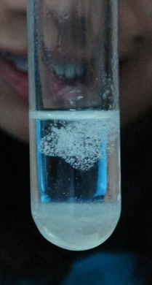

Extracted DNA: With some salt, soap, and rubbing alcohol, anyone can extract DNA from a sample of cells. Extracted DNA resembles a gooey clump of tiny threads. What is in DNA? What is the purpose of each component in DNA? In your response, use and underline the following terms: nucleotide, phosphate, sugar, and base. (Image source: Wikimedia)

Score this response (1,2,3) - Complete: ^{Accurate:} ^{Precise:} ^{Overall:}

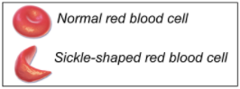
Sickle Cell Anemia: Sickle cell anemia is a genetic disease caused when a single base in the gene for the hemoglobin protein is changed. This results in malformed hemoglobin proteins that alter the shape of red blood cells. This causes painful blood clots and reduced oxygen content in the blood. How could changing one base in a gene change the entire protein and harm the body? In your response, use and underline the following terms: protein shape, protein function, and amino acid properties. (Image source: Wikimedia)

Score this response (1,2,3) - Complete: ^{Accurate:} ^{Precise:} ^{Overall:}
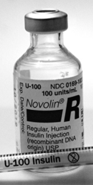
Genetic Modification: Scientists have created a wide variety of genetically modified organisms. Examples include goats that produce spider silk proteins, corn that produces its own pesticide, and bacteria that produce human insulin. How can a gene from one organism become expressed by the cells of another organism? In your response, use & underline the following terms: transcription, mRNA, translation, ribosome and tRNA. (Image source: Flickr)

Score this response (1,2,3) - Complete: ^{Accurate:} ^{Precise:} ^{Overall:}

Genetic Modification, Part 2: How can scientists move a gene from the cells of one organism to another? In your response, use and underline the following terms: restriction enzyme; restriction site; and sticky ends.

Score this response (1,2,3) - Complete: ^{Accurate:} ^{Precise:} ^{Overall:}

Part 2: Critiquing Responses
Directions: Rate each of the following responses and provide a brief written justification for why you think they earned a 1 (still learning), 2 (acceptable), or 3 (sophisticated). If possible, repeat this on the previous page.

Q: How does DNA determine the observable traits of living organisms?
Daryll: DNA has genes in it. The cell creates the trait by forming chromosomes in the cell, splitting with helicase, and then dividing.
3 2 1 Complete: Do they fully address the entire question while addressing DNA, proteins, and/or traits?
3 2 1 Accurate: Is every aspect of the written response factually correct?
3 2 1 Precise: Are they effectively using terms from the course in a clear and specific manner?

Overall Score: /3 Comments:
Avery: DNA has an order for its bases. This provides the instructions for a protein and the order in which the amino acids are assembled.

3 2 1 Complete: Do they fully address the entire question while addressing DNA, proteins, and/or traits?
3 2 1 Accurate: Is every aspect of the written response factually correct?
3 2 1 Precise: Are they effectively using terms from the course in a clear and specific manner?

Overall Score: /3 Comments:
Lucia: DNA stores information. It has sugars and bases. The order of sugars and bases determines the traits.
3 2 1 Complete: Do they fully address the entire question while addressing DNA, proteins, and/or traits?
3 2 1 Accurate: Is every aspect of the written response factually correct?
3 2 1 Precise: Are they effectively using terms from the course in a clear and specific manner?

Overall Score: /3 Comments:
Oscar: DNA is made from phosphate, sugar, and base molecules. Phosphate and sugar provide structure; base molecules (A, C, G, T) store information. The order of codons (3 bases) in DNA determines the order of amino acids in a protein, which determines the shape and function of the protein, which determines the trait.
3 2 1 Complete: Do they fully address the entire question while addressing DNA, proteins, and/or traits?
3 2 1 Accurate: Is every aspect of the written response factually correct?
3 2 1 Precise: Are they effectively using terms from the course in a clear and specific manner?

Overall Score: /3 Comments:

Part 3 Investigation: Woolly Mammoths
Directions: In this investigation, you will be using your understanding of DNA to explain how scientists might resurrect the wooly mammoth from extinction. Read the article excerpt below. Then work in small groups to answer the accompanying questions.

Scientists Say They Could Bring Back Woolly Mammoths. But Maybe They Shouldn't
By Scott Neuman. September 15, 2021

Using recovered DNA to "genetically resurrect" an extinct species — the central idea behind the Jurassic Park films — may be moving closer to reality with the creation this week of a new company that aims to bring back woolly mammoths thousands of years after the last of the giants disappeared from the Arctic tundra.

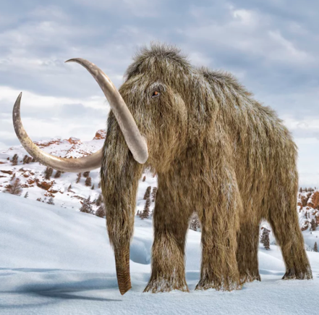
Flush with a $15 million infusion of funding, Harvard University genetics professor George Church, known for his pioneering work in genome sequencing and gene splicing, hopes the company can usher in an era when mammoths "walk the Arctic tundra again." He and other researchers also hope that a revived species can play a role in combating climate change.

To be sure, what's being proposed is actually a hybrid created using a gene-editing tool known as CRISPR-Cas9 to splice bits of DNA recovered from frozen mammoth specimens into that of an Asian elephant, the mammoth's closest living relative. The resulting animal — known as a "mammophant" — would look, and presumably behave, much like a woolly mammoth.
(Article & Image source: NPR)

Discussion Questions
- Elephants and mammoths share 99% of the same DNA. How would adding a relatively small amount of DNA to an elephant’s genome result in creating a mammoth-like animal?
Address the relationship between DNA, proteins, and traits in your explanation.
- How is it possible that genes from one species can function in the cells of another species?
Address transcription and translation in your explanation.
- How would adding genes from a mammoth change the traits of an elephant?
Address codons, amino acids, and protein folding in your explanation.
- Summarize how genes can be moved from one species to another using restriction enzymes and/or CRISRP-Cas9.
- Do you think this is a good idea? Is it ethical to revive a species that went extinct thousands of years ago? Create evidence-based arguments for both sides of this debate.

Part 4: Jeopardy Review
Overview: In this activity, you will be playing a Jeopardy-style game to review key concepts from the course. This presentation can be accessed at https://bit.ly/WUHS-Bio-DNA-Jeopardy. The rules for this review game are posted within the presentation. You can also use this presentation outside of class to help prepare you for the unit test. Your instructor may decide to use an alternative option (like Gimkit or Kahoot).

Part 5: Review
Overview: For each objective, rank it as a 1 (completely unsure), 2 (somewhat unsure), or 3 (completely sure) based on your comfort with that objective. Afterwards, you will have time for group and whole-class review. Items in bold should be prioritized as you’re preparing for the summative assessment.
- What is the primary purpose of DNA? How does DNA enable a cell to function?
- What molecules are found in a DNA macromolecule? What is the purpose of each component of DNA?
- What are complementary base pairs? Explain why nucleotide bases always combine in specific ways.
- How do complementary base pairs, helicase, and polymerase each enable DNA to be replicated?
- What provides a sense of direction within a DNA macromolecule as it is being copied? Explain.
- What are codons? How do they enable DNA to provide instructions for assembling a protein?
- Why does a cell need both RNA and DNA?
- Briefly summarize what occurs in transcription and translation.
- Summarize the purpose of each of the following: mRNA, RNA polymerase, and transcription factors.
- Summarize the purpose of each of the following: ribosomes, tRNA, and amino acids.
- What determines how a protein functions?
- How do the following affect the shape of a protein? Hydrophobic/hydrophilic amino acids, charge, cysteine bonds.
- Sickle cell anemia occurs when a T-base in DNA is substituted for an A. How does changing a single base result in changes at the molecular, cellular, and bodily levels?
- How is it possible that a gene from one organism can be moved to another organism and remain functional?
- Explain how the following are similar and different: genetic engineering, genome, GMO.
- How are genetically modified organisms created? In your response, include the following: restriction enzyme, restriction site, sticky ends.

