Mutations & Change Unit – Week 2
Score
□ Above & Beyond
□ Fully Complete
□ Mostly Complete
□ Incomplete – fix the following pages:
Name: Hour Date:
Date Packet is due: after Part 5 Why late?
If your work was late, describe why
Semester Schedule
Traits & Genes
Week 1 - What determines the traits of an organism?
Week 2 - How are traits inherited from parents?
Week 3 – Can we predict traits?
Week 4 - Assessment

DNA & Proteins
Week 1: What is DNA and how does it work?
Week 2: How does DNA affect protein assembly?
Week 3: How does a protein determine traits?
Week 4 - Assessment

Mutations & Change
Week 1: How do mutations change genes & proteins?
Week 2: How can mutations result in new traits?
Week 3: How can mutations lead to new species?
Week 4 - Assessment

Biodiversity & Extinctions
Week 1: How does biodiversity affect ecosystems?
Week 2: Why do some species go extinct?
Week 3: How can human activity cause extinctions?
Week 4 - Assessment

Driving Question: How can mutations result in new traits?

Anchoring Phenomenon: Last week we investigated how and why mutations occur. This week we will shift our focus to determine how changes from mutations can result in new species in response to competition and environmental pressures. We will explore how these processes result in changes that can result in new species over time.

Deeper Questions
- How do environmental conditions and competition affect whether mutations are helpful, harmful, or neutral?
- How and why do the traits of species sometimes change?
- Why do some species’ traits change faster than others?
- What factors determine whether a species’ traits will change?

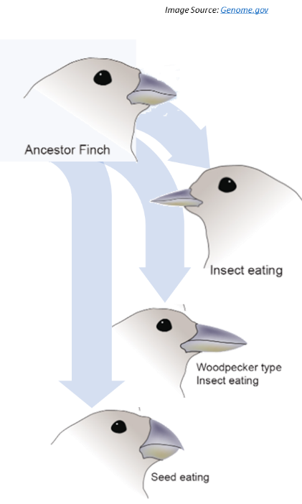
NGSS Standards:
HS-LS1-2 - How inheritable variations result from 1) changes via meiosis; 2) errors during replication; 3) mutations via environmental factors
HS-LS4-3 – How organisms with advantageous traits increase in proportion in their populations.
HS-LS4-4 - How natural selection leads to adaptations of populations.
HS-LS4-2 - Evolution is due to 4 factors: 1) reproduction; 2) heritable mutations; 3) competition; 4) enhanced survival & reproduction in comparison to individuals without beneficial mutations.

Weekly Schedule

Part 1: Introduction
- Initial Ideas – Changing Traits
- Data Dive – Natural Selection Lab
- Discussion & Developing Explanations

Part 2: Core Ideas
- Core Ideas
- Revisions of Part 1 Explanations

Part 3: Investigation
- Part A - PhET Natural Selection

Part 4: Review & Assessment
- Ranking Your Readiness
- Assessment

Part 5: Life Connections
- Antibiotic Resistance Investigation Set-up

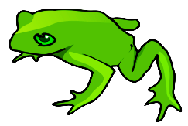
Part 1: Introduction – Natural Selection Lab
Overview: In this activity, you will begin by discussing your initial ideas about how species’ adaptations can emerge as a result of mutations. (Image Source: SVG)

Initial Ideas: As a result of differences in their genes, different kinds of tree frogs have different rates of survival and reproduction in some environments compared to others. Green tree frogs are more prevalent in wetlands with lush green vegetation. Gray tree frogs are more common among hardwood trees with gray bark.
- Three students shared their ideas about how and why different kinds of tree frogs exist. Do you agree or disagree with each student’s claim?
  - Marisol: "I think that a frog turns green or gray depending on where it is found; for example, tree frogs turn green if they’re born in a wetland or gray if they’re born in a forest." Agree / Disagree
  - Daryll: "I disagree. I think that the frogs are already green or gray when they’re born. Their DNA doesn’t change, just their survival rate." Agree / Disagree
  - Nina: “I don’t agree. DNA can definitely change from mutations. I just think the mutations happen regardless of what environment the frogs live in.” Agree / Disagree
- Work in your small groups to discuss your ideas. How are your ideas similar or different? Decide as a group whether each statement is correct (and why). Be prepared to present your ideas to the class.
Data Dive: In this activity, you will be modeling how the environment affects survival and reproduction. Your “environment” will be two pencil boxes filled with fabric. Your “organisms” are colored beads. There will be two rounds of predation and reproduction for each box. In each round, a student will represent a “predator” and remove 20 beads per round. This will be followed by a round of reproduction. You will then compare survival and reproductive rates among your beads and infer how each kind of environment affected these outcomes.

Directions:
- Acquire the following: 2 pencil boxes lined with different colors and patterns of fabric; 50 beads of one color; 50 beads of another color. Record your initial data on the following page.
- Select a group member to be the first predator. During this first round of predation…
  - Predators must keep their eyes open.
  - Predators must grab the first bead they see regardless of color preferences.
  - Predators can only grab one bead at a time.
  - After a bead is removed, the pencil box lid should be closed and the box should be shaken.
  - Repeat until 20 beads have been removed.
- During the first round of reproduction…
  - Count the number of beads for each color that remain in the box and record your data.
  - Calculate the survival rate for each color of beads (remaining beads per color ÷ total beads).
  - Take the total number of remaining beads per color and divide by 2. Add this number of beads to your box. Round up for decimals. E.g., If 31 beads remain 31 ÷ 2 = 15.5 Add 16
  - Record your data.
- Choose a new group member to be a ‘predator’. Repeat the steps above for a second round of predation.
- Repeat the steps above for a second round of reproduction.
- Repeat these steps for a pencil box with different colors and patterns.
Data:

Bead 1 Color: Bead 2 Color:
Describe Environment 1:
Environment 1 Data Bead 1 Bead 2 TOTAL

Total At Start
% of Population
(Bead X ÷ Total Beads)

Remaining After
First Predation
% of Population
(Bead X ÷ Total Beads)

Population After
First Reproduction
% of Population
(Bead X ÷ Total Beads)

Remaining After
Second Predation
% of Population
(Bead X ÷ Total Beads)

Population After
2nd Reproduction
% of Population
(Bead X ÷ Total Beads)
`
How did the rates of survival and reproduction of Bead 1 compare to that of Bead 2?

How did this environment affect these outcomes?

Bead 1 Color: Bead 2 Color:
Describe Environment 2:
Environment 2 Data Bead 1 Bead 2 TOTAL

Total At Start
% of Population
(Bead X ÷ Total Beads)

Remaining After
First Predation
% of Population
(Bead X ÷ Total Beads)

Population After
First Reproduction
% of Population
(Bead X ÷ Total Beads)

Remaining After
Second Predation
% of Population
(Bead X ÷ Total Beads)

Population After
2nd Reproduction
% of Population
(Bead X ÷ Total Beads)
How did the rates of survival and reproduction of Bead 1 compare to that of Bead 2?

How did this environment affect these outcomes?
How do environmental factors determine whether a mutation is helpful, harmful, or neutral? Don’t worry if you aren’t completely sure about your answer! You will come back and revise this explanation again.

Part 2: Core Ideas
Overview: In this activity, you will begin with a short slideshow presentation. This will provide you with core ideas that will help you clarify your initial ideas. Your instructor will decide on how to implement this portion depending on your previous experience and capabilities with this content.
You will then work in small teams to answer the questions listed below. You should take notes in a notebook, on a dry erase board, or on scratch paper so that you are prepared to deliver your responses during the class discussion that will follow. Note: your instructor may assign specific questions to your group if time is limited.

Intro Video: https://www.yout-ube.com/watch?v=M3bROOvWMcM

Core Ideas Presentation: https://bit.ly/WUHS-Bio-MutationsW2
Driving Questions:
- What determines whether mutations are beneficial, harmful, or neutral?
- What is a silent mutation? What is an adaptation? Why do some mutations result in genetic diseases, while others are silent, while others result in adaptations?
- Why do some birds, like vultures and ostriches, lack some or all of the feathers on their head? How did this change occur, and why is it prevalent in some birds but not others?
- Some species, like sharks and crocodiles, have changed very little since the time of the dinosaurs. Why do some species change extensively over time while others show little evidence of change?
- What is natural selection? How does natural selection relate to changes to traits from mutations?
- How are green and gray tree frogs an example of natural selection?
- What is the difference between natural selection and artificial selection?
- What is evolution? How is evolution similar but different from natural selection?
- Summarize and explain the four factors that are necessary for evolution to occur.
- What is a species? How does evolution by natural selection result in new species?
- “Mutations occur randomly and independently from the environment.” What does this mean?
- What evidence suggests that evolution by natural selection can occur? Address each of the following: homologous structures; analogous structures; vestigial structures; DNA; fossils; and measurable evolution.
- Revising Explanations: Return to your original explanation that you created at the end of Part 1. Based on this new information, how would you now respond to this question?
How do environmental factors determine whether a mutation is helpful, harmful, or neutral?
Summarize how environmental factors affect the pace at which species’ traits change over time.

Part 3 Investigation: PhET Natural Selection
Overview: In this investigation, you will use a computer simulation to investigate how species change in response to natural selection.
Pre-Investigation Questions: Work as a group to determine the best response to each question. Be prepared to provide verbal responses for these questions for your instructor before you complete the investigation.
- What factors most affect whether a mutation is helpful, harmful, or neutral?
- Why do some species change more rapidly than others?
- What is the difference between natural selection and evolution? How they both similar and different?
- What are the four key factors that determine whether species change in response to natural selection?
When you think you are ready, raise your hand. Your instructor will listen to your verbal responses.
This activity was successfully completed (instructor signature)

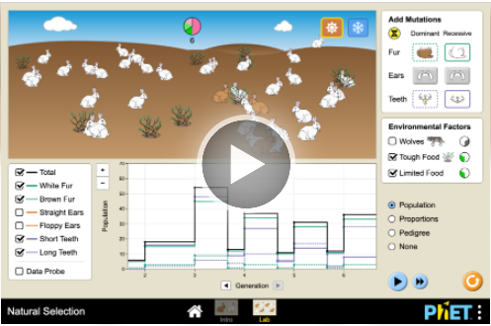
Methods: Check each box as you complete each step.
First Simulation
- ☐ First, use an approved devise and visit https://phet.colorado.edu/en/simulations/natural-selection/ (or use an internet search engine and search “PhET Natural Selection”). Your screen should resemble this
- ☐ Second, click the Play arrow button. Then click “Intro”.
  - In the “Add Mutation” box in the upper right, click the brown fur button under “Dominant”.
  - Click “Limited Food” in the “Environmental Factors” box. Leave “Wolves” unclicked for now.
  - In the box in the bottom left, click “Data Probe”.
  - Click the sun icon in the upper right (next to the snowflake).
  - Complete your predictions on the next page.
- ☐ Next, click the yellow “Add Mate” button. Let the program run until it reaches the 3rd generation.
- Click “Pause” once it reaches Generation 3 (do not go past 3.5). Record your data on the next page.
  - Be sure to drag the gray line to the appropriate generation when recording data; e.g., if the gray line is not between 3 and 4, it will not show the data for the third generation of rabbits.
- ☐ Next, click “Wolves” under “Environmental Factors”. Record your predictions on the next page. Click “Play”. Pause the simulation after Generation 6. Record your data on the next page.
- ☐ Click the “Snow” icon (upper right). Keep the wolves box clicked. Record your predictions on the next page. Click “Play”. Pause the simulation after Generation 10. Record your data on the next page.
Second Simulation
- ☐ Click the “Lab” button at the center bottom of the screen.
  - Click all of the boxes in the white box in the lower left.
  - In the white box in the upper right, click all of the boxes in the “Dominant” column for fur, ears, and teeth. Complete your predictions on the next page.
- ☐ Next, click the yellow “Add Mate” button. Let the program run until it reaches the 3rd generation.
- ☐ Click “Pause” once it reaches Generation 3 (do not go past 3.5). Record your data on the next page.
- ☐ Next, click “Tough Food” under “Environmental Factors” to simulate the transition to more woody plants. Click “Play”. Pause the simulation after Generation 6. Record your data on the next page.
- ☐ Click the “Snow” icon (upper right). Record your predictions on the next page. Click “Play”. Pause the simulation after Generation 9. Record your data on the next page.
- ☐ Click “Wolves” under “Environmental Factors”. Click “Play”. Pause the simulation after Generation 12. Record your data on the next page.
- ☐ Complete the remaining questions. Be prepared to discuss and defend your ideas for the class.
Predictions & Data – First Simulation:

- Prediction 1: There are two traits for rabbits in this simulation – brown vs. white fur. Brown fur is dominant to white. Which trait do you think will be more prevalent by the end of the simulation? Why?

- Prediction 2: Do you think that the addition of wolves will affect the percentage of rabbits with brown vs. white fur? Explain.

- Prediction 3: Do you think that the transition from warm to snowy conditions will affect the percentage of rabbits with brown vs. white fur? Explain.

- Use the table below to record your data after each round of the simulation.
 | Total Population of Rabbits | White Fur Total Population | % White Fur (White Fur/Total) | Brown Fur Total Population | % Brown Fur (Brown Fur/Total)
Initial
Start of Generation 3
(limited food)
Start of Generation 6
(wolves added)
Start of Generation 10
(transition to snow)

- Were your predictions accurate? Explain.

Predictions & Data – Second Simulation:
- Predictions: White fur, floppy ears, and long teeth are dominant traits. You will slowly change the environment by adding woody vegetation, snowy conditions, and wolves. For each option, circle the traits you expect to be most prevalent in this population by the final generation and explain why.
Brown / White Fur because …
Floppy / Upright Ears because …
Long / Short Teeth because …

- Use the table below to record your data after each round of the simulation.
 | Total Population of Rabbits | % White Fur (White Fur/Total) | % Brown Fur (Brown Fur/Total) | % Floppy Ears (Flop Ears/Total) | % Upright Ears (Up Ears/Total) | % Long Teeth (LT/Total) | % Short Teeth (ST/Total)
Initial
Start of Generation 3
(limited food)
Start of Generation 6
(tough food)
Start of Generation 9
(transition to snow)
Start of Generation 12
(wolves added)

- Based on the data above, which had a greater impact on fur color, a) whether the trait was dominant or recessive, or b) the environmental conditions? Explain and justify with data.

- Did the rabbit color change more drastically when the snow was introduced, or when the wolves were introduced? Why do you think this was the case? Support your argument with data (Gen. 9 vs. 12).

Class Discussion Questions: discuss within your groups; then be prepared to defend your ideas to the class.
- Briefly summarize how changes from mutations affected a) the rabbits’ DNA, b) their proteins & cells, c) the bodies of the rabbits, and d) the rabbit populations.
- Three different mutations resulted in new traits (brown fur, floppy ears, and long teeth). Were these acquired or hereditary mutations? Explain what these terms mean and justify your ideas with evidence.
- The second simulation involved three mutations. Two traits (fur color, teeth size) were directly affected by environmental conditions. One trait (floppy ears) was not. Did this have any impact on the change in prevalence of each trait? How does this relate to the environmental factors that affect evolution by natural selection?
- What affected the rabbit color more, a) whether or not the conditions were snowy, or b) whether or not there were predators? Why? Explain and support your claims and ideas with evidence.
- Did these mutations happen because of changes to environmental conditions, or did these mutations occur independently of environmental conditions?
- Which would result in a faster rate of change, a) an environment with plentiful vegetation and minimal predators, or b) an environment with limited vegetation and more predation? Explain.
- Four factors are necessary for evolution by natural selection to occur: 1) sexual reproduction, 2) heritable genetic variation, 3) competition, and 4) differences in survival & reproduction. Determine whether each of these factors were present in this simulation and justify your claims with evidence.

Part 4: Review & Assessment
Overview: Rank each Driving Question in Part 2 as a 1 (completely unsure), 2 (somewhat unsure), or 3 (completely sure) based on your comprehension. Then work in teams to review each item and prepare a response. Next, write a final explanation below. You will conclude by completing a formative assessment.
How do environmental factors determine whether a mutation is helpful, harmful, or neutral?
Summarize how environmental factors affect the pace at which species’ traits change over time.

Part 5: Life Connections – Antibiotic Resistance
Overview: This activity involves the initial stages of a multi-day investigation. You will be investigating how populations of bacteria change in response to selection pressures created by antibiotics. You will use this activity to model and observe how evolution by natural selection occurs among species. You will be starting these steps today because it will take time for bacteria to grow on your petri dishes.

Intro Video: https://ed.ted.com/lessons/how-antibiotics-become-resistant-over-time-kevin-wu
Methods:
- Sanitize your lab bench or work area using either a) alcohol wipes or b) by spraying a disinfectant (e.g., Lysol) and wiping with a clean paper towel.
- Sanitize your hands by washing or using hand sanitizer.
- Acquire a petri dish, vial of saline, and a sterile cotton swab from your instructor. Do NOT open these items.
- Use a permanent marker to divide the bottom of your petri dish into quadrants.
- Label the bottom of the Petri dish with your last names, class period, and the date (keep the writing very small and only on the very edges of the petri dish).
- Open the cotton swab; be careful not to allow the cotton tip to touch any surfaces.
- Determine which group member’s mouth will be swabbed.
- Have the volunteer hold the base of the cotton swab between their thumb and forefinger. Have another group member prepare a timer or watch the second hand of a clock.
  - When both are ready, have the volunteer insert the swab on one side of their mouth between the cheek and upper gum. Press the swab firmly against the gum and twirl the cotton swab. Move the swab back and forth and up and down between the cheek and gum for 30 seconds total.
- Partially open the lid of the petri dish with the opening facing away from you. This will reduce the likelihood of accidental contamination.
- Gently spread the moistened cotton swab across the surface of the agar gel so that it is evenly distributed across the entire surface. Rotate the swab as you do so. Close the lid of the petri dish when finished.
- Your instructor should have filter paper disks that have been soaked into antibiotic solutions at four different concentrations.
  - Use a forceps to place a disk on each quadrant of the petri dish (tap them gently with sterile forceps to stick them to the agar.
  - Label each quadrant with the concentration of antibiotic in the disk.
- Place the plates on their lids and keep in an incubator at 37°C for at least 24 hours.

Mutations & Change Unit - Week 2 Formative Assessment
Adapted from STEM Teaching Tools
Name: Hour Date: Score: /
Directions: A 3x5 notecard with handwritten notes can be used to guide your answers. Your instructor may allow you to work in assigned groups. If so, have a different person write each response while others assist.

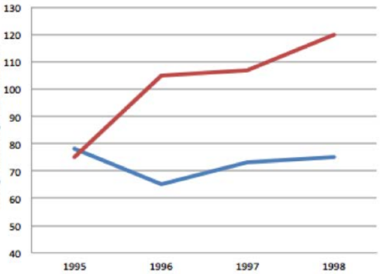
Background Info: Green anoles are a type of lizard that live in trees in Florida. In the 1950s, a similar species of lizards called brown anoles invaded Florida from Cuba. We know two things about the brown anoles:
Islands with Brown Anoles
a. They live in similar habitats and eat similar food as the green anoles.
Average Perch Height (cm)
b. Brown anoles eat the newly hatched babies of green anoles.
Islands without Brown Anoles

Scientists conducted two investigations to determine whether or not the population of green anoles was evolving due to the invasion of brown anoles. First, they introduced brown anoles to three islands and left three islands alone. Then they measured the average height at which green anoles were found in trees (perch height) before and after introducing the invasive brown anoles. This graph shows the data they collected on perch height.

Next, scientists knew that living higher in the trees was associated with larger footpads and more sticky scales
on the anoles’ feet. In 2010, the scientists collected data to investigate whether or not the population of
green anoles adapted because of the invasion. Their data is shown here.
 | Green Anoles on an Island WITHOUT Brown Anoles | Green Anoles on an Island WITH Brown Anoles
Average Perch Height in Trees | 70 cm | 120 cm
Average Size of the Toe pads | 1.27 cm | 1.33 cm (4.5% increase)
Avg. Number of Sticky Scales on Feet | 51 sticky scales | 54 sticky scales (6.5% increase)

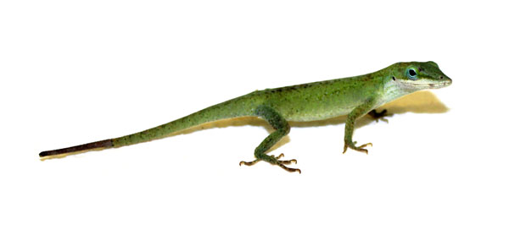
- What patterns do you see in the data above? How do the traits of the green anoles differ between populations on islands with brown anoles compared to islands without brown anoles?
Writer’s Name:

- When the brown anoles invaded, scientists noted that they ate similar food and lived in similar habitats as the green anoles. Why does this matter for the survival of the green anoles? How might this affect the rate of change in the adaptations of this species?
Writer’s Name:
- How did the changes to sticky scales & footpads occur? What caused these changes to these traits?
Writer’s Name:
- Four factors are necessary for evolution to occur. Explain whether or not each of the following four factors are present in the example of the green anoles. Justify your claims with evidence.
Sexual Reproduction:
Heritable Genetic Variation:
Competition:
Repro/Survival Rates:
Writer’s Name:
- If green anoles were affected by a new predator, would the rate of change in their traits increase, decrease, or stay constant? Make a prediction and justify with evidence.

Writer’s Name:

