The Big Bang – Week 2 Labwork
Score
□ Above & Beyond
□ Fully Complete
□ Mostly Complete
□ Incomplete – fix the following pages:
Name: Hour Date:
Date Packet is due: Why late? Score:
^{Day of Week Date} If your project was late, describe why
Driving Question: How can expansion determine the universe’s age?
Semester Schedule
How the Sun Works
Week 1: What is matter? What is energy?
Week 2: What’s inside the sun?
Week 3: How can we measure the sun?
Week 4: Where does the sun’s energy come from?
Week 5: Unit Assessment
The Life of Stars
Week 1: How long do stars last?
Week 2: Why do stars die?
Week 3: What happens after stars die?
Week 4: Unit Assessment

How It All Began
Week 1: How can we determine the universe’s size?
Week 2: How can expansion determine the universe’s age?
Week 3: Unit Assessment

Navigating Space
Week 1: How and why do things orbit in space?
Week 2: How can we predict orbits?
Week 3: Unit Assessments

Anchoring Phenomenon: Based on evidence such as redshift, CMBR, and Einstein’s equations that the universe is continually expanding. This suggests the universe was once much smaller. How did the universe begin? And what evidence supports our conclusions?

Deeper Questions
- How did matter and energy change as the Big Bang occurred?
- How does the ratio of hydrogen and helium provide evidence for the Big Bang?
- What is antimatter, dark matter, and dark energy?
- How has evidence from sources like CERN, the Hubble Telescope, and JWST shaped our existing understanding of the Big Bang?

Weekly Schedule

Part 1: Introduction
- Initial Ideas – Predicting the Big Bang
- Discussion & Developing Explanations

Part 2: Core Ideas
- Core Ideas
- Revisions of Part 1 Explanations

Part 3: Investigation
- Part A – Big Bang Timeline
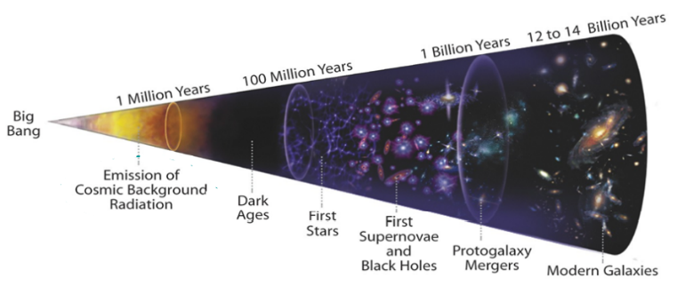
- Part B – Big Bang Meme Contest

Part 4: Review & Assessment
- Critiquing Ideas
- Assessment

Part 5: Side Quest
- Weekly Recap
- Side Quests
NGSS Standard: HS-ESS1-2: Construct an explanation of the Big Bang theory based on astronomical evidence of light spectra, motion of distant galaxies, and composition of matter in the universe.

Part 1: Big Bang Predictions
Overview: In this activity, you will predict how the universe has changed since the Big Bang began by compiling ideas, explanatory models, and evidence from the entire course.
Directions: Work in teams to address the questions below. Then use your responses as a guide to develop predictions about how the universe has changed since the Big Bang.

Review Questions
- What are atoms made from?
- Why are there different kinds of elements? What determines if an atom is one element or another?
- What is the difference between matter and energy? What does the equation E = mc² tell us about the relationships between matter and energy?
- How are pressure, temperature, and volume related?
- Why do some gas clouds form stars while others only form gas planets? What conditions are necessary for nuclear fusion to occur in stars? What happens when fusions slows/stops, and why does this occur?
- Where do stars come from? How do stars change as they age, and what are the potential final outcomes for a star? How do these outcomes relate to the formation of new stars and new solar systems?
- What is hydrostatic equilibrium and how does it affect the life stages and longevity of stars?
- Where do new elements come from? What process creates most of the elements on the periodic table?
- What do redshift, Hubble’s Law and Hubble’s Constant indicate about how the universe is changing?
- What do Einstein’s theories of relativity indicate about if/how the universe changes as time goes on?
Big Bang Prediction Questions – use your responses to the questions about to make the following predictions:
- As we get closer and closer to the beginning of the universe, what assumptions can we make about a) the size, b) pressure, and c) temperature of the universe?
- How might matter and energy have been different at the start of the universe compared to today?
- What kinds of matter existed at the beginning of the universe? How might early conditions affect how matter formed and how matter changed?
- If hydrogen fusion forms helium and eventually all other elements, where did hydrogen come from?
- Predict which came first, nuclear fusion or the formation of stars. Explain your reasoning.
- Why does matter exist? Why isn’t everything just energy?
- Is everything matter and energy, or could there be other substances?
As a class, discuss your ideas. What are ideas that most agreed on? Where did your ideas differ?
We disagreed or are unsure about…
We all agree that…

Part 2: Core Ideas
Overview: In this activity, you will look at a short slideshow presentation to clarify your initial ideas. Your instructor will decide on how to implement this portion depending on your previous experience and capabilities. You will then work in small teams to answer the questions listed below. You should take notes in a notebook, dry erase board, or on scratch paper so that you are prepared for the class discussion that will follow. Note: your instructor may assign specific questions to your group if time is limited.

Intro Video: Click Here
Core Ideas Presentation: https://bit.ly/WUHS-Astro-BigBangW2

Driving Questions:
- What is a singularity? How does this relate to the underlying premise of the Big Bang Theory?
- How does a scientific theory differ from more common usage of the term “theory”? If something is a scientific theory, what does this imply?
- Summarize the four main forces. How were these forces different at the start of the Big Bang during the Radiation Era? How does this relate to The Theory of Everything?
- What are elementary particles? Briefly summarize how quarks, leptons, bosons, and photons affect matter and energy.
- What is antimatter? How do matter and antimatter interact with each other?
- How have CERN and the Large Hadron Collider enabled us to better understand the Big Bang?
- How did conditions change roughly 100 seconds after the Big Bang? How did this change interactions between matter and antimatter?
- How did conditions change roughly two minutes after the Big Bang? How did this affect matter?
- How do the current ratios of hydrogen and helium in the universe provide evidence for the Big Bang?
- What is primordial nucleosynthesis? How did this process affect the amount of helium and deuterium that exists in the universe today?
- How can deuterium be used to determine the concentrations of matter throughout the universe?
- What is dark matter? How do we know it exists?
- How did interactions between neutrons, protons, and electrons change during the Matter Era? How did this affect the interactions between matter and energy? Why is this point known as the Dark Ages?
- Why did stars start forming during this era? How did this affect the production of heavier elements on the periodic table?
- How did data from the Hubble Telescope change our understanding of how the universe is changing?
- What is dark energy and how does this relate to the findings from the Hubble Telescope?
- What is the James Webb Space Telescope (JWST)? What kind of data will be collected by JWST?
- Why does the JWST use infrared radiation? Wouldn’t visible light be more useful?
Revising Explanations: What is the basic premise of the Big Bang Theory? What evidence supports this?

Part 3A: Investigation – Big Bang Timeline
Overview: You will collaborate to track events as they occurred in chronological order during the Big Bang. Use the Core Ideas presentation for this week to summarize what occurred at each point.

- The Radiation Era occurred after the Big Bang. At this point
the four fundamental forces were
- About 10⁻⁴³ to 10⁻³⁶ seconds after the Big Bang, the universe
This caused the force of gravitation to
This is also when began to form.
- At 10⁻³⁶ seconds after the Big Bang
- Within the first 100 seconds after the Big Bang
These conditions enabled the start of
This enabled neutrons and protons to
- At roughly 2 minutes after the Big Bang, temperatures cooled to . Deuterium could
now
This was still hot enough to
- The Matter Era occurred . As the universe continued to cool,
This allowed radiation to . The period after the formation of
the first atoms (w/ a proton, neutron, and electron) are often called the
- Between 200 million and 3 billion years after the Big Bang

Directions: When ready, raise your hand. Your instructor will determine if you are ready to move on.
This activity was successfully completed (instructor signature)

Part 3B: Investigation – Big Bang Memes
Overview: For this activity, you will collaborate to create memes that demonstrate your understanding of events and processes that occurred during the Big Bang.

Directions: In your groups, make four internet memes related to this week’s content. Click here to access a meme generator that is school appropriate. Each meme should reflect your understanding of core ideas from this week. Your memes to not have to be funny per se, but they should make sense and accurately reflect the material. Make sure that your memes are appropriate for school.

When your group is ready to present your four memes, raise your hand. Your instructor will view your memes and listen to your explanations and then determine if you are ready to move on.
This activity was successfully completed (instructor signature)

Part 4: Review & Assessment
Overview: Rank each Driving Question in Part 2 as a 1 (completely unsure), 2 (somewhat unsure), or 3 (completely sure) based on your comprehension. Then work in teams to review each item and prepare a response. Next, write a final explanation below. You will conclude by completing a formative assessment.
Revising Explanations: What is the basic premise of the Big Bang Theory? What evidence supports this?

This page is intentionally blank.

Big Bang – Week 2 Assessment
Name: Hour Date: Score: /
Directions: This is an open-notes quiz. You should work with your assigned team to complete responses to the questions below. Each person should write the response to at least one question. Write your initials next to the answer(s) you wrote. Those who are not writing should collaborate to create the response that will be written.

- First explain the basic premise of the Big Bang Theory. Then summarize how each of the following provide evidence for this idea: redshift & Hubble’s Law; CMBR; hydrogen & helium ratios
Initials:
- What are elementary particles? Briefly summarize how quarks, leptons, bosons, and photons affect matter and energy.
Initials:

- Summarize how matter changed at 100 seconds, at 2 minutes, and at 1000 seconds after the Big Bang. Address each of the following: antimatter; deuterium; primordial nucleosynthesis
Initials:
Initials:
- How did interactions between neutrons, protons, and electrons change during the Matter Era? How did this affect the interactions between matter and energy? Why is this called the Dark Ages?
Initials:
- Summarize how evidence and data from each of the following informed our understanding of the Big Bang: CERN & the LHC; the Hubble Telescope; the JWST. Summarize any conclusions that emerged specifically because of these resources.
Initials:
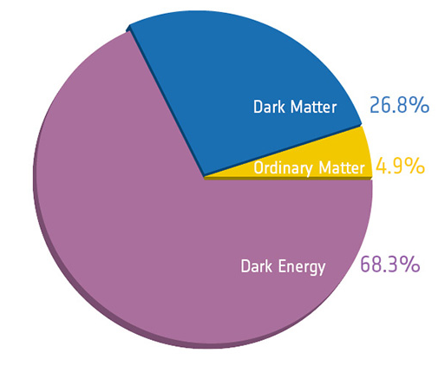
- The data shown here indicate that only 4.9% of the composition of the universe consists of actual matter. The remainder consists of dark energy and dark matter. Explain the difference between dark energy and dark matter. Then explain how we know these entities exist if we can’t observe them.
Initials:

