DNA & Proteins Unit – Packet 2
Score
□ Above & Beyond
□ Fully Complete
□ Mostly Complete
□ Incomplete – fix the following pages:
Name: Hour Date:
Date Packet is due: after Part 5 Why late?
If your work was late, describe why
Semester Schedule
Traits & Genes
Packet 1 - What determines the traits of an organism?
Packet 2 - How are traits inherited from parents?
Packet 3 – Can we predict traits?
Packet 4 - Assessment

DNA & Proteins
Packet 1: What is DNA and how does it work?
Packet 2: How does DNA affect protein assembly?
Packet 3: How does a protein acquire its shape & function?
Packet 4 - Assessment

Mutations & Change
Packet 1: How do mutations change genes & proteins?
Packet 2: How can mutations lead to new traits & species?
Packet 3: How do mutations affect natural selection?
Packet 4 - Assessment

Biodiversity & Extinctions
Packet 1: How does biodiversity affect ecosystems?
Packet 2: How and why do extinctions occur?
Packet 3: Assessment

Driving Question: How does DNA affect protein assembly?

Anchoring Phenomenon: DNA can be extracted from cells simply using alcohol and soap. However, extracted DNA often looks very different from the simplistic images of double helixes we normally see in popular culture. How can this molecule provide instructions for assembling complex macromolecules?

Schedule

Part 1: Introduction
- Initial Ideas – Big ol’ Whales
- Data Dive – Analyzing Whale DNA
- Discussion & Developing Explanations

Part 2: Core Ideas
- Core Ideas
- Revisions of Part 1 Explanations

Part 3: Investigation
- Part 3A: The Armstrong Siblings
- Part 3B: Transcription & Translation Demo

Part 4: Review & Assessment
- Ranking Your Readiness
- Formative Assessment & Mastery Check

Part 5: Life Connections
- Life Connections – DNA, RNA, and Medicine

Deeper Questions
- How is the information in DNA used to assemble amino acids?
- How does a cell “know” how to interpret the information stored within DNA?
- What is RNA and how is it both similar and different from DNA?

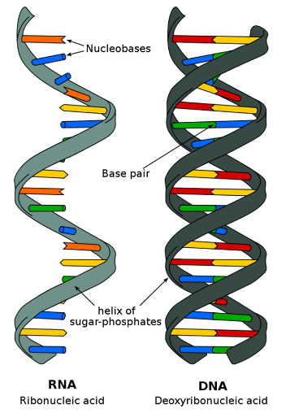
NGSS Standards:
HS-LS1-1 - How the structure of DNA determines the structure of proteins and function.
HS-LS1-2 - How inheritable variations result from 1) changes via meiosis; 2) errors during replication; 3) mutations via environmental factors
HS-LS1-4: How mitosis and differentiation enable complex organisms.

Part 1: Introduction – Big ol’ Whales
Overview: In this activity, you will begin by discussing your initial ideas about how DNA determines traits using findings from research on whales.

Reading: Whales are some of the largest animals in the history of the world. At roughly 100 feet long and 190 metric tons, the blue whale is the largest animal ever. In a period of 5-10 million years, whales evolved from ancestors the size of sea lions to their current size. This was a rapid development for such a significant evolutionary change. Two competing hypotheses have emerged to explain how and why whales grew so large at such a rapid pace.

The first hypothesis is that changes in the whale’s DNA caused their large body size. According to this idea, whales developed larger body sizes as a result of genetic mutations (changes to DNA). These mutations resulted in traits that provided benefits like increased energy efficiency, improved temperature regulation, and enhanced their reproductive success. This genetic adaptation was also aided by environmental factors such as the abundance of food and the ability to move efficiently through the water.

The second hypothesis is that whales became the largest animals due to easy access to food. According to this theory, whales evolved to take advantage of the vast amounts of biomass available in the ocean. This idea suggests that whales evolved larger body size in response to larger amounts of food; this enabled them to store more energy and survive in the harsh marine environment. This would also have allowed whales to migrate long distances to areas where food was more abundant, as larger body size would have allowed them to store enough energy to survive during these migrations.

Questions:
- Whales are found in many different marine environments, including polar regions where biomass production is very limited. How does this information affect these two hypotheses?
  - It supports the first hypothesis but weakens arguments for the second hypothesis.
  - It supports the second hypothesis but weakens arguments for the first hypothesis.
  - It supports both the first and second hypothesis.
  - It weakens arguments for both the first and second hypothesis.
- Which of the following would be a possible rationale for the first hypothesis?
  - Most marine ecosystems support more photosynthesis and have higher carrying capacities.
  - Whales that live in nutrient-rich waters have easier access to diets high in fat and protein.
  - If proteins that regulate cell division became dysfunctional, rates of mitosis would increase and lead to a larger body size.
  - Larger body sizes would enable whales to outcompete smaller organisms for access to food.
- Which of the following hypothetical scenarios would most support the second hypothesis?
  - Rates of ocean photosynthesis increased significantly prior to the first fossil evidence of changes to the whale’s DNA.
  - Whales initially were only found in the warmest marine environments but then migrated to colder regions.
  - Whales have a dysfunctional gene for a protein that regulates mitosis, resulting in higher rates of cell division compared to other similar species.
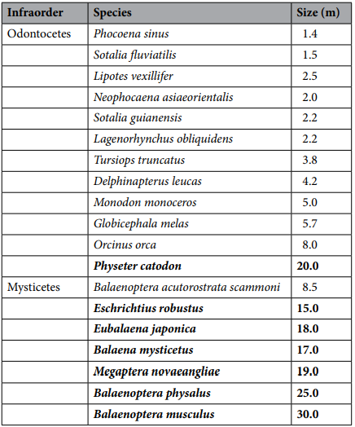
Data Dive: A team of researchers (Silva et al., 2023) analyzed the genes of several whale species. They observed that the EGF gene had become dysfunctional in many of the largest whale species. The EGF gene helps cells assemble proteins that regulate processes such as cell division, apoptosis, formation of blood vessels, and wound healing/tissue repair. The EGF gene is also important for tooth formation.

Whales with the dysfunctional EGF gene stop assembling the EGF protein at the 948th amino acid. This causes the protein to only partially form. This results in an incomplete and non-functional EGF protein.

For the data on the right, the whales in bold are those over 10 m (33 feet). The largest whales tend to be part of the mysticetes (toothless) group. These whales lack teeth and use protein-based structures called baleen to filter their food from ocean water. In contrast, whales in the odontocetes (toothed) group tend to be smaller.

- Begin by individually attempting to make sense of this data. What trends or patterns do you notice? How does this relate to prior knowledge that you have?
- Next, work in your teams to discuss your ideas. Where do you agree? Where do you disagree? Can you use this data to reach an agreement? Do others have prior knowledge or experience that could help?

- Based on this data, what is one conclusion that would be supported by this data? How is this conclusion supported by this data? What specifically suggests that your claim is accurate?
- Based on this data, what is a second conclusion that would be supported by this data? How is this conclusion supported by this data? What specifically suggests that your claim is accurate?
- How does this data pertain to the two hypotheses on the previous page?
- Discussion & Developing Ideas: As a class, discuss your ideas about this data. What are the ideas that most agreed on? Where did your ideas differ as a class? Record your ideas in the spaces below.
We all agree that…
We disagreed or are unsure about…

How did changes to the whale’s DNA affect its proteins and traits? Write down your initial explanation in the space below. You will come back and revise this explanation throughout this packet.

Part 2: Core Ideas
Overview: In this activity, you will begin with a short slideshow presentation. This will provide you with core ideas that will help you clarify your initial ideas. Your instructor will decide on how to implement this portion depending on your previous experience and capabilities with this content.
You will then work in small teams to answer the questions listed below. You should take notes in a notebook, on a dry erase board, or on scratch paper so that you are prepared to deliver your responses during the class discussion that will follow. Note: your instructor may assign specific questions to your group if time is limited.

Intro Videos: Transcription & Translation
Core Ideas Presentation: https://bit.ly/WUHS-Bio-DNAProteinsW2
Driving Questions:
- What is RNA? What is the purpose of RNA? How is it both similar and different from DNA?
- RNA and DNA are both macromolecules made from chains of nucleotides. Why does a cell need both RNA and DNA?
- RNA is involved in two key processes: transcription and translation. Briefly summarize what occurs in each of these processes.
- Summarize the purpose of each of the following during transcription: mRNA and RNA polymerase.
- Create the complementary mRNA sequence if the start of a gene was: 3’ TAC-GCT-ATG 5’
- Summarize the purpose of each of the following during translation: ribosomes (rRNA), tRNA, and amino acids.
- What would happen if the following became dysfunctional? RNA polymerase; ribosomes.
- How does tRNA ‘know’ which amino acids to deliver to assemble a protein? How does tRNA deliver amino acids in the correct order for a given protein?
- Some antibiotics target and disable RNA polymerase in harmful bacteria. How would this stop or slow the growth of bacteria and reduce the risk of an infection?
- Revising Explanations: Return to your original explanation that you created at the end of Part 1. Based on this new information, how would you now respond to this question?
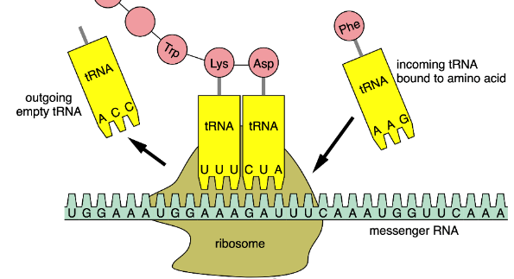
How does DNA determine protein assembly and traits?

Part 3A Investigation: The Armstrong Siblings
Overview: In this investigation, you will create pictures for a metaphorical story to explain transcription and translation. Your job will be to draw pictures of what is described in each box. It is ok if you are not artistic - stick people are just fine! If you’d prefer not to draw, you may draw diagrams or flow charts or anything that will help you to remember what is in the box. Be prepared to explain the metaphors in this story as a group.
When you think you are ready to explain this metaphorical story, raise your hand. Your instructor will listen to your verbal responses.
This activity was successfully completed (instructor signature)
Tyrone Armstrong – the truck driver who delivers amino acids to the Ribosome Protein Factory.
Protein Factory - Where proteins are made by Rhonda using amino acids delivered by Tyrone.

The Nucleus Mansion
Where Donald Armstrong lives, and where Myron gets his instructions.

Myron N. Armstrong – Donald’s messenger from the Nucleus Mansion to the Protein Factory.
Donald Armstrong – He lives in the Nucleus Mansion and decides what products the Protein Factory makes.
Rhonda Armstrong – the CEO of the Protein Factory. She runs this factory for Donald.
Myron delivers Donald’s messages to Rhonda. She operates the Ribosome Protein Factory.

Donald can only communicate with the Protein Factory through his brother, Myron. Myron can only memorize what Donald says.
Donald Armstrong lives in the Nucleus Mansion. He decides what the Protein Factory makes. He never leaves the mansion.
Myron’s messages tell Tyrone and Rhonda the order that amino acids must be delivered and added for each protein.

In summary, Donald communicates with Rhonda through messages delivered by Myron. Rhonda uses this the information to assemble the amino acids into proteins. These amino acids are delivered to the Protein Factory by Tyrone.

Myron’s messages tell Rhonda how to assemble different amino acids to make specific proteins.

Amino acids are delivered to Rhonda’s factory by her brother, Tyrone. Tyrone uses trucks to deliver amino acids.

Part 3B: Transcription/Translation Modeling
Overview: In this exercise, you will create 2D or 3D models to explain key aspects of transcription & translation..

Materials needed (per group of 4): resources for 2D and/or 3D modeling. These could involve any of the following: Playdoh, dry erase boards, scratch paper, a digital art program, etc. It could also involve a pre-existing kit.

Methods:
- In your assigned teams, review the key concepts from this unit. Check to ensure everyone in your group feels comfortable with their understanding of each key concept.
- Develop a plan for how to portray transcription and translation using your available resources.
  - Your 2D or 3D models do not need to be precise – if they only vaguely resemble the items they depict, that’s ok.
  - What matters most is your capacity to use these materials to demonstrate your comprehension of how transcription and translation enable information in DNA to be used to assemble proteins.
- Prepare to use your 2D/3D models to explain each of the following:
  - How RNA differs from DNA.
  - How an mRNA copy is made by RNA polymerase during transcription.
  - How a ribosome assembles proteins from amino acids during translation.
  - How tRNA ‘knows’ which amino acid to deliver each time.
- When you think you are ready to explain your work, raise your hand. Your instructor will listen to your verbal responses and check your work.

This activity was successfully completed (instructor signature)

Part 4: Review & Assessment
Overview: Rank each Driving Question in Part 2 as a 1 (completely unsure), 2 (somewhat unsure), or 3 (completely sure) based on your comprehension. Then work in teams to review each item and prepare a response. Next, write a final explanation below. You will conclude by completing a formative assessment.
How does DNA determine protein assembly?

Part 5: Life Connections – RNA & Medicine
In this activity, you will have an opportunity to interview an individual with professional expertise in this packet’s content topics, or watch a pre-recorded video. This activity will be reflective of social science research, or gathering, analyzing and interpreting information about human interactions. Often this work is conducted using qualitative interviews, which are interviews designed for research and data collection.
Part 1 - Planning
- Briefly summarize the topics that were covered in this packet in one sentence:
In this packet, we studied
- As a group, discuss what questions you still have about this packet’s topics. Ideally, use some of the following to start your questions: Who, What, When, Where, Why, How
Once you have developed three questions, ask for your instructor to provide you with some feedback.
- From this list, choose a research question for your group and complete the prompt below:
We are unsure
- Turn your research question into a hypothesis. What do you think is the answer to your research question given what you currently know?
We hypothesize that

- Create three interview questions that you could ask this individual that may provide information related to your research question. Try to focus on their particular area of expertise as you craft your questions.
1.
2.
3.
- Be prepared to briefly describe your research question and hypothesis. Explain how your interview questions will provide you with information that will help to address your research question.
Part 2 – Interview Field Notes - Use the space below to record some field notes as the guest speaker presents to the class. Record anything that you hear or observe that might be relevant to your research question.
Part 3 – Analysis & Debrief (your instructor may choose to use verbal discussion instead of written responses)
- Does your data (your observations and field notes from this interview) support or refute your hypothesis? Circle one: Supports it / Refutes it / Not sure
Explain:

This page is intentionally blank.

DNA & Proteins Unit - Packet 2 Formative Assessment
Name: Hour Date: Score: /
Directions: A 3x5 notecard with handwritten notes can be used to guide your answers. Your instructor may allow you to work in assigned groups. If so, have a different person write each response while others assist.

- DNA and RNA are both macromolecules made from repeating chains of nucleotides. Why does a cell need both RNA and DNA? Include and underline the following terms: transcription & translation.
Writer’s Name:
Three students shared their ideas about the function of DNA and RNA.
  - Mike: "DNA is found in animal cells, and RNA is found in plant cells."
  - Lucia: "RNA is what turns DNA into a protein."
  - Oscar: “DNA is the instructions for a protein; RNA is the instructions for making fat.”
- Provide a critique for each response. What was inaccurate about their statement?
Mike:
Lucia:
Oscar:
Writer’s Name:
- Some antibiotics fight bacteria by targeting and disabling RNA polymerase. How would this affect transcription and translation in bacterial cells? How would this slow or stop a bacterial infection?
Writer’s Name:
The mRNA vaccines do not contain any live virus. They work by ‘teaching’ our cells to make a harmless piece of a viral protein. After making the viral protein, cells display it on their surface. This trains our antibodies to recognize and destroy a virus before it can infect our cells. (Source: CDC)
- This excerpt describes how mRNA vaccines work. Traditional vaccines inject part of a virus into the body to create an immune response. How can an mRNA vaccine “teach” a cell how to produce a viral protein? In your response, explain the function of mRNA during transcription & translation.
Writer’s Name:
- Briefly summarize what occurs during translation. Then explain how tRNA “knows” which amino acid to deliver next as the protein is being assembled. Include and underline the following terms: mRNA, ribosome, tRNA, codon.
Writer’s Name:
- The EGF protein limits cell division. In some species of whales, a codon within the EGF gene changed into a stop codon. A) Summarize how this would affect EGF protein translation. B) Then explain how these changes enabled the large size of some whales.
Writer’s Name:

