Mutations & Change Unit – Packet 2
Score
□ Above & Beyond
□ Fully Complete
□ Mostly Complete
□ Incomplete – fix the following pages:
Name: Hour Date:
Date Packet is due: after Part 5 Why late?
If your work was late, describe why
Semester Schedule
Traits & Genes
Packet 1 - What determines the traits of an organism?
Packet 2 - How are traits inherited from parents?
Packet 3 – Can we predict traits?
Packet 4 - Assessment

DNA & Proteins
Packet 1: What is DNA and how does it work?
Packet 2: How does DNA affect protein assembly?
Packet 3 – Assessment
Packet 4 – How are new genes added to DNA? (Mini-Unit)

Mutations & Change
Packet 1: How does a protein acquire its shape & function?
Packet 2: How do mutations change genes & proteins? Packet 3: How can mutations lead to new traits & species?
Packet 4 – Assessment
Packet 5 – How Does Antibiotic Resistance Occur?

Biodiversity & Extinctions
Packet 1: How does biodiversity affect ecosystems?
Packet 2: How and why do extinctions occur?
Packet 3: Final Assessment

Driving Question: How do mutations change genes & proteins?

Anchoring Phenomenon: We have briefly encountered mutations already through examples such as sickle cell anemia. This week, we will dive deeper into how mutations occur, what causes mutations, and how different kinds of mutations affect the production of proteins and the traits of organisms.

Deeper Questions
- What kinds of mutations can occur?
- Why do mutations occur?
- What are the impacts of different kinds of mutations?

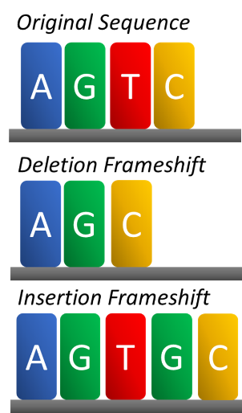
NGSS Standards:
HS-LS1-2 - How inheritable variations result from 1) changes via meiosis; 2) errors during replication; 3) mutations via environmental factors
HS-LS4-3 – How organisms with advantageous traits increase in proportion in their populations.
HS-LS4-4 - How natural selection leads to adaptations of populations.
HS-LS4-2 - Evolution is due to 4 factors: 1) reproduction; 2) heritable mutations; 3) competition; 4) enhanced survival & reproduction in comparison to individuals without beneficial mutations.

Weekly Schedule

Part 1: Introduction
- Initial Ideas – Double-Muscle Cattle
- Data Dive – Mutations, Proteins, & Traits
- Discussion & Developing Explanations

Part 2: Core Ideas
- Core Ideas
- Revisions of Part 1 Explanations

Part 3: Investigation
- DNA Mutation Simulation

Part 4: Review & Assessment
- Ranking Your Readiness
- Assessment

Part 5: Life Connections
- Weekly Recap
- Life Connections – Genetic Diseases

Part 1: Introduction – Double Muscle Cattle
Overview: In this activity, you will begin by discussing your initial ideas about mutations through a case study about ‘double muscled’ cattle.

Initial Ideas: Mutations are changes that occur in a gene for a protein. Altering the DNA can change the way in which proteins are assembled. This can change the shape of the protein, potentially impairing its function.
- Three students shared their ideas about why mutations occur. Do you agree or disagree with each student’s claim?
  - Mike: "I think that mutations occur because of errors that happen when DNA is duplicated during mitosis or meiosis." Agree / Disagree
  - Lucia: "I think that mutations occur because of factors outside of the body. For example, I know that too much sunlight or eating too much processed food can be problematic." Agree / Disagree
  - Oscar: “I think that mutations result from errors that occur during transcription or translation.”
Agree / Disagree
- Work in your small groups to discuss your ideas. How are your ideas similar or different? Decide as a group whether each statement is correct (and why). Be prepared to present your ideas to the class.
Data Dive: Watch the video and then read the information below. Video: https://youtu.be/Nmkj5gq1cQU
“Double muscling” is a genetic condition caused by a mutation in the gene for the myostatin protein. This protein regulates muscle development – it limits the rate at which muscle fibers develop. Animals with deformed myostatin proteins will be born with 2-3 times as many muscle fibers compared to cattle without the mutation. This visibly increases muscle growth compared to normal cattle.

Double muscling might seem beneficial, as cattle are often raised for meat production. However, there are drawbacks to this condition. First, animals affected by this are so large at birth that they sometimes require a surgical operation (called a Cesarean section, or C-section) to be born. Second, double muscled animals sometimes have thicker tongues. This can impair their ability to eat. Finally, the meat from double muscled animals is generally lower in quality. This is due to a lower fat content compared to meat from unaffected animals.
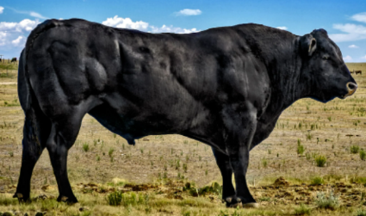
Two breeds of cattle are especially prone to the double-muscled mutation. One example is the Piedmontese breed (top). In these cattle, double-muscling is usually caused by a change in a single base of one codon. As a result, the codon codes for a cysteine amino acid instead of tyrosine.

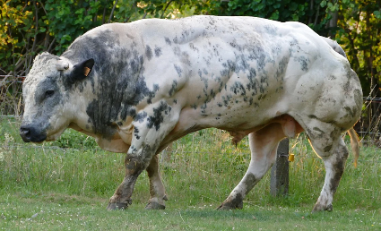
In the Belgian Blue breed (bottom), 11 bases are missing from the genes of most affected animals. This changes every codon that occurs after this mutation. This changes large portions of the amino acid sequence in the myostatin protein.

In both cases, the myostatin protein is assembled using a different sequence of amino acids. This alters the shape and impairs the function of that protein. This prevents the protein from regulating muscle growth, resulting in more muscular animals.
(Image Sources – Top: Popsci; Bottom: Pixabay)

Questions:
- How do cells assemble proteins during transcription and translation? How do amino acid properties affect protein shape and function? How do proteins affect an organism’s traits?
- What does the myostatin protein do? How would a mutation in the myostatin change the traits of cattle?
- In some cases, the myostatin gene is changed so that the amino acid tyrosine to be replaced by cysteine. What is unique about the amino acid cysteine? Predict how this change would affect the protein.
- In Belgian Blue cattle, 11 nucleotides are missing from the genes of most affected animals. This changes every codon after this mutation. How would this change the amino acid sequence?
- Which seems like it would affect a protein more, a) substituting one base for another base, or b) inserting or deleting bases from a gene? Explain your reasoning and support it with evidence.
- This article summarizes two different kinds of mutations. What do you think is responsible for these different kinds of mutations? What might cause substitution, deletion, or insertion of bases in a gene?
Discussion & Developing Ideas
- As a class, discuss your ideas about this data. What are ideas that most agreed on? Where did your ideas differ as a class? Record your ideas in the spaces below.
We disagreed or are unsure about…
We all agree that…
- How can DNA be altered by mutations, and why do mutations occur? Write down your initial explanation in the space below. Don’t worry if you aren’t completely sure about your answer! You will come back and revise this explanation as you gain more information during this unit.

Part 2: Core Ideas
Overview: In this activity, you will begin with a short slideshow presentation. This will provide you with core ideas that will help you clarify your initial ideas. Your instructor will decide on how to implement this portion depending on your previous experience and capabilities with this content.
You will then work in small teams to answer the questions listed below. You should take notes in a notebook, on a dry erase board, or on scratch paper so that you are prepared to deliver your responses during the class discussion that will follow. Note: your instructor may assign specific questions to your group if time is limited.

Intro Video: https://www.youtube.com/watch?v=Jl1Aa7Iq4tc

Core Ideas Presentation: Packet 2 Core Ideas
Driving Questions:
- What is a mutation?
- What is the difference between an acquired mutation and a hereditary mutation?
- How were the thalidomide case studies an example of acquired mutations? How are double muscle cattle examples of hereditary mutations?
- What are the causes of hereditary and acquired mutations? What factors cause changes to DNA?
- What are mutagens? What are examples of mutagens?
- What is the difference between a substitution mutation and a frameshift mutation?
- What are two causes of frameshift mutations?
- Why do frameshift mutations tend to have more impact than substitution mutations?
- What is a chromosomal mutation? How is this different from other kinds of mutations?
- What are four ways in which chromosomal mutations can occur?
- How is Down’s syndrome an example of a chromosomal mutation?
- Revising Explanations: Return to your original explanation that you created at the end of Part 1. Based on this new information, how would you now respond to this question?
What are different ways in which DNA can be altered by mutations?
What causes mutations?

Part 3 Investigation: DNA Mutation Simulation
Adapted from materials by Biology Corner
Overview: In this investigation, you will use a computer simulation to investigate different kinds of mutations.
Pre-Investigation Questions: Work as a group to determine the best response to each question. Be prepared to provide verbal responses for these questions for your instructor before you complete the investigation.
- What is the difference between acquired and hereditary mutations?
- What is the difference between substitution mutations and frameshift mutations?
- What are potential causes of mutations?
- Why do some mutations change proteins and traits more than others?
When you think you are ready, raise your hand. Your instructor will listen to your verbal responses.
This activity was successfully completed (instructor signature)

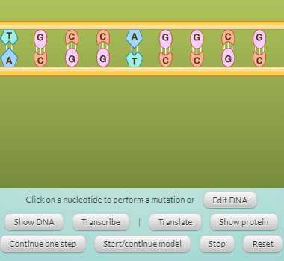
Methods: Check each box as you complete each step.
- ☐ First, access this program on an approved device by clicking here or here (or use a search engine to search for DNA Mutation Simulation LabXchange). Your screen should resemble this
- ☐ Second, click the “Transcribe” button to see a simulation of how RNA polymerase creates the mRNA copy of a gene.
  - Then click the “Translate” button to see how the protein is assembled using the mRNA copy.
  - Finally, click “Show Protein” to see the product.
  - Observe the amino acids in this protein. Notice how they are color-coded. Use the table on the next page to determine what these colors indicate. Record this below.
- ☐ Next, click “Reset” and then “Edit DNA”. Change the DNA to reflect how a substitution mutation would occur. Repeat the steps above. Record your observations on the next page.
- ☐ Next, click “Reset” and then “Edit DNA”. Change the DNA to reflect how a frameshift mutation would occur due to a deletion. Repeat the steps above. Record your observations on the next page.
- ☐ Finally, click “Reset” and then “Edit DNA”. Change the DNA to reflect how a frameshift mutation would occur due to an insertion. Repeat the steps above. Record your observations on the next page.
Investigation Questions:
- The original gene was: ATGCCAGGCGGCGAGAGCTTGCTAATTGGCTTATAG
What was the amino acid sequence that was produced in response to this sequence?
Met ______ ______ ______ ______ ______ ______ ______ ______ ______ ______
- The amino acids were color-coded by this program. What did these colors represent?
Hint: use the codon wheel and amino acid table on the next page to assist you with these questions.
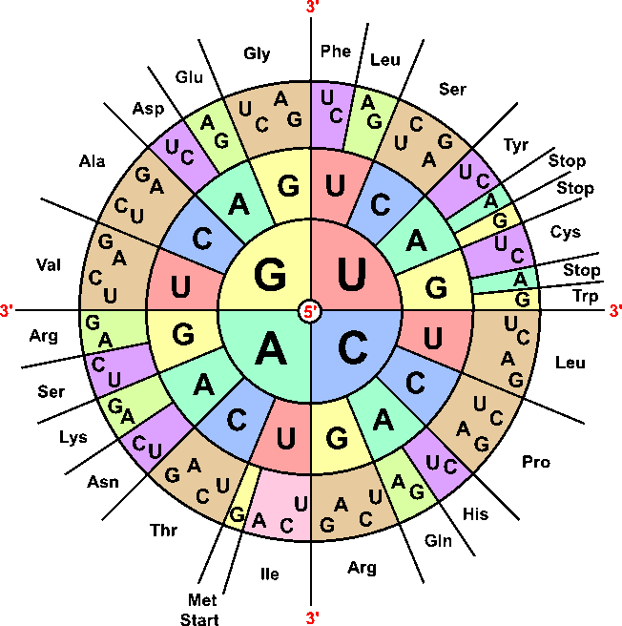
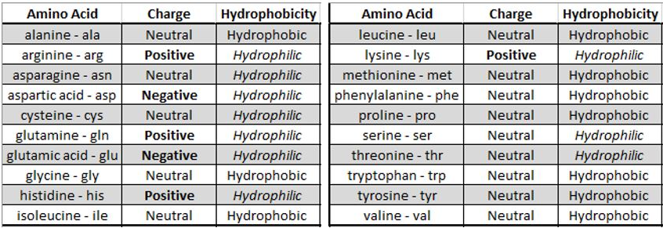

- How did you change the original DNA sequence to reflect a substitution mutation? Cross out the base that was substituted and write its replacement using the sequence below:
ATGCCAGGCGGCGAGAGCTTGCTAATTGGCTTATAG
- What was the amino acid sequence that was produced in response to this sequence?
______ ______ ______ ______ ______ ______ ______ ______ ______ ______ ______
- How did you change the original DNA sequence to reflect a frameshift mutation due to a deletion? Cross out the base that was deleted using the sequence below:
ATGCCAGGCGGCGAGAGCTTGCTAATTGGCTTATAG
- What was the amino acid sequence that was produced in response to this sequence?
______ ______ ______ ______ ______ ______ ______ ______ ______ ______ ______
- How did you change the original DNA sequence to reflect a frameshift mutation due to an insertion? Show the base you inserted using the sequence below:
ATGCCAGGCGGCGAGAGCTTGCTAATTGGCTTATAG
- What was the amino acid sequence that was produced in response to this sequence?
______ ______ ______ ______ ______ ______ ______ ______ ______ ______ ______
- While frameshift mutations generally change proteins more than substitution mutations, there are exceptions. Using the same program, edit the original DNA to reflect the change below.
ATGCCAGGCGGCGAGAGCTTGCTAATTGGCTTATAG
ATGCCAGGCGGCTAGAGCTTGCTAATTGGCTTATAG
How did this change the amino acid sequence? Why did this minor change result in this outcome?
Be prepared to discuss and defend your ideas in small groups and as a class.

Part 4: Review & Assessment
Overview: Rank each Driving Question in Part 2 as a 1 (completely unsure), 2 (somewhat unsure), or 3 (completely sure) based on your comprehension. Then work in teams to review each item and prepare a response. Next, write a final explanation below. You will conclude by completing a formative assessment.
What are different ways in which DNA can be altered by mutations?
What causes mutations?

Part 5: Life Connections – Genetic Diseases
Directions: Use the directions below to obtain more information about a specific genetic disease using an internet search engine.
- Visit the following website: https://www.genome.gov/For-Patients-and-Families/Genetic-Disorders
(or type “Genetic Disorders” and “NIH” into an internet search engine to find the article).
- Skim through the list of genetic disorders. With a partner or group, choose a disorder to focus on.
  - Your instructor may require each group to choose a different disorder. Follow their instructions.
- With your group, use this resource to address the following:
  - Summarize this disease. What does it involve? How does it affect the body?
  - What are the symptoms of this disease?
  - What causes this disease? How is this a genetic disease? Is there a specific mutation?
  - How is this disease diagnosed?
- Use an internet search engine to find another source that provides information about this disease. Address each of the following in this Google doc: https://forms.gle/HQchByVL5oEbR4qT8
  - Credibility: Who is the author? What are their credentials? Are they sufficiently qualified to provide this kind of information? Who is sponsoring or publishing this information?
  - Accuracy: Does this information seem accurate based on what you already know about this topic? Do you have any reason to be concerned about accuracy in this source?
  - Reliability: Does the website present a certain bias or viewpoint?
  - Relevance: Does this website sufficiently enable you to address your questions about this topic?
  - Date: When was this information published? Is it still relevant, or is it potentially out of date?
  - Sources: Does the author cite their sources? Are their sources credible?
  - Overall: Based on your responses, do you think this is a good source to use for you research?
- Be prepared to discuss your group’s findings in a class discussion. Choose a spokesperson for each consideration.
This page is intentionally blank.

Mutations & Change Unit – Packet 2 Formative Assessment
Name: Hour Date: Score: /
Directions: A 3x5 notecard with handwritten notes can be used to guide your answers. Your instructor may allow you to work in assigned groups. If so, have a different person write each response while others assist.

- What is a mutation? How do mutations in DNA affect proteins and traits?
Writer’s Name:

- Three students shared their ideas about why mutations occur. Do you agree or disagree with each student’s claim?
  - Mike: "I think that mutations occur because of errors that happen when DNA is duplicated during mitosis or meiosis." Agree/ Disagree
  - Lucia: "I think that mutations occur because of factors outside of the body. Like, I know that too much sunlight or eating too much processed food can be problematic." Agree / Disagree
  - Oscar: “I think that mutations result from errors that occur during transcription or translation, particularly when DNA is being copied into mRNA.” Agree / Disagree
- Which claim(s) is/are most accurate? Why?
Writer’s Name:
- What is the difference between an acquired mutation and a hereditary mutation?
Writer’s Name:
- Summarize the difference between substitution and frameshift mutations. Then explain how these different mechanisms for mutations affect codons, amino acids, and protein assembly differently.
Writer’s Name:
- Birth defects due to thalidomide, double muscle cattle, and Down’s syndrome were all examples used to illustrate the effects of mutations. Briefly summarize the cause of each example and explain how each respective kind of mutation resulted in these outcomes.
Thalidomide:
Double-Muscling:
Down’s Syndrome:
Writer’s Name:

