Traits & Genes Unit – Packet 4
Score
□ Above & Beyond
□ Fully Complete
□ Mostly Complete
□ Incomplete – fix the following pages:
Name: Hour Date:
Date Packet is due: after Part 5 Why late?
If your work was late, describe why
Semester Schedule
Traits & Genes
Packet 1 - What determines the traits of an organism?
Packet 2 - How are traits inherited from parents?
Packet 3 – Can we predict traits?
Packet 4 - Assessment

DNA & Proteins
Packet 1: What is DNA and how does it work?
Packet 2: How does DNA affect protein assembly?
Packet 3: How does a protein acquire its shape & function?
Packet 4 - Assessment

Mutations & Change
Packet 1: How do mutations change genes & proteins?
Packet 2: How can mutations lead to new traits & species?
Packet 3: How do mutations affect natural selection?
Packet 4 - Assessment

Biodiversity & Extinctions
Packet 1: How does biodiversity affect ecosystems?
Packet 2: How and why do extinctions occur?
Packet 3: Assessment

Driving Question: What determines the traits of organisms, and how is this information passed among cells and between generations?

Anchoring Phenomenon: Throughout this unit, we have explored what determines the widely varying traits of organisms. In this final packet, we will put all the pieces together to develop sophisticated explanations for the phenomena we have encountered in this unit.

Schedule

Part 1: Introduction
- Comparative Data Dives – Butterfly Traits, Ben’s Red Calf, Division Dilemmas, Irish Potato Famine.

Part 2: Critiquing Responses
- Evaluating Sample Responses
- Writing a “Level 3” Response

Part 3: Investigation
- Predicting Blood Types

Part 4: Review
- Jeopardy Review Game

Part 5: Final Review
- Review of Driving Questions
- Final Q&A

Deeper Questions
- How can we explain the wide variety of traits among living organisms? What determines the traits of organisms?
- How is the information for traits passed on as cells divide?
- How is the information for traits passed on between generations?
- How can we used observations to accurately predict traits as they are passed from parents to offspring?

NGSS Standards: HS-LS1-4. Use a model to illustrate the role of cellular division (mitosis) and differentiation in producing and maintaining complex organisms.
HS-LS3-1 - Role of DNA/chromosomes as instructions for traits inherited from parents via meiosis
LS-LS3-3 - Predicting likelihood of different traits in a population/offspring
HS-LS1-4: How does mitosis and differentiation enable complex organisms?

Part 1: Introduction – Comparative Data Dives
Directions: Analyze the information provided below. Then construct explanations using the provided terms.

Butterfly Traits: Three different butterflies are shown here. Each exhibits different kinds of traits. For example, each is a different size. Each also has a different wing color and pattern, among many other differences. What determines the traits of these butterflies (or any other species)? In your response, use and underline the following terms: protein, DNA, gene, and trait.

Score this response (1,2,3) - Complete: ^{Accurate:} ^{Precise:} ^{Overall:}

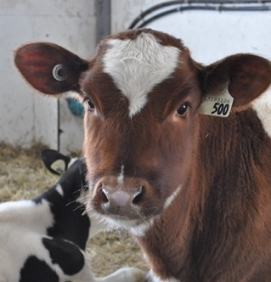
Ben’s Red Calf: Ben was assisting his parents as cow gave birth to a calf. Both parents of this calf were black and white. However, when the calf emerged, it had red hair! How could two black & white animals give birth to a bright red calf? In your response, use and underline the following terms: dominant phenotype, recessive phenotype, genotype, heterozygous, and homozygous recessive. Use the Punnett square to explain your ideas.

Score this response (1,2,3) - Complete: ^{Accurate:} ^{Precise:} ^{Overall:}

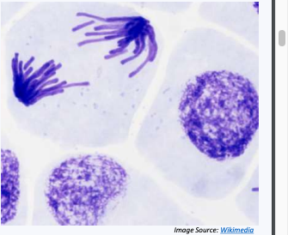
Division Dilemmas: Your body consists of hundreds of trillions of cells. Almost all these cells have the same DNA. This is necessary to have the instructions needed for your cells to assemble the proteins needed to function. How do cells ensure that each cell receive an exact copy of DNA every time it divides? In your response, use and underline the following terms: mitosis, DNA duplication; chromosomes, histones, and spindles.

Score this response (1,2,3) - Complete: ^{Accurate:} ^{Precise:} ^{Overall:}
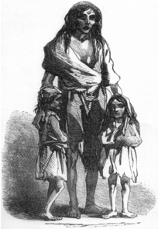
Irish Potato Famine, Part 1: During the mid-1800s, over a million people in Ireland died from starvation in a period of only three years. This was primarily due to failures of their potato crops. How did limited genetic diversity from asexual reproduction affect this outcome? In your response, use & underline the following terms: genetic diversity; asexual vs. sexual reproduction.

Score this response (1,2,3) - Complete: ^{Accurate:} ^{Precise:} ^{Overall:}

Irish Potato Famine, Part 2: How does sexual reproduction help to improve genetic diversity and enhance species survival? In your response, use and underline the following terms: gametes; meiosis; crossing over; fertilization. (Image Source)

Score this response (1,2,3) - Complete: ^{Accurate:} ^{Precise:} ^{Overall:}
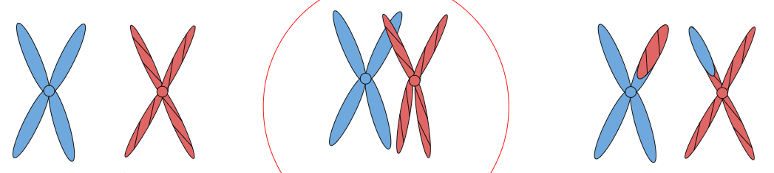

Part 2: Critiquing Responses
Directions: Rate each of the following responses and provide a brief written justification for why you think they earned a 1 (still learning), 2 (acceptable), or 3 (sophisticated). If possible, repeat this same process with your responses on the previous page.

Q: What determines the observable traits of living organisms?
Ali: Cells make proteins from DNA. Differences in DNA result in different proteins. Proteins make traits.
3 2 1 Complete: Do they fully address the entire question while addressing DNA, proteins, and/or traits?
3 2 1 Accurate: Is every aspect of the written response factually correct?
3 2 1 Precise: Are they effectively using terms from the course in a clear and specific manner?

Overall Score: /3 Comments:
Marisol: Traits are determined by how proteins are assembled. Instructions for these proteins are found in chromosomes inherited from their parents’ gametes. Chromosomes are tightly packed DNA.

3 2 1 Complete: Do they fully address the entire question while addressing DNA, proteins, and/or traits?
3 2 1 Accurate: Is every aspect of the written response factually correct?
3 2 1 Precise: Are they effectively using terms from the course in a clear and specific manner?

Overall Score: /3 Comments:
Nina: How proteins are assembled determines traits. Genes, or stretches of DNA, determine how proteins are assembled. Generally, you inherit a copy of each gene from each parent. These genes can be dominant or recessive. Dominant genes are always expressed as traits; recessive genes are only expressed if no dominant genes are present.
3 2 1 Complete: Do they fully address the entire question while addressing DNA, proteins, and/or traits?
3 2 1 Accurate: Is every aspect of the written response factually correct?
3 2 1 Precise: Are they effectively using terms from the course in a clear and specific manner?

Overall Score: /3 Comments:
Oscar: Proteins produce the genes that make the traits. Genes come from parents during meiosis.
3 2 1 Complete: Do they fully address the entire question while addressing DNA, proteins, and/or traits?
3 2 1 Accurate: Is every aspect of the written response factually correct?
3 2 1 Precise: Are they effectively using terms from the course in a clear and specific manner?

Overall Score: /3 Comments:

Part 3 Investigation: Blood Types
Directions: In this investigation, you will be using your understanding of genetics to determine how blood types work in humans.

Overview: Marisol just learned that she has type AB blood. This kind of makes sense to her because her mom has type A blood, and her dad has type B blood. However, her brother has type O blood. She learned in biology that blood type has to do with proteins found on the surface of blood cells. These proteins act as signals for the body; for example, a person with type A blood cannot receive type B blood. The body would reject this blood because the proteins on the surface of the blood cells differ from what is normally found in that body.

However, the bell rang before Marisol could ask how everyone in her family could have a different blood type. At lunch, Marisol and her friends discuss their ideas. They are finishing up a unit on genetics in biology and feel like they might be able to answer this question on their own.

- Do you agree or disagree with each student’s claim? Why?
  - Marisol: "I am pretty sure that if your cells make a protein, you must have a gene for that protein. So I must have genes for both A and B proteins in my DNA." Agree / Disagree
  - Oscar: "Your brother’s situation sounds like the red calf story we read. I think that O must be recessive to the other blood types. So maybe both of your parents are heterozygous; each carries the O gene but doesn’t express it." Agree / Disagree
  - Ali: “Sometimes genes are incompletely dominant, or co-dominant. There are also polygenic traits. We learned about this in biology last week, so maybe that explains it somehow.” Agree / Disagree
- Work in your small groups to discuss your ideas. How are your ideas similar or different? Decide as a group whether each statement is correct (and why). Be prepared to present your ideas to the class.
- Work together to create a Punnett square that helps to explain this situation. Remember…
  - Marisol’s mom has type A blood.
  - Marisol’s dad has type B blood.
  - Marisol’s has type AB blood.
  - Marisol’s brother has type O blood.
- What claim are you making with your Punnett square?
- What evidence and reasoning supports your claim? How do you know you’re not wrong?

Part 4: Jeopardy Review
Overview: In this activity, you will be playing a Jeopardy-style game to review key concepts from the course. This presentation can be accessed at https://bit.ly/WUHS-Bio-TraitsGenes-Jeopardy. The rules for this review game are posted within the presentation. You can also use this presentation outside of class to help prepare you for the unit test. Your instructor may decide to use an alternative option (like Gimkit or Kahoot).

Part 5: Review
Overview: For each objective, rank it as a 1 (completely unsure), 2 (somewhat unsure), or 3 (completely sure) based on your comfort with that objective. Afterwards, you will have time for group and whole-class review.
- What are traits? What are examples of traits? What determines an organism’s traits?
- What is DNA? What is a gene? What is a chromosome? How are these terms similar and different?
- What is the primary purpose or function of packing DNA into a chromosome?
- Explain how the steps of mitosis ensure that duplicated cells each receive a complete copy of DNA.
- What would happen if a typical cell did not receive a copy of an organism’s DNA?
- How do spindles and histones ensure that every cell receives a copy of an organism’s DNA?
- How can trillions of cells with thousands of different varieties of cell types emerge from a single cell?
- What are the advantages and disadvantages of both sexual and asexual reproduction?
- How was limited genetic diversity a cause of the Irish Potato Famine?
- What is a gamete? What is meiosis? Why these important for sexual reproduction?
- What is the difference between a diploid and haploid cell? Why must gametes be haploid?
- What is the difference between mitosis and meiosis? How are they similar and how are they different?
- What is crossing over? How does it increase the genetic diversity of an organism’s offspring?
- How are traits inherited from parents to offspring?
- Briefly summarize Gregor Mendel’s work and his findings.
- What determines whether a dominant or a recessive gene is expressed as a trait?
- What is indicated by the terms homozygous dominant, homozygous recessive, and heterozygous?
- What is an allele? What is a genotype? What is a phenotype? How are these terms related?
- Demonstrate how to use a Punnett square to predict the traits of offspring.
- Summarize each of the following: codominant traits; incompletely dominant traits; polygenic traits.
- How is coat color in Labrador retrievers an example of how genes can sometimes affect the expression of each other?
- Why do parents sometimes give birth to offspring with different traits?

