Life of Stars – Week 2 Labwork
Name: Hour Date:
Date Packet is due: Why late? Score:
^{Day of Week Date} If your project was late, describe why
Driving Question: Why do stars die?
Semester Schedule
How the Sun Works
Week 1: What is matter? What is energy?
Week 2: What’s inside the sun?
Week 3: How can we measure the sun?
Week 4: Where does the sun’s energy come from?
Week 5: Unit Assessment
The Life of Stars
Week 1: How long do stars last?
Week 2: Why do stars die?
Week 3: What happens after stars die?
Week 4: Unit Assessment

How It All Began
Week 1: How can we determine the universe’s size?
Week 2: How can expansion determine the universe’s age?
Week 3: What can we learn from background radiation?
Week 4: Unit Assessment

Navigating Space
Week 1: How and why do things orbit in space?
Week 2: How can we predict orbits?
Week 3: Unit Assessments

Anchoring Phenomenon: How do the properties of atoms determine the life cycles of stars?

Deeper Questions
- Why can atoms fuse? What factors determine whether atoms can fuse or not fuse?
- Why can some elements undergo nuclear fusion while some other elements undergo nuclear fission?
- How do these factors affect how a star ages and why stars die?

Weekly Schedule

Part 1: Introduction
- Initial Ideas – Fusion vs. Fission
- Discussion & Developing Explanations

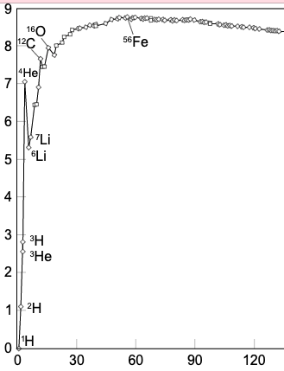
Part 2: Core Ideas
- Core Ideas
- Revisions of Part 1 Explanations

Part 3: Investigation
- PhET Simulations

Part 4: Review & Assessment
- Critiquing Ideas
- Assessment

Part 5: Side Quest
- Weekly Recap
- Side Quests
NGSS Standard:
HS-ESS1-3: Communicate scientific ideas about the way stars, over their life cycle, produce elements.

Part 1: Initial Ideas About Fusion vs. Fission
Overview: In this activity, you will develop some initial ideas about the subatomic properties of atoms that shape the life cycles of stars through a video, reading, and discussion.
Directions: Watch the accompanying video (https://youtu.be/2W-GEE6YU4M). Next, read the passage below. Then work in small groups to address the questions below.

“Fission, a term coined by scientists Lise Meitner and Otto Frisch, is named after the term “binary fission” in biology to describe cell division. Just as cells divide, in fission an atom splits into smaller particles. Fission takes place when a large, somewhat unstable isotope (atoms with the same number of protons but different number of neutrons) is bombarded by high-speed particles, usually neutrons. These neutrons are accelerated and then slammed into the unstable isotope, causing it to fission, or break into smaller particles. During the process, a neutron is accelerated and strikes the target nucleus, which in the majority of nuclear power reactors today is Uranium-235. This splits the target nucleus and breaks it down into two smaller isotopes (the fission products), three high-speed neutrons, and a large amount of energy. This resulting energy is then used to heat water in nuclear reactors and ultimately produces electricity. The high-speed neutrons that are ejected become projectiles that initiate other fission reactions, or chain reactions.

Conversely, fusion takes place when two low-mass isotopes, typically isotopes of hydrogen, unite under conditions of extreme pressure and temperature. Atoms of Tritium and Deuterium (isotopes of hydrogen, Hydrogen-3 and Hydrogen-2, respectively) unite under extreme pressure and temperature to produce a neutron and a helium isotope. Along with this, an enormous amount of energy is released, which is several times the amount produced from fission.

While fission is used in nuclear power reactors since it can be controlled, fusion is not yet utilized to produce power. Some scientists believe there are opportunities to do so. Fusion offers an appealing opportunity, since fusion creates less radioactive material than fission and has a nearly unlimited fuel supply. These benefits are countered by the difficulty in harnessing fusion. Fusion reactions are not easily controlled, and it is expensive to create the needed conditions for a fusion reaction. However, research continues into ways to better harness the power of fusion, but research is in experimental stages, as scientists continue to work on controlling nuclear fusion in an effort to make a fusion reactor to produce electricity.

Both fission and fusion are nuclear reactions that produce energy, but the processes are very different. Fission is the splitting of a heavy, unstable nucleus into two lighter nuclei, and fusion is the process where two light nuclei combine together releasing vast amounts of energy. While different, the two processes have an important role in the past, present and future of energy creation.” Source: Duke Energy Corp. (2021). Fission vs. Fusion – What’s the Difference? Retrieved online on 11/29/2021 at https://nuclear.duke-energy.com/2021/05/27/fission-vs-fusion-whats-the-difference-6843001
Questions
- What is the difference between nuclear fusion and nuclear fission?
- Both fusion and fission result in the release of energy despite being opposite processes. Why do you think this is?
- Do you think that all atoms can undergo fusion and/or fission? Why or why not?
- Why is it that some atoms fuse while other atoms can be split into smaller atoms? What atomic properties determine whether an atom can undergo fission or fusion?
- How do these atomic properties relate to the life cycles of stars?

Part 2: Core Ideas
Overview: In this activity, you will look at a short slideshow presentation. This will provide you with core ideas that will help you clarify your initial ideas. Your instructor will decide on how to implement this portion depending on your previous experience and capabilities with this content.
You will then work in small teams to answer the questions listed below. You should take notes in a notebook, on a dry erase board, or on scratch paper so that you are prepared to deliver your responses during the class discussion that will follow. Note: your instructor may assign specific questions to your group if time is limited.

Core Ideas Presentation: https://bit.ly/WUHS-AstroStarsW2

Driving Questions:
- How is nuclear fusion different from combustion?
- What is mass defect? Why does mass defect occur?
- True or false: the mass of an electron, proton, and neutron is greater when they are separate compared to when they form an atom. Explain.
- What is nuclear binding energy? How does it relate to both mass defect as well as the stability of an atom?
- What primarily determines the stability of an element?
- What is a nucleon? How does binding energy per nucleon relate to the amount of energy released during nuclear fusion?
- Briefly explain what information the mass defect curve provides and why this is significant to the life cycle of stars.
- As high mass stars age, their cores eventually accumulate greater and greater proportions of iron. Why does this limit the lifespan of stars?
- Nuclear fusion involves combining atoms, while nuclear fusion involves splitting atoms. Why is it that both processes result in a release of energy?
- Revising Explanations: How do these atomic properties relate to the life cycles of stars?

Part 3: Investigation – PhET Simulations
Overview: You will use a series of simulations to test and refine your ideas about how subatomic properties like mass defect affect the life cycle stages of stars.
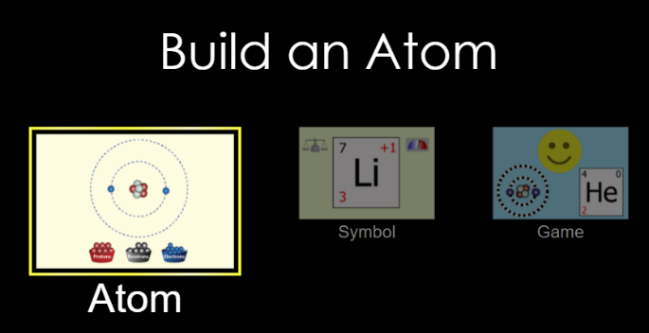
Part A: Build an Atom
Directions:
- Visit https://phet.colorado.edu/sims/html/build-an-atom/latest/build-an-atom_en.html (or type “PhET Build an Atom” into an internet search engine).
- On the first screen click “Atom” (see image at the top right).
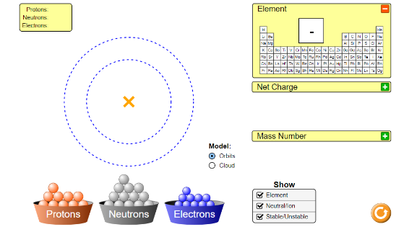
- You should see a screen that looks like the second image. Click “Stable/Unstable” from the Show menu (gray square at the bottom center to the right of the blue electrons bin).
- Add a proton to the center of the atom (the orange “X” at the center of the concentric circles). You have created hydrogen!
- Experiment with the simulation. Use the orange “reset” button in the lower right if needed (be sure to click “Stable/Unstable after each reset). Explore each of the following:
  - What happens if the number of protons is different from the number of neutrons?
  - What happens if the number of protons is different from the number of electrons?
  - What happens if the number of neutrons is different from the number of neutrons?
  - How does the number of protons change the atom?
  - How does the number of neutrons change the atom?
  - How does the number of electrons change the atom?
Questions:
- How did changing the proton number affect the atom? (Hint: consider charge & element type).
- How did changing the number of electrons affect the atom?
- How did changing the number of neutrons affect the atom?
- Can an atom have different amounts of protons vs. electrons and still be stable?
- Can an atom have different amounts of protons vs. neutrons and still be stable?
- Summarize how a hydrogen atom is changed into a helium atom. Where does this occur? What conditions are necessary?
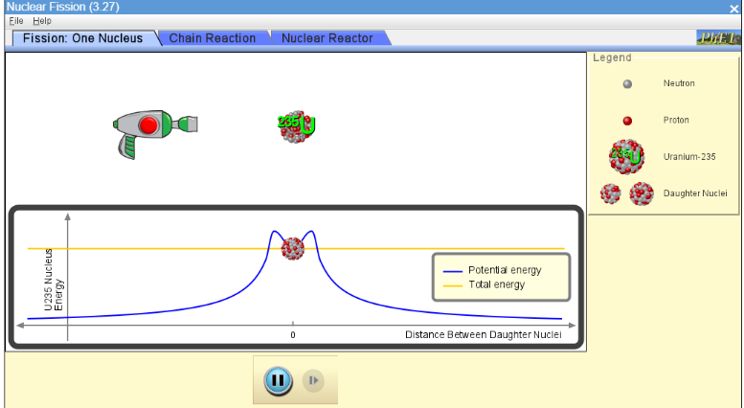
- Which is greater, a) the mass of the individual protons, neutrons, and electrons, or b) the mass of the same number of protons, neutrons, and electrons in an atom? Why? Use mass defect in your response.
Part B: Nuclear Fission
Directions:
- Visit https://phet.colorado.edu/sims/cheerpj/nuclear-physics/latest/nuclear-physics.html?simulation=nuclear-fission (or type “PhET Fission” into an internet search engine).
- Your screen will show an image of Uranium 235. The nucleus of the U-235 atom comprises 92 protons and 143 neutrons (92 + 143 = 235).
- Press the red “trigger” on the neutron gun in the upper left. Observe what happens when you fire an extra neutron into the uranium atom.
- Complete the questions on the next page.

Questions:
- Using the mass defect curve below, explain why uranium is more likely to undergo fission (splitting) whereas hydrogen is more likely to undergo fusion.
- Currently, all nuclear power is produced through nuclear fission of heavy elements like uranium. Which would provide comparatively more energy, nuclear fission of uranium or nuclear fusion of hydrogen? Explain how you know using the mass defect curve below.
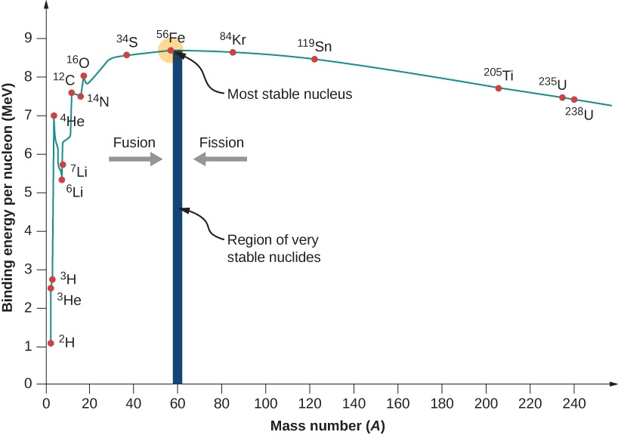
- Heavy elements above iron are formed in supernova explosions as a star dies. How does a supernova enable the fusion of elements above iron to occur? Why can’t these elements form otherwise?

Part 4: Review & Assessment
Overview: you will begin by reviewing the driving questions below in your small groups. For each objective, rank it as a 1 (completely unsure), 2 (somewhat unsure), or 3 (completely sure) based on your comfort with that objective. Then work in teams to create responses to the questions (your instructor will determine if you will answer all the questions or only a portion).

Driving Questions:
- How is nuclear fusion different from combustion?
- What is mass defect? Why does mass defect occur?
- True or false: the mass of an electron, proton, and neutron is greater when they are separate compared to when they form an atom. Explain.
- What is nuclear binding energy? How does it relate to both mass defect as well as the stability of an atom?
- What primarily determines the stability of an element?
- What is a nucleon? How does binding energy per nucleon relate to the amount of energy released during nuclear fusion?
- Briefly explain what information the mass defect curve provides and why this is significant to the life cycle of stars.
- As high mass stars age, their cores eventually accumulate greater and greater proportions of iron. Why does this limit the lifespan of stars?
- Nuclear fusion involves combining atoms, while nuclear fusion involves splitting atoms. Why is it that both processes result in a release of energy?
- Revising Explanations: How do these atomic properties relate to the life cycles of stars?

Part 5: Side Quest
Overview: For this activity, you will begin with a recap of the things that you learned in this packet. You will then identify topics related to astronomy that you personally find interesting to investigate more deeply over the remainder of the semester.
Weekly Recap (use a whiteboard, scratch paper, online document, etc.)
- Summarize everything that you have learned through this packet within your group. Try to identify the common themes, major ideas, and most important concepts from the content you have learned.
- Is there anything that anyone still doesn’t completely understand? Is there anything that anyone maybe disputes or disagrees with? Did anything seem particularly surprising or noteworthy?
- What you think are the most important ideas and concepts that you have learned so far. Aim to have at least 5 or 6 ideas. It is ok to have more than this.
Side Quest: In this activity, you will begin to identify some topics related to astronomy to investigate more deeply over the course of the semester. Be prepared to discuss your ideas.

- In the space below, summarize the topic that you would like to investigate as a semester-long side quest.
- Is this topic feasible for a full-semester project? Use the space below to break the topic into 3-5 subtopics that you will address in the coming weeks:
- What is your overarching learning objective for this topic? In other words, what is it that you want your class to learn or be able to do because of your presentation?

Life of Stars – Week 2 Assessment
Name: Hour Date: Score: /
Directions: This is an open-notes quiz. You should work with your assigned team to complete responses to the questions below. Each person should write the response to at least one question. Write your initials next to the answer(s) you wrote. Those who are not writing should collaborate to create the response that will be written.

- The image below shows the mass of subatomic components. Briefly summarize why the mass of a proton, neutron, and electron is greater when they are separate than when they exist as part of an atom.
Initials:
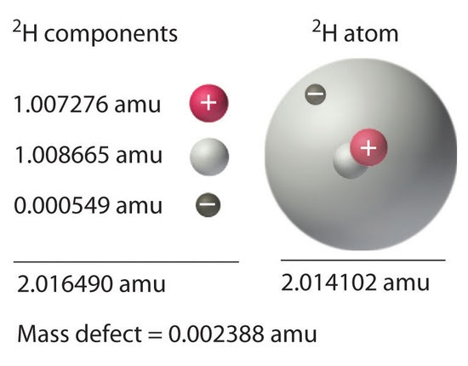
- What is nuclear binding energy? How does it relate to both mass defect as well as the stability of an atom? Use the image on the next page to guide your answer.
Initials:

- As high mass stars age, their cores eventually accumulate greater and greater proportions of iron. Why does this limit the lifespan of stars?
Initials:
- Nuclear fusion involves combining atoms, while nuclear fusion involves splitting atoms. Why is it that both processes result in a release of energy?
Initials:

