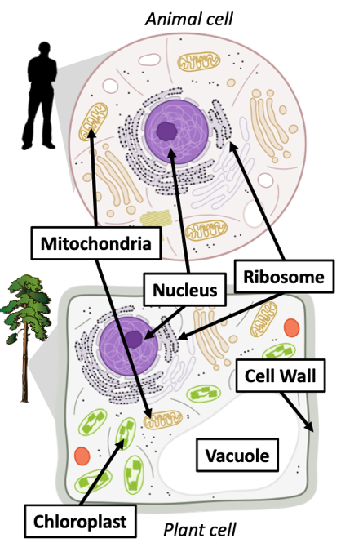
WUHS Biology: Plants Unit Summary
Plant Cells Have Organelles. Like animals, plants are living organisms. Plant cells contain organelles such as a nucleus, mitochondria, and ribosomes. Both plant and animal cells can recharge ATP molecules in the mitochondria when glucose and oxygen (O₂) are rearranged to form CO₂ and H₂O during cellular respiration.
Both plant and animal cells contain fatty membranes and protein-based structures. Like animal cells, plant cells use ribosomes to assemble proteins from amino acids. Plant cells also assemble fats from fatty acids in the cytoplasm.
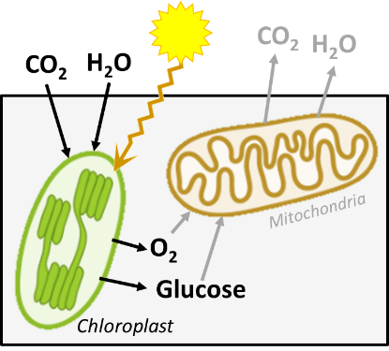
Production of Glucose. Plant cells also have organelles that animal cells do not. These include chloroplasts, cell walls, and vacuoles. Chloroplasts are the organelle where photosynthesis occurs. During photosynthesis, the atoms in CO₂ and H₂O are rearranged to form glucose and O₂. During this process, light energy is converted into the chemical energy found in the high energy bonds (C-C and C-H) of glucose.
Glucose molecules produced during photosynthesis are used for multiple purposes. Most glucose is converted back into CO₂ and H₂O during cellular respiration to recharge ATP. Like all cells, plant cells need a continuous source of charged ATP to power cellular activities.
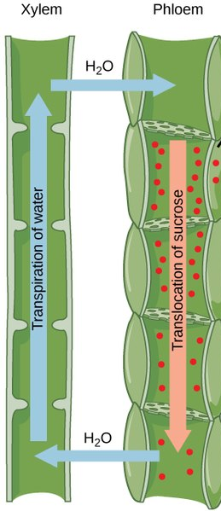
Production of Cellulose. If the plant has access to adequate amounts of light, CO_{2,} and H₂O, they will produce more glucose than is needed for cellular respiration. Some of this extra glucose can be assembled into long chains to form a strong, rigid macromolecule called cellulose. Plant cells have a thick outer ‘shell’ outside their membranes. This shell is called the cell wall and it is primarily comprised of cellulose. This is what gives plants their rigidity and shape (similar to the function of the skeletons of animals). Because cellulose makes up most of the mass of a plant, most of a plant’s mass ultimately comes from the CO₂ and H₂O that is rearranged to make glucose (& O₂).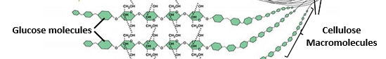
Transport Within the Plant. Some of the extra glucose will also be sent to other cells in the plant. Only the cells with access to light can perform photosynthesis. Cells that lack access to light (such as root cells) depend on leaf cells to produce the glucose that they need for cellular respiration and other purposes.
Just as animals can move substances throughout their body through the blood in arteries and veins, plants have a specialized “tubes” to transport water, minerals, glucose, and all other needed substances. These “tubes” are called xylem and phloem.
Xylem enables water and minerals to move up the plant (evaporation ‘pulls’ water up the xylem). Xylem provides a way to transport the water needed for photosynthesis from the roots to the leaves. Leaf cells add glucose and other molecules to the water to form sap; this travels to all other cells through the phloem. Phloem provides a way to transport glucose (and all other molecules) from the leaves to all other cells in the plant.
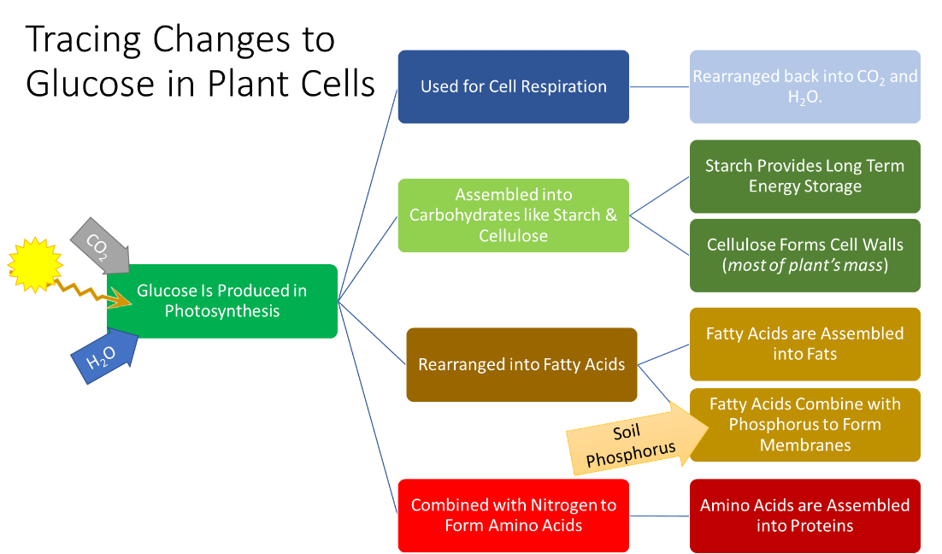
Making All Other Plant Molecules. Like animal cells, plant cells need macromolecules like carbohydrates, proteins, and fats to function. Glucose molecules are the basis for creating all other molecules in plant cells.
Enzymes are specialized proteins that change other molecules. Enzymes can rearrange the atoms in glucose with minerals from the soil (such as nitrogen or phosphorus) to form all other molecules found in the plant. Enzymes change other molecules, but the enzyme itself will stay the same before and after the reaction.
Function of Enzymes. Enzymes can assemble, disassemble, or rearrange molecules to form new molecules. One example of this is the enzyme rubisco. This enzyme rearranges the atoms in CO₂ and H₂O to form glucose. Another example includes the enzyme starch synthase. This enzyme assembles individual glucose molecules to form a carbohydrate macromolecule called starch. Another enzyme, called amylase, can break down the chains of glucose in starch back into individual glucose molecules so that they can be used for cellular respiration.
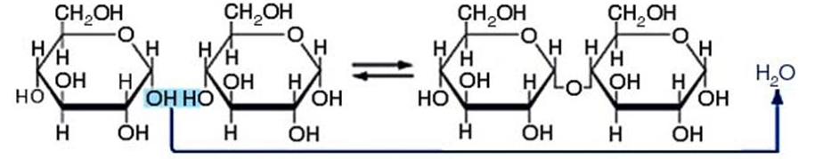
To assemble molecules like glucose into macromolecules like starch or cellulose, enzymes remove oxygen and hydrogen atoms from molecules to form water. Glucose molecules will then attach to each other, as shown below. Other enzymes can insert water molecules to break up a macromolecule into individual molecules.
Interactions Among Living Organisms. Enzymes enable species to interact with each other. When animals consume plants, they use their enzymes to disassemble plant macromolecules into the individual molecules. Animal cells then use these molecules to either recharge ATP (during cellular respiration in the mitochondria) or to assemble proteins and fats during biosynthesis.
Similarly, decomposers like mushrooms and bacteria also use enzymes to disassemble macromolecules in dead or dying organisms. Unlike animals, decomposers excrete enzymes to break up macromolecules. The decomposer will then absorb glucose, amino acids, and fatty acids into their cells. Decomposers eventually convert most macromolecules into CO₂ and H₂O, which can be reabsorbed by plants to make glucose and O₂. Decomposers also return minerals to the soil. Decomposers are vital for matter to continuously cycle among living organisms.
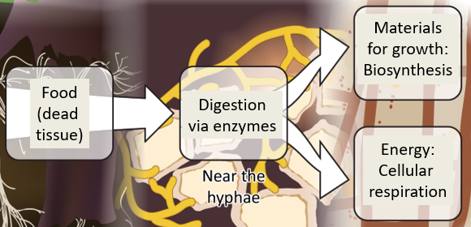
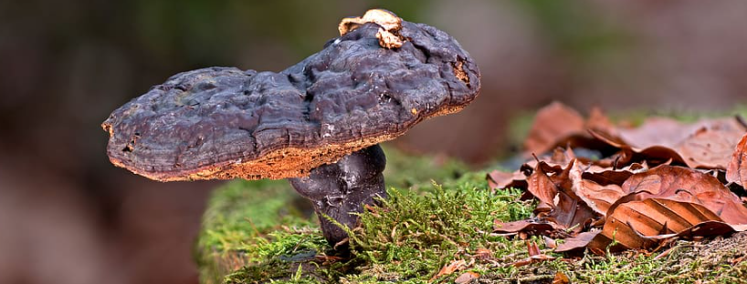

Unit Vocabulary:
Cell Wall: a tough outer shell of cellulose that coats the plant cell membrane.
Cellulose: a long rigid chain of glucose molecules.
Chloroplast: organelle in plant cells that produces glucose molecules during photosynthesis.
Decomposers (like fungi & bacteria) are organisms that break down dead tissues.
Enzymes are proteins that assemble, disassemble, or rearrange molecules to form new molecules.
Phloem: long tubes of cells that use gravity to move molecules like glucose down from the leaves to other cells for respiration and biosynthesis.
Photosynthesis: the cellular process in which plants produce glucose and oxygen from CO2 and H2O.
Vacuoles: storage organelles for plant cells.
Xylem: long tubes of cells that use evaporation to move water and minerals upward from the roots to its leaves.
Research Vocabulary:
Constants: the conditions that are kept the same between each replicate. If possible, an experiment should not be performed under changing conditions.
Control: a part of an experiment that is untreated for the sake of comparison.
Dependent variable: the thing(s) that you measure in an experiment.
Hypothesis: a prediction about how an experiment will turn out.
Independent variable: the thing you purposely changed in an experiment.
Rationale: states why your hypothesis might be right using evidence and/or logic.
Research question: what we’re trying to figure out during an investigation.
Sample size: refers to how many points of data will be collected. Trials refer to the number of times you will repeat the experiment. The larger the sample size and the more trials you perform, the more useful and valid your findings.

