Plants Unit – Week 3
Score
□ Above & Beyond
□ Fully Complete
□ Mostly Complete
□ Incomplete – fix the following pages:
Name: Hour Date:
Date Packet is due: after Part 5 Why late?
If your work was late, describe why
Semester Schedule
Matter & Energy
Week 1: What happens when something burns?
Week 2: What happens to molecules during burning?
Week 3: Unit Assessment
Animals
Week 1: What are animal cells made from?
Week 2: What happens to food when it is consumed?
Week 3: What happens inside animal cells?
Week 4: Unit Assessment

Plants
Week 1: How do plant cells differ from animal cells?
Week 2: How do plants get their food and gain mass?
Week 3: How do plants get other needed molecules?
Week 4: Unit Assessment

Ecosystems
Week 1: Why do some places have more species than others?
Week 2: How does human activity affect living species?
Week 3: Unit Assessment

Driving Question: How do plants get other needed molecules?

Anchoring Phenomenon: Throughout this unit, we have explored how plant cells function. We explored how plants can use water and carbon dioxide to produce glucose, and how enzymes can change glucose into other molecules. In this unit, we will explore this more deeply through an investigation that compares growth in treated and untreated plants.

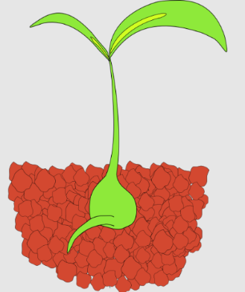

Weekly Schedule

Part 1: Introduction
- Review of Core Ideas
- Planning & Carrying Out Investigations

Part 2: Data Collection & Analysis
- Data Collection
- Analyzing Data

Part 3: Scientific Writing
- How Scientists Communicate
- Project & Presentation Checklists

Part 4: Work Time
- Preparing Your Presentation
- Peer Review Form

Part 5: Review & Assessment
- Presenting Your Findings
- Mastery Check – Planning & Carrying Out an Investigation

Deeper Questions
- How do scientists design experiments to answer questions?
- How can we analyze data to identify patterns and develop explanations?
- How do scientists communicate their ideas using standardized formats?
NGSS Standards:
HS-LS1-2. Organization of interacting systems in multicellular organisms.
HS-LS1-6. How carbon, hydrogen, and oxygen from sugar molecules may combine with other elements to form amino acids and/or other large carbon-based molecules.
HS-LS1-5. How photosynthesis transforms light energy into stored chemical energy.
HS-LS1-7. Cellular respiration is a chemical process whereby food molecules and oxygen molecules form new compounds resulting in a net transfer of energy.

Part 1A: Introduction - Review
Overview: In this activity, you will review key concepts from this unit to prepare for your investigation. You will work in small teams to answer the questions listed below. You should take notes in a notebook, on a dry erase board, or on scratch paper so that you are prepared to deliver your responses during the class discussion that will follow. Note: your instructor may assign specific questions to your group if time is limited.

- True or false: animal cells and plant cells are mostly similar in terms of what they are made from and how they function. Explain.
- Do plant cells have mitochondria? If so, what process occurs in their mitochondria? How does this relate to the functions of a plant cell?
- What are three organelles found in plant cells that are not found in animal cells?
- What is a cell wall? What is cellulose? How do both of these affect the function of plants & plant cells?
- What is a vacuole? What is its purpose and function in a plant cell?
- What is a chloroplast? What process occurs in chloroplasts? How does this affect the function of plants and plant cells?
- Most of the glucose produced during photosynthesis is used for what purposes?
- True or false: just like animal cells, plant cells are organized into tissues, organs, and systems.
- What is xylem? What is its purpose and function?
- What is phloem? What is its purpose and function?
- How do plants move molecules like glucose and water if they lack a heart to pump fluids? Include the following terms in your response: xylem; evaporation; leaf pores; phloem; gravity.
- Cells in the roots and inside the stems of plants do not have access to light. How do these cells acquire the glucose they need for cell respiration and for other purposes?
- How did the General Sherman get so big? Where does the mass (atoms) of plant cells come from?
- Both animal cells and plant cells need carbs, fat, and protein to function. How do plants acquire these molecules if they cannot consume other organisms?
- How do plant cells produce carbohydrates?
- How do plant cells produce fatty acids?
- How do plant cells produce amino acids?
- How do the atoms in glucose and soil minerals relate to all the molecules found within a plant cell?
- True or false: an enzyme has a completely different molecular structure after a reaction is completed. Explain.
- How many different types of enzymes are found in plant cells? Why?
- How do some enzymes assemble macromolecules from individual molecules?
- How do some enzymes disassemble macromolecules into individual molecules?
- How do enzymes enable species to interact with each other?
- What are decomposers? What are examples of decomposers?
- Why are decomposers important for species interactions?
- How does a plant acquire molecules like protein and fat?

Part 1B: Planning & Carrying Out Investigations
Overview: In this activity, you will determine how to effectively plan and conduct a systematic scientific investigation using radish growth as an example.

Instructions: In the investigation you started earlier, you are measuring differences in growth between treated and untreated plants. Previously, you planted radishes under two different conditions (as decided by your instructor or as a class). Some radishes received a treatment; other radishes were untreated and serve as a basis for comparison.

Soon you will determine the impact of this treatment on plant growth by measuring either the mass or the height of the radishes (or both). The greater the height and/or mass of the plants, the greater their rate of growth. Use this information to complete the questions below.

Questions:
- To begin, we need to determine our research question. A research question is what we’re trying to figure out during an investigation. Fill in the blanks below:
We are trying to figure out
- Now let’s turn this into a hypothesis. A hypothesis is like a guess or a prediction – it is how you would answer your research question based on your existing knowledge. Fill in the blanks below:
We predict that
- Now provide a rationale for your hypothesis. A rationale simply states why you think your hypothesis might be right; it provides some evidence and/or logic that supports the validity of your hypothesis.
We think this because:

- Every experiment has two important components – a dependent variable & an independent variable.
An independent variable is the thing you purposely changed to test your hypothesis and answer your research question. Generally speaking, an experiment should only have one independent variable.
What is your independent variable?
A dependent variable is the thing that you measure to determine if your hypothesis is correct. It is the data you collect to answer your research question. You can have more than one dependent variable, but it needs to relate to your hypothesis.
What is your dependent variable(s)?
- A control is a part of your experiment that does not receive any treatment. It is needed so that we have something to compare to. A control helps us to determine the extent to which our independent variable (what we changed) affected our dependent variable (what we measured).
In this experiment, what is your control?
- Sample size and trials affect the validity of your findings. Sample size refers to how many points of data will be collected. Trials refer to the number of times you will repeat the experiment under the same conditions. The larger the sample size and the more trials you perform, the more useful and valid your findings are for answering your research question.
What is your sample size (how many points of data are collected per class)?
How many trials will your class run? How might your sample size and number of
trials affect the validity of your findings?
- Constants are the conditions that are kept the same between each replicate. If possible, an experiment should not be performed under changing conditions. This would make it impossible to determine whether our results were affected by our independent variable or by other changes. This would make our results less useful for answering our research question and for determining if our hypothesis is accurate.
What is being kept constant in this experiment?

- When scientists report their findings, they include a detailed explanation of their methods & materials. This enables other researchers to replicate their work to see if they can obtain the same findings. This also affects the claims a researcher can make about their findings. An experiment with more robust methods enables researchers to make stronger claims about the validity of their findings.
What materials were needed to complete this experiment? List all below:
The methods portion of an experiment should be like a recipe – it should provide all of the steps and materials needed to successfully replicate an experiment (just like a baking recipe provides all of the ingredients and steps needed to create a delicious dessert).
How does this experiment test your hypothesis and answer your research question? Summarize ALL of the steps of our experiment in the space below. Be sure to ask yourself, “Could someone outside my class create the exact same experiment with the same results using this information?”
Step 1:
Step 2:
Step 3:
Step 4:
Step 5:
Step 6:
Step 7:

Part 2: Data Collection & Analysis
Overview: You will be collecting data to answer your research question and determine whether your hypothesis was correct.

Methods:
- Acquire your group’s containers of radishes.
- Use a ruler with cm & mm measurements to determine the height of each radish plant.
  - Place the ruler at the base of each plant.
  - Gently stretch out the plant as far as it will go without breaking. Record the maximum distance the plant will stretch
- Record the data for each plant in each container (treated & control) in the table provided in this section.
- As a class, determine the average size of the plants for each treatment. To do so…
  - Add up the measurements for each plant in each treatment for your group.
  - Divide each sum by the total number of data points.
  - For example, if the data for one container of radishes were: 4, 5, 3, 5, 4, 3 then the sum would be 4 + 5 + 3 + 5 + 4 + 3 = 24
Then divide this value by the total number of data points 24 ÷ 6 = 4
Your average plant height in this case is 4 cm.
- If feasible, measure the mass of each plant using a digital balance. Record the average mass for each treatment.
- Complete the accompanying questions. Be prepared to discuss your findings as a class.
Data: Record your data using the table below.
 | Plant Heights (cm) | Average Height for your Group | Class Avg
Control | ____ + ____ + ____ + ____ + ____ + ____ = ____
Treated | ____ + ____ + ____ + ____ + ____ + ____ = ____
Show how you calculated the averages for your group and for the class in the space below:
Group Averages

Class Averages

Create a graph showing the class averages for height below. To create a graph…
- First, label each axis.
  - The independent variable (treated or control) goes on the x-axis (the horizontal axis).
  - The dependent variable goes on the y-axis (the vertical axis). This would be the average size of the plants in the treated and control groups.
- Next, determine the type of graph you are making.
  - In this case, we need to compare the average height of treated and control plants. A bar graph works best for this purpose. Each bar should be labeled as either “Treated” or “Control”.
- Third, determine the scale you will use on the y-axis (vertical axis).
  - Determine your highest and lowest values for your average data.
  - Your scale should be large enough to encompass all of the values of data but should also be small enough to make it easy to compare the differences in data.
  - Usually your scale starts at zero but does not have to.
  - Values on the y-axis should increase in equal increments (i.e., increase by the same amount).
- Finally, plot your data, add labels, and write a caption.
  - Determine the height of each bar based on the average value for each treatment. Match this value to where it is found on your y-axis. Draw a bar that matches this value and neatly fill in the bar using pen or pencil.
  - Provide all labels that would be needed to understand all information on the graph.
  - Create a caption that explains what kinds of trends and patterns are present in this graph. Then explain what these trends indicate for your research question and hypothesis.

Caption: In this graph, you can see
Questions: Discuss in small groups. Your instructor will determine how to record your ideas (e.g., whiteboards, scratch paper, online document, etc.). Prepare to discuss your ideas for each question. Determine who will serve each of the following roles for each question: speaker, writer, information seeker, facilitator & fact checker.
- Summarize your findings. Based on the class averages, what happened? What were the key findings?
- What do these data indicate regarding your research question? Explain.
- Do your findings support or refute your group’s hypothesis? Explain.
- How could these findings be explained using the core ideas from the curriculum? Specifically, how might differences in plant growth and reproduction be explained by…
  - Rates of Photosynthesis
  - Rates of Cellular Respiration
  - Rates of Biosynthesis
  - Activities of Cellular Enzymes
  - Availability of CO₂, H₂O, Soil Minerals, etc.
  - Any other information from the course.
- How do these findings relate to real world considerations (such as food production)? How might this expand our understanding of this issue? How might we design solutions for this problem using this information?
- How valid are these findings? Do our data answer this question definitively? Are there ways in which we could re-do this experiment to improve the validity of our data?
- What questions remain unanswered? What is still unclear to you or members of your group? What questions emerged as a result of this work? (If a scientist is doing their job effectively, their work will almost always result in new questions).
- What are the next steps? If time and resources allowed, would it make most sense to a) repeat the experiment in exactly the same manner; b) change the experiment to improve the data it can produce; c) develop a new investigation based on these findings; or d) something else?
- Your instructor may choose to meet with individual groups. If so, raise your hand when you are ready. Your instructor will listen to your responses. If you are ready to move on, they will sign below.
This activity was successfully completed (instructor signature)

Part 3: Scientific Writing
Overview: Communication skills are a critical component of science. A scientist must be able to communicate their results in order for other scientists to build on their work and make further discoveries. Without communication, scientific advancement is not possible.

Scientists follow a very rigid style of writing so that all publications are consistent and predictable. If you need to review a lot of material quickly, it is very helpful to know where those specific facts will be located. Science writing should include all the following components:
- Title: a title includes the study subject, independent and dependent variables, and the outcome. Authors are usually listed alphabetically by last name below the title. You should also include your school.
- Abstract: a summary of the entire research publication that conveys all of the key points as succinctly as possible.
- Introduction: this summarizes the study subject, the research question, hypothesis, rationale, and provides and brief summary of the methods.
- Background Information: the concepts, facts, and terminology from other sources related to your experiment so that the average reader can understand your work. All facts should be followed with parenthetical citation indicating the source of that information [(Author, Year) (Smith, 2022)].
- Methods & Materials: this summarizes how the experiment was conducted. It should resemble a cookbook recipe. It should be detailed enough that anyone could replicate your work.
- Results: this section provides all relevant data and observations from your experiment. It should also include at least one graph or table summarizing your data. A caption should describe the trends and patterns in the data and their significance. Both the x- and y-axis must be labeled. Your results can also include observations - what are some things that you observed that aren’t obvious or evident in the data.
- Discussion & Conclusion: this section summarizes the meaning of your data as it relates to your original question and hypothesis. It should include the following:
  - Restate the research question and hypothesis.
  - Explain whether the data support or reject your hypothesis (or if more data is needed).
  - Describe why you think the data supports/refutes/does not affect your hypothesis.
  - Discuss the validity of your findings (i.e., what might limit the ability of your data to address your research question; how might this experiment be improved?).
  - What is the relevance of this investigation and its data? How might this provide insights to questions and provide potential solutions to problems? Why was this work valuable?
- Bibliography/Works Cited: this is the alphabetical list of all the sources you used to create your paper. All sources used for this experiment should be cited using APA citation (Last Name. First Name. (Year). Title. Source.). For example: Kohn, Craig. (2013). What are Stem Cells? www.ted.com/talks/kohn/
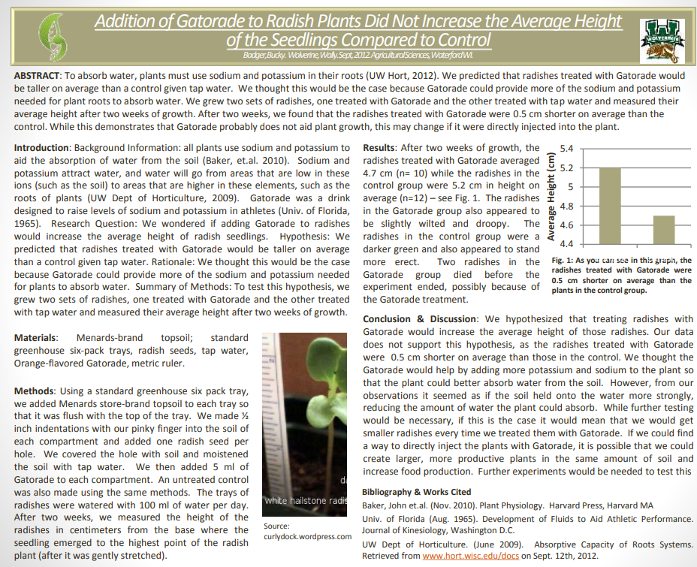

This shows an example of effective science writing from another class. This format is a scientific poster. This format provides a succinct summary of an entire investigation in an organized, systematic manner.

Directions: Work in your groups to complete the following sections: title, abstract, introduction, background information, and methods & materials.

Your instructor will determine if you should create a poster, paper, or digital presentation. Regardless of format, all of the sections listed on the previous page should be included.

A checklist is provided to guide you as you develop your presentation – use this to make sure you did not miss anything that is needed for your writing! If you are missing items on the checklist, it will affect your grade! Only writing that includes every item on the checklist will be accepted for grading.

After you collect your data, complete the following sections: results, conclusion/discussion, and bibliography.

Science Writing Checklist
Overview: You will be using your findings from your investigation to prepare a research poster, scientific paper, or digital presentation (as determined by your instructor). Regardless of the format, your work should include all of the following items. Use this page as a checklist to make sure everything needed is included.

Title: this section needs to include…
- The study subject (the topic/question you studied).
- The independent variable and the dependent variable(s).
- The final results.
- Your names, class, hour, and school.

Introduction: this section needs to include…
- The research question (We wondered if…).
- The hypothesis (We predicted that…).
- The rationale, or reason for your hypothesis (We thought this would be the case because…).
- Summary of methods (To test this hypothesis, we…).

Background Information: this section needs to include…
- Concepts, facts, and terminology from other sources so the average reader can understand your work.
- All facts must be followed with parenthetical citation for the source of the information (Author, Year).
- All sources used in the background information need to also be cited in the bibliography.

Methods & Materials: this section needs to include…
- A materials list of all items used in the investigation.
- A cook-book recipe-style description of how you conducted this experiment.

Results: this section needs to include…
- A written summary of your results, data, and observations.
- A graph/chart/table with…
  - A legend explaining all symbols or abbreviations.
  - Labeled x-axis and y-axis.
  - A caption with a description of all important patterns and trends in the data.

Discussion: this section needs to include…
- The original research question and hypothesis.
- An explanation of whether the data support or reject your hypothesis (or if more data is needed).
- A summary of why you think the data supports/refutes/does not address the validity of your hypothesis.
- A discussion of the validity of your findings (i.e., what might limit the ability of your data to address your research question; how might this experiment be improved?).
- The relevance of this investigation and its data (e.g., how might this provide insights to questions and provide potential solutions to problems? Why was this work valuable?)

Bibliography: this section needs to include…
- All sources used must be listed alphabetically. Each should include: 1) Author’s name (last name, first name); 2) Year of publication; 3) Title of document; and 4) Publication source or website.
- E.g., Badger, Bucky; Wolverine, Wally. (2022). Plant Productivity. www.usda.gov/horticulture

Presentation Checklist
Overview: You will be presenting your findings as a group to conclude this project. For your presentation, you will need to break up roles below among the people in your group. If you have less than four people, some individuals may need to do multiple sections. Be sure to address all of the following as you present. You can have speaking notes. However, avoid speaking directly from notes if possible when presenting.

Partner 1: Introduction
- Begin by stating the research question, hypothesis, and rationale.
- Next, summarize background information that your audience will need to understand in order to comprehend and appreciate your work. For example, if you are discussing plant growth, you need to provide information about how plants grow and how plant cells functions.
Partner 2: Methods
- Begin with a summary of the methods you used to test your hypothesis (To test this hypothesis, we…)
- Then state all the materials used to conduct your experiment (We used the following materials…)
- Address sample size, trial numbers, and constants; explain how these affected your work’s validity.
Partner 3: Results
- Begin with a graph of your data. Summarize the patterns and trends in the data. Be sure to explain how the x-axis and y-axis are labeled to support your audience’s understanding.
- Next, state the significance of these results and how they relate to your research question and hypothesis. Do the results support your hypothesis, or do they refute it?
- Conclude by addressing other observations made during the experiment that might not be reflected in this data.
Partner 4: Conclusion
- Begin by restating the research question and hypothesis.
- Next, explain whether your team has decided that your hypothesis is correct or incorrect based on your data (or if you are unable to determine this at this moment). Justify this stance with evidence/reasoning.
- Third, state the confidence you have in your results. Is this enough to answer your research question once and for all? Are your methods able to provide data that fully supports valid conclusions?
- Conclude by stating what would should happen next in order to answer your question. Is more research needed? Should it be the same kind of research and/or should other questions be explored that might have arisen during your work? What are the next steps for addressing your research question?
Questions: You should prepare for follow-up questions from your instructor. Potential examples include:
- How do plant cells function? How are plant cells similar and different from animal cells?
- What occurs during photosynthesis? Where does this process occur? Why is it important to plants?
- How do plants move substances among their cells if they lack a heart and blood vessels?
- All cells need access to glucose, amino acids, and fatty acids. Animals acquire these molecules by consuming other organisms. How do plants acquire these molecules?
- How do plants use enzymes to change glucose and soil minerals to produce other molecules?
- How does your work reflect core principles of scientific investigations? How could it be improved?

Part 4: Peer Review Form
Name: Date: Hour:
Directions: Please evaluate your group as well as yourself on the basis of contributions and effort on a scale of 1 to 5. A group member who makes an outstanding contribution and did their best would receive a score of 5. A group member who did very little might score around a 3, and a group member who did little or nothing might get a one or a two. Provide a reason for your score – why did you give that score? (5’s need no reason)
1. Group Member’s Name: Score: 1 2 3 4 5
Reason:
2. Group Member’s Name: Score: 1 2 3 4 5
Reason:
3. Group Member’s Name: Score: 1 2 3 4 5
Reason:
4. Your Name: Score: 1 2 3 4 5
Reason:
Additional comments or concerns:
Changes you would recommend for this activity:

