How the Sun Works – Week 4 Labwork
Name: Hour Date:
Date Packet is due: Why late? Score:
^{Day of Week Date} If your project was late, describe why
Driving Question: Where does the sun’s energy come from?
Semester Schedule
How the Sun Works
Week 1: What is matter? What is energy?
Week 2: What’s inside the sun?
Week 3: How can we measure the sun?
Week 4: Where does the sun’s energy come from?
Week 5: Unit Assessment
The Life of Stars
Week 1: How long do stars last?
Week 2: Why do stars die?
Week 3: What happens after stars die?
Week 4: Unit Assessment

How It All Began
Week 1: How can we determine the universe’s size?
Week 2: How can expansion determine the universe’s age?
Week 3: What can we learn from background radiation?
Week 4: Unit Assessment

Navigating Space
Week 1: How and why do things orbit in space?
Week 2: How can we predict orbits?
Week 3: Unit Assessments

Anchoring Phenomenon: Conversion of matter into energy?

Deeper Questions
- How can we determine how the sun functions using existing/indirect knowledge about its size & temp?
- How does the sun’s mass affect its temperature?
- How can matter be converted into energy?

Weekly Schedule

Part 1: Introduction
- Initial Ideas – Early Ideas About the Sun
- Discussion & Developing Explanations

Part 2: Core Ideas
- Core Ideas
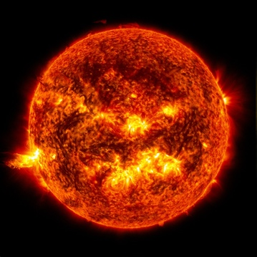
- Revisions of Part 1 Explanations

Part 3: Investigation
- PhET Gas Laws
- Play-Doh Nuclear Fusion

Part 4: Review & Assessment
- Critiquing Ideas
- Assessment

Part 5: Side Quest
- Weekly Recap
- Side Quests
NGSS Standards:
HS-ESS1-1: Develop a model based on evidence to illustrate the life span of the sun and the role of nuclear fusion in the sun’s core to release energy that eventually reaches Earth in the form of radiation.

Part 1: Intro – Early Ideas About the Sun
Overview: In this activity, you will read a short passage. You will then use this as the basis for a discussion about the content and structure of the sun.
Directions: Individually read the passage below. Then work with your group to address the questions below. Your instructor will determine if you should use scratch paper, a white board, an online document, etc.

Armed with the science of the mid-19th century, physicists and astronomers had long thought that "solar heat" resulted from the constant fall of meteors and asteroids into the Sun. In 1841, calculations by Julius von Mayer (1814-1878), a German physician and chemist, indicated that asteroids striking the Sun at high velocity would generate "from 4,600 to 9,200 times as much heat as would be generated by the combustion of an equal mass of coal." There was a flaw in the model, however: in order to keep the Sun shining, a huge number of asteroids would be required and no one could explain where they would come from.

The "gravitational contraction" theory, first proposed by Hermann von Helmholtz (1821-1894) was much more satisfying for a scientific mind. According to the German physicist and physician, the pressure generated by gravitational forces from the prodigious mass of the Sun was responsible for the heat generated. Developed, expanded and refined by William Thomson (1824-1907), better known as Lord Kelvin, the Helmholtz-Thomson model held for more than four decades. But not without being challenged ...

While the nature of the Sun's energy source kept a large proportion of the scientific community busy, others were preoccupied by the age of the Earth. In Darwin's wake, biologists needed a very ancient Earth to allow for the patient process of evolution, as did geologists seeking to account for the stacking of rock strata and sediments they had begun exploring. For Earth, which was necessarily younger than the Sun, a minimum of 200 million years was required, yet the Helmholtz-Thomson model provided only for a 20- to 50-million-year-old Sun. Something had to give.

Not only did the "gravitational contraction" model assign an age to the Sun, it also projected its life expectancy, which did not exceed another few dozen million years. Unless, as Thomson wrote in 1891, "sources now unknown to us are prepared in the great storehouse of creation." And as it happened, there was something quite extraordinary that was just coming out from the "the great storehouse of creation."

Radioactivity was discovered in 1896 by French physicist Henri Becquerel (1852-1908) but it was not until a few years later that the phenomenon attracted wide interest among physicists and chemists. At the turn of the century measurements demonstrated that the radioactive decay of radium, measured in calories, generated 200,000 times more heat than the burning of coal.

Was it conceivable that the Sun was made (at least partly) of radium? Ernest Rutherford (1871-1937), the New Zealand-born physicist, thought it possible and did the math: an amount of 2.5 ppm (0.00025 percent) of radium in the Sun would account for its observed rate of energy emission. But once again there was a flaw: nowhere did the "signature" of radium appear in the spectrum of sunlight.

©2021, ITER Organization - https://www.iter.org/newsline/-/3570

Questions
- The reading on the previous page describes three explanations for how the sun can continuously ‘burn’ for exceptionally long periods of time. In the space below, briefly summarize each theory. Then summarize the evidence that disproves it.
Theory 1:
Disproving Evidence:
Theory 2:
Disproving Evidence:
Theory 3:
Disproving Evidence:
- Without using an internet browser or other reference, summarize how you currently think the sun can produce vast amounts of heat and light for billions of years:
- What is still unclear or uncertain to you regarding how the sun functions?
- We have currently addressed a number of key pieces of information that will help us to determine how the sun functions. After each item, briefly summarize what we have learned. Use your notes if needed.
What is the sun made from?
How big is the sun? How far away is the sun?
How hot is the sun?
- Be prepared to discuss how we know these topics as a class.

Part 2: Core Ideas
Overview: In this activity, you will look at a short slideshow presentation. This will provide you with core ideas that will help you clarify your initial ideas. Your instructor will decide on how to implement this portion depending on your previous experience and capabilities with this content.
You will then work in small teams to answer the questions listed below. You should take notes in a notebook, on a dry erase board, or on scratch paper so that you are prepared to deliver your responses during the class discussion that will follow. Note: your instructor may assign specific questions to your group if time is limited.

Summary Video: https://www.youtube.com/watch?v=W1ZQ4JBv3-Y
Core Ideas Presentation: https://bit.ly/WUHS-Astro-Sun-W4

Driving Questions:
- What is the relationship between pressure and temperature in a gas?
- What does E = mc² mean? Explain each symbol and summarize what this formula indicates (and how).
- In the 1920s, Aston developed a means to determine the mass of elements. How? How did this contribute to our understanding of the sun’s function?
- What was Perrin’s contribution to our understanding of the sun’s function?
- How did Eddington use the collective findings of Einstein, Aston, and Perrin to develop an evidence-based argument for how the sun functions?
- What is the Coulomb Barrier? How does it relate to both nuclear fusion & the function of the sun?
- Summarize each step of the proton-proton chain, and explain how this results in the conversion of matter into energy.
- In space, some balls of helium and hydrogen form planets (like Saturn). Some form stars (like our sun). And some are unstable and explode. What determines which outcome occurs and why?
- Revising Explanations: How does the sun produce vast amounts of heat and light for billions of years?

Part 3: Investigation A – Gas Laws
Overview: You will use a computer simulation to explore the relationship between pressure and temperature in gases.
Directions: Using a school-approved device, visit https://phet.colorado.edu/sims/html/gas-properties/latest/gas-properties_en.html (or type “PhET Gas Properties in an internet search engine). Follow the instructions for each question below.

- Begin by clicking “Explore”. Your screen should resemble the image below. Using your mouse or touchpad, click on the handle of the pump (bottom center) and add particles to your sealed container. As you move the pump handle up and down, you will observe particles moving into the container. Pay close attention to the pressure gauge as you do so.
- Next, use your mouse or touchpad to click on the left handle of the container. Move that handle to the right to reduce the size of the container. Observe how the pressure and temperature change in response.
- Finally, use your mouse or touchpad to adjust the temperature (the bucket in the bottom center). Observe how the pressure changes as increase or decrease the temperature of this container.
- Answer the questions on the next page.
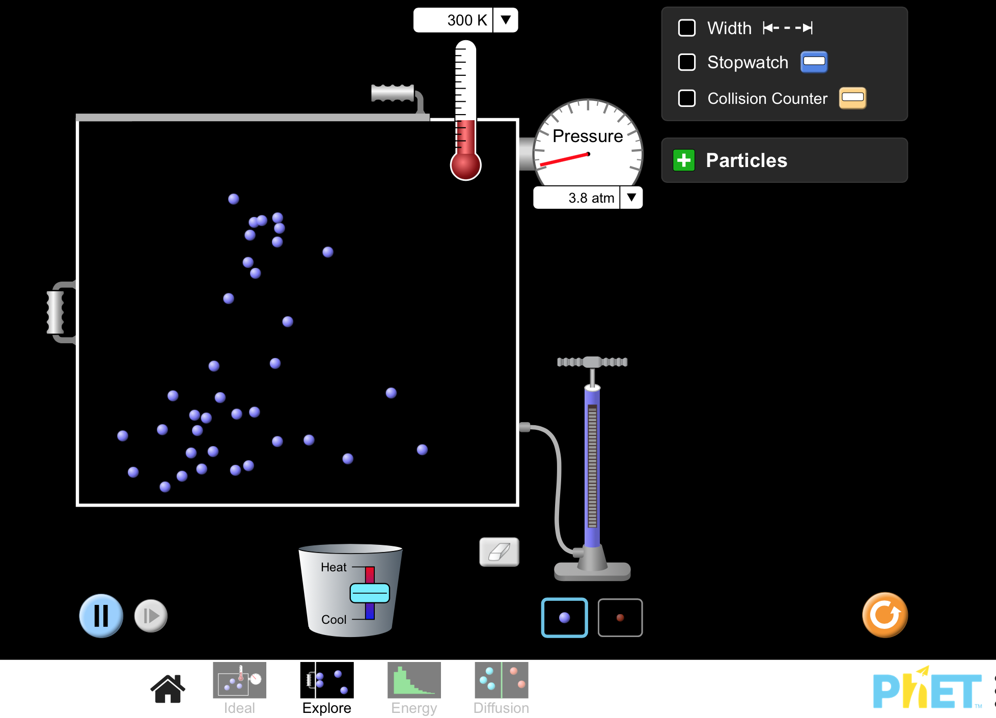

- Complete the questions below.
  - How did adding particles to the container change the pressure?
  - How did changing the size of the container change the pressure?
  - How did changing the temperature change the pressure?
  - How did changing the pressure change the temperature?
  - What is the relationship between temperature and pressure in a gas?
  - What creates pressure inside the sun? How does this relate to the temperature of the sun?

Part 3: Investigation B – Play-Doh Nuclear Fusion
Overview: In this activity, you will be using Play-Doh to create models of subatomic particles as they interact during nuclear fusion in the sun.

Directions: Use the instructions on the following page to create each of your subatomic particles out of Play-Doh. Conclude by answering the post-investigation questions on this page. (Note: your instructor may ask you to record your answers to questions using a different format, such as a whiteboard or online document).

Creating Your Play-Doh Particles: Use the instructions on the next page and the image below to create each of your molecules. Use your molecules as scientific models to help you improve and revise your answers to the questions above. In science, models are tools that help us clarify our thinking and make more accurate predictions. Models can be pictures, examples, scale models, or anything that helps us reason more accurately about a concept.
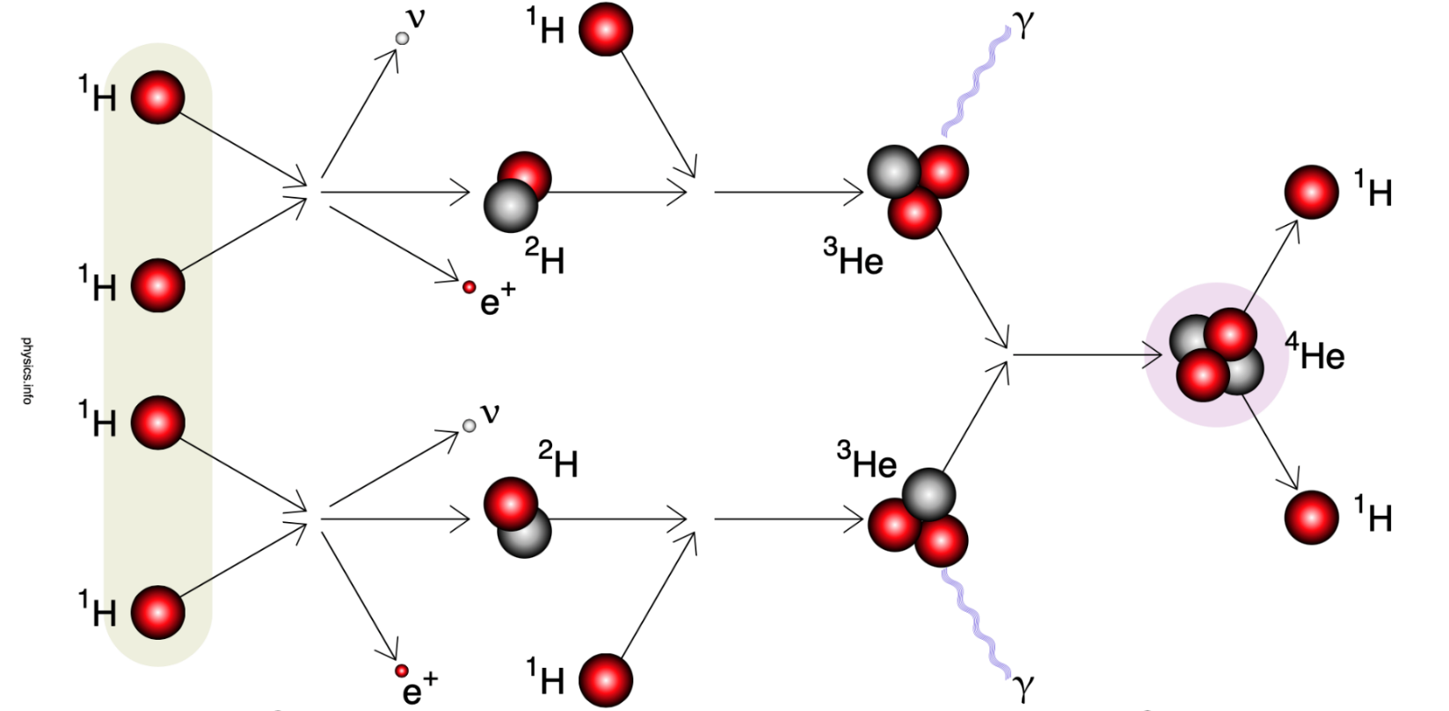
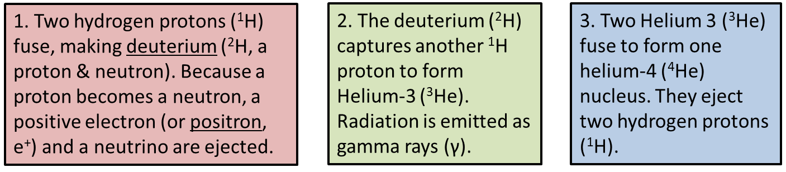
1) To create your particles, you will need the following:
- One color of Play-Doh balls to represent positively-charged protons.
- Another color of Play-Doh balls to represent neutral neutrons.
- A final color of Play-Doh to represent all other elements (e.g., gamma radiation, neutrinos, electrons).
  - You might also choose to represent these using a pen or marker, especially for elements that are forms of electromagnetic radiation.
- Paper towel or printer paper to organize your particles.
- A pen or marker to label each item.
2) Using the picture on the previous page as a guide when creating your model.

3) Based on the core ideas from this week, be prepared to orally explain how nuclear fusion works within the sun. Your instructor may ask you about some of the following (among other potential topics):
- The stages of the proton-proton chain.
- The conditions necessary for fusion (e.g., pressure, temperature, etc.).
- The Coulomb Barrier
- Hydrostatic equilibrium.
- Eddington’s 3 Outcomes
When you think you are ready, raise your hand and show your instructor.
This activity was successfully completed (instructor signature)

Part 4: Review & Assessment
Overview: you will begin by reviewing the driving questions below in your small groups. For each objective, rank it as a 1 (completely unsure), 2 (somewhat unsure), or 3 (completely sure) based on your comfort with that objective. Then work in teams to create responses to the questions (your instructor will determine if you will answer all the questions or only a portion).

After you have had time to create your responses, you will critique the responses of another group before coming together as a whole class. Be sure to use the “rules” for matter and energy as you do so. You will conclude by completing an assessment for this week’s ideas.

Driving Questions
- What is the relationship between pressure and temperature in a gas?
- What does E = mc² mean? Explain each symbol and summarize what this formula indicates (and how).
- In the 1920s, Aston developed a means to determine the mass of elements. How? How did this contribute to our understanding of the sun’s function?
- What was Perrin’s contribution to our understanding of the sun’s function?
- How did Eddington use the collective findings of Einstein, Aston, and Perrin to develop an evidence-based argument for how the sun functions?
- What is the Coulomb Barrier? How does it relate to both nuclear fusion & the function of the sun?
- Summarize each step of the proton-proton chain, and explain how this results in the conversion of matter into energy.
- In space, some balls of helium and hydrogen form planets (like Saturn). Some form stars (like our sun). And some are unstable and explode. What determines which outcome occurs and why?
- Revising Explanations: How does the sun produce vast amounts of heat and light for billions of years?

Part 5: Side Quest
Overview: For this activity, you will begin with a recap of the things that you learned in this packet. You will then identify topics related to astronomy that you personally find interesting to investigate more deeply over the remainder of the semester.
Weekly Recap (use a whiteboard, scratch paper, online document, etc.)
- Summarize everything that you have learned through this packet within your group. Try to identify the common themes, major ideas, and most important concepts from the content you have learned.
- Is there anything that anyone still doesn’t completely understand? Is there anything that anyone maybe disputes or disagrees with? Did anything seem particularly surprising or noteworthy?
- What you think are the most important ideas and concepts that you have learned so far. Aim to have at least 5 or 6 ideas written down. It is ok to have more than this.
Side Quest: In this activity, you will begin to identify some topics related to astronomy to investigate more deeply over the course of the semester. Be prepared to discuss the following with your instructor.

- Summarize the topic that you would like to investigate as your side quest.
- Why did you choose this topic? Why do you find this topic interesting or intriguing?
- What is your learning objective for this project? In other words, what do you want to learn and what do you want others to know by the time you finish your presentation?
- Are you working alone or with a group? If in a group, how will you divide the work?
- What is your strategy for developing a presentation? How will you effectively teach this topic?
- Is this topic appropriate for the time available to you?
- Are you excited about this topic? Is it something that is personally interesting to you?

How the Sun Works – Week 4 Assessment
Name: Hour Date: Score: /
Directions: This is an open-notes quiz. You should work with your assigned team to complete responses to the questions below. Each person should write the response to at least one question. Write your initials next to the answer(s) you wrote. Those who are not writing should collaborate to create the response that will be written.

- How are temperature and pressure related? In your explanation, explain the equation: P = knT
Initials:
- What does Einstein’s famous equation, E = mc² actually tell us? And what is significant about the speed of light in this equation? Why is this part of this equation?
Initials:

- Briefly summarize Aston’s work and explain how his discoveries contributed to our understanding of how the sun functions.
Initials:
Initials:

- How did Eddington use the work of Einstein, Perrin, and Aston to develop the first evidence-based argument about how the sun is able to burn continuously for billions of years?
Initials:
- Briefly summarize the process of nuclear fusion in the sun. Be sure to address all of the following: Coulomb’s barrier, proton-proton chain, neutrinos, how hydrogen fuses into helium.
Initials:
- What is hydrostatic equilibrium? How does this maintain a star’s stability? How does this concept relate to Eddington’s three possible outcomes for gas balls?
Initials:
- About half the star systems in the Milky Way are comprised on double- or triple-star solar systems. Also, our solar system’s largest planet, Jupiter, is nearly as large as some stars. Why isn’t Jupiter a second star in our solar system?
Initials:

