Animals Unit – Week 1
Name: Hour Date:
Date Packet is due: Why late? Score:
^{Day of Week Date} If your project was late, describe why
Driving Question: What happens to food when it is consumed?
Semester Schedule
Matter & Energy
Week 1: What happens when something burns?
Week 2: What happens to molecules during burning?
Week 3: Unit Assessment
Animals
Week 1: What are animal cells and food made from?
Week 2: What happens to food when it is consumed?
Week 3: What happens inside animal cells?
Week 4: Unit Assessment

Plants
Week 1: What are plant cells made from?
Week 2: How do plants get their food?
Week 3: What happens inside plant cells?
Week 4: Unit Assessment

Ecosystems
Week 1: How do living organisms affect each other?
Week 2: Tracing Matter
Week 3: Global Biodiversity
Week 4: Humans & Biodiversity

Anchoring Phenomenon: This week we are investigating why Olympic athletes must consume so much more food than usual, and why their diets vary depending on different sports.

Deeper Questions
- What happens to food when it is consumed?
- What are the cells of animals made from?
- How are cells similar and different at the atomic level compared to the food we consume?

Weekly Schedule

Part 1: Introduction
- Initial Ideas – Olympic Diets Video
- Data Dive – Olympic Diets Data
- Discussion & Developing Explanations

Part 2: Core Ideas
- Nutshell Video
- Core Ideas – Zooming Into Cells
- Revisions of Part 1 Explanations

Part 3: Investigation
- What’s in Our Food?
- Revisions of Part 1 Explanations
- Optional: Voluntary Quiz

Part 4: Review & Assessment
- Critiquing Ideas
- Assessment

Part 5: Life Connections
- Weekly Recap
- Life Connections
NGSS Standards:
HS-LS1-2. Develop and use a model to illustrate the hierarchical organization of interacting systems that provide specific functions within multicellular organisms.
HS-LS1-6. Construct and revise an explanation based on evidence for how carbon, hydrogen, and oxygen from sugar molecules may combine with other elements to form amino acids and/or other large carbon-based molecules.
HS-LS1-7. Use a model to illustrate that cellular respiration is a chemical process whereby the bonds of food molecules and oxygen molecules are broken and the bonds in new compounds are formed resulting in a net transfer of energy.

Part 1: Introduction
Overview: In this activity, you will begin by recording your ideas about what happens to food when it is consumed. You will then watch a short video about the diets of Olympians and then work in teams to identify patterns and trends in data from the video. This will enable you to develop an initial explanation that you will revise over the course of this week. You will then conclude by comparing your observations and explanations to those of other groups to check your accuracy and make revisions.

Initial Ideas: Olympians have to consume large quantities of food to enable peak performances during competition. What happens to the food that they consume? Why do they consume different kinds of food?
- Decide whether you agree or disagree with each of the following.
A) “Most of the food they eat will be lost as waste (feces).” AGREE/DISAGREE
B) “Athletes mostly convert solid food into gases that they breathe out.” AGREE/DISAGREE
C) “Athletes convert the matter in food into energy to perform and compete.” AGREE/DISAGREE
- Work in your small groups to discuss your ideas. Try to identify how your ideas are similar or different. Then work as a team to decide as a group whether each statement is correct or incorrect (and why). Be prepared to present your ideas to the class.
Video: Next, watch the following video individually or as a class (based on your teacher’s instructions): https://www.youtube.com/watch?v=wvQ7tpBhxS0

Data Dive: In the image on the next page, you can see differences in the diets of different kinds of athletes.
- Begin by individually attempting to make sense of this image. What trends or patterns do you notice? How does this relate to any prior knowledge or experience that you have?
- Next, work in your teams to discuss your ideas. Where do you agree? Where do you disagree? Can you use this data to reach agreement? Do others have prior knowledge/experience that could help?
- Based on this data, what is one conclusion that would be supported by this data?
  - How is this conclusion supported by this data?
  - What specifically suggests that your claim is accurate?
- Based on this data, what is a second conclusion that would be supported by this data?
  - How is this conclusion supported by this data?
  - What specifically suggests that your claim is accurate?
- Would you change any of your responses to the first question above? (See Question #1 under Initial Ideas). Discuss as a team.
Be prepared to discuss your ideas with other groups and/or as a class.
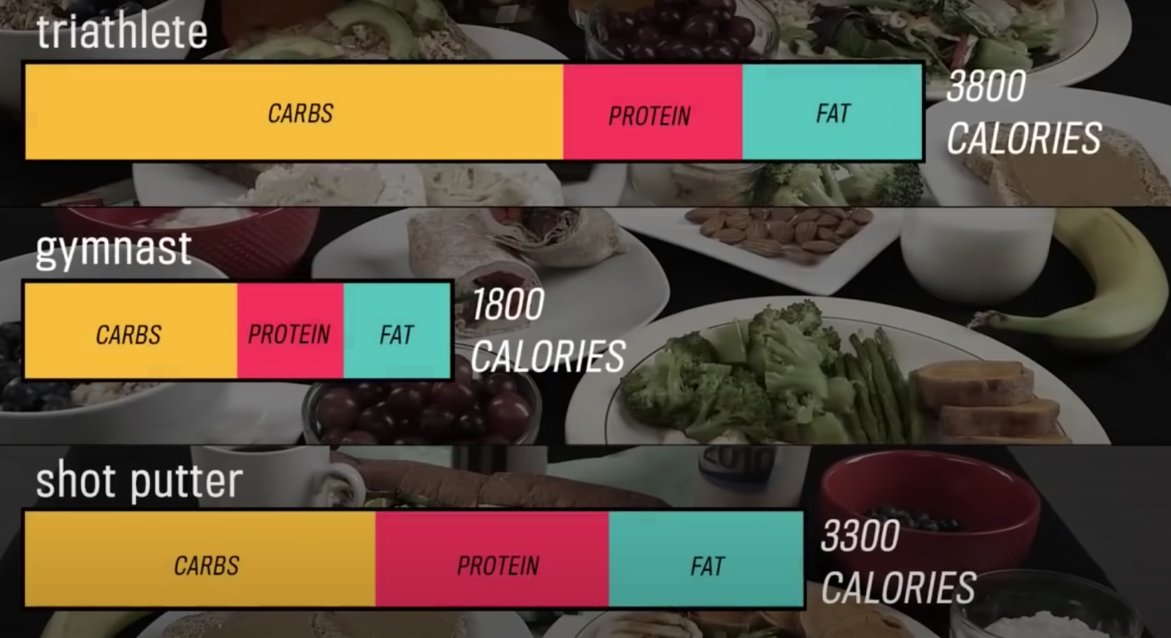

Discussion & Developing Ideas
- As a class, discuss your ideas about what happens to the food that an athlete consumes. What are ideas that most agreed on? Where did your ideas differ as a class? Based on your instructor’s directions, use the space below or another option (e.g., whiteboard, online document, etc.) to record your ideas.
We all agree that…
We disagreed about…
- What happens to the food that athletes consume? Why do they need different diets? Write down your initial explanation in the space below. Don’t worry if you aren’t completely sure about your answer! You will come back and revise this explanation as you gain more information during this unit.
I think that when an athlete consumes food…

Part 2: Core Ideas
Overview: In this activity, you will begin by watching a short video. This will help to clarify some of the questions you may have had yesterday.
Next, you will look at a short slideshow presentation. This will provide you with core ideas that will help you clarify your initial ideas. Your instructor will decide on how to implement this portion depending on your previous experience and capabilities with this content.
You will then work in small teams to answer the questions listed below. You should take notes in a notebook, on a dry erase board, or on scratch paper so that you are prepared to deliver your responses during the class discussion that will follow. Note: your instructor may assign specific questions to your group if time is limited.

Core Ideas Presentation: https://bit.ly/WUHS-Bio-Animals-W1

Driving Questions:
- What is a cell? What are cells made from?
- What are macromolecules? What are macromolecules made from?
- How are carbohydrates, fats, and proteins examples of macromolecules?
- What is an organelle? How do organelles enable the cells of most organisms to function?
- How are the following related but different? Cells, Organelles, Tissues, Organs, Systems.
- Summarize each of the following levels: atomic-molecular, cellular, organismal, and ecosystem-planetary.
- Revising Explanations: Return to your original explanation that you created at the end of Part 1. Based on this new information, how would you now respond to this question?
I think that when an athlete consumes food…
Remember the following “rules” for energy and matter:
- All solids, liquids, and gases are made of tiny particles called atoms. Multiple atoms can bond together to form molecules (e.g., water molecules consist of 1 oxygen atom & 2 hydrogen atoms).
- In biology, atoms last forever. Atoms cannot be created or destroyed (e.g., a carbon atom is always a carbon atom). Atoms found on molecules can be rearranged to form new molecules.
- In biology, energy lasts forever. Energy cannot be created or destroyed. Energy can exist as light, heat, motion, or as chemical energy stored in the bonds of molecules. Energy in one form can be transferred into a different form (e.g., light energy can be transformed into heat energy).

Part 3: Investigation – Reading Food Labels
Adapted from Carbon TIME. Used with permission.
Overview: Food labels can tell us a lot about the molecules in the cells of the organisms that they come from—especially large organic molecules. In this activity, you will be using food nutrition labels to analyze the macromolecules found inside different kinds of cells within different kinds of organisms.

Directions: Complete the Pre-Investigation Questions below. Then study the food labels in the following pages. Complete the activity by following the directions in the Post-Investigation Questions (Note: your instructor may ask you to record your answers to questions using a different format, such as a whiteboard or online document).

Pre-Investigation Questions: Answer these questions individually and in small groups before starting this activity. Your instructor will determine if/where you should record your answers (e.g., whiteboard, scratch paper, etc.). Your instructor may choose to assign specific questions to your group and/or may have you critique the responses of other groups for accuracy.
- What is a cell? What are cells made from?
- What are macromolecules? What are macromolecules made from?
- How are carbohydrates, fats, and proteins examples of macromolecules?
- What is an organelle? How do organelles enable the cells of most organisms to function?
- How are the following related but different? Cells, Organelles, Tissues, Organs, Systems.
- Summarize each of the following levels: atomic-molecular, cellular, organismal, and ecosystem-planetary.
- Record your answer below: What do you think happens to the atoms in food when it is consumed?
I think …
Analyzing Food Labels: The labels on the next page show how many grams of different materials are in 100 g of each food. Follow these steps to fill out the table on the following page.

Remember the following “rules” for energy and matter:
- All solids, liquids, and gases are made of tiny particles called atoms. Multiple atoms can bond together to form molecules (e.g., water molecules consist of 1 oxygen atom & 2 hydrogen atoms).
- In biology, atoms last forever. Atoms cannot be created or destroyed (e.g., a carbon atom is always a carbon atom). Atoms found on molecules can be rearranged to form new molecules.
- In biology, energy lasts forever. Energy cannot be created or destroyed. Energy can exist as light, heat, motion, or as chemical energy stored in the bonds of molecules. Energy in one form can be transferred into a different form (e.g., light energy can be transformed into heat energy).

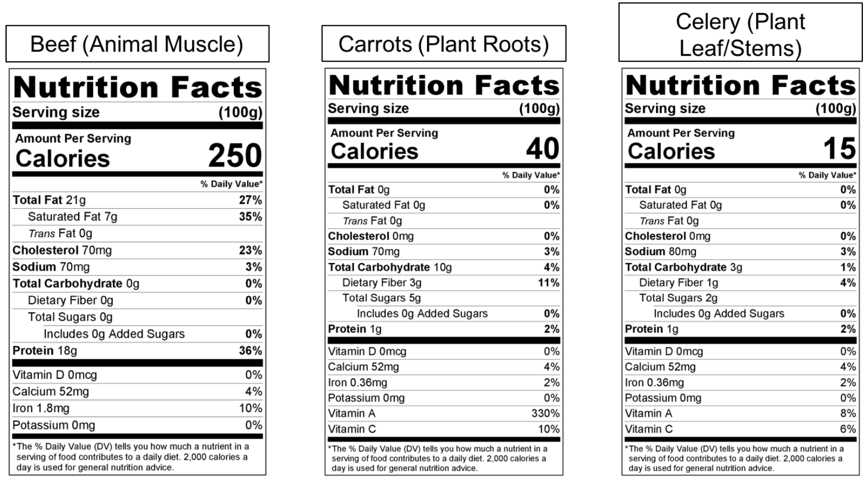

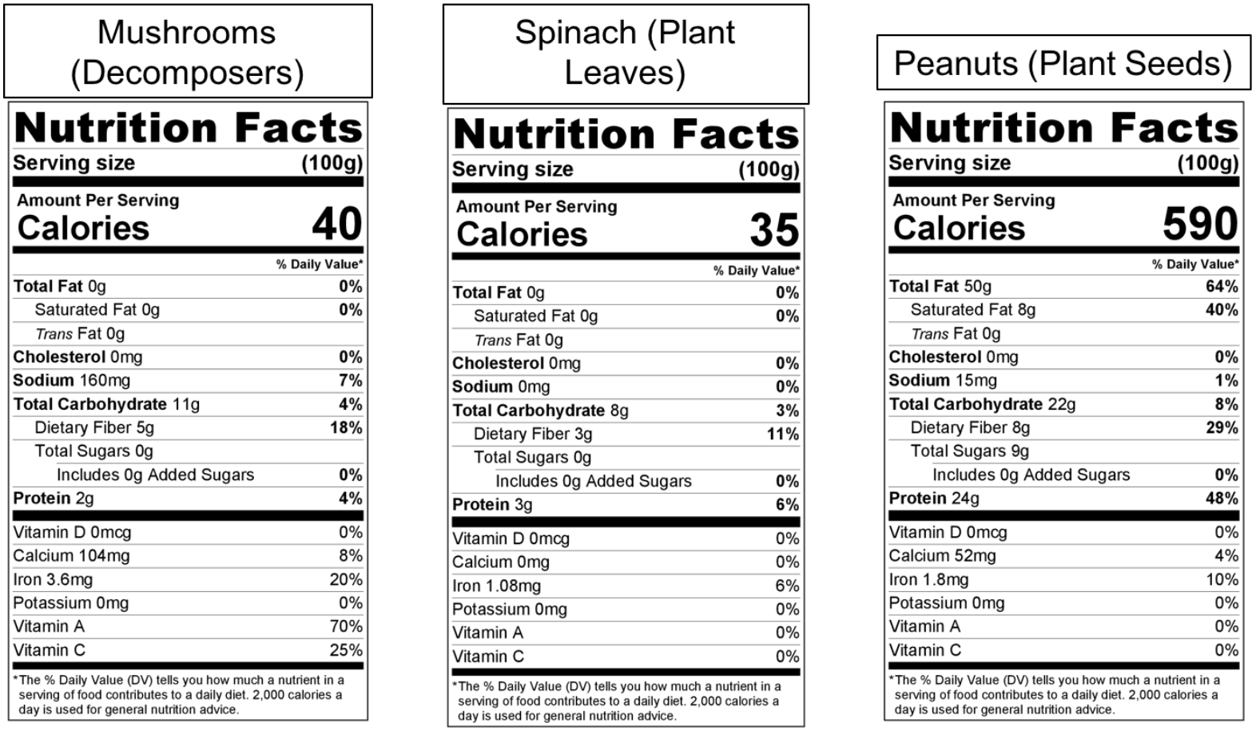

Background Information
(use this to help you with the questions on the next page).

What does the nutrition label tell you about what cells are made of? Here are some things you can learn by reading the nutrition label carefully:

What are the main organic molecules in cells? Large organic molecules, including carbohydrates, proteins, and fats, do all the work of cells. These organic materials are made mostly of carbon, hydrogen, and oxygen atoms and have high-energy bonds.

- Carbohydrates include:
  - Sugars such as glucose that all cells use as a source of energy. Sugars are small organic molecules (5 or 6 carbon atoms, plus hydrogen and oxygen atoms).
  - Starches are large organic molecules (hundreds or thousands of carbon atoms plus hydrogen and oxygen atoms). Most plants store food in starch molecules.
  - Fiber such as cellulose molecules (thousands of carbon atoms, plus hydrogen and oxygen atoms). Fiber molecules make up the cell walls of plant cells, making stems stiff and wood hard.
- Proteins are large organic molecules (usually hundreds of carbon atoms, plus hydrogen, oxygen, nitrogen, and other atoms) found in every cell. They do much of the cell’s work, such as movement of materials and making new molecules.
- Fats are large organic molecules (usually 50-100 carbon atoms, plus hydrogen and oxygen atoms) found in every cell. They are essential molecules in the membrane that encloses every cell, and some animals and plants use fats to store energy; they have lots of C-C and C-H bonds.
So, this is what the nutrition label tells us about carrots:
- Fat: 0 g or 0% of the mass
- Carbohydrates (sugar, starch, fiber): 10 g or 10% of the mass
- Protein: 1 g or 1% of the mass
What about other molecules: cholesterol, vitamins, and minerals? Look at the label carefully. It also includes other materials that cells need in small amounts (less than 1% of the cell’s mass) to do their work. These include vitamins (vitamin A and vitamin C), cholesterol, and minerals (sodium and iron).

What about water? All plant and animal bodies and most foods are made mostly of organic materials and water. You can figure out how much water is in a food by subtracting the mass of the organic materials from the total mass of the food (100 g). If you add up all the materials on the carrot label, here is what you get:
- Fat: 0 g or 0% of the mass
- Cholesterol, sodium, vitamins, and minerals: less that 1 g or 1% of the mass
- Carbohydrates (sugar, starch, fiber): 10 g or 10% of the mass
- Protein: 1 g or 1% of the mass
- Total for all organic materials and minerals: about 12 g or 12% of the mass
- This means that the other 88% of the mass of the carrot is WATER!
What about chemical energy? Scientists use “calories” to measure how much chemical energy is found in the C-C and C-H bonds of cells’ organic molecules. The label shows that there are 40 calories of chemical energy in every 100 grams of carrots.
Completing the Table
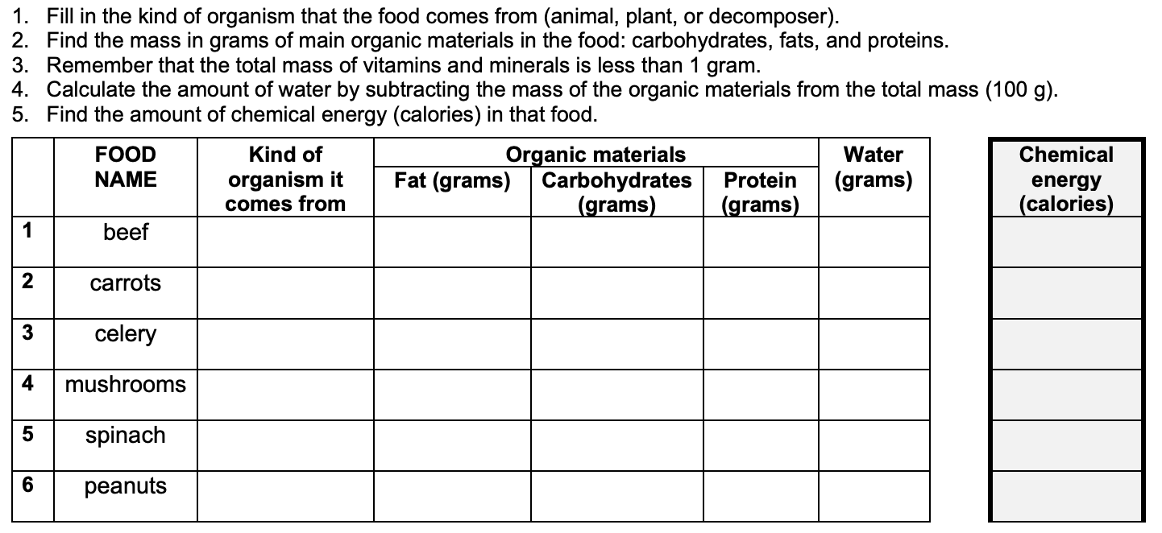

Post- Investigation Questions

- Compare the organic materials in beef (cow muscle) with the organic materials in carrots (plant roots), celery (plant leaf stems), and spinach (plant leaves). What are the differences in the kinds and amounts of organic materials in animals, plants, and fungi?

- Why do these differences exist? Why would different kinds of organisms have different levels of key macromolecules like carbohydrates, proteins, and fats?

- If macromolecules are simply long repeating chains of the same molecule, how do you think that organisms can use the macromolecules from the species they consume to make their own macromolecules? Summarize what you think happens to the atoms in food when it is consumed.

Part 4: Review & Assessment
Overview: you will begin by reviewing the driving questions below in your small groups. For each objective, rank it as a 1 (completely unsure), 2 (somewhat unsure), or 3 (completely sure) based on your comfort with that objective. Then work in teams to create responses to the questions (your instructor will determine if you will answer all the questions or only a portion).

After you have had time to create your responses, you will critique the responses of another group before coming together as a whole class. Be sure to use the “rules” for matter and energy as you do so. You will conclude by completing an assessment for this week’s ideas.

Driving Questions
- What is a cell? What are cells made from?
- What are macromolecules? What are macromolecules made from?
- How are carbohydrates, fats, and proteins examples of macromolecules?
- What is an organelle? How do organelles enable the cells of most organisms to function?
- How are the following related but different? Cells, Organelles, Tissues, Organs, Systems.
- Summarize each of the following levels: atomic-molecular, cellular, organismal, and ecosystem-planetary.
- What do you think happens to the atoms in food when it is consumed?
Remember the following “rules” for energy and matter:
- All solids, liquids, and gases are made of tiny particles called atoms. Multiple atoms can bond together to form molecules (e.g., water molecules consist of 1 oxygen atom & 2 hydrogen atoms).
- In biology, atoms last forever. Atoms cannot be created or destroyed (e.g., a carbon atom is always a carbon atom). Atoms found on molecules can be rearranged to form new molecules.
- In biology, energy lasts forever. Energy cannot be created or destroyed. Energy can exist as light, heat, motion, or as chemical energy stored in the bonds of molecules. Energy in one form can be transferred into a different form (e.g., light energy can be transformed into heat energy).

Part 5: Life Connections – What Happens to Fat?
Adapted from Carbon TIME. Used with permission.
Directions: For this activity, read the paragraph below. Then decide which arguments sound most accurate. Be prepared to explain why.

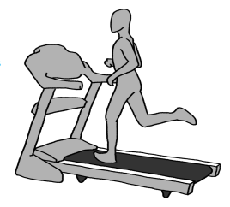
Overview: Five friends who’ve been going to the gym together and trying to lose some weight are talking after their workout one day. They all wonder what happens when they lose weight. Where does the fat go? This is what they thought:
- Marco: I think that when I exercise and lose weight I’m turning fat into energy.
- Andre: I breathe a lot when I exercise. I think fat gets turned into stuff I breathe out.
- Kara: I think that when I exercise my body burns the fat up. Then it’s gone.
- Mei: I get so hot when I exercise. I think my body turns the fat into heat.
- Lu: I think when I exercise my body turns the fat into sweat and I sweat it out through my skin.

Who do you agree with and why? It’s ok to pick more than one person. Explain your thinking.
I most agree with the following:
because…
Be prepared to discuss your ideas in small groups and as a class.

Animals Unit, Week 1 Assessment
Name: Hour Date: Score: /
Directions: A 3x5 notecard with handwritten notes can be used to guide your answers.
- Fats, proteins, and carbohydrates are all examples of macromolecules. What is a macromolecule? In your response, include and explain each of the following in your response: atoms, molecules, macromolecules, carbon, hydrogen, oxygen, high energy bonds.

- What is a cell made from? Include and explain each of the following in your response: atoms, molecules, macromolecules, organelles.

- Do you agree or disagree with what each student claims? Circle “Agree” or “Disagree” for each of the three claims below.
A) “Most of the food they eat will be lost as waste (feces).” AGREE/DISAGREE
B) “Athletes mostly convert solid food into gases that they breathe out.” AGREE/DISAGREE
C) “Athletes convert the matter in food into energy to perform and compete.” AGREE/DISAGREE
- Provide an explanation. Why did you agree or disagree with each student’s claim?
a)
b)
c)

- How are the following related? Cells, Organisms, Organs, Systems, Tissues.

