Animals Unit – Week 3

Name: Hour Date:

Date Packet is due: Why late? Score:   
 Day of Week Date If your project was late, describe why

**Driving Question**: How do the cells of animals use food to enable movement and function? How do the cells of animals use food to enable growth and maturation?

**Semester Schedule**

**Matter & Energy**

Week 1: What happens when something burns?

Week 2: What happens to molecules during burning?

Week 3: Unit Assessment

**Animals**

Week 1: What are animal cells and food made from?

Week 2: What happens to food when it is consumed?

Week 3: What happens inside animal cells?

Week 4: Unit Assessment

**Plants**

Week 1: What are plant cells made from?

Week 2: How do plants get their food?

Week 3: What happens inside plant cells?

Week 4: Unit Assessment

**Ecosystems**

Week 1: How do living organisms affect each other?  
Week 2: Tracing Matter  
Week 3: Global Biodiversity

Week 4: Humans & Biodiversity

**Anchoring Phenomenon**: So far we have investigated what happens when athletes, cattle, and worms consume food. We will be concluding our investigations by specifically tracing the matter and energy in food as it is digested and changed through both cellular respiration and biosynthesis.

**Deeper Questions**

1. How do the cells acquire energy from the high energy bonds of food? What happens to atoms in food molecules during this process?
2. How do the cells acquire matter from food to build and repair cells and bodily tissue? What happens to the energy in food molecules during this process?

**Weekly Schedule**

**Part 1: Introduction**

**NGSS Standards**:   
HS-LS1-2. Develop and use a model to illustrate the hierarchical organization of interacting systems that provide specific functions within multicellular organisms.  
 HS-PS1-4. Develop a model to illustrate that the release or absorption of energy from a chemical reaction system depends upon the changes in total bond energy.   
HS-PS1-7. Use mathematical representations to support the claim that atoms, and therefore mass, are conserved during a chemical reaction.   
HS-LS1-6. Construct and revise an explanation based on evidence for how carbon, hydrogen, and oxygen from sugar molecules may combine with other elements to form amino acids and/or other large carbon-based molecules.   
HS-LS1-7. Use a model to illustrate that cellular respiration is a chemical process whereby the bonds of food molecules and oxygen molecules are broken and the bonds in new compounds are formed resulting in a net transfer of energy.   
HS-LS2-5. Develop a model to illustrate the role of photosynthesis and cellular respiration in the cycling of carbon among the biosphere, atmosphere, hydrosphere, & geosphere.

* Initial Ideas
* Data Dive – Thirsty Moth
* Discussion & Developing Explanations

**Part 2: Core Ideas**

* Nutshell Video
* Core Ideas
* Revisions of Part 1 Explanations

**Part 3: Investigation**

* Molecular Modeling
* Revisions of Part 1 Explanations

**Part 4: Review & Assessment**

* Critiquing Ideas
* Assessment

**Part 5: Life Connections**

* Weekly Recap
* Life Connections



Part 1: Introduction

**Directions**: Begin by reading the excerpt below. Then look at the data provided below. Use this information to answer the questions on the following page. If you are unsure about how to interpret the data, work with your group and seek help from your instructor if necessary. Your instructor will decide if you should record your answers using the space provided in this packet, a dry erase board, a digital document, or another option.



**Introduction**: In the early 1900s, a University of Wisconsin scientist named Stephen Babcock decided that he wanted to have a malted milk shake. *Malted milk* is a dry powder consisting of evaporated milk, barley, and wheat. It is sometimes added to milk shakes to create a richer flavor.

When Babcock opened the jar of malted milk, he was surprised to find a moth larva. This puzzled Babcock, as he knew that the moth larva’s body was 75% water, but the sealed jar of malted milk was completely dry and had no water whatsoever.

How could an organism with a body comprised of mostly water survive in an environment that was completely lacking water?

1. As a group, develop an initial hypothesis to explain how this moth larva was able to survive in this environment. How do you think the larvae acquired the water in its body? *Note: If you’re unsure, that’s ok! Just provide your best ideas. You can always change your ideas as you gain more evidence*.
2. Provide a rationale for your ideas. In other words, how do you know that these ideas make sense? What evidence or logic supports your ideas?

Dr. Babcock knew that the atoms found in both glucose and oxygen molecules are rearranged to form carbon dioxide and water (*see image below*). While most organisms exhale water vapor along with carbon dioxide, Babcock suspected that the moth larva had a way to “hold on” to the water molecules it produced during cellular respiration.

Decades later, scientists named Fraenkel and Blewett suspected that the amount of humidity in the air might affect how much the moth larvae need to eat. They hypothesized that moth larvae grown in dry conditions would eat different amounts of food than larvae grown in humid conditions.

1. What do you think? Will moth larvae in dry conditions eat more, less, or the same amount as moth larvae grown in humid conditions? Complete the sentence prompts below:   
     
   *I think that moth larvae in dry conditions will need to eat (circle one): More Less The Same  
     
   food compared to moth larvae grown in humid conditions. I think this because…*
2. Do you think that the moth larvae in the dry conditions will grow faster, slower, or the same rate as moth larvae grown in the humid conditions? Complete the sentence prompts below:   
     
   *I think that moth larvae in dry conditions will grow (circle one): Faster Slower The Same   
     
   compared to moth larvae grown in humid conditions. I think this because…*
3. Decades later, scientists were also able to measure oxygen consumption between moths grown in dry conditions in comparison to those grown in humid conditions. Complete the sentence prompts below:   
     
   *I think that moth larvae in dry conditions will need (circle one): More Less The Same   
     
   oxygen compared to moth larvae grown in humid conditions. I think this because…*

Fraenkel and Blewett determined that in dry air, the moth larvae need to eat more food to reach a particular body weight. Dry air also increased the length of the larval period (i.e. the time to reach maturity). Conversely, the moth larvae grown in humid conditions needed less food to reach a given body weight and had shorter larval periods.

Later, scientists named Jindra and Sehnal determined that moth larvae in dry conditions consistently consumed more oxygen in comparison to larvae grown in humid conditions.

1. Were your predictions accurate? Explain below.
2. What questions do you have as a result of these findings? What is still unclear or uncertain to you?

**Sources:**

Babcock, S. M. (1912). *Metabolic water: its production and role in vital phenomena* (Vol. 22). The University of Wisconsin Agricultural Experiment Station.

Fraenkel, G., & Blewett, M. (1944). The utilisation of metabolic water in insects. *Bulletin of Entomological Research*, *35*(2), 127-139.

Jindra, M., & Sehnal, F. (1990). Linkage between diet humidity, metabolic water production and heat dissipation in the larvae of Galleria mellonella. *Insect biochemistry*, *20*(4), 389-395.

Part 2: Core Ideas

**Overview**: In this activity, you will look at a short slideshow presentation. This will provide you with core ideas that will help you clarify your initial ideas. Your instructor will decide on how to implement this portion depending on your previous experience and capabilities with this content.   
  
You will then work in small teams to answer the questions listed below. You should take notes in a notebook, on a dry erase board, or on scratch paper so that you are prepared to deliver your responses during the class discussion that will follow. *Note: your instructor may assign specific questions to your group if time is limited.*

**Core Ideas Presentation**: <https://bit.ly/WUHS-Bio-Animals-Week3>

**Driving Questions**:

1. What is cellular respiration?
2. What is biosynthesis?
3. How are the atoms in food molecules moved or rearranged during cellular respiration?
4. What happens to the energy in food molecules during cellular respiration?
5. What are mitochondria? What is ATP? How are these terms related to cellular respiration?
6. How are mitochondria and ATP like rechargeable batteries and/or battery chargers?
7. How are the atoms in food molecules moved or rearranged during biosynthesis?
8. What happens to the energy in food molecules during biosynthesis?
9. What is mitosis? How does it relate to biosynthesis?
10. Why is mitosis important for animal growth and development?
11. **Revising Explanations**: How do the cells of animals use food to enable movement and function?
12. **Revising Explanations**: How do the cells of animals use food to enable growth and maturation?

**Remember the following “rules” for energy and matter:**

* **All solids, liquids, and gases are made of tiny particles called atoms**. Multiple atoms can bond together to form molecules (*e.g., water molecules consist of 1 oxygen atom & 2 hydrogen atoms*).
* In biology, **atoms last forever**. Atoms cannot be created or destroyed (*e.g., a carbon atom is always a carbon atom*). Atoms found on molecules can be rearranged to form new molecules.
* In biology, **energy lasts forever**. Energy cannot be created or destroyed. Energy can exist as light, heat, motion, or as chemical energy stored in the bonds of molecules. Energy in one form can be transferred into a different form (*e.g., light energy can be transformed into heat energy*).

Part 3: Investigation

**Overview:** In this activity, you will be using Play-doh to create models of key molecules in biology.

**Directions**: Begin by answering the pre-investigation questions below. Then use the instructions on the following page to create each of your molecules out of Play-doh. Conclude by answering the post-investigation questions on this page. (*Note: your instructor may ask you to record your answers to questions using a different format, such as a whiteboard or online document*).

**Pre-Investigation Questions**: Answer these questions individually and in small groups before creating your Play-doh molecules. Your instructor will determine if/where you should record your answers (e.g., whiteboard, scratch paper, etc.). Your instructor may choose to assign specific questions to your group and/or may have you critique the responses of other groups for accuracy.

1. What is cellular respiration?
2. What is biosynthesis?
3. How are the atoms in food molecules moved or rearranged during cellular respiration?
4. What happens to the energy in food molecules during cellular respiration?
5. What are mitochondria? What is ATP? How are these terms related to cellular respiration?
6. How are mitochondria and ATP like rechargeable batteries and/or battery chargers?
7. How are the atoms in food molecules moved or rearranged during biosynthesis?
8. What happens to the energy in food molecules during biosynthesis?
9. What is mitosis? How does it relate to biosynthesis?
10. Why is mitosis important for animal growth and development?
11. Record your answer below: **What do you think happens to the matter and energy in food when it is consumed? Summarize two different ways in which the matter and energy of food can be used.**

1. Summary:   
  
   
  
2. Summary**:**

**Creating Your Play-Doh Molecules**: Use the instructions on the next page to create each of your molecules. Use your molecules as *scientific models* to help you improve and revise your answers to the questions above. In science, *models* are tools that help us clarify our thinking and make more accurate predictions. Models can be pictures, examples, scale models, or anything that helps us reason more accurately about a concept.

**1) To create your molecules, you will need the following:**

* Shape

  Description automatically generated with medium confidence**To create six molecules of oxygen (O2)** 
  + 12 balls of the same color to represent oxygen atoms.
  + Use toothpicks to represent chemical bonds.   
    *Note: O2 gas has a double-bond, so oxygen atoms   
    should be connected with two toothpicks.*
* 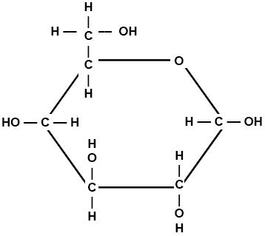**To create one sugar molecule (C6H12O6)**
  + Using the same color as you used previously for oxygen, create six balls of that color for the 6 oxygen molecules
  + Using a different color, create six balls for the 6 carbon atoms
  + Using a third color, create 12 balls for the 12 hydrogen atoms
  + Use the image at the right to assemble your glucose molecule using toothpicks to represent chemical bonds.
  + Mark any **high energy bonds (C-C and C-H)** with a twist tie, piece of tape, string, or other physical marker.
  + *Note: every atom should be connected to another atom using a toothpick (including the –OH atoms).*

When you think you are finished, **raise your hand and show your instructor**.   
  
*This activity was successfully completed* (*instructor signature*)

**2) Disassemble your O2 and glucose molecules. Using the same Play-doh atoms you used to create glucose and oxygen, create CO2 and H2O using the instructions below.**

* **To create six molecules of carbon dioxide (CO2):**
  + 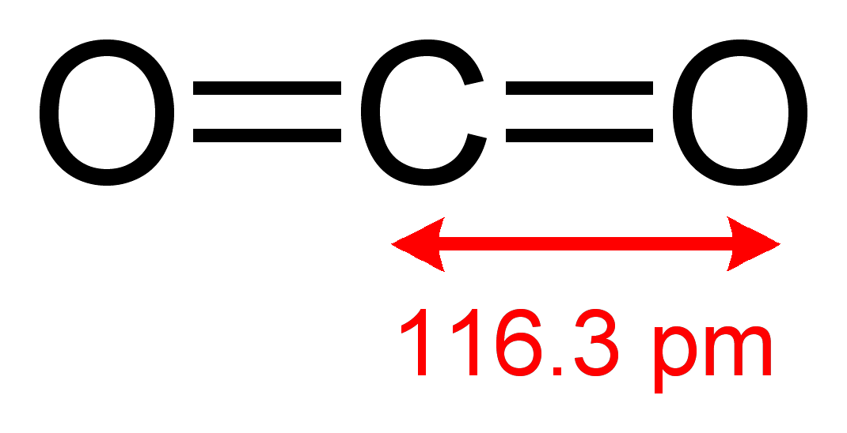Connect two oxygen atoms to a carbon atom.
  + Create six CO2 molecules.
  + 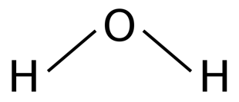*Note: oxygen atoms should be connected to   
    carbon with two toothpicks each.*
* **To create six molecules of water (H2O)**
  + Connect an oxygen atom to two hydrogen atoms.
  + Create six water molecules.

**3) Based on the core ideas from this week, explain how each of these molecules relates to what happens when food is digested.** When you think you are finished, **raise your hand and show your instructor**. While you are waiting for their approval and after they give their approval, complete the post-investigation questions on the next page.   
  
*This activity was successfully completed* (*instructor signature*)

**Post- Investigation Questions**: Answer these questions after creating your Play-doh molecules. Make a mental note of how your thinking about these questions changed after creating your molecular models.

1. How do the atoms in glucose and oxygen that an animal consumes/breathes relate to the atoms in the carbon dioxide and water vapor that an animal exhales?
2. How many carbon dioxide (CO2) and water (H2O) molecules could be made if you rearranged *all* the atoms found in glucose (C6H12O6) and oxygen (O2)? Show your work below.
3. Are there any high-energy bonds (C-C or C-H) in glucose (C6H12O6) or oxygen (O2)?   
     
   Are there any high-energy bonds (C-C or C-H) in carbon dioxide (CO2) or water (H2O)?   
     
   How do you think that this relates to how animals get energy from the food that they consume? (*Note: your thinking may still be changing about this question. That’s ok – provide the best answer you can).*

1. What do you think happens to the atoms in food when it is consumed?
2. What do you think happens to the energy in food when it is consumed?

Part 4: Review & Assessment

**Overview:** you will begin by reviewing the driving questions below in your small groups. For each objective, rank it as a 1 (*completely unsure*), 2 (*somewhat unsure*), or 3 (*completely sure*) based on your comfort with that objective. Then work in teams to create responses to the questions (your instructor will determine if you will answer all the questions or only a portion).

After you have had time to create your responses, you will critique the responses of another group before coming together as a whole class. Be sure to use the “rules” for matter and energy as you do so. You will conclude by completing an assessment for this week’s ideas.

**Driving Questions**

1. What is cellular respiration?
2. What is biosynthesis?
3. How are the atoms in food molecules moved or rearranged during cellular respiration?
4. What happens to the energy in food molecules during cellular respiration?
5. What are mitochondria? What is ATP? How are these terms related to cellular respiration?
6. How are mitochondria and ATP like rechargeable batteries and/or battery chargers?
7. How are the atoms in food molecules moved or rearranged during biosynthesis?
8. What happens to the energy in food molecules during biosynthesis?
9. What is mitosis? How does it relate to biosynthesis?
10. Why is mitosis important for animal growth and development?
11. **Revising Explanations**: How do the cells of animals use food to enable movement and function?
12. **Revising Explanations**: How do the cells of animals use food to enable growth and maturation?

**Remember the following “rules” for energy and matter:**

* **All solids, liquids, and gases are made of tiny particles called atoms**. Multiple atoms can bond together to form molecules (*e.g., water molecules consist of 1 oxygen atom & 2 hydrogen atoms*).
* In biology, **atoms last forever**. Atoms cannot be created or destroyed (*e.g., a carbon atom is always a carbon atom*). Atoms found on molecules can be rearranged to form new molecules.
* In biology, **energy lasts forever**. Energy cannot be created or destroyed. Energy can exist as light, heat, motion, or as chemical energy stored in the bonds of molecules. Energy in one form can be transferred into a different form (*e.g., light energy can be transformed into heat energy*).

Part 5: Life Connections – What Happens to Fat?  
*Adapted from Carbon TIME. Used with permission.*

**Directions:** For this activity, read the paragraph below. Then decide which arguments sound most accurate. Be prepared to explain why. Compare your responses to your earlier ideas to see how your thinking has evolved.

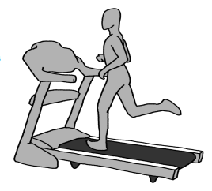**Overview:** Five friends who’ve been going to the gym together and trying to lose some weight are talking after their workout one day. They all wonder what happens when they lose weight. Where does the fat go? This is what they thought:

* *Marco: I think that when I exercise and lose weight I’m turning fat into energy.*
* *Andre: I breathe a lot when I exercise. I think fat gets turned into stuff I breathe out.*
* *Kara: I think that when I exercise my body burns the fat up. Then it’s gone.*
* *Mei: I get so hot when I exercise. I think my body turns the fat into heat.*
* *Lu: I think when I exercise my body turns the fat into sweat and I sweat it out through my skin.*

**Who do you agree with and why**? It’s ok to pick more than one person. Explain your thinking.

I most agree with the following:

because…

**What were your early ideas about this question, and how has your thinking about this question changed over the past weeks**?

*Be prepared to discuss your ideas in small groups and as a class.*

This page is intentionally blank. Feel free to use for extra notes if needed.

Animals Unit, Week 3 Assessment

Name: Hour Date: Score: /

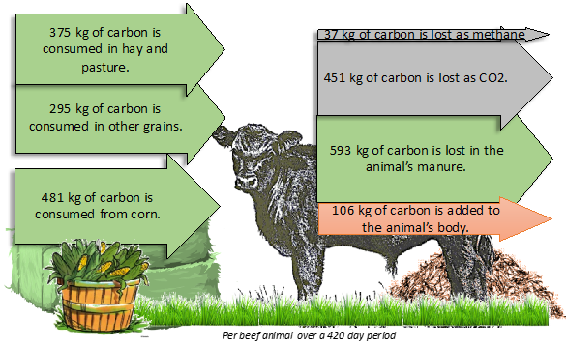  
**Directions**: A 3x5 notecard with handwritten notes can be used to guide your answers.

1. **Using the data from the image above, which of the following can we conclude?**Most of the carbon atoms that a steer consumes…
   1. …are added to its body.
   2. …released as methane when a steer burps.
   3. …are breathed out or released in feces.
   4. …are turned into fat and used for bodily energy.
2. **Which of the following cellular processes would be most responsible for the 451 kg of carbon that was added to the steer’s body?**
   1. Cellular Respiration b. Biosynthesis c. Combustion d. All of the above
3. **Explain your reasoning for your answer for the question above.**­
4. **Which of the following cellular processes would be most responsible for the 106 kg of carbon that was released as CO2?**
   1. Cellular Respiration b. Biosynthesis c. Combustion d. All of the above
5. **Explain your reasoning for your answer for the question above.**­
6. **As it grows, a steer may gain around 1000 lbs. (453 kg). Where did most of this mass come from? Circle all that apply.** 
   1. Cellular Respiration b. Biosynthesis c. Mitosis d. ATP
7. **Explain your answer for the question above.**
8. **How do mitochondria and ATP relate to the food that an animal consumes?** 
   1. The atoms in food molecules are rearranged to form ATP in the mitochondria.
   2. The energy in food molecules is transferred to ATP in the mitochondria.
   3. The mitochondria convert the C, H, & O atoms in glucose into chemical energy stored in ATP.
9. **How does mitosis relate to the food that an animal consumes?** 
   1. Through biosynthesis, cells assemble macromolecules and grow larger; *mitosis* is the process in which a large cell divides into two smaller cells.
   2. During cellular respiration, cells rearrange glucose and oxygen into CO2 and H2O, which are used to assemble the new cells created during mitosis.
   3. Cells create matter, and cellular respiration provides the chemical energy needed to divide this newly created matter into two new cells.
10. **On the right, you can see differences in the content of inhaled and exhaled air. Which of the following causes these differences?** 
    1. Cellular Respiration b. Biosynthesis c. Mitosis d. ATP
11. **Explain your answer for the question above.**
12. When a mouse is alive it has energy stored in its living parts (muscles, fat, etc.). When the mouse dies all the parts are still there, but no longer alive. **Does a dead mouse still contain energy?** a.Yes b. No
13. **Explain your answer. If you answered YES, what kind(s) of energy are in the mouse after it dies and where is energy stored? If you answered NO, why does a dead mouse not have energy?**