Animals Unit – Week 4

Name: Hour Date:

Date Packet is due: Why late? Score:   
 Day of Week Date If your project was late, describe why

**Driving Question**: How do the cells of animals use food to enable movement and function? How do the cells of animals use food to enable growth and maturation?

**Semester Schedule**

**Matter & Energy**

Week 1: What happens when something burns?

Week 2: What happens to molecules during burning?

Week 3: Unit Assessment

**Animals**

Week 1: What are animal cells and food made from?

Week 2: What happens to food when it is consumed?

Week 3: What happens inside animal cells?

Week 4: Unit Assessment

**Plants**

Week 1: What are plant cells made from?

Week 2: How do plants get their food?

Week 3: What happens inside plant cells?

Week 4: Unit Assessment

**Ecosystems**

Week 1: How do living organisms affect each other?  
Week 2: Tracing Matter  
Week 3: Global Biodiversity

Week 4: Humans & Biodiversity

**Anchoring Phenomena**: In this unit, we have investigated what happens when athletes, cattle, and worms consume food. We will be concluding this unit by revisiting each phenomenon and revising our explanations.

**Deeper Questions**

1. How do the cells acquire energy from the high energy bonds of food? What happens to atoms in food molecules during this process?
2. How do the cells acquire matter from food to build and repair cells and bodily tissue? What happens to the energy in food molecules during this process?

**Weekly Schedule**

**Part 1: Introduction**

**NGSS Standards**:   
HS-LS1-2. Develop and use a model to illustrate the hierarchical organization of interacting systems that provide specific functions within multicellular organisms.  
 HS-PS1-4. Develop a model to illustrate that the release or absorption of energy from a chemical reaction system depends upon the changes in total bond energy.   
HS-PS1-7. Use mathematical representations to support the claim that atoms, and therefore mass, are conserved during a chemical reaction.   
HS-LS1-6. Construct and revise an explanation based on evidence for how carbon, hydrogen, and oxygen from sugar molecules may combine with other elements to form amino acids and/or other large carbon-based molecules.   
HS-LS1-7. Use a model to illustrate that cellular respiration is a chemical process whereby the bonds of food molecules and oxygen molecules are broken and the bonds in new compounds are formed resulting in a net transfer of energy.   
HS-LS2-5. Develop a model to illustrate the role of photosynthesis and cellular respiration in the cycling of carbon among the biosphere, atmosphere, hydrosphere, & geosphere.

* Comparative Data Dives
  + Olympic Diets
  + Cattle Diets
  + Mealworm Mass
  + Thirsty Moths

**Part 2: Critiquing Responses**

* Evaluating Sample Responses
* Writing a “Level 3” Response

**Part 3: Investigation – Dirty Mouths**

* Explaining Petri Dish Mass Changes

**Part 4: Review**

* Jeopardy Review Game

**Part 5: Final Review**

* Review of Driving Questions
* Final Q&A



Part 1: Introduction – Comparative Data Dives

**Directions**: Analyze the data provided below. Then explain the trends in the data using the provided terms.

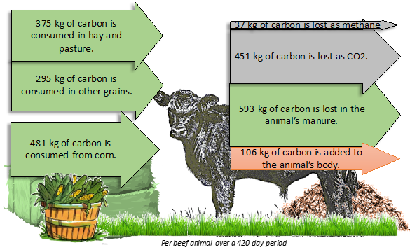

**Olympic Diets:** This shows the different diets of Olympic athletes. To effectively compete in their sports, athletes must consume differing levels of calories and have different proportions of carbohydrates, protein, and fat in their diets.

**Why do different athletes need differing amounts of carbohydrates, fats, and protein?** Use the following in your response: *molecules, macromolecules,* *carbohydrates, fats, protein glucose, amino acids, fatty acids, energy, matter.*

*Complete: Accurate: Precise:*

**What happens to the food that is consumed by a steer as it grows?** Use the following in your response: *macromolecules, energy, matter, cellular respiration, high energy bonds, ATP, mitochondria, CO2, H2O, biosynthesis, feces.*

*Complete: Accurate: Precise:*

**Cattle Diets:** this shows the mass of carbon atoms that a calf will consume over 420 days as it grows into a full-grown animal. *Note: this image does not include hydrogen, oxygen, and nitrogen atoms that are also found in the food*.

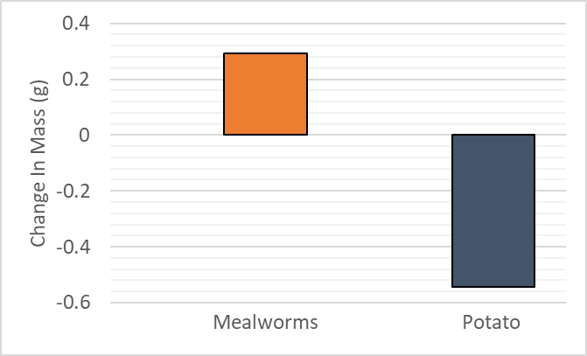**Mealworm Mass:** This shows the average gain in mass in the mealworms and the average mass lost from a potato as it was eaten by mealworms. Note: in this experiment, CO2 and water vapor concentrations increased in the air inside the container.

|  |  |  |
| --- | --- | --- |
|  | **Mealworm Mass Change (g)** | **Potato Mass Change  (g)** |
| Group 1 | 0.20 | -0.48 |
| Group 2 | 0.24 | -0.63 |
| Group 3 | 0.44 | -0.52 |
| Group 4 | 0.28 | -0.52 |
| Group 5 | 0.31 | -0.57 |
| **AVERAGE** | **0.29** | **-0.54** |



**Did the amount of mass gained by the worms equal the amount of mass lost by the potato? Why or why not?** Use the following in your response: *macromolecules, energy, matter, cellular respiration, mitochondria, high energy bonds, ATP, CO2, H2O, biosynthesis.*

*Complete: Accurate: Precise:*

**How could an organism with a body comprised of mostly water survive in an environment that was completely lacking water?** Use the following in your response: *carbohydrates, glucose, cellular respiration, high energy bonds, ATP, mitochondria, CO2, H2O.*

*Complete: Accurate: Precise:*

**Thirsty Moths:** When Dr. Babcock opened a jar of malted milk, he was surprised to find a moth larva. The moth larva’s body was 75% water; however, the sealed jar of malted milk was completely dry and had no water whatsoever.

Part 2: Critiquing Responses

**Overview**: In this activity, you will be critiquing student answers for their sophistication. The main goals are to prepare you to write high-level responses on the unit test and to know the difference between high- and low-level responses.

**A high level response (3/3) is one that is…**

* **Complete**: The response addresses all relevant and important concepts inherent in the question that is being asked. In addition, the response fully addresses changes to matter and energy when needed.
  + Matter: When needed, the response explains the molecules that go into a reaction *and* the molecules that are formed after a biological reaction (e.g., burning or cellular respiration).
  + Energy: When needed, the response explains how energy is being transformed from one type to another.
* **Accurate**: Every aspect of the written response is factually correct as it is written.
* **Precise**: The response effectively uses terminology from the course in an exact manner. The response is not vague or confusing.

**A low level response (1/3) is one that is…**

* **Incomplete**: The response does not address all aspects of the question asked AND/OR the response leaves out key information from the course needed to answer the question. Furthermore, the response does not address changes to matter and energy if needed.
  + Matter: When needed, the response does not trace the path of atoms from one molecule to another during a biological reaction. The response does not state what molecules enter the reaction or which molecules are formed as a result of that reaction.
  + Energy: When needed, the response does not explain how energy is being transformed from one type to another.
* **Inaccurate**: Aspects of the response are incorrect or portray content in a manner that is inaccurate.
* **Imprecise**: The response uses vague or uncertain terms (e.g., saying “stuff” instead of “matter”, or has confusing or overly-broad language such as, “…and the atoms move somewhere else…”)

**Directions**: In small groups (3-4), take turns critiquing each other’s responses from Part 1. Exchange your packets and have each person decide the extent to which your responses are complete or incomplete, and accurate. Spaces are provided below each blank. Provide a score (1-3) for each consideration using the descriptions above.

If time allows, or if you don’t have a group to exchange with, repeat this same process with the sample responses on the following page.

**Sample Responses**: Rate each of the following responses based on whether they are complete, accurate, and precise. For each ranking, provide a brief written justification for why you think they earned a 1 (still learning), 2 (acceptable), or 3 (sophisticated).

**Q: What happens when a person exercises to lose weight? What happens to the matter & energy in fat?**  
**Lucy**: Exercise helps you by converting the fat into energy; this is why your body loses atoms.

*3 2 1 Complete: Does their response address all aspects of the question? Does it explain all changes to matter and energy?*

*3 2 1 Accurate: Is every aspect of the written response factually correct?*

*3 2 1 Precise: Are they effectively using terms from the course in a clear and specific manner?*

Overall Score: Comments:

**Mei**: Fat molecules rearrange into CO2 and H2O that we breathe out as we exercise. The chemical energy in the C-C/C-H bonds gets converted into motion and heat, and we need to sweat to cool off.

*3 2 1 Complete: Does their response address all aspects of the question? Does it explain all changes to matter and energy?*

*3 2 1 Accurate: Is every aspect of the written response factually correct?*

*3 2 1 Precise: Are they effectively using terms from the course in a clear and specific manner?*

Overall Score: Comments:

**José**: The chemical bonds in the fat are turned into motion and heat.

*3 2 1 Complete: Does their response address all aspects of the question? Does it explain all changes to matter and energy?*

*3 2 1 Accurate: Is every aspect of the written response is factually correct?*

*3 2 1 Precise: Are they effectively using terms from the course in a clear and specific manner?*

Overall Score: Comments:

**Robert**: You lose fat atoms by breathing them out of your body. The energy from the fat is lost.

*3 2 1 Complete: Does their response address all aspects of the question? Does it explain all changes to matter and energy?*

*3 2 1 Accurate: Is every aspect of the written response factually correct?*

*3 2 1 Precise: Are they effectively using terms from the course in a clear and specific manner?*

Overall Score: Comments:

Part 3: Investigation – Dirty Mouths

**Directions**: Read the information below before answering the questions on the following page.

**Overview:** Three instructors decided to investigate who had the ‘dirtiest’ mouth. They dabbed the inside of their mouths with cotton swabs. They then gently brushed the cotton swabs across the surface of petri dishes filled with a substance called *agar* to see which of their samples of saliva would grow the most bacteria.

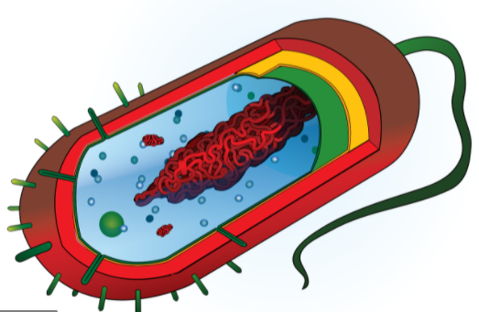

**Background Information**: *Bacteria* are single-celled organisms. Bacterial cells lack most of the organelles found within plant and animal cells. Most bacterial cells consist of a simple membrane, a loop of DNA, and small structures that assemble amino acids into proteins. The bodies of animals (including humans) are home to many, many different kinds of bacteria. In fact, there are ten times more bacterial cells in the human body than there are human cells! This is possible because bacterial cells are much smaller than human cells.

Figure 1- Bacteria are simple one-celled organisms.

Despite not having mitochondria, the cells of bacteria are still powered by ATP. Bacterial cells use a simpler version of *cellular respiration* to transfer chemical energy from the high-energy bonds of glucose to ATP. The end result of this process is the same as cellular respiration in animal cells – the atoms found in oxygen and glucose are rearranged to form CO2 and H2O. Bacteria must also undergo *biosynthesis* to enlarge their cells.

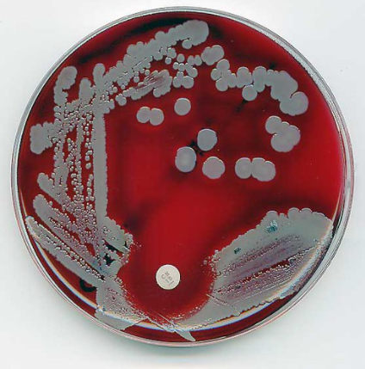Bacteria can be grown in a lab using *agar*. Agar is a gel that is extracted from seaweed. Agar is a *carbohydrate* - it is comprised of long connected chains of sugar molecules. When mixed with water, salt, and extracts from meat and/or yeast, agar gel provides a reliable source of nutrition. This is useful for growing bacteria in controlled, predictable manner. This combination of agar and a source of water, salt, and protein is called *nutrient agar*.

To identify what kinds of bacteria are present in a substance, scientists add a sample of that substance to nutrient agar gel. The bacteria then use this gel to acquire the matter and energy needed to enlarge their cells. Once the cell is large enough, a bacterium will divide into two individual bacteria. In warm temperatures and with a plentiful supply of water, carbohydrates, protein, etc., many bacteria will divide into two new cells multiple times per hour. A single bacterium could divide into over 16 million new bacterial cells within an 8-hour workday. The types of bacteria found in a sample can be determined by the visual appearance of a bacterial colony that grows on nutrient agar.

Figure 2 - Bacteria grow rapidly on petri dishes of nutrient agar, creating large visible colonies that can be used for identification.

**Data**: The instructors placed the nutrient agar with their samples of saliva in a warm environment. This allowed the bacteria to grow rapidly. The instructors identified the types of bacteria present in their mouths based on the visual appearance of the bacterial colonies. They also measured the difference in mass of the agar gel before and after growing the bacterial colonies.

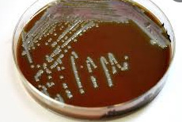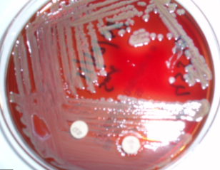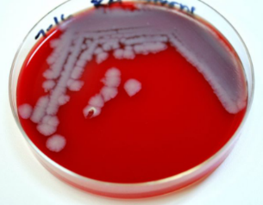The images below show the growth of bacteria from the saliva of each instructor. The table below shows the change in mass of each petri dish before and after the bacteria were allowed to grow and divide. The instructors also noted that new moisture was present inside the lids of the petri dishes on the second day.

|  |  |  |
| --- | --- | --- |
|  | **Initial Mass of Agar Petri Dish (g)** | **Final Mass of Agar Petri Dish (g)** |
| Instructor 1 | 33.4 | 31.2 |
| Instructor 2 | 33.7 | 30.9 |
| Instructor 3 | 33.7 | 31.6 |

**Questions**

1. Which instructor had the dirtiest mouth? How does this evidence support your claim?
2. Why did the petri dishes of nutrient agar lose mass? In your response, use the following terms: *cellular respiration, oxygen, glucose, CO2, H2O, and ATP.*
3. Three students are wondering how a bacterial cell grows larger and divides. They summarize their ideas below. Do you agree or disagree with each statement? Justify your choice with evidence & reasoning.

**Trey**: I think that the bacterial cell grows by dividing in half. This creates two cells from one. The cell creates more matter to grow larger.

*Agree / Disagree* (circle one). Explain:   
  
   
*Score Trey’s response (1,2,3) - Complete: Accurate: Precise: Overall:*

**Martin**: I think that if the bacterial cell converts enough agar into cellular molecules, it can grow large enough to divide in half.   
  
*Agree / Disagree* (circle one). Explain:

*Score Martin’s response (1,2,3) - Complete: Accurate: Precise: Overall:*

**Jasmine**: I think that the bacterial cell converts the chemical energy in the chains of sugar in the glucose into the atoms that the cell needs to grow larger and divide in half.   
  
*Agree / Disagree* (circle one). Explain:   
  
   
*Score Jasmine’s response (1,2,3) - Complete: Accurate: Precise: Overall:*

Part 4: Jeopardy Review

**Overview:** In this activity, you will be playing a Jeopardy-style game to review key concepts from the course. This presentation can be accessed at <https://bit.ly/WUHS-Bio-Animals-Jeopardy>. The rules for this review game are posted within the presentation. You can also use this presentation outside of class to help prepare you for the unit test. Your instructor may decide to use an alternative option (like Gimkit or Kahoot).

Part 5: Review

**Overview:** For each objective, rank it as a 1 (*completely unsure*), 2 (*somewhat unsure*), or 3 (*completely sure*) based on your comfort with that objective. Afterwards, you will have time for group and whole-class review.

1. What is a cell? What are cells made from?
2. What are macromolecules? What are macromolecules made from?
3. How are carbohydrates, fats, and proteins examples of macromolecules?
4. What is an organelle? How do organelles enable the cells of most organisms to function?
5. How are the following related but different? *Cells, Organelles, Tissues, Organs, Systems.*
6. Summarize each of the following levels: *atomic-molecular, cellular, organismal, and ecosystem-planetary.*
7. What first happens to food in the digestive tract after it is consumed? How does this occur?
8. What are the two primary purposes that food serves when it is consumed?
9. Most of the time, consumed food is used for what?
10. What happens to the energy found in the high energy bonds (C-C, C-H) in food when digested?
11. Corn is mostly comprised of carbohydrate macromolecules. What does this mean?
12. A cell can rearrange the atoms in glucose and oxygen to form what molecules?
13. How are the carbon dioxide (CO2) and water (H2O) molecules that an organism breathes out related to the molecules in the food and oxygen that it consumes?
14. About 90% of consumed food is utilized for its energy. How do cells use the remaining 10%?
15. What happens to the energy in the high energy bonds in food when it is used to create and maintain the animal’s cells?
16. What is cellular respiration?
17. What is biosynthesis?
18. How are the atoms in food molecules moved or rearranged during cellular respiration?
19. What happens to the energy in food molecules during cellular respiration?
20. What are mitochondria? What is ATP? How are these terms related to cellular respiration?
21. How are mitochondria and ATP like rechargeable batteries and/or battery chargers?
22. How are the atoms in food molecules moved or rearranged during biosynthesis?
23. What happens to the energy in food molecules during biosynthesis?
24. What is mitosis? How does it relate to biosynthesis?
25. Why is mitosis important for animal growth and development?
26. How do the cells of animals use food to enable movement and function?
27. How do the cells of animals use food to enable growth and maturation?

This page is intentionally blank. Feel free to use for extra notes if needed.