Plants Unit – Week 1
Name: Hour Date:
Date Packet is due: Why late? Score:
^{Day of Week Date} If your project was late, describe why
Driving Question: What are plant cells made from?
Semester Schedule
Matter & Energy
Week 1: What happens when something burns?
Week 2: What happens to molecules during burning?
Week 3: Unit Assessment
Animals
Week 1: What are animal cells and food made from?
Week 2: What happens to food when it is consumed?
Week 3: What happens inside animal cells?
Week 4: Unit Assessment

Plants
Week 1: What are plant cells made from?
Week 2: How do plants get their food?
Week 3: What happens inside plant cells?
Week 4: Unit Assessment

Ecosystems
Week 1: How do living organisms affect each other?
Week 2: Tracing Matter
Week 3: Global Biodiversity
Week 4: Humans & Biodiversity

Anchoring Phenomenon: This week we are investigating where the mass of a plant comes from. Specifically, we are wondering how a towering sequoia tree can grow from a tiny little seed.

Deeper Questions
- What are the cells of plants made from?
- Where does the mass of plant cells come from?
- How are plant cells both similar and different from animal cells?

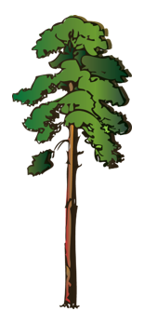
Weekly Schedule

Part 1: Introduction
- Initial Ideas – General Sherman Videos
- Data Dive - The General Sherman Sequoia
- Discussion & Developing Explanations

Part 2: Core Ideas
- Core Ideas – Plant Cells
- Comparing Plant & Animal Cells
- Revisions of Part 1 Explanations

Part 3: Investigation
- Part 3A: Seedling Mass
- Part 3B: Cell Microscopy

Part 4: Review & Assessment
- Critiquing Ideas
- Assessment

Part 5: Life Connections
- Weekly Recap
- Life Connections
NGSS Standards:
HS-LS1-2. Develop and use a model to illustrate the hierarchical organization of interacting systems that provide specific functions within multicellular organisms.
HS-LS1-6. Construct and revise an explanation based on evidence for how carbon, hydrogen, and oxygen from sugar molecules may combine with other elements to form amino acids and/or other large carbon-based molecules.
HS-LS1-5. Use a model to illustrate how photosynthesis transforms light energy into stored chemical energy.
HS-LS1-7. Use a model to illustrate that cellular respiration is a chemical process whereby the bonds of food molecules and oxygen molecules are broken and the bonds in new compounds are formed resulting in a net transfer of energy.

Part 1: Introduction - The General Sherman
Overview: In this activity, you will begin by watching two short videos about the largest trees in the world, sequoias. You will then interpret data about how tiny seeds can grow into the largest living organisms on the planet. This will enable you to develop an initial explanation that you will revise over the course of this week. You will then conclude by comparing your observations and explanations to those of other groups to check your accuracy and make revisions.

Initial Ideas: The largest living organisms on the planet are trees. Where do trees get their mass from? How do these trees acquire the atoms they need to grow to such large sizes?
- Three students shared their ideas about what happened. Do you agree or disagree with each student’s claim?
  - Mike: "I think a growing plant gains most of its mass from nutrients in the soil." Agree/ Disagree
  - Lucia: "I think a plant gains most of its mass from gases in the air." Agree / Disagree
  - Oscar: “I think a plant gains most of its mass from the sunlight.” Agree / Disagree
- Work in your small groups to discuss your ideas. Try to identify how your ideas are similar or different. Then work as a team to decide as a group whether each statement is correct or incorrect (and why). Be prepared to present your ideas to the class.
Videos: Next, watch the following videos individually or as a class (based on your teacher’s instructions):
Video 1 – Comparing heights of trees: https://www.youtube.com/watch?v=JyjHtxAOhP4
Video 2 - The General Sherman: https://www.youtube.com/watch?v=FjDuR0FzUjA

Data Dive: On the next page, you can see data comparing the mass of the General Sherman to a sequoia seed.
- Begin by individually attempting to make sense of this image. What trends or patterns do you notice? How does this relate to any prior knowledge or experience that you have?
- Next, work in your teams to discuss your ideas. Where do you agree? Where do you disagree? Can you use this data to reach agreement? Do others have prior knowledge/experience that could help?
- Based on this data, what is one conclusion that would be supported by this data?
  - How is this conclusion supported by this data?
  - What specifically suggests that your claim is accurate?
- Based on this data, what is a second conclusion that would be supported by this data?
  - How is this conclusion supported by this data?
  - What specifically suggests that your claim is accurate?
- Would you change any of your responses to the first question above? (See Question #1 under Initial Ideas). Discuss as a team.
Be prepared to discuss your ideas with other groups and/or as a class.
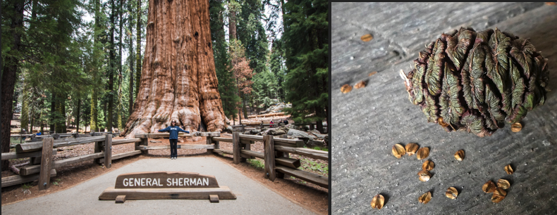
Sequoia Seed
Weight: 0.005 g.

General Sherman (Sequoia Tree)
Live Weight: 5.6 million kg (12.4 million lbs.).
Dry weight: 3.1 million kg (6.8 million lbs.).

Discussion & Developing Ideas
- As a class, discuss your ideas about where the mass of a tree comes from. What are ideas that most agreed on? Where did your ideas differ as a class? Based on your instructor’s directions, use the space below or another option (e.g., whiteboard, online document, etc.) to record your ideas.
We all agree that…
We disagreed about…
- How did the General Sherman get so big? Where does the mass (atoms) of plant cells come from? Write down your initial explanation in the space below. Don’t worry if you aren’t completely sure about your answer! You will come back and revise this explanation as you gain more information during this unit.
I think that the mass of the General Sherman came from…

Part 2: Core Ideas
Overview: In this activity, you will begin with a short slideshow presentation. This will provide you with core ideas that will help you clarify your initial ideas. Your instructor will decide on how to implement this portion depending on your previous experience and capabilities with this content.
You will then work in small teams to answer the questions listed below. You should take notes in a notebook, on a dry erase board, or on scratch paper so that you are prepared to deliver your responses during the class discussion that will follow. Note: your instructor may assign specific questions to your group if time is limited.

Core Ideas Presentation: https://bit.ly/WUHS-Bio-PlantsW1

Driving Questions:
- Plants and animals are eukaryotic organisms. What does this mean? How are they different from prokaryotic organisms?
- How are the organelles found in plant cells like those found in animal cells?
- True or false: both plant cells and animal cells have DNA. Explain.
- True or false: biosynthesis (such as when amino acids are assembled into a protein) occurs in both plant cells and animal cells. Explain.
- True or false: both plant cells and animal cells have mitochondria where glucose and oxygen are rearranged into CO₂ and H₂O through cellular respiration. Explain.
- True or false: to acquire the chemical energy needed to function, both plant cells and animal cells need a constant supply of glucose and oxygen. Explain.
- True or false: only animals produce CO₂ and H₂O; plant cells produce oxygen. Explain.
- True or false: plant cells form tissues, and organs, and then systems just like animal cells. Explain.
- What are xylem and phloem? How do they relate to the function of a plant?
- True or false: most plants have a circulatory system similar to animals. Explain.
- Briefly summarize the three organelles that plant cells have that animal cells do not.
- What is photosynthesis? Where does it occur?
- How can some plants (like sequoias) grow so tall without any kind of skeletal system to support them?
- What is cellulose? What is it made from? Is it a macromolecule? Where is it found in a plant cell?
- Revising Explanations: Return to your original explanation that you created at the end of Part 1. Based on this new information, how would you now respond to this question?
I think that the mass of the General Sherman came from …
Given the similarities between plant & animal cells, how do plants like the General Sherman grow & function?

Part 3A: Investigation – Seedling Mass
Adapted from Carbon TIME. Used with permission.
Overview: In this activity, you will compare the mass of radish seeds to the mass of seedlings that have sprouted. You will then develop evidence-based arguments to explain your findings.

Directions: Review the pre-investigation questions below with your group. When your group is ready to provide responses, raise your hand. Your instructor will ask you to provide explanations for some questions before starting the investigation. They will sign off when you’re ready (Note: your instructor may ask you to record your answers to questions using a different format, such as a whiteboard or online document).

Pre-Investigation Questions:
- What are specific ways in which plant cells are both similar and different to animal cells?
- Does cellular respiration occur in plant cells? How do you know?
- Does biosynthesis occur in plant cells? How do you know?
- Do plant cells need steady supply of glucose and oxygen? Why?
- Do most plants have a circulatory system similar to animals? Explain.
- What enables some plants to grow so tall? Do plants have a skeletal system like animals? Explain
- What is cellulose? What is it made from? Is it a macromolecule? Where is it found in a plant cell?
When you think you are ready, raise your hand. Your instructor will listen to your verbal responses.
This activity was successfully completed (instructor signature)

- Revising Explanations:
I think that the mass of the General Sherman came from …
Given the similarities between plant & animal cells, how do plants like the General Sherman grows & function?
Remember the following “rules” for energy and matter:
- All solids, liquids, and gases are made of tiny particles called atoms. Multiple atoms can bond together to form molecules (e.g., water molecules consist of 1 oxygen atom & 2 hydrogen atoms).
- In biology, atoms last forever. Atoms cannot be created or destroyed or turned into energy (e.g., a carbon atom is always a carbon atom). However, atoms can be rearranged to form new molecules.
- In biology, energy lasts forever. Energy cannot be created or destroyed. Energy can exist as light, heat, motion, or as chemical energy. Energy can be transformed (e.g., light can transform into heat).

Radish Seedling Mass: As a seed germinates and grows, it changes in mass. Where does a seedling get this extra mass? This investigation will provide data to help address this question.

Background: About 1-2 weeks prior to this, your instructor placed moistened paper towels and radish seeds in a sealed plastic bag (like a sandwich bag). They ensured the seeds remained moist and had access to light. During this time, most of the seeds should have begun to germinate, or grow into seedlings.

Directions: First, acquire six radish seedlings and six radish seeds from your instructor. Using a scale (sensitive to 0.01 g if possible), record the total mass in grams of the six seeds and six seedlings.

Then calculate the average mass of the seeds and seedlings by dividing the total mass by the number of individual seeds or seedlings (6). Make sure that you are recording only the mass of the seeds and seedlings and not the container (if unsure, ask your instructor for assistance before moving on).

Finally, determine the dry mass of the radish seedlings, or the mass of radishes after subtracting the mass of water. This tells us how much mass the radish gained that wasn’t water. Dry mass is 9% of the seedling mass. You can also dry the plants and record this data if you have time.

Data:
- Total seed mass of six radish seeds: g
- Average seed mass g (divide total seed mass by 6)
- Total seedling mass of six radish seedlings: g
- Average seedling mass g (divide total seedling mass by 6)
Calculate the total dry mass of six radish seedings by multiplying total seedling mass by 0.09 OR use a dehydrator or well-lit area to allow the seedlings to completely dry out.
- Total dry mass of six radish seedlings: g
- Average seedling dry mass g (divide total dry mass by 6)
- Total dry mass gained by six radish seedlings g
(subtract total seed mass from total dry mass of seedlings)
- Average dry mass gained by each seedling g (divide total dry mass gained by 6)
Create a bar graph for average seed mass, average seedling mass, and average seedling dry mass below.
Average Seed Mass Average Seedling Mass Average Seedling Dry Mass

Part 3B: Investigation – Plant Cell Microscopy
Overview: In this lab, you will be examining plant cells under a microscope at varying magnifications. You will try to identify as many organelles as you can within each cell.

Materials needed (per group of 4): A light microscope, microscope slides and covers, plant leaves (spinach works well), scissors, tap water, pencils.

Complete these blanks before beginning based on your instructor’s directions:
- Where does your instructor want you to get your microscopes from?
- How should you carry your microscopes?
- Where has your instructor placed your needed materials?
- What do you need to do to prevent damage to the microscope while working?
- What should you do when you think you are done?
Methods: Check each box as you complete each step.
- Prepare a microscope slide. To prepare a slide:
  - ☐ Take a glass microscope slide and make sure it is clean. If there is any debris or smudges, use soap and water to clean and wipe dry with a clean paper towel (but do not scratch the slide).
  - ☐ Acquire a plastic coverslip; keep in a safe place until you are ready to use it.
  - ☐ Obtain a sample of the plant material provided by your instructor (such as a spinach leaf).
  - ☐ Cut the leaf into a small piece (smaller than a postage stamp). Cut the sample into the smallest slivers that you can create. Use a knife, scissors blade, or clean blunt object (such as a glass stirring rod) to gently dice and mash the leaf until you have a consistent “paste”.
  - ☐ Mix in a drop of water to your glass slide and place a cover slip over the water and leaf cells.
- ☐ Place the microscope slide on the microscope’s stage (the flat space with clips beneath the lenses).
  - ☐ Switch to the 4x lens. Use the coarse and then the fine adjustment knob to focus the image.
  - ☐ Draw what you see (in pencil) below in the appropriate circle on the next page.
- ☐ Switch to the 10x lens. Use the coarse and then the fine adjustment knob to focus the image.
  - ☐ Draw what you see (in pencil) below in the appropriate circle.
- ☐ Finally, switch to the high-power 40x objective lens. ONLY use the fine adjustment knob to focus.
  - ☐ Draw what you see (in pencil) below in the appropriate circle.
- ☐ Turn off your microscope’s light. Record observations on the next page.
- ☐ Clean your glass slide using soap and water and dry with a paper towel. Place items where instructed.
Observations: Draw what you see at each magnification. Label the following if you can identify them: cell wall, cell membrane, nucleus, mitochondria, chloroplasts, ribosomes, and vacuole (some may not be visible).
Items to Identify
Cell Wall
Cell Membrane
Nucleus
Mitochondria
Chloroplasts
Ribosomes
Vacuole
10X
40X
4X

Written Observations: Describe what you saw below using complete sentences. What organelles could you identify at each magnification? Examples include: cell wall, nucleus, mitochondria, chloroplasts, ribosomes, vacuole, etc. What organelles were you unable to find at any magnification?

4x:
10x:
40x:

Part 4: Review & Assessment
Overview: For each objective, rank it as a 1 (completely unsure), 2 (somewhat unsure), or 3 (completely sure) based on your comfort with that objective. Then work in teams to review each item and prepare a response. You will conclude by completing a formative assessment.

Driving Questions
- Plants and animals are eukaryotic organisms. What does this mean? How are they different from prokaryotic organisms?
- How are the organelles found in plant cells like those found in animal cells?
- True or false: both plant cells and animal cells have DNA. Explain.
- True or false: biosynthesis (such as when amino acids are assembled into a protein) occurs in both plant cells and animal cells. Explain.
- True or false: both plant cells and animal cells have mitochondria where glucose and oxygen are rearranged into CO₂ and H₂O through cellular respiration. Explain.
- True or false: to acquire the chemical energy needed to function, both plant cells and animal cells need a constant supply of glucose and oxygen. Explain.
- True or false: only animals produce CO₂ and H₂O; plant cells produce oxygen. Explain.
- True or false: plant cells form tissues, and organs, and then systems just like animal cells. Explain.
- What are xylem and phloem? How do they relate to the function of a plant?
- True or false: most plants have a circulatory system similar to animals. Explain.
- Briefly summarize the three organelles that plant cells have that animal cells do not.
- What is photosynthesis? Where does it occur?
- How can some plants (like sequoias) grow so tall without any kind of skeletal system to support them?
- What is cellulose? What is it made from? Is it a macromolecule? Where is it found in a plant cell?
- Revising Explanations:
I think that the mass of the General Sherman came from …
Given the similarities between plant & animal cells, how do plants like the General Sherman grows & function?
Remember the following “rules” for energy and matter:
- All solids, liquids, and gases are made of tiny particles called atoms. Multiple atoms can bond together to form molecules (e.g., water molecules consist of 1 oxygen atom & 2 hydrogen atoms).
- In biology, atoms last forever. Atoms cannot be created or destroyed or turned into energy (e.g., a carbon atom is always a carbon atom). Atoms can be rearranged to form new molecules.
- In biology, energy lasts forever. Energy cannot be created or destroyed. Energy can exist as light, heat, motion, or as chemical energy. Energy can be transformed (e.g., light can transform into heat).

Part 5: Life Connections – Houseplant for a Busy Family
Adapted from Carbon TIME. Used with permission.
Directions: For this activity, read the paragraph below. Then decide which arguments sound most accurate. Be prepared to explain why.

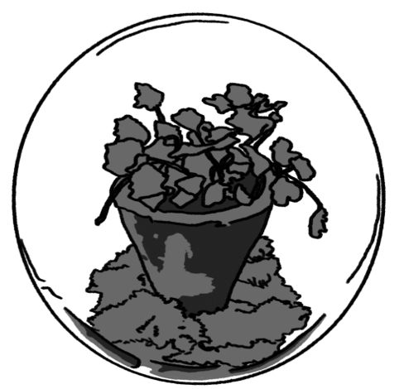
Overview: Carla’s mom wanted to get a houseplant, but she wanted one that wouldn’t need lots of tending. She went online and learned about something called a vivarium, which is a self-contained garden (with plants, water, air and fertilized soil) in a glass container. The container can be completely sealed so no water or gases can get in or out. The info Carla’s mom saw online said that plants in a sealed vivarium that are placed in a sunny area can live for a long time without needing anything.
Carla’s mom brought up the idea of making a vivarium at dinner one night. Some family members were skeptical about what would happen to the plants in a vivarium. They knew that you can’t always trust info from the Internet. Here’s what they thought.
:
- Mom: The plants will keep growing forever because plants have everything they need. They can make their own food as long as they have light.
- Carla: The plants will stop growing but will still live because their growth is limited by how much carbon is in the container
- Marco: The plants will die because they require carbon dioxide and they will use up all the carbon dioxide in the container.
- Grandma: The plants will die because they will use up all the water in the container.
Who do you agree with and why? It’s ok to pick more than one person. Explain your thinking. In your explanation, focus on resources and processes that support plant life and growth.
I most agree with the following:
because…
Be prepared to discuss your ideas in small groups and as a class.

Plants Unit, Week 1 Assessment
Name: Hour Date: Score: /
Directions: A 3x5 notecard with handwritten notes can be used to guide your answers.

A microscopic image of a plant cell is shown below. Use this to answer the questions below.
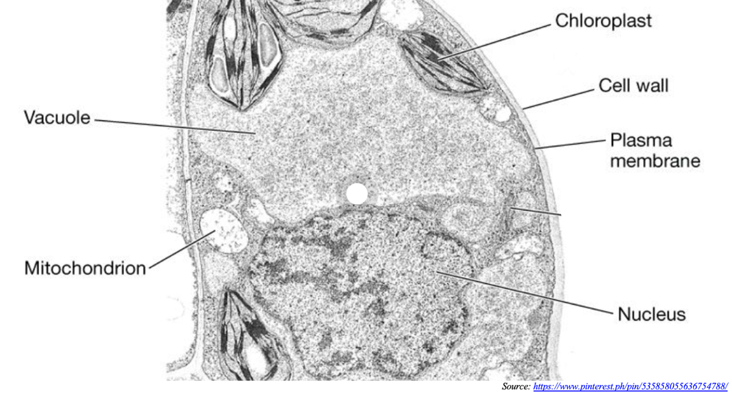

- Marisol thinks that plants use sunlight as a source of energy to power their cells. Daryll thinks that plants must utilize glucose as a source of chemical energy like animals. He observed that plant cells also have mitochondria (singular: mitochondrion) while examining plant cells under a microscope in class.
Which claim seems more accurate to you? Support your ideas with evidence and reasoning.
Hint: What is the purpose of the mitochondria? What occurs during cellular respiration?

Complete: + ✓ - Accurate: + ✓ - Precise: + ✓ - Overall: 3 2 1

- Marisol and Daryll are also trying to figure out how trees can grow so tall. Daryll thinks that plants must have some kind of skeleton like an animal. Marisol thinks that the cell walls of plants serve some kind of structural role.
Which claim seems more accurate to you? Support your ideas with evidence and reasoning.
Hint: What is the purpose of the cell wall? What is cellulose and what does it do for a plant?

Complete: + ✓ - Accurate: + ✓ - Precise: + ✓ - Overall: 3 2 1

- Marisol and Daryll are also trying to figure out how plant cells gain mass (atoms). Daryll insists that plants can create atoms from sunlight (or other forms of light energy) during photosynthesis.
Marisol argues plants seem to have a nucleus containing DNA. She remembers that DNA is the ‘instructions’ for assembling proteins; she reasons that plants must also assemble amino acids into proteins through biosynthesis just like animals.
Which claim seems more accurate to you? Support your ideas with evidence and reasoning.
Hint: How does biosynthesis of proteins and fats affect cell growth and division (mitosis)?

Complete: + ✓ - Accurate: + ✓ - Precise: + ✓ - Overall: 3 2 1

An image of a cross section of a plant stem is shown below. Use this to answer the question below.
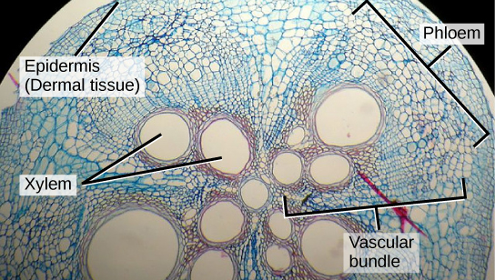

- Marisol and Daryll are also trying to figure out whether trees have “blood” like animals do.
Marisol thinks that plants are just a bunch of cells without any kind of circulatory system. She argues that trees don’t have hearts so they can’t have blood.
Daryll disagrees; he remembers when his family got sap from their home’s maple trees and argues this is maybe the same as their “blood”. He isn’t sure if this is accurate or not.
Which claim seems more accurate to you? Support your ideas with evidence and reasoning.
Hint: What is the purpose of the xylem and phloem? What is a vasculature system and what does it do for a plant?

Complete: + ✓ - Accurate: + ✓ - Precise: + ✓ - Overall: 3 2 1

Plants - Week 1 Investigation Mastery Check
Name: Hour Date: Score: /10

Data from a classroom experiment is shown below. Use this data to answer the questions below.

Group name | Number of days for growth | Initial mass of seeds (g) | Initial mass of soil (g) | Final dry mass of plants (g) | Final dry mass of soil (g) | Change in plant mass (g) | Change in soil mass (g)
A | 33 | 0.05 | 39.39 | 1.79 | 39.19 | 1.74 | -0.20
B | 33 | 0.03 | 44.51 | 1.13 | 45.46 | 1.10 | 0.95
C | 33 | 0.07 | 33.63 | 1.15 | 32.90 | 1.08 | -0.73
D | 33 | 0.05 | 32.78 | 1.23 | 32.63 | 1.18 | -0.15
E | 33 | 0.06 | 32.51 | 1.18 | 32.36 | 1.12 | -0.15
F | 33 | 0.06 | 33.14 | 1.64 | 32.60 | 1.58 | -0.54
AVERAGE | 33 | 0.05 | 35.99 | 1.35 | 35.86 | 1.30 | -0.14

- Which of the following conclusions is best supported by this data?
The amount of mass gained by the plant seedlings…
  - …is roughly the same as the amount of mass lost from the soil.
  - …is greater than the amount of mass lost from the soil.
  - …is less than the amount of mass lost from the soil.
- Which of the following would be reasonable explanations for the outcome of this experiment?
Most of the mass (atoms) gained by the plant…
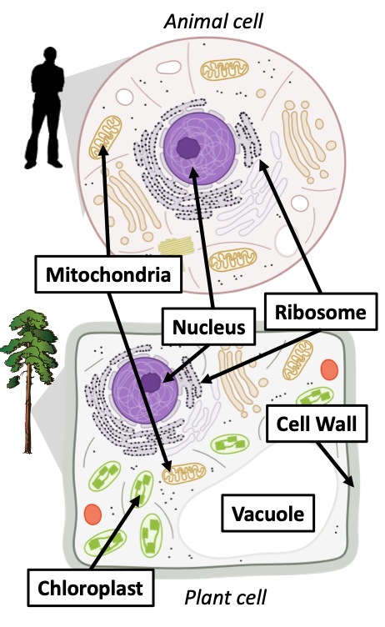
  - …came from the soil.
  - …was produced by the plants’ cells as they divided.
  - …was transformed from sunlight.
  - …none of the above can be accurate.
Remember – in biology, atoms cannot be created or destroyed! Energy cannot be turned into atoms.
Consult the image to the right as you answer the following questions.
- True or false: both animal cells and plant cells are eukaryotic
(eukaryotic means their cells contain organelles).
- True or false: plant cells have mitochondria that perform cellular respiration.
- True or false: plant cells can rearrange glucose and oxygen to produce CO₂ and H₂O.
- True or false: plant cells have a nucleus containing DNA.
- True or false: plant cells have ribosomes where biosynthesis can occur.
- What are 3 organelles found in plant cells but not animal cells?

