Plants Unit – Week 2
Name: Hour Date:
Date Packet is due: Why late? Score:
^{Day of Week Date} If your project was late, describe why
Driving Question: How do plants get their food?
Semester Schedule
Matter & Energy
Week 1: What happens when something burns?
Week 2: What happens to molecules during burning?
Week 3: Unit Assessment
Animals
Week 1: What are animal cells and food made from?
Week 2: What happens to food when it is consumed?
Week 3: What happens inside animal cells?
Week 4: Unit Assessment

Plants
Week 1: What are plant cells made from?
Week 2: How do plants get their food?
Week 3: What happens inside plant cells?
Week 4: Unit Assessment

Ecosystems
Week 1: How do living organisms affect each other?
Week 2: Tracing Matter
Week 3: Global Biodiversity
Week 4: Humans & Biodiversity

Anchoring Phenomenon: This week we are investigating how plants get their food, and how this enables plants and plant cells to grow and function.

Deeper Questions
- What do plants eat?
- How do plant cells get their energy?
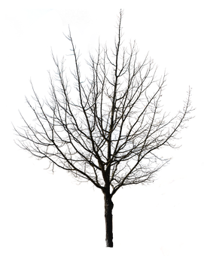
- How do plant cells gain mass (atoms)?

Weekly Schedule

Part 1: Introduction
- Initial Ideas
- Data Dive – van Helmont’s Tree
- Discussion & Developing Explanations

Part 2: Core Ideas
- Core Ideas – Photosynthesis
- Revisions of Part 1 Explanations

Part 3: Investigation
- Part 3: Light & Dark Plant Observations

Part 4: Review & Assessment
- Critiquing Ideas
- Assessment

Part 5: Life Connections
- Weekly Recap
- Life Connections
NGSS Standards:
HS-LS1-2. Develop and use a model to illustrate the hierarchical organization of interacting systems that provide specific functions within multicellular organisms.
HS-LS1-6. Construct and revise an explanation based on evidence for how carbon, hydrogen, and oxygen from sugar molecules may combine with other elements to form amino acids and/or other large carbon-based molecules.
HS-LS1-5. Use a model to illustrate how photosynthesis transforms light energy into stored chemical energy.
HS-LS1-7. Use a model to illustrate that cellular respiration is a chemical process whereby the bonds of food molecules and oxygen molecules are broken and the bonds in new compounds are formed resulting in a net transfer of energy.

Part 1: Introduction – van Helmont’s Tree
Directions: Begin by reading the scenario and analyze the data provided below. Use this information to answer the questions on the following page. Your instructor will decide if you should record your answers using the space provided in this packet, a dry erase board, a digital document, etc.

Introduction: Jean Baptista van Helmont (1577-1644) performed an experiment to determine the source of a tree’s mass (atoms): “I took an earthen pot and in it placed 200 pounds of earth which had been dried out in an oven. This I moistened with rain water, and in it planted a shoot of willow which weighed five pounds. When five years had passed the tree which grew from it weighed 169 pounds and about three ounces. The earthen pot was wetted whenever it was necessary with rain or distilled water only. It was very large, and was sunk in the ground, and had a tin plated iron lid with many holes punched in it, which covered the edge of the pot to keep air-borne dust from mixing with the earth. I did not keep track of the weight of the leaves which fell in each of the four autumns. Finally, I dried out the earth in the pot once more, and found the same 200 pounds, less about 2 ounces.”

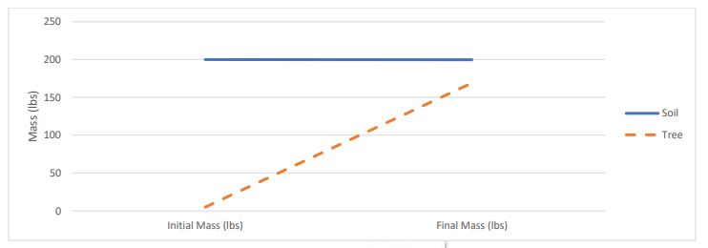
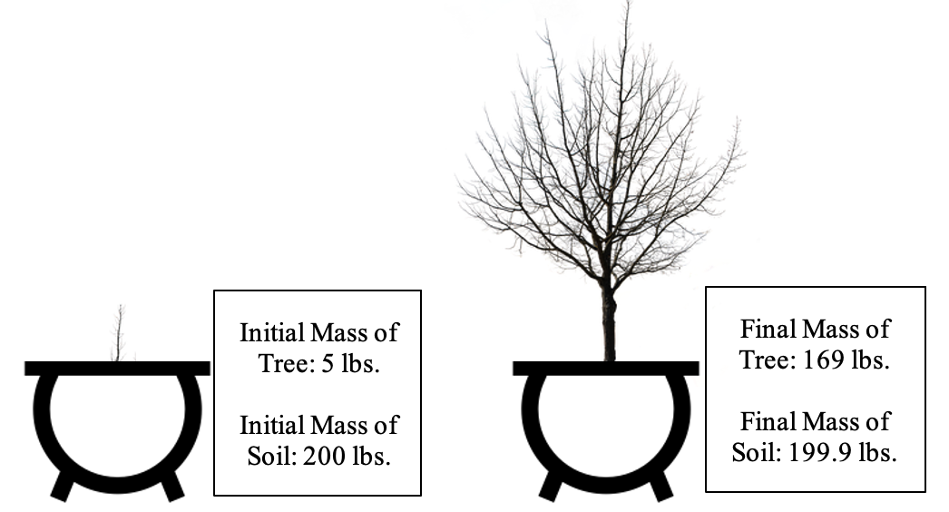
- How did the change in mass over the five-year period differ between the tree and the soil? Be prepared to answer individually, in small groups, and as a class.
- Three students shared their ideas. Do you agree or disagree with each student’s claim?
  - Avery: “Trees absorb most of its mass from soil minerals through its roots.” Agree/ Disagree
  - Bristol: “Trees are mostly acquire mass from water and from gases in the air.” Agree/ Disagree
  - Chandra: “Seeds create more atoms from sunlight through photosynthesis.” Agree/ Disagree
- Does the data from van Helmont’s experiment (see previous page) disprove any of these student’s ideas? Explain how:
- From where do you think a tree acquires most of its mass? Summarize your ideas:
- How do plants acquire the fats and proteins needed for their cells? Summarize your ideas:
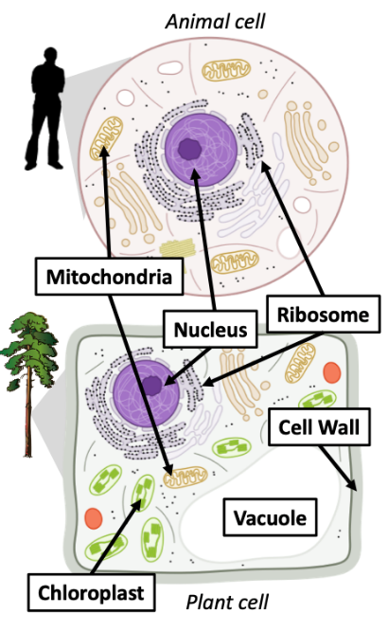
- A plant cell is compared with an animal cell in the space below. In the space below, identify the processes that occurs in the mitochondria, ribosome, and chloroplast. Then summarize how this process enables the cell to function. Some blanks have been completed for you.
Organelle: Process: Cellular Respiration
Function:
Organelle: Ribosome Process:
Function:
Organelle: Process:
Function: Produces glucose & O₂ from CO₂ & H₂O
Be prepared to discuss your ideas with other groups and/or as a class.

Part 2: Core Ideas
Overview: In this activity, you will begin with a short slideshow presentation. This will provide you with core ideas that will help you clarify your initial ideas. Your instructor will decide on how to implement this portion depending on your previous experience and capabilities with this content.
You will then work in small teams to answer the questions listed below. You should take notes in a notebook, on a dry erase board, or on scratch paper so that you are prepared to deliver your responses during the class discussion that will follow. Note: your instructor may assign specific questions to your group if time is limited.

Core Ideas Presentation: https://bit.ly/WUHS-Bio-PlantsW2

Driving Questions:
- What is photosynthesis? What molecules go into photosynthesis and what molecules are produced?
- How is energy transformed during photosynthesis?
- What are three potential purposes for the glucose that is produced during photosynthesis?
- Summarize photosynthesis in four steps.
- How is photosynthesis like “reverse combustion”?
- How does photosynthesis relate to cellular respiration?
- How does photosynthesis relate to biosynthesis?
- Animals use the food they eat to acquire the fat and protein needed for biosynthesis in their cells. How do plants acquire the fat and protein they need if they don’t “eat” like animals do?
- If most of the mass of a plant comes from CO₂ and H₂O, how do plants use minerals from the soil and/or from fertilizers?
- Revising Explanations: Return to your original explanation that you created at the end of Part 1. Based on this new information, how would you now respond to this question?
I think that the mass of plants comes from …
How do plants acquire the fats and proteins needed for their cells? Summarize your ideas:

Part 3A: Investigation – Light & Dark Plant Observations
Adapted from Carbon TIME. Used with permission.
Overview: In this activity, you will compare changes in BTB from plants that are kept in the light compared to those that are kept in the dark.

Directions: Review the pre-investigation questions below with your group. When your group is ready to provide responses, raise your hand. Your instructor will ask you to provide explanations for some questions before starting the investigation. They will sign off when you’re ready (Note: your instructor may ask you to record your answers to questions using a different format, such as a whiteboard or online document).

Pre-Investigation Questions:
- What is photosynthesis? What molecules go into photosynthesis and what molecules are produced?
- How is energy transformed during photosynthesis?
- What are three potential purposes for the glucose that is produced during photosynthesis?
- Summarize photosynthesis in four steps.
When you think you are ready, raise your hand. Your instructor will listen to your verbal responses.
This activity was successfully completed (instructor signature)

- Revising Explanations:
I think that the mass of plants comes from …
How do plants acquire the fats and proteins needed for their cells? Summarize your ideas:
Remember the following “rules” for energy and matter:
- All solids, liquids, and gases are made of tiny particles called atoms. Multiple atoms can bond together to form molecules (e.g., water molecules consist of 1 oxygen atom & 2 hydrogen atoms).
- In biology, atoms last forever. Atoms cannot be created or destroyed or turned into energy (e.g., a carbon atom is always a carbon atom). Atoms can be rearranged to form new molecules.
- In biology, energy lasts forever. Energy cannot be created or destroyed. Energy can exist as light, heat, motion, or as chemical energy. Energy can be transformed (e.g., light can transform into heat).

- In this experiment, you will place some plants in a in a well-lighted place and some in a darkened location (e.g., a box or closet). These plants will be inside sealed containers with blue and yellow BTB. How do you think the BTB will change based on where plants are placed? Remember – if BTB turns blue, it means that the amount of CO₂ in the air decreased. If BTB turns yellow, it means that the amount of CO₂ in the air increased.
- Predicted changes in color of the blue BTB in the lighted plants bag:
- Predicted changes in color of the yellow BTB in the lighted plants bag:
- Predicted changes in color of the blue BTB in the darkened plants bag:
- Predicted changes in color of the yellow BTB in the darkened plants bag:
- Explain your predictions for the lighted plants. Why do you think the BTB will change in this way?

- Explain your predictions for the dark plants. Why do you think the BTB will change in this way?

Investigation Directions (Your instructor may have completed some of these steps earlier):
☐ Fill small foil tins (like those used for baking small loaves of bread) halfway with potting soil. Lightly pat the soil down. Each group may have your own container, or your whole class may share containers depending on the resources available.
☐ Add a dozen or so radish seeds and cover with a small amount of soil so that all seeds are no longer visible.
☐ Pat the soil lightly again and gently water each foil tin until the soil and seeds are fully moist (but not soaked).
☐ Place the tin of seeds inside of a large clear sealable bag (such as a ½ gallon or gallon sized Ziplock bag). Place the tin with moist soil and seeds in a warm, well-lit location. Provide at least two weeks for germination. Monitor the plants to make sure they have adequate moisture, light, and warmth.
☐ On the day of the experiment, add two cups or petri dishes with BTB. One cup should have yellow BTB. The second should have blue BTB.
☐ Close the containers, putting half of them in a well-lighted place and half of them in a dark box or closet.
☐ Come back the next day to observe changes in the color of the BTB.

Group Data:
Lighted Plants
- Date BTB was added to the lighted plant bags: Date removed:
^{Month/Day} ^{Month/Day}
- Changes in color of the blue BTB in the lighted plants bag:
- Changes in color of the yellow BTB in the lighted plants bag:
Darkened Plants
- Date BTB was added to the darkened plant bags: Date removed:
^{Month/Day} ^{Month/Day}
- Changes in color of the blue BTB in the darkened plants bag:
- Changes in color of the yellow BTB in the darkened plants bag:
Whole-Class Data:
Make notes about how the observations and measurements of other groups compared to yours. Describe patterns in your class data.
1. Changes in color of the BTB for plants in the light:
2. Changes in color of the BTB for plants in the dark:
Post-Investigation Questions:
- How did your investigation results compare to your predictions? Were your predictions accurate or inaccurate? Explain.

- Why did the BTB change the way that it did for the plants in the light? What occurred at the cellular level? How did this affect changes at the atomic-molecular level?
Cellular:
Molecular:
Cellular = changes in rates of processes like cellular respiration & photosynthesis. Molecular = changes in movement of atoms and transformation of energy.
- Why did the BTB change the way that it did for the plants in the dark? What occurred at the cellular level? How did this affect changes at the atomic-molecular level?
Cellular:
Molecular:
Cellular = changes in rates of processes like cellular respiration & photosynthesis. Molecular = changes in movement of atoms and transformation of energy.

Part 3B: Investigation – Molecular Modeling
1) Create CO₂ and H₂O using the instructions below.
- To create six molecules of carbon dioxide (CO₂):
  - Connect two oxygen atoms to a carbon atom.
  - Create six CO₂ molecules.
  - Note: oxygen atoms should be connected to carbon with two toothpicks each.
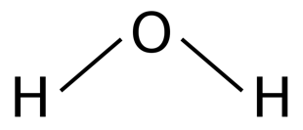
- To create six molecules of water (H₂O)
  - Connect an oxygen atom to two hydrogen atoms.
  - Create six water molecules.
3) Based on the core ideas from this week, explain how each of these molecules relates to how plants gain mass. When you think you are finished, raise your hand and show your instructor.
This activity was successfully completed (instructor signature)

2) Disassemble your CO₂ and H₂O molecules. Using the same Play-doh atoms, create O₂ and glucose using the instructions below. Be sure to mark any high energy bonds. Where did this energy come from?
- To create six molecules of oxygen (O₂)
  - 12 balls of the same color to represent oxygen atoms.
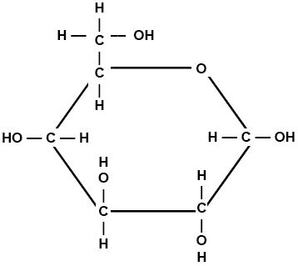
  - Use toothpicks to represent chemical bonds.
Note: O₂ gas has a double-bond, so oxygen atoms should be connected with two toothpicks.
- To create one sugar molecule (C₆H₁₂O₆)
  - Using the same color as you used previously for oxygen, create six balls of that color for the 6 oxygen molecules
  - Using a different color, create six balls for the 6 carbon atoms
  - Using a third color, create 12 balls for the 12 hydrogen atoms
  - Use the image at the right to assemble your glucose molecule using toothpicks to represent chemical bonds.
  - Mark any high energy bonds (C-C and C-H) with a twist tie, piece of tape, string, or other physical marker.
  - Note: every atom should be connected to another atom using a toothpick (including the –OH atoms).
When you think you are finished, raise your hand and show your instructor.
This activity was successfully completed (instructor signature)

Part 4: Review & Assessment
Overview: For each objective, rank it as a 1 (completely unsure), 2 (somewhat unsure), or 3 (completely sure) based on your comfort with that objective. Then work in teams to review each item and prepare a response. You will conclude by completing a formative assessment.

Driving Questions
- What is photosynthesis? What molecules go into photosynthesis and what molecules are produced?
- How is energy transformed during photosynthesis?
- What are three potential purposes for the glucose that is produced during photosynthesis?
- Summarize photosynthesis in four steps.
- How is photosynthesis like “reverse combustion”?
- How does photosynthesis relate to cellular respiration?
- How does photosynthesis relate to biosynthesis?
- Animals use the food they eat to acquire the fat and protein needed for biosynthesis in their cells. How do plants acquire the fat and protein they need if they don’t “eat” like animals do?
- If most of the mass of a plant comes from CO₂ and H₂O, how do plants use minerals from the soil and/or from fertilizers?
- Revising Explanations: Return to your original explanation that you created at the end of Part 1. Based on this new information, how would you now respond to this question?
I think that the mass of plants comes from …
How do plants acquire the fats and proteins needed for their cells? Summarize your ideas:

Part 5: Life Connections
Overview: For this activity, you will begin with a recap of the things that you learned in this packet. You will then take part in one of two activities. If possible, you will interview a local professional whose work involves the ideas we discussed this week. If this is not possible you will take part in a separate activity. If time is limited, your instructor may decide to postpone some of these options.
Weekly Recap (use a whiteboard, scratch paper, online document, etc.)
- Summarize everything that you have learned through this packet within your group. Try to identify the common themes, major ideas, and most important concepts from the content you have learned.
- Is there anything that anyone still doesn’t completely understand? Is there anything that anyone maybe disputes or disagrees with? Did anything seem particularly surprising or noteworthy?
- What you think are the most important ideas and concepts that you have learned so far. Aim to have at least 5 or 6 ideas written down. It is ok to have more than this.
Option A: Interview an Expert: In this activity, you will have an opportunity to interview an individual with professional expertise in this week’s content topics. This activity will be reflective of social science research, or gathering, analyzing and interpreting information about human interactions. Often this work is conducted using qualitative interviews, which are interviews designed for research and data collection.
This activity will be divided into three parts:
- Part 1 – Planning: After your instructor describes today’s guest speaker, your group will identify your research question, which should pertain to the topics covered in class this week. Your instructor may ask your group to share your research question and interview questions prior to the interview and make sure that a variety of questions are ready.
- Part 2 – Interview: Your instructor will facilitate the interview. Your group should record fields notes during this time that you will use at the end of the hour to address your research question.
- Part 3 – Analysis & Debrief: You will be provided with some time to consider the responses that they receive and reach a tentative conclusion about their research question based on this data.
Part 1 - Planning:
- Briefly summarize the topics that were covered in class this week in one sentence: This week in class,
we studied
- As a group, discuss what questions you still have about this week’s topics. Ideally, use some of the following to start your questions: Who, What, When, Where, Why, How
1.
2.
3.
Once you have developed three questions, ask for your instructor to provide you with some feedback.
- From this list, choose a research question for your group and complete the prompt below:
Research Question: We are unsure
- Turn your research question into a hypothesis. What do you think is the answer to your research question given what you currently know?
We hypothesize that
- Create three interview questions that you could ask this individual that may provide information related to your research question. Try to focus on their particular area of expertise as you craft your questions.
1.
2.
3.
- Be prepared to briefly describe your research question and hypothesis, and how your interview questions will provide you with information that will help to address your research question.
Part 2 – Interview Field Notes
Use the space below to record some field notes as the guest speaker presents to the class. Record anything that you hear or observe that might be relevant to your research question. Note: you should also consider recording the guest speaker’s responses to other group’s questions if they are relevant to your own research question.

Part 3 – Analysis & Debrief (your instructor may choose to use oral responses as well as or instead of written)
What are your conclusions based on the guest speaker’s responses? Answer the questions below.

- Does your data (your observations and field notes from this interview) support or refute your hypothesis? Circle one: Supports it / Refutes it / Not sure
Explain:
- If you were to continue this work, what kinds of investigations would you do next? Describe a potential research experiment that would be a suitable follow-up for today.

Option B: Life Connections: In this activity, students will break into teams based on their personal interests and/or career aspirations. They will then work in their assigned teams to address the questions below. After a sufficient amount of time, students will summarize their discussions for the class.

- As a group, try to determine how these ideas relate decisions you will make in your future life. Specifically…
  - How do these concepts relate to prior knowledge experiences from your life?
  - How could your prior knowledge and experience help you to better understand these concepts?
  - How might your daily activities in your life be affected by these concepts?
  - How might the decisions you make as part of your career be influenced by these ideas?
- As you listen to the ideas presented by other groups, listen for any ideas you might have missed that might be relevant to your life.

Plants Unit, Week 2 Assessment
Name: Hour Date: Score: /
Directions: A 3x5 notecard with handwritten notes can be used to guide your answers.

1. A class is investigating how plants grow. The teacher asks the students, “Where does most of the mass of a plant come from?” Three students shared their ideas about what happened. Do you agree or disagree with each student’s claim?
Mike: "I think a growing plant gains most of its mass from nutrients in the soil." Agree / Disagree
Lucia: "I think a plant gains most of its mass from gases in the air." Agree / Disagree
Oscar: “I think a plant gains most of its mass from the sunlight.” Agree / Disagree

2. Provide an explanation. Why did you agree or disagree with each student’s claim?
Mike:
Lucia:
Oscar:

The class does an experiment to investigate how plants grow. They started by selecting six identical plants. Three of those plants (1-3) were grown in regular soil. The other three plants (4-6) had extra soil nutrients added to the soil in their pots. The class put all six plants under identical conditions (i.e., the same light conditions, the same watering conditions) and let them grow for one month. At the end of the month, the class weighed each of the six plants and recorded their weights in the table below. They also recorded the weight of the soil nutrients added to three of the pots.
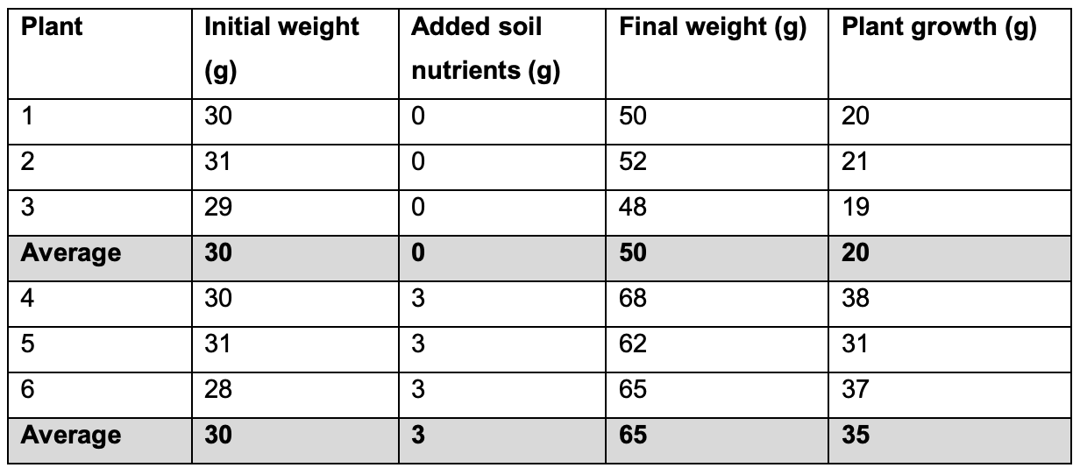

3. For plants 4-6, the students added 3 g of nutrients to the soil but the plants gained ______ g of mass.
a. 20 b. 35 c. 65 Hint: subtract the initial weight from the final weight.
4. Which claim do you think is best supported by the data?
a. Mike’s claim b. Lucia’s claim c. Oscar’s claim
5. Provide an explanation. How does this data support the claim that you chose?

6. A plant cell is shown below. Show how each of the four molecules are absorbed or produced during photosynthesis and cellular respiration using 8 arrows. Two arrows have been provided as an example.
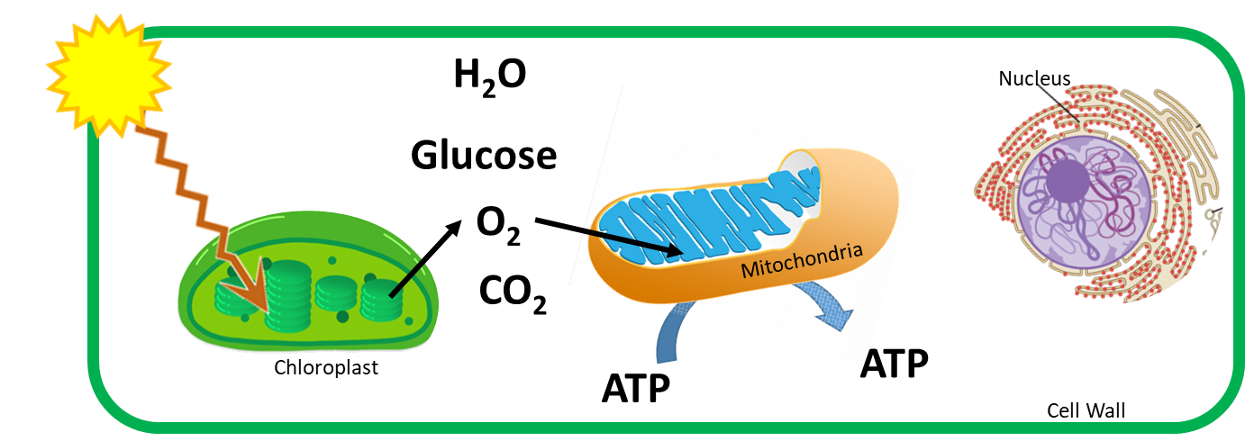
Each molecule should have an arrow pointing towards or away from both the chloroplast and the mitochondria.
Data from a classroom experiment is shown below. Use this data to answer the questions below.
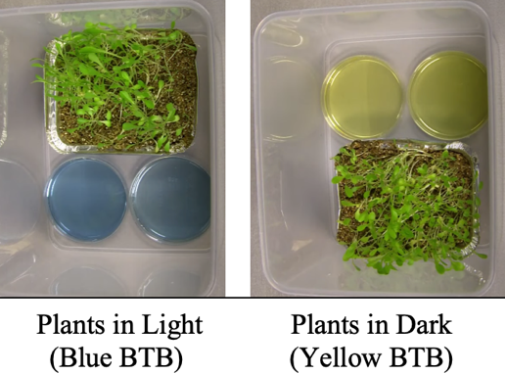
 | Blue BTB | Yellow BTB
Plants in Light | Stayed Blue | Turned Blue
Plants in Dark | Turned Yellow | Stayed Yellow
BTB Color Change | Yellow = Increased CO₂ | Blue =  Decreased CO₂

7. Which of the following conclusions is best supported by this data?
When plants are in the dark…
a. …carbon dioxide moves into plant leaf cells and oxygen moves out.
b. …oxygen moves into plant leaf cells and carbon dioxide moves out.
c. …the leaf cells go dormant, so no gases move into or out of plant leaf cells.
d. …equal amounts of carbon dioxide and oxygen move both in and out of plant leaf cells.
8. Why would plants in the light produce different amounts of CO₂ compared to plants in the dark? What causes carbon dioxide or oxygen to move in or out of plant leaf cells in the dark? In your response, include the following: photosynthesis; chloroplast; cellular respiration; mitochondria. Underline each word when used.

Plants - Week 2 Investigation Mastery Check
Name: Hour Date: Score: /8

Data from a classroom experiment is shown below. Use this data to answer the questions below.
 | Blue BTB | Yellow BTB
Plants in Light | Stayed Blue | Turned Blue
Plants in Dark | Turned Yellow | Stayed Yellow
BTB Color Change | Yellow = Increased CO2 | Blue =  Decreased CO2

- Which of the following conclusions is best supported by this data?
The plants in the light conditions __________ compared to the plants in the dark conditions.
  - …produced more CO₂ …
  - …produced less CO₂ …
  - …produced a similar amount of CO₂ …
- Which of the following would be reasonable explanations for the outcome of this experiment?
  - Plants cannot produce CO₂ because they are not animals. They can only produce O₂.
  - Plants only produce CO₂ if they cannot photosynthesize. Otherwise they only produce O₂.
  - Both photosynthesis and cell respiration occur in the light, but only cell respiration can occur in the dark.
  - If plants are in the dark, worms and bugs will respire and make H₂O and CO₂.
Each molecule should have an arrow pointing towards or away from both the chloroplast and the mitochondria.

- Show how each of the four molecules are absorbed or produced during both photosynthesis and cellular respiration using 8 arrows. (Two arrows have been provided; 1 pt for photosynthesis; 1 pt for cell respiration).
- Glucose provides the chemical energy needed to recharge ATP. Where did the chemical energy in glucose come from? a. The atoms in glucose b. Oxygen (O₂) c. Light energy d. All of the above
- The cell wall of the plant cell is made from cellulose and comprises most of the mass of a plant. Cellulose is made from chains of… a. Fatty acids b. Amino Acids c. Glucose d. ATP
- If photosynthesis could not occur, glucose and O₂ levels in the cell would ________ and CO₂ and H₂O levels in the cell would __________.
  - Increase; Decrease b. Decrease; Increase c. Stay the same; Increase d. Decrease; Stay the same
- Which of the following would reduce the rate of photosynthesis?
  - Lack of light b. Reduced CO₂ levels c. Reduced water levels d. All of the above
This page is intentionally left blank. Use as needed for notes or other purposes.

