Plants Unit – Week 3
Name: Hour Date:
Date Packet is due: Why late? Score:
^{Day of Week Date} If your project was late, describe why
Driving Question: What happens inside plant cells?
Semester Schedule
Matter & Energy
Week 1: What happens when something burns?
Week 2: What happens to molecules during burning?
Week 3: Unit Assessment
Animals
Week 1: What are animal cells and food made from?
Week 2: What happens to food when it is consumed?
Week 3: What happens inside animal cells?
Week 4: Unit Assessment

Plants
Week 1: What are plant cells made from?
Week 2: How do plants get their food?
Week 3: What happens inside plant cells?
Week 4: Unit Assessment

Ecosystems
Week 1: How do living organisms affect each other?
Week 2: Tracing Matter
Week 3: Global Biodiversity
Week 4: Humans & Biodiversity

Anchoring Phenomenon: This week we are investigating how plants produce the amino acids, fatty acids and other molecules needed to create all molecules and macromolecules inside their cells.

Deeper Questions
- How do plants acquire fat and protein?
- How do plants perform biosynthesis?
- What are enzymes and how do they enable cells to function?

Weekly Schedule

Part 1: Introduction
- Initial Ideas
- Data Dive – Peanut vs. Spinach Nutrition
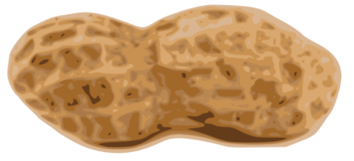
- Discussion & Developing Explanations

Part 2: Core Ideas
- Core Ideas – Plant Biosynthesis
- Revisions of Part 1 Explanations

Part 3: Investigation
- Part 3: Pigment Chromatography

Part 4: Review & Assessment
- Critiquing Ideas
- Assessment

Part 5: Life Connections
- Life Connections – School Bus Footprints
NGSS Standards:
HS-LS1-2. Develop and use a model to illustrate the hierarchical organization of interacting systems that provide specific functions within multicellular organisms.
HS-LS1-6. Construct and revise an explanation based on evidence for how carbon, hydrogen, and oxygen from sugar molecules may combine with other elements to form amino acids and/or other large carbon-based molecules.
HS-LS1-5. Use a model to illustrate how photosynthesis transforms light energy into stored chemical energy.
HS-LS1-7. Use a model to illustrate that cellular respiration is a chemical process whereby the bonds of food molecules and oxygen molecules are broken and the bonds in new compounds are formed resulting in a net transfer of energy.

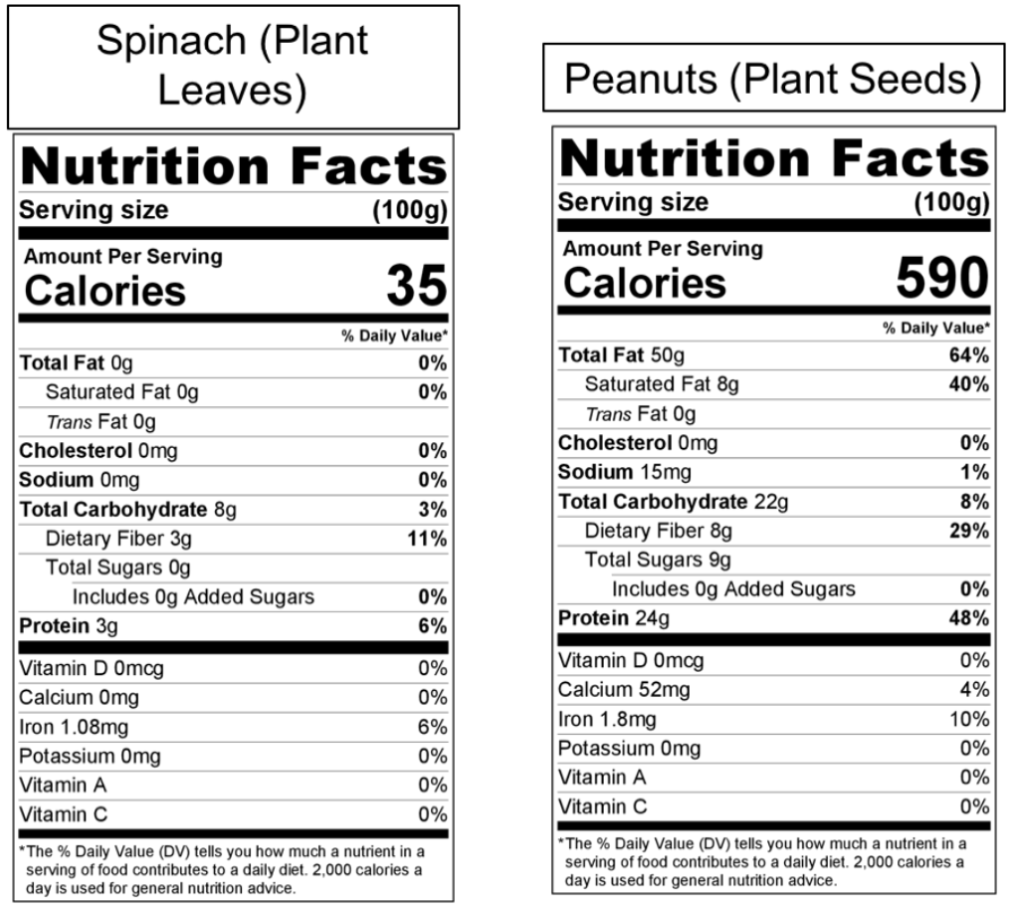
Part 1: Peanut vs. Spinach Nutrition
Directions: Use the data in the nutrition label to answer the questions below. Your instructor will decide if you should record your answers using the space provided in this packet, a dry erase board, a digital document, etc.

Introduction: Food labels can tell us a lot about the molecules in the cells of the organisms that they come from—especially large organic molecules. Be prepared to answer the following questions individually, in small groups, and as a class.
- How does the carbohydrate, protein, and fat content of spinach leaves compare to peanuts?
- How do you think peanuts acquire or produce such a concentrated supply of fat and protein?
- Three students shared their ideas. Do you agree or disagree with each student’s claim?
  - Avery: “Everything inside of plant cells is made from glucose (or chains of glucose). Only animals are capable of making fat and protein.” Agree/ Disagree
  - Bristol: “Plant cells contain fat and protein, which they absorb from animals and other organisms when they decompose in the soil.” Agree/ Disagree
  - Chandra: “Plants are able to rearrange atoms in glucose and combine these atoms with soil minerals to make the amino acids they need to make protein.” Agree/ Disagree
- Which claim seems most accurate? Why?
- How do plants acquire the fats and proteins needed for their cells? Summarize your ideas:
Be prepared to discuss your ideas with other groups and/or as a class.

Part 2: Core Ideas
Overview: In this activity, you will begin with a short slideshow presentation. This will provide you with core ideas that will help you clarify your initial ideas. Your instructor will decide on how to implement this portion depending on your previous experience and capabilities with this content.
You will then work in small teams to answer the questions listed below. You should take notes in a notebook, on a dry erase board, or on scratch paper so that you are prepared to deliver your responses during the class discussion that will follow. Note: your instructor may assign specific questions to your group if time is limited.

Core Ideas Presentation: https://bit.ly/3COOaPE

Driving Questions:
- How does glucose relate to all other molecules found inside a plant cell?
- Where does biosynthesis in plant cells begin?
- Where does a plant cell acquire the atoms needed to produce molecules such as fatty acids and amino acids?
- What are enzymes? How do enzymes increase the rate at which cells can form new molecules?
- True or False: enzymes increase the rate at which cells produce new molecules by providing atoms needed to assemble those molecules. Explain.
- What is the difference between monomers and polymers? How do these terms relate to the function of some enzymes?
- True or false: most macromolecules are polymers. Explain.
- How can enzymes combine short monomers to form one long polymer?
- How can enzymes break apart a long polymer into multiple short monomers?
- How does the enzyme Rubisco enable photosynthesis to occur?
- How do enzymes like starch synthase and fatty acid synthase change molecules?
- How does the enzyme amylase change molecules?
- How do enzymes enable animals to change the molecules in plants so that they can become a part of their own body?
- What is a decomposer? How do plants (and other species) depend on decomposers?
- Revising Explanations: Return to your original explanation that you created at the end of Part 1. Based on this new information, how would you now respond to this question?
How do plants acquire the fats and proteins needed for their cells? Summarize your ideas:

Part 3: Investigation – Pigment Chromatography
Adapted from materials developed by Joe Hendricks
Overview: In this investigation, you will separate plant pigments of two kinds of leaves using paper. You will also determine which leaves or which parts of leaves contain the chlorophyll necessary to carry out photosynthesis, and trace how these molecules are created from glucose.

Background: Photosynthesis begins when light is absorbed by molecules called pigments in the chloroplasts of plant cells. Pigments absorb light energy that eventually is transformed into the chemical energy found in the high energy bonds of glucose. Many green leaves contain pigment colors that are not seen until autumn because they are hidden by the green chlorophyll pigment.

One technique for separating and identifying plant pigments is called paper chromatography. In paper chromatography, a solution is absorbed into paper. As it moves further into the paper, it carries dissolved substances (such plant pigments from crushed leaves in this case). The pigments are carried along at different rates because they are attracted to different degrees to the paper.

Materials: fresh spinach leaves; a second kind of leaf; cork stopper; large test tube; bent pin; chromatography paper; colored pencils; test tube rack; chromatography solvent.

Investigation Directions (Your instructor may have completed some of these steps earlier):
- Obtain a large test tube.
- Cut a strip of chromatography paper to just fit inside the test tube. Cut a point at the end of the strip.
- Draw a faint pencil line 2 cm from the pointed end of the filter paper.
- Obtain a fresh spinach leaf and place the leaf over the pencil line on the chromatography paper.
- Roll the edge of a coin over the leaf using your pencil line as a guide so that the pigments of the leaf are driven into the chromatography paper.
- Repeat step 5 until you have a dark green, thin line of pigment. Wait a minute or two between rolls to allow the paper to absorb the pigments.
- Attach the chromatography paper to the cork stopper using a bent pin to hold the paper in place.
- Place the paper and cork stopper in the large test tube and mark the position of the point of the paper on the outside of the test tube with a glass marking pen. Remove the paper and cork stopper.
- Under the fume hood, have your teacher add chromatography solvent to the level you have marked. Carefully place the chromatography paper and cork stopper into the test tube and then place the set up in a test tube rack. The pigment line must be above the solvent at all times!
- Allow the solvent to ascend the paper for 30 minutes. While waiting, complete the Verbal Investigation Questions (next page) and get approval from your instructor.
- When the solvent is near the top of the chromatography paper, remove it and mark how far the solvent moved up the paper (solvent front). Place your paper in the fume hood until the solvent has evaporated. Note the colored bands on your chromatography paper.

- Make a sketch of the bands of color obtained on your chromatogram in the data section. Use colored pencils to indicate the color of pigments and identify each band. Some possible colors and pigments they represent are:
- Carotenes: yellow or orange and usually appear near the top of the paper
- Xanthophylls: yellow, usually appear below the carotenes
- Chlorophyll a: blue-green, usually appear below the xanthophylls
- Chlorophyll b: yellow-green, usually appear below chlorophyll a
- Anthocyanin: purple, red, usually appear below chlorophyll b
  - Note: Your sample may not have all of these pigments.
- Repeat this entire procedure using a different kind of leaf if available.

Verbal Investigation Questions: Review the questions below with your group. When your group is ready to provide responses, raise your hand. Your instructor will ask you to provide explanations for some questions before starting the investigation. They will sign off when you’re ready (Note: your instructor may ask you to record your answers to questions using a different format, such as a whiteboard or online document).
- How does glucose relate to all other molecules found inside a plant cell?
- Where does biosynthesis in plant cells begin?
- Where does a plant cell acquire the atoms needed to produce molecules such as fatty acids and amino acids?
- What are enzymes? How do enzymes increase the rate at which cells can form new molecules?
- What are some ways in which both glucose and enzymes relate to the pigments found inside plant cells?
When you think you are ready, raise your hand. Your instructor will listen to your verbal responses.
This activity was successfully completed (instructor signature)

Data: In the space below, accurately sketch the bands of color observed in your chromatogram. Use appropriate colored pencils or markers to indicate the color of each pigment. Identify each pigment band. Tape your chromatogram below in the space provided.

Post-Investigation Questions:
- Which pigments were you able to identify?
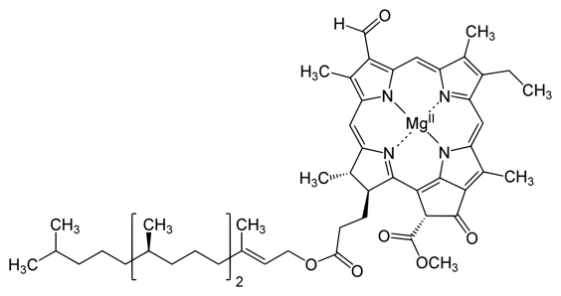
- A chlorophyll molecule can be seen here. Would it be possible for a glucose molecule to provide all of the atoms needed to assemble this molecule? What other atoms would be needed and where would a plant acquire these atoms?

- How did the plant cell produce these pigments? Find and circle chlorophyll and ß carotene. Then use a colored pencil, pen, or marker to trace the pathway back to glucose.
Glucose glucose-6-phosphate fructose-6-phosphate fructose-1,6-diphosphate

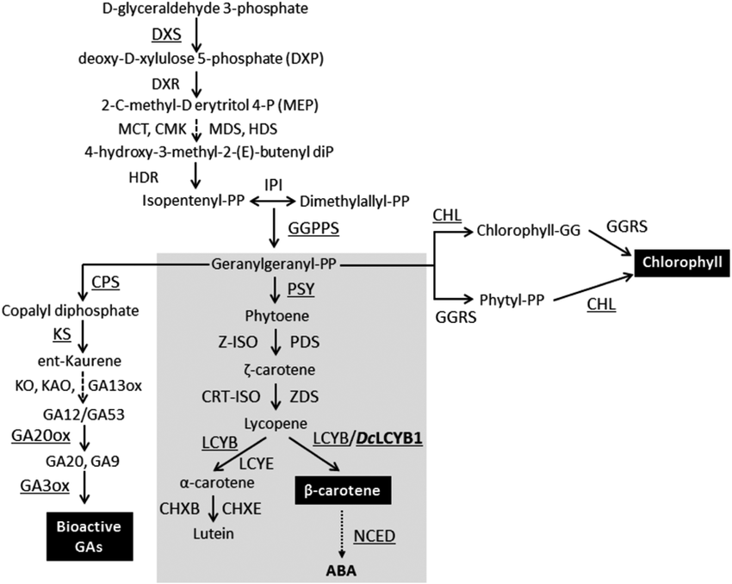

Part 4: Review & Assessment
Overview: For each objective, rank it as a 1 (completely unsure), 2 (somewhat unsure), or 3 (completely sure) based on your comfort with that objective. Then work in teams to review each item and prepare a response. You will conclude by completing a formative assessment.

Driving Questions
- How does glucose relate to all other molecules found inside a plant cell?
- Where does biosynthesis in plant cells begin?
- Where does a plant cell acquire the atoms needed to produce molecules such as fatty acids and amino acids?
- What are enzymes? How do enzymes increase the rate at which cells can form new molecules?
- True or False: enzymes increase the rate at which cells produce new molecules by providing atoms needed to assemble those molecules. Explain.
- What is the difference between monomers and polymers? How do these terms relate to the function of some enzymes?
- True or false: most macromolecules are polymers. Explain.
- How can enzymes combine short monomers to form one long polymer?
- How can enzymes break apart a long polymer into multiple short monomers?
- How does the enzyme Rubisco enable photosynthesis to occur?
- How do enzymes like starch synthase and fatty acid synthase change molecules?
- How does the enzyme amylase change molecules?
- How do enzymes enable animals to change the molecules in plants so that they can become a part of their own body?
- What is a decomposer? How do plants (and other species) depend on decomposers?
- Revising Explanations: Return to your original explanation that you created at the end of Part 1. Based on this new information, how would you now respond to this question?
How do plants acquire the fats and proteins needed for their cells? Summarize your ideas:

Part 5: Life Connections – School Bus Footprints
Adapted from Carbon TIME. Used with permission.
Overview: For this activity, you will determine how much CO₂ is taken out of the atmosphere (or sequestered) into a large tree. You will then compare this with the amount of CO₂ released from our daily activities.

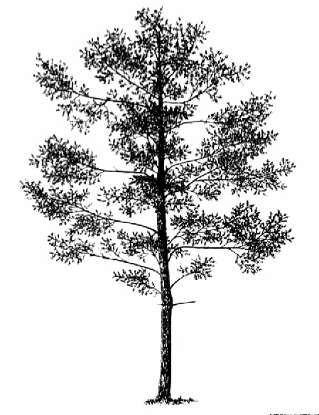
Directions: in this activity, you will be determining how many trees you would have to plant per year to completely offset the CO₂ emissions for an average school bus (i.e., its carbon footprint). To do so, you will choose a tree from your school’s campus (or one nearby) and determine how much CO₂ it absorbs in a given year. You will then use data about the average CO₂ emissions from a school bus to determine how many of these trees it would take to completely absorb this CO₂ by photosynthesis.
Image source: conifers.org

- Determine the diameter (width) of your tree’s canopy: Work with a partner. You will need a ball of string and a meter stick or measuring tape. One person (Partner A) should stand under the edge of the tree’s canopy (the furthest point from the trunk that leaves are found) and hold the ball of string. The other person (Partner B) should unwind the string and walk past the tree trunk to the edge of the canopy directly across from the first person. Mark the edge of the canopy on the string and use a meter stick or measuring tape to measure the diameter of the canopy in meters. It may be easier to measure in centimeters and then divide by 100. *Your instructor may decide to provide the size of the tree for you in advance. This is recommended if another lab is occurring at the same time.
- What is the diameter (width) of your tree’s canopy? meters
- What is the radius of your tree’s canopy? To calculate the radius of the tree’s canopy, divide the diameter in half.
Diameter: ______________ m ÷ 2 = m (Radius of tree’s canopy)
- What is the total area of your tree’s canopy? To calculate the total area of the tree’s canopy, square the radius and multiple it by pi (3.14).
Radius Squared = m² (e.g. if your radius was 2 m, this would be 2 x 2 = 4 m²)
Squared Radius x 3.14 = m² (Total area of the tree’s canopy)
- Next we need to determine how much CO₂ is absorbed by the tree per year. A typical tree will absorb 0.205 kg (0.5 lbs.) of CO₂ per square meter of tree canopy. To determine how much CO₂ that our tree will absorb per year, we have to multiply the total area of the tree’s canopy that we calculated in the previous question by 0.205 kg.

Total Area of the Canopy: x 0.205 kg =
This is the amount of CO₂ sequestered by this particular tree in a given year.↑

- A school bus emits an average of 17,237 kg (38,000 lbs.) of CO₂ per year. How many trees of this size would it take to sequester the average annual emissions of one school bus?
^{Show your work!}
- What happens to the CO₂ that is absorbed by a tree?
- School buses transport roughly 26 million students per year. On average, school buses get an average of 7 miles of transportation for every gallon of diesel fuel. The average privately-owned vehicle gets 20.8 MPG. Would it be better for students to be driven to school (or drive themselves) than for them to take a bus?
Keep in mind that the average school bus transports 36 students. When students are driven to school, the average privately-owned vehicle transports 1.5 students over a 10-mile roundtrip between home and school. This information is summarized in the table below. Which would be more efficient, transporting students by bus or by a privately-owned vehicle?
 | Bus | Car
Average Number of Students Transported | 36 | 1.5
Average Miles Per Gallon by Vehicle | 7 | 20.8
Gal of Fuel Used Per Bus/car Per School Year | 1714.00 | 86.50
Average Gal of Fuel Used Per Student Per Year | 47.6 | 57.7
Data taken from http://www.americanschoolbuscouncil.org/issues/environmental-benefits
It would be more efficient to transport students by

- In 2014, the US emitted a total of 5.4 trillion kg (12 trillion lbs.) of CO₂ from energy production and use. Based on your data, how many trees of this size would be needed each year to offset these emissions?
^{Show your work!}
By now it might seem evident that in most cases we do not have enough open space to plant a sufficient number of trees to absorb all of the CO₂ from student transportation, let alone from the rest of human activity. However, there are other ways in which a person’s carbon footprint can be reduced besides planting trees. The table on the next page has estimations of the extent to which the CO₂ emissions from your lifestyle could be reduced from simple lifestyle changes.
Sustainable Behavioral Choices to Offset School Bus Emissions | Equiv. kg CO_{2 (per year)} | % of Annual  Avg Bus Emissions per Student | % of Avg American's Emissions  _{(per year)}
Biking/Walking to school 1 day a week for a year (average) | -64.0 | 20% | 0.32%
Biking/Walking to school every day for a year (average) | -319.3 | 100% | 1.60%
Using cold water to wash clothes and a low-flow showerhead for a year | -148.3 | 46% | 0.74%
Eliminating beef from your diet for one year | -489.9 | 153% | 2.45%
Eliminating red meat from your diet for one year | -747.1 | 234% | 3.74%
Practicing a "Meatless Monday" diet every week for a year | -111.1 | 35% | 0.56%
Adopting a vegetarian diet (still includes eggs & dairy) for a year | -865.9 | 271% | 4.34%
Reducing portions to USDA-recommended serving sizes of meat, poultry, & eggs | -369.2 | 116% | 1.85%
Avoiding air travel for one year (assuming average US flyer miles) | -89.8 | 28% | 0.45%
Avoiding a transatlantic flight for a given year | -758.9 | 238% | 3.80%
Using a fan instead of an AC window unit (per resident; summer nights only) | -511.7 | 160% | 2.56%
Using a fan instead of central AC (per resident; summer nights only) | -506.2 | 159% | 2.54%
Using a clothesline instead of a dryer for 6 months (per resident) | -106.6 | 33% | 0.53%
Observing posted speed limits for one year (for average driving statistics) | -327.5 | 103% | 1.64%
Choosing a 10% Renewable Energy Utility Option (per resident) | -226.3 | 71% | 1.13%
Switching a home's energy to carbon-neutral energy (per resident) | -2265.5 | 709% | 11.34%
75% reduction of "Standby Power" used by appliances for 1 year (per resident) | -127.5 | 40% | 0.64%
Reducing your daily shower time by 5 minutes | -372.4 | 117% | 1.87%
Switching one 75-watt incandescent bulb for a CFL (bulb's lifetime) | -369.2 | 116% | 1.85%
Only using a hand dryer at school restroom (4x/day, weekdays) | -19.1 | 6% | 0.09%
Switching to LED Christmas lights instead of traditional lights (per resident) | -83.0 | 26% | 0.42%
Choosing no-rush shipping for a year of online purchases (for twenty-1 lb. Packages) | -384.2 | 120% | 1.92%
Setting a thermostat 2 degrees warmer in summer and 2 degrees cooler in winter (per resident) | -348.8 | 109% | 1.75%
Properly insulating a water heater & reducing the max temp < 120 deg. (per resident) | -323.0 | 101% | 1.62%
Limiting daily television time to 2 hours (vs. avg of 6 hours/day) for one year | -53.5 | 17% | 0.27%
A more complete version of this table with sources of information for this data can be found at http://wuhsag.weebly.com/uploads/1/4/0/9/14095127/2017-7-17_co2_equivalents_table.xlsx

- Using the table above, circle or star 6+ activities that you personally could adopt in order to reduce your lifestyle’s CO₂ emissions by 318 kg (700 lbs.) or more. (318 kg of CO₂ is what the average student creates per year when they ride the bus to school and will serve as the baseline for this activity).
Keep in mind that you can only choose activities that could apply to your own lifestyle. For example, if it is unlikely that your family will switch to a source of energy for your home that is completely carbon-neutral within the next year, you cannot choose that item as an option. You can also only choose activities that are not currently a part of your lifestyle (the goal is to reduce your lifestyle by an additional 318 kg). Choose options until you reach 318 kg (700 lbs.) of CO₂ or more.

Plants Unit, Week 3 Assessment
Name: Hour Date: Score: /
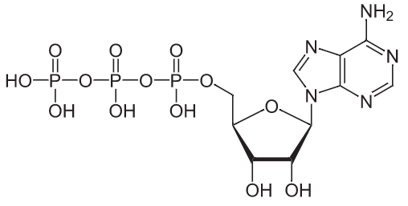

- Three students shared their ideas about the ATP molecule shown here. They are debating where the atoms in this molecule came from. Do you agree or disagree with each student’s claim?
  - Nina: “The plant produces this molecule by absorbing water and carbon dioxide and rearranging the atoms.” Agree / Disagree
  - Oscar: “The carbon, oxygen, and hydrogen atoms came from glucose. The other atoms are minerals absorbed from the soil.” Agree / Disagree
  - Marcos: “The plant uses enzymes to rearrange carbon atoms into the phosphorus and nitrogen atoms needed to make ATP.” Agree / Disagree
- Which claim seems most accurate? Why?
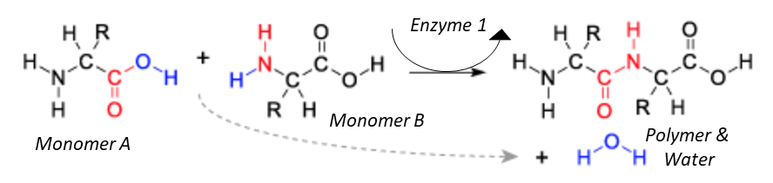
- The image above provides a summary how monomers are assembled into polymers. Briefly summarize how the two molecules going into the reaction (i.e., Monomer A and Monomer B) are changed by the enzyme. Summarize how the enzyme is able to enable these changes to occur.
Hint: Monomer A and Monomer B are both amino acids.
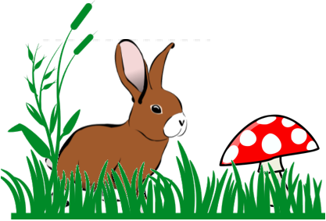
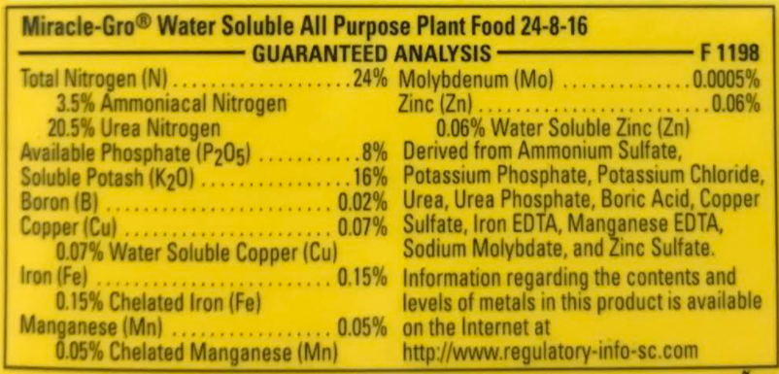
- Farmers and gardeners often apply fertilizers to their crops. Nitrogen and phosphorus are among the most prevalent ingredients in fertilizer. Why are these elements needed for crop production?
Grass (plant), a rabbit (animal), and a mushroom (decomposer) are shown in this image. Use this to respond to the following questions.
- How does the grass produce the carbohydrates, proteins, and fats in order to acquire the matter and energy needed for its cell to function?
- How does the rabbit use macromolecules (or polymers) from the plant to gain the matter and energy needed for its cells to function?
- How does the mushroom acquire macromolecules (or polymers) from the grass and rabbit to gain the matter and energy needed for its cells to function?

Plants - Week 3 Investigation Mastery Check
Name: Hour Date: Score: /10
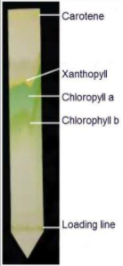
Data from a classroom experiment and an image of chlorophyll a is shown here. Use this data to answer the questions below.

- Where did the carbon atoms (C) come from in this molecule?
1 Source: https://www.slideserve.com/eloise/chromatography-pigment-separation-of-spinach-leaves?scrlybrkr=0ab2c856
  - Water in the soil
  - Gases in the air
  - Minerals in the soil
  - They were produced by the plant from sunlight

- Where did the hydrogen atoms (H) come from in this molecule?
2 Source: https://www.slideserve.com/eloise/chromatography-pigment-separation-of-spinach-leaves?scrlybrkr=0ab2c856
  - Water in the soil
  - Gases in the air
  - Minerals in the soil
  - They were produced by the plant from sunlight
- Where did the nitrogen atoms (N) come from in this molecule?
3 Source: https://www.slideserve.com/eloise/chromatography-pigment-separation-of-spinach-leaves?scrlybrkr=0ab2c856
  - Water in the soil
  - Gases in the air
  - Minerals in the soil
  - They were produced by the plant from sunlight
- Where did the magnesium atoms (Mg) come from in this molecule?
4 Source: https://www.slideserve.com/eloise/chromatography-pigment-separation-of-spinach-leaves?scrlybrkr=0ab2c856
  - Water in the soil
  - Gases in the air
  - Minerals in the soil
  - They were produced by the plant from sunlight
- Which best describes the role of enzymes for producing this molecule?
  - Atoms were removed from enzymes to assemble a chlorophyll molecule.
  - Enzymes were absorbed from the soil and combined with glucose to make chlorophyll.
  - Enzymes changed atoms in glucose into nitrogen and magnesium to create chlorophyll.
  - Enzymes produce chlorophyll by rearranging carbon, oxygen, and hydrogen atoms with soil minerals.
- This image shows the production of a protein through an enzymatic reaction. Which of the following would be synonymous with “Monomer A”?
  - Protein b. Amino Acid c. Enzyme d. None of the above
- Which of the following would be synonymous with “Monomer B”?
  - Protein b. Amino Acid c. Enzyme d. None of the above
- Which of the following would be synonymous with “polymer” in the image above?
  - Protein b. Amino Acid c. Enzyme d. None of the above
- This image shows two monomers combining to form a polymer and water. Where did the water come from?
  - Oxygen and hydrogen atoms that were removed from the monomers.
  - From cellular respiration needed to produce ATP.
  - From atoms in the enzyme.
  - From the heat produced during the reaction.
- Rubisco is an enzyme that rearranges atoms in water and carbon dioxide to produce glucose.
Starch synthase is an enzyme that combines glucose monomers into a starch polymer.
Amylase is an enzyme that breaks down starch polymers into glucose monomers.
What do these enzymes have in common?
  - They produce polymers from monomers.
  - They produce monomers from polymers.
  - They reduce the amount of time and energy needed for a biological reaction to occur.
  - They provide the original source of atoms needed to assemble the fats, proteins, and carbohydrates in the cell.
Remember…
- Glucose is assembled from carbon dioxide and water molecules using light energy. This process is called photosynthesis.
- Atoms in glucose can be rearranged with minerals from the soil to form amino acids, fatty acids, and other plant molecules. Glucose can also be assembled into macromolecules like starch and cellulose.
- Most macromolecules are polymers, or long repeating chains of the same molecule.
- The individual molecules that are assembled to create polymers are called monomers.
- Enzymes are specialized proteins that enable molecular reactions in cells to occur more quickly and easily.
- Enzymes enable new molecules to be formed but are not part of the molecules that are produced during a reaction.
- Enzymes can combine short monomers to form long polymers by removing oxygen and hydrogen atoms.
- Enzymes can break apart long polymers into individual monomers by “inserting” a water molecule between each monomer.

5406 million metric tons. Source: U.S. Energy-Related Carbon Dioxide Emissions, 2014 http://www.eia.gov/environment/emissions/carbon/

