How the Sun Works – Week 2 Labwork
Name: Hour Date:
Date Packet is due: Why late? Score:
^{Day of Week Date} If your project was late, describe why
Driving Question: What is inside the sun?
Semester Schedule
How the Sun Works
Week 1: What is matter? What is energy?
Week 2: What’s inside the sun?
Week 3: How can we measure the sun?
Week 4: Where does the sun’s energy come from?
Week 5: Unit Assessment
The Life of Stars
Week 1: How long do stars last?
Week 2: Why do stars die?
Week 3: What happens after stars die?
Week 4: Unit Assessment

How It All Began
Week 1: How can we determine the universe’s size?
Week 2: How can expansion determine the universe’s age?
Week 3: What can we learn from background radiation?
Week 4: Unit Assessment

Navigating Space
Week 1: How and why do things orbit in space?
Week 2: How can we predict orbits?
Week 3: Unit Assessments

Anchoring Phenomenon: What is inside the sun? What is the sun made from?

Deeper Questions
- How can we measure what’s in the sun if we can’t visit it?
- What is sunlight?
- Can the structure of the sun tell us anything about its function?

Weekly Schedule

Part 1: Introduction
- Initial Ideas – Kelvin’s Bad Guesses
- Discussion & Developing Explanations

Part 2: Core Ideas
- Core Ideas
- Revisions of Part 1 Explanations

Part 3: Investigation
- Spectrum Tube Investigation

Part 4: Review & Assessment
- Critiquing Ideas
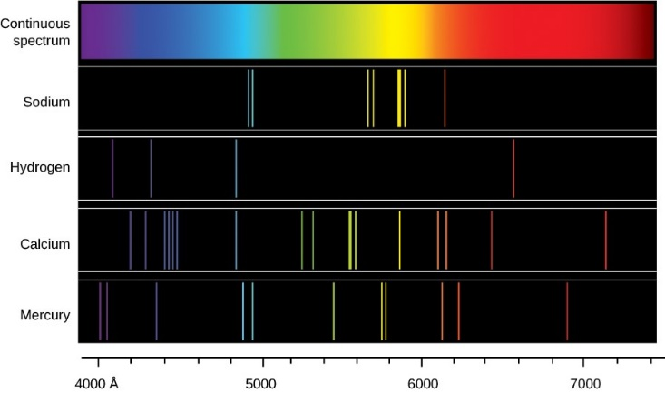
- Assessment

Part 5: Side Quest
- Weekly Recap
- Side Quests
NGSS Standards:
HS-ESS1-1: Develop a model based on evidence to illustrate the life span of the sun and the role of nuclear fusion in the sun’s core to release energy that eventually reaches Earth in the form of radiation.

Part 1: Introduction – Kelvin’s Bad Guesses
Overview: In this activity, you will read a short passage. You will then use this as the basis for a discussion about the content and structure of the sun.
Directions: Individually read the passage below. Then work with your group to address the questions below. Your instructor will determine if you should use scratch paper, a white board, an online document, etc.
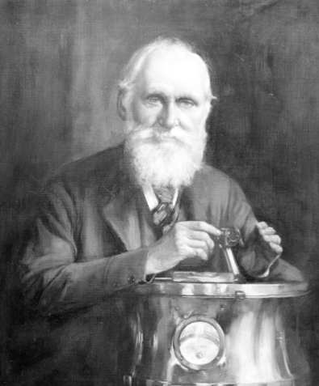
Lord Kelvin was one of the most extraordinary figures of any century. Kelvin really was a kind of Victorian superman. In the course of a long career, he wrote 661 papers, accumulated 69 patents, and gained renown in nearly every branch of the physical sciences. Among much else, he suggested the method that led directly to the invention of refrigeration, devised the scale of absolute temperature that still bears his name, invented the boosting devices that allowed telegrams to be sent across oceans, and made innumerable improvements to shipping and navigation.
His theoretical work, in electromagnetism, thermodynamics, and the wave theory of light, was equally revolutionary. He had really only one flaw and that was an inability to calculate the correct age of the Earth. The question occupied much of the second half of his career, but he never came anywhere near getting it right. His first effort, he suggested that the Earth was 98 million years old, but cautiously allowed that the figure could be as low as 20 million years or as high as 400 million.
With the passage of time Kelvin would become more forthright in his assertions and less correct. He continually revised his estimates downward, from a maximum of 400 million years, to 100 million years, to 50 million years, and finally, in 1897, to a mere 24 million years. Kelvin wasn’t being willful. It was simply that there was nothing in physics that could explain how a body the size of the Sun could burn continuously for more than a few tens of millions of years at most without exhausting its fuel. Therefore, he presumed that the Sun and its planets were relatively, but inescapably, youthful.
The problem was that nearly all the fossil evidence contradicted this.
Adapted from Bill Bryson’s “A Short History of Nearly Everything”
Questions
- Lord Kelvin is one of the most accomplished individuals in the history of science. Why did Kelvin continuously underestimate the age of the sun and planets despite a vast amount of fossil evidence?
- The sun has burned continuously for 4.6 billion years. How is this possible?
- Most matter would have completely combusted in this time. What is the sun made from that enables it to burn for billions of years?
- It is impossible for us to directly collect measurements from the sun itself. How is it that we can even know anything about the sun without directly collecting data from it?

Part 2: Core Ideas
Overview: In this activity, you will look at a short slideshow presentation. This will provide you with core ideas that will help you clarify your initial ideas. Your instructor will decide on how to implement this portion depending on your previous experience and capabilities with this content.
You will then work in small teams to answer the questions listed below. You should take notes in a notebook, on a dry erase board, or on scratch paper so that you are prepared to deliver your responses during the class discussion that will follow. Note: your instructor may assign specific questions to your group if time is limited.

Core Ideas Presentation: https://bit.ly/WUHS_astro_sun_W2

Driving Questions:
- The earth is continuously bombarded by radiation from the sun. What is radiation?
- What are three kinds of radiation? Summarize each.
- What determines whether electromagnetic radiation exists as radio waves, light, X-rays, etc.?
- What is spectroscopy? What is a spectral signature?
- What is the difference between an absorption line and an emission line? How are they similar?
- What are the parts of an atom? How do these relate to the spectral signatures we can observe?
- Why do different substances have different spectral signatures? In your response, be sure to address the following: electron, higher orbit, lower orbit, photon, wavelength.
- Revising Explanations: What is the sun made from? How do we know this?

Part 3: Spectrum Tube Investigation
Overview: In this activity, you will be using spectrum tubes and spectroscopy glasses to directly observe absorption and emission spectra for different elements and molecules.

Materials Needed: Spectrum tubes; spectrum tube power supply; diffraction glasses; flashlights.

Directions: Begin by answering the pre-investigation questions below (your instructor may ask you to record answers somewhere else).

Pre-Investigation Questions: Answer these questions individually and in small groups before creating your spectroscope. Use scratch paper, dry erase boards, online documents, or another option to record your answers.
- What is spectroscopy? How can analysis of diffracted light tell us anything about objects in space?
- Light is a form of electromagnetic radiation. What is radiation?
- How does spectroscopy work? How can we develop conclusions based on this information?
- Why do different substances have different spectral signatures? In your response, be sure to address the following: electron, higher orbit, lower orbit, photon, wavelength.
When you think you are ready, raise your hand and be prepared to explain your answers to your instructor.
This activity was successfully completed (instructor signature)

Methods: Complete each step as listed below.
- Your instructor will pass out diffraction glasses. These glasses diffract white light into the full spectrum of colors. When instructed, put on your glasses. Observe how your classroom lights appear when viewed wearing these glasses. Discuss in your groups how these glasses might produce this effect.
- Your instructor should have spectrum tubes and a power supply in a location visible to everyone in the class. In a moment, they will insert different glass tubes into the power supply. Each of these tubes contains different kinds of elements or molecules. The power supply will run electricity through the gas in each tube, exciting the atoms inside. In the space below, predict what you will see when electricity is passed through tubes containing different elements and molecules:
- Your instructor should now turn off the classroom lights and use the power supply with different spectrum tubes. Observe with and without your glasses. Summarize the differences you observed as electricity passes through different spectrum tubes. Then explain why these differences occurred.
- At this point, your instructor should provide your group with at least one of the spectrum tubes as well as a flashlight. When instructed to do so, you will shine a light through the glass tube full of a gas and observe how it appears with and without your diffraction glasses. In the space below, predict what you will see when light passes through tubes containing different elements and molecules:
- Your instructor should now turn off the classroom lights and provide you with time to make your observations. Observe without your diffraction glasses, and then with your glasses. Then exchange tubes with another group and repeat (be careful – these are fragile glass tubes!). Summarize the differences you observed as light passes through each tube. Then explain why this occurred.
Post- Investigation Questions:
- You likely saw very different outcomes when electricity passed through each tube compared to when light passed through. Why did these differences occur? Use your notes if needed.

- You also likely saw different outcomes depending on the kinds of elements found in each tube. Why would this matter? Why would different elements produce different responses when electrified and when light passes through?
- In the space below, draw a diagram to show how changes at the sub-atomic level results in different spectral signatures.

Part 4: Review & Assessment
Overview: Rank each Driving Question in Part 2 as a 1 (completely unsure), 2 (somewhat unsure), or 3 (completely sure) based on your comprehension. Then work in teams to review each item and prepare a response. Next, write a final explanation below. You will conclude by completing a formative assessment.
Revising Explanations: What is the sun made from? How do we know this?

Part 5: Side Quest
Overview: In this activity, you will begin to identify some topics related to astronomy to investigate more deeply over the course of the semester. Be prepared to discuss your ideas.

- In the space below, summarize the topic that you would like to investigate as a semester-long side quest.
- Is this topic feasible for a full-semester project? Use the space below to break the topic into 3-5 subtopics that you will address in the coming weeks:
- What is your overarching learning objective for this topic? In other words, what is it that you want your class to learn or be able to do as a result of your presentation?
p

How the Sun Works – Week 2 Assessment
Name: Hour Date: Score: /
Directions: A 3x5 notecard with handwritten notes can be used to guide your answers.
- Three individuals are discussing astronomy. They are trying to determine how it is possible to know the kinds of matter that comprise the sun. They make three claims, which are summarized below:
Adara thinks that NASA has sent probes into the sun to take samples to analyze on earth.
Brooklyn argues that we don’t actually know anything about the sun; scientists are just guessing.
Caris thinks that almost everything we know about the sun comes from studying sunshine.
Whose claim seems most accurate? Explain:
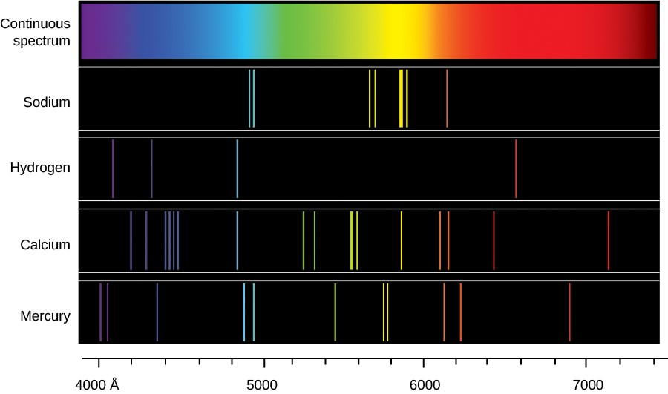
- The image at the right shows the emission spectra for four different gases. Briefly explain what this image is showing. Include and underline the following terms: electron; higher and lower orbits; photon; wavelengths; element.

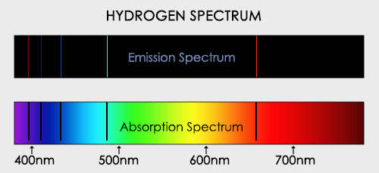
The image above shows an emission spectrum and an absorption spectrum for hydrogen.
- Under what conditions does a substance produce an emission spectrum? Why?
- Under what conditions does a substance produce an absorption spectrum? Why?
- Why do we see bands in the same locations in both the emission and absorption spectra?
- Light is a form of electromagnetic radiation. What is radiation?
How is light similar and/or different from other forms of radiation, such as radio waves or X-rays?

