How the Sun Works – Week 2 Labwork
Name: Hour Date:
Date Packet is due: Why late? Score:
^{Day of Week Date} If your project was late, describe why
Driving Question: What is inside the sun?
Semester Schedule
How the Sun Works
Week 1: What is matter? What is energy?
Week 2: What’s inside the sun?
Week 3: How can we measure the sun?
Week 4: Where does the sun’s energy come from?
Week 5: Unit Assessment
The Life of Stars
Week 1: How long do stars last?
Week 2: Why do stars die?
Week 3: What happens after stars die?
Week 4: Unit Assessment

How It All Began
Week 1: How can we determine the universe’s size?
Week 2: How can expansion determine the universe’s age?
Week 3: What can we learn from background radiation?
Week 4: Unit Assessment

Navigating Space
Week 1: How and why do things orbit in space?
Week 2: How can we predict orbits?
Week 3: Unit Assessments

Anchoring Phenomenon: What is inside the sun? What is the sun made from?

Deeper Questions
- How can we measure what is in the sun if we can’t visit the sun?
- What is sunlight?
- Can the structure of the sun tell us anything about its function?

Weekly Schedule

Part 1: Introduction
- Initial Ideas – Kelvin’s Bad Guesses
- Discussion & Developing Explanations

Part 2: Core Ideas
- Core Ideas
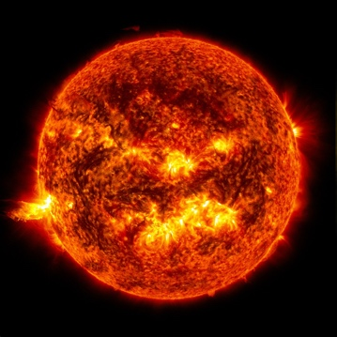
- Revisions of Part 1 Explanations

Part 3: Investigation
- CD Spectroscopes

Part 4: Review & Assessment
- Critiquing Ideas
- Assessment

Part 5: Side Quest
- Weekly Recap
- Side Quests
NGSS Standards:
HS-ESS1-1: Develop a model based on evidence to illustrate the life span of the sun and the role of nuclear fusion in the sun’s core to release energy that eventually reaches Earth in the form of radiation.

Part 1: Introduction – Kelvin’s Bad Guesses
Overview: In this activity, you will read a short passage. You will then use this as the basis for a discussion about the content and structure of the sun.
Directions: Individually read the passage below. Then work with your group to address the questions below. Your instructor will determine if you should use scratch paper, a white board, an online document, etc.
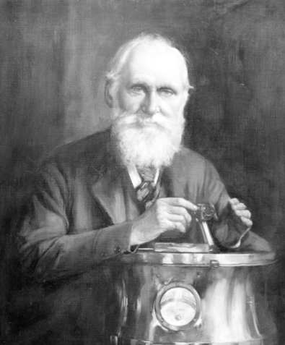
Lord Kelvin was one of the most extraordinary figures of any century. Kelvin really was a kind of Victorian superman. In the course of a long career, he wrote 661 papers, accumulated 69 patents, and gained renown in nearly every branch of the physical sciences. Among much else, he suggested the method that led directly to the invention of refrigeration, devised the scale of absolute temperature that still bears his name, invented the boosting devices that allowed telegrams to be sent across oceans, and made innumerable improvements to shipping and navigation.
His theoretical work, in electromagnetism, thermodynamics, and the wave theory of light, was equally revolutionary. He had really only one flaw and that was an inability to calculate the correct age of the Earth. The question occupied much of the second half of his career, but he never came anywhere near getting it right. His first effort, he suggested that the Earth was 98 million years old, but cautiously allowed that the figure could be as low as 20 million years or as high as 400 million.
With the passage of time Kelvin would become more forthright in his assertions and less correct. He continually revised his estimates downward, from a maximum of 400 million years, to 100 million years, to 50 million years, and finally, in 1897, to a mere 24 million years. Kelvin wasn’t being willful. It was simply that there was nothing in physics that could explain how a body the size of the Sun could burn continuously for more than a few tens of millions of years at most without exhausting its fuel. Therefore, he presumed that the Sun and its planets were relatively, but inescapably, youthful.
The problem was that nearly all the fossil evidence contradicted this.
Adapted from Bill Bryson’s “A Short History of Nearly Everything”
Questions
- Lord Kelvin is one of the most accomplished individuals in the history of science. Why did Kelvin continuously underestimate the age of the sun and planets despite a vast amount of fossil evidence?
- The sun has burned continuously for 4.6 billion years. How is this possible?
- Most matter would have completely combusted in this time. What is the sun made from that enables it to burn for billions of years?
- It is impossible for us to directly collect measurements from the sun itself. How is it that we can even know anything about the sun without directly collecting data from it?

Part 2: Core Ideas
Overview: In this activity, you will look at a short slideshow presentation. This will provide you with core ideas that will help you clarify your initial ideas. Your instructor will decide on how to implement this portion depending on your previous experience and capabilities with this content.
You will then work in small teams to answer the questions listed below. You should take notes in a notebook, on a dry erase board, or on scratch paper so that you are prepared to deliver your responses during the class discussion that will follow. Note: your instructor may assign specific questions to your group if time is limited.

Core Ideas Presentation: https://bit.ly/WUHS_astro_sun_W2

Driving Questions:
- The earth is continuously bombarded by radiation from the sun. What is radiation?
- What are three kinds of radiation? Summarize each.
- What determines whether electromagnetic radiation exists as radio waves, light, X-rays, etc.?
- What is spectroscopy? What is a spectral signature?
- What is the difference between an absorption line and an emission line? How are they similar?
- What are the parts of an atom? How do these relate to the spectral signatures we can observe?
- Why do different substances have different spectral signatures? In your response, be sure to address the following: electron, higher orbit, lower orbit, photon, wavelength.
- Revising Explanations: What is the sun made from? How do we know this?

Part 3: Investigation – CD Spectroscopes
Overview: In this activity, you will be using cardboard tubes and CD’s to create a spectroscope. This will enable you to observe spectral diffraction from different kinds of light.

Directions: Begin by answering the pre-investigation questions below. Then use the instructions on the following page to create your spectroscopes. (your instructor may ask you to record answers somewhere else).

Pre-Investigation Questions: Answer these questions individually and in small groups before creating your spectroscope. Use scratch paper, dry erase boards, online documents, or another option to record your answers.
- What is spectroscopy? Why is it important to astronomy?
- Light is a form of electromagnetic radiation. What is radiation?
- How can analysis of diffracted light tell us anything about objects in space?
- How does spectroscopy work? How can we develop conclusions based on this information?
- Why do different substances have different spectral signatures? In your response, be sure to address the following: electron, higher orbit, lower orbit, photon, wavelength.
When you think you are ready, raise your hand and be prepared to explain your answers to your instructor.
This activity was successfully completed (instructor signature)

Creating Your Spectroscope (Adapted from www.Exploratorium.edu/snacks/cd-spectroscope).

Materials Needed: blank CDs; cardboard tubes (12”+ long and 3” wide) with plastic caps; black construction paper; a razor knife; tape; different lightbulbs AND/OR spectrum tubes; a saw; a cutting guide (attached).

Assembly (if your instructor has already completed these steps, move on to the next section).
- Wrap the cutting guide around your tube.
- Use a saw to cut the tube at an angle along the curved line on the cutting guide.
- Use a razor knife to cut a rectangular cutting hole (the black square on the cutting guide).
- Cut a slit 1 mm x 5 cm in the plastic cap furthest from the CD.
- Cut a piece of black construction paper to fit inside of this cap. Cut a 1 mm x 5 cm slit in this paper to match the slit in the plastic cap.
- Cut a piece of construction paper to fit inside of the second cap to block out any unwanted light.
- Insert the CD into the CD slot – it should tilt at a 30 degree angle. It should reflect light coming through the top slit into your eye.
Using your Spectroscope
- Hold the tube upright. Begin by aiming the slit towards a fluorescent light.
- Press your eye into the viewing hole. It may be necessary to adjust the angle at which your look through the viewing hole until you see a colored spectrum (i.e., a rainbow).
- On the CD, look for breaks in the colored bands on the CD’s surface. This is the spectral signature of the fluorescent light.
- Repeat this process for different kinds of light from different kinds of lightbulbs. If available, also observe the light from spectrum tubes from different elements.
(Note: spectrum tubes are likely to be too faint for this spectroscope. Angling a CD directly under the spectrum tube yields better results).
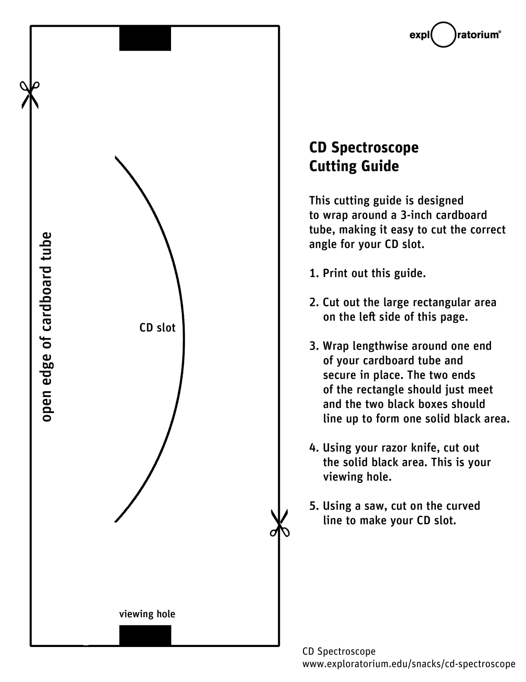
Post- Investigation Questions: Answer these questions after creating your spectroscope. Make a mental note of how your thinking about these questions changed after creating your molecular models.
- Summarize differences in your spectroscope observations while observing different kinds of light and/or spectrum tubes. What differences, if any, did you observe between different sources of light?

- In the space below, draw a diagram to show how changes at the sub-atomic level results in different spectral signatures.

- You should have seen different patterns on the CD in your spectroscope under different kinds of light. Why do these differences occur?
- Imagine that you are interested in how the composition of our own solar system’s sun compares to that of distant stars. How could you use a more precise spectrometer to address this question?

Part 4: Review & Assessment
Overview: Rank each Driving Question in Part 2 as a 1 (completely unsure), 2 (somewhat unsure), or 3 (completely sure) based on your comprehension. Then work in teams to review each item and prepare a response. Next, write a final explanation below. You will conclude by completing a formative assessment.
Revising Explanations: What is the sun made from? How do we know this?

Part 5: Side Quest
Overview: For this activity, you will begin with a recap of the things that you learned in this packet. You will then identify topics related to astronomy that you personally find interesting to investigate more deeply over the remainder of the semester.
Weekly Recap (use a whiteboard, scratch paper, online document, etc.)
- Summarize everything that you have learned through this packet within your group. Try to identify the common themes, major ideas, and most important concepts from the content you have learned.
- Is there anything that anyone still doesn’t completely understand? Is there anything that anyone maybe disputes or disagrees with? Did anything seem particularly surprising or noteworthy?
- What you think are the most important ideas and concepts that you have learned so far. Aim to have at least 5 or 6 ideas written down. It is ok to have more than this.
Side Quest: In this activity, you will begin to identify some topics related to astronomy to investigate more deeply over the course of the semester. Be prepared to discuss your ideas.

- In the space below, summarize the topic that you would like to investigate as a semester-long side quest.
- Is this topic feasible for a full-semester project? Use the space below to break the topic into 3-5 subtopics that you will address in the coming weeks:
- What is your overarching learning objective for this topic? In other words, what is it that you want your class to learn or be able to do as a result of your presentation?

How the Sun Works – Week 2 Assessment
Name: Hour Date: Score: /
Directions: A 3x5 notecard with handwritten notes can be used to guide your answers.
- Three individuals are discussing astronomy. They are trying to determine how it is possible to know the kinds of matter that comprise the sun. They make three claims, which are summarized below:
Adara thinks that NASA has sent probes into the sun to take samples to analyze on earth.
Brooklyn argues that we don’t actually know anything about the sun; scientists are just guessing.
Caris thinks that almost everything we know about the sun comes from studying sunshine.
Whose claim seems most accurate? Explain:
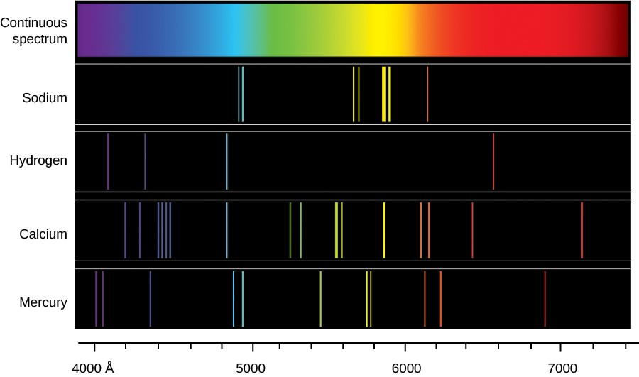
- The image at the right shows the emission spectra for four different gases. Briefly explain what this image is showing. Include and underline the following terms: electron; higher and lower orbits; photon; wavelengths; element.

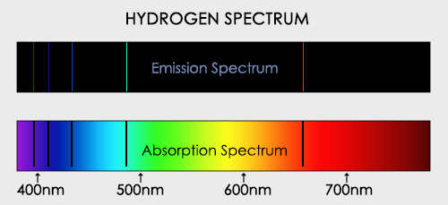
The image above shows an emission spectrum and an absorption spectrum for hydrogen.
- Under what conditions does a substance produce an emission spectrum? Why?
- Under what conditions does a substance produce an absorption spectrum? Why?
- Why do we see bands in the same locations in both the emission and absorption spectra?
- Light is a form of electromagnetic radiation. What is radiation?
How is light similar and/or different from other forms of radiation, such as radio waves or X-rays?

