DNA & Proteins Unit – Week 3

Score

□ Above & Beyond

□ Fully Complete

□ Mostly Complete

□ Incomplete – *fix the following pages*:

Name: Hour Date:

Date Packet is due:after Part 5 Why late?   
 If your work was late, describe why

**Semester Schedule**

**Traits & Genes**

Week 1 - What determines the traits of an organism?

Week 2 - How are traits inherited from parents?

Week 3 – Can we predict traits?

Week 4 - Assessment

**DNA & Proteins**

Week 1: What is DNA and how does it work?

Week 2: How does DNA affect protein assembly?

Week 3: How does a protein determine traits?

Week 4 - Assessment

**Mutations & Change**

Week 1: How do mutations change genes & proteins?

Week 2: How can mutations result in new traits?

Week 3: How can mutations lead to new species?

Week 4 - Assessment

**Biodiversity & Extinctions**

Week 1: How does biodiversity affect ecosystems?

Week 2: Why do some species go extinct?

Week 3: How can human activity cause extinctions?

Week 4 - Assessment

**Driving Question**: How does a protein determine traits?

**Anchoring Phenomenon**: So far we have examined how DNA stores information in base molecules, and how RNA provides a link between the info stored in DNA and the assembly of proteins. However, we still don’t know how a chain of amino acids forms the macromolecules that create the traits of an organism. We’ll explore this further this week.

**Weekly Schedule**

**Part 1: Introduction**

* Initial Ideas – Sickle Cell Anemia
* Data Dive – Differences in Protein Shapes
* Discussion & Developing Explanations

**Part 2: Core Ideas**

* Core Ideas
* Revisions of Part 1 Explanations

**Part 3: Investigation**

* Part 3: Pipe-cleaner Proteins

**Part 4: Review & Assessment**

* Ranking Your Readiness
* Assessment

**Part 5: Life Connections**

* Weekly Recap
* Life Connections – GMO Debates

**Deeper Questions**

1. How do amino acids in a protein determine its shape and function?
2. What happens if a protein’s shape is changed?
3. How can cells be changed so that they produce new proteins and acquire new traits?

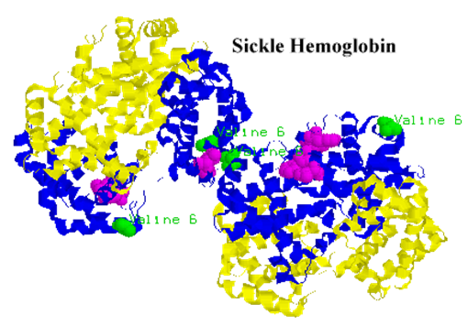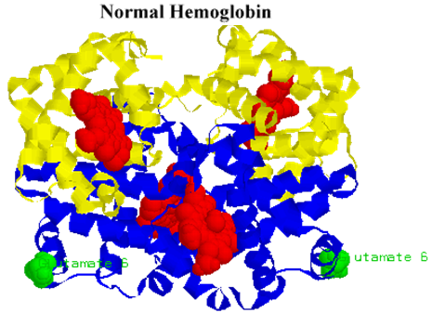

**NGSS Standards**:   
HS-LS1-1 - How the structure of DNA determines the structure of proteins and function.

HS-LS1-2 - How inheritable variations result from 1) changes via meiosis; 2) errors during replication; 3) mutations via environmental factors

HS-LS1-4: How mitosis and differentiation enable complex organisms.



Part 1: Introduction – Sickle Cell Anemia

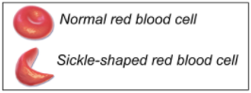 **Overview**: In this activity, you will begin by discussing your initial ideas about how changes in DNA and amino acid chains can affect the formation of functional proteins.

**Initial Ideas**: Some members of Daryll’s extended family carry genes for a genetic disease called sickle cell anemia. This disease causes symptoms such as blood clots, painful swelling, and reduced oxygen content in the blood.

Daryll recently learned that sickle cell anemia results from a change to a base molecule in the gene for the protein hemoglobin. Hemoglobin is the protein that binds to oxygen in red blood cells. If the gene changes, the protein’s shape changes. This changes red blood cells from a donut-shape to a half-moon shape.

Daryll is unclear why changing a single base in a gene would affect proteins, change cells, and harm the entire body. He discusses this with his friends at lunch. They each share their ideas.

1. **Do you agree or disagree with each student’s claim**?
   1. Daryll: "I know that DNA provides the instructions for assembling a protein. Maybe changing one base changes the entire DNA" Agree/ Disagree
   2. Avery: "I know that DNA is read in groups of 3 bases. The entire protein must have changed because a single amino acid was changed." Agree / Disagree
   3. Chandra: “This makes sense – if proteins are made from DNA, then changing the DNA will change the protein.” Agree / Disagree
2. **Work in your small groups to discuss your ideas.** How are your ideas similar or different? Decide as a group whether each statement is correct (and why). Be prepared to present your ideas to the class.

**Data Dive**: In this data dive, you will make observations about differences in genes and protein shape that occur in sickle cell anemia. Use the images below to answer the questions on the following pages.

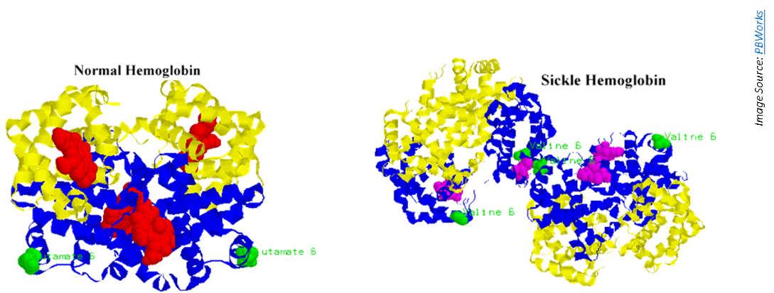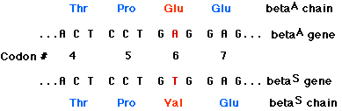

*Normal Gene*

*Sickle Cell Gene*

1. **Begin by individually attempting to make sense of these image**. What do you think you are seeing in these images? How does this relate to any prior knowledge or experience that you have?
2. **Next, work in your teams to discuss your ideas**. Where do you agree? Where do you disagree? Can you use this data to reach agreement? Do others have prior knowledge/experience that could help?
3. **Based on this data, what is one difference you can observe between the normal and sickle cell genes and/or proteins?** 
   1. How is this conclusion supported by this data?
   2. What specifically suggests that your claim is accurate?
4. **Based on this data, what is a second difference you can observe between the normal and sickle cell genes and/or proteins?** 
   1. How is this conclusion supported by this data?
   2. What specifically suggests that your claim is accurate?
5. **Would you change any of your responses to the first question above?** (See Question #1 under *Initial Ideas*). Discuss as a team.

**Discussion & Developing Ideas**

1. As a class, discuss your ideas about this data. What are ideas that most agreed on? Where did your ideas differ as a class? Based on your instructor’s directions, use the space below or another option (e.g., whiteboard, online document, etc.) to record your ideas.

We all agree that…

We disagreed about…

1. **How does a protein determine traits? How does the function of a protein relate to its shape?** Write down your initial explanation in the space below. Don’t worry if you aren’t completely sure about your answer! You will come back and revise this explanation as you gain more information during this unit.

Part 2: Core Ideas

**Overview**: In this activity, you will begin with a short slideshow presentation. This will provide you with core ideas that will help you clarify your initial ideas. Your instructor will decide on how to implement this portion depending on your previous experience and capabilities with this content.   
  
You will then work in small teams to answer the questions listed below. You should take notes in a notebook, on a dry erase board, or on scratch paper so that you are prepared to deliver your responses during the class discussion that will follow. *Note: your instructor may assign specific questions to your group if time is limited.*

**Intro Video**: <https://www.youtube.com/watch?v=yZ2aY5lxEGE>

**Core Ideas Presentation**: <https://bit.ly/WUHS-Bio-DNAProteinsW3>

**Driving Questions**:

1. What determines the function of a protein?
2. What properties determine the shape of a protein?
3. What is the difference between a hydrophobic amino acid and a hydrophilic amino acid?
4. Where are hydrophobic and hydrophilic amino acids found in a protein? Why?
5. How does the positive or negative charge of some amino acids affect the shape of a protein?
6. How are cysteine amino acids unique? How do these amino acids affect the shape of a protein?
7. Sickle cell anemia occurs when a T-base in DNA is substituted for an A. How does changing a single base result in changes at the molecular, cellular, and bodily levels?
8. How is it possible that a gene from one organism can be moved to another organism and remain functional?
9. Explain how the following are similar and different: *genetic engineering, genome, GMO*.
10. How are genetically modified organisms created? In your response, include the following: *restriction enzyme, restriction site, sticky ends.*
11. Is it likely that you will encounter GMOs in your day to day life? Explain using examples.
12. How does CRISPR-Cas9 enable genetic modification? How is it different from earlier forms of genetic engineering?
13. **Revising Explanations**: Return to your original explanation that you created at the end of Part 1. Based on this new information, how would you now respond to this question?

**How does a protein determine traits?**  
  
   
  
   
  
**How can a new gene be added to an organism where it never existed before?**

Part 3A Investigation: Pipe-cleaner Proteins

**Overview**: you will use models to explore how amino acid properties affect protein shape and function.

**Background**: The function of a protein is determined by its shape, and the shape of the protein is determined by the order of its amino acids. We can explore proteins in an indirect way through modeling. A scientific model is a substitute for the actual thing we are studying, but it is also similar to what it represents. It tends to follow the same rules as the actual object, and it provides us with a simpler idea of a more complex process so that we can better understand it. In this case, you will be using pipe cleaners, beads, and cut up straws to model how proteins fold, and how mutations affect the shape of proteins.

**There are 3 important properties of amino acids that affect protein folding:**

1. 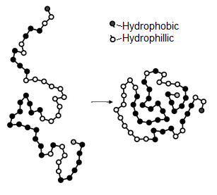**Hydrophobicity** – hydrophobic (*water hating*) amino acids will always try to get to the inside of a protein. Hydrophilic (*water loving*) amino acids will try to move as far outside of the protein as they can.
2. **Charge** – amino acids can have one of three charges – positive, negative, or neutral. Just like magnets, positively and negatively charged amino acids attract each other. Similarly-charged amino acids will repel each other.
3. **Cysteine** **Bonds** –Cysteine amino acids will move toward each other and form strong bonds.

*To create your protein, complete the steps on the next page:*

1. **Begin by transcribing this DNA into mRNA. The first two codons have been started for you.**

***DNA Strand*** *(the second side of this strand has been omitted for easier reading)*

3’ TAC-TTA-CGA-TGG-TAC-ACG-CAA-TCT-ATA-CTC-AAA-TAT-AGG-ACC-TTG-ACG-TCG-AAT-CTC-CAC-TGT-ACC-TTG-AAC-CTG-ACT 5’

2. ***mRNA Strand*** *(remember that C’s become G’s, T’s become A’s, G’s become C’s, and A’s become U’s):*

5’-AUG-AAU-

1. **Next, transcribe the mRNA sequence into an amino acid sequence based on codon codes.**

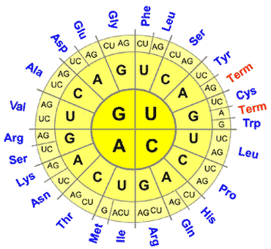MET-ASN-

1. **Third, determine the color of bead (or beads) that should represent each amino acid above.** Use the chart of amino acid properties below. Use markers or  
   colored pencils to color code your sequence above.

**Hydrophobicity** – yellow beads will represent hydrophobic amino acids; purple beads are hydrophilic amino acids.

**Charge** – blue beads are amino acids with a positive charge and red beads will be the negatively charged amino acids.

**Cysteine bonds** – use green to represent the amino acids cysteine.

**Some amino acids may have multiple beads**! For example, Arginine is both positively charged (blue) and hydrophilic (purple).

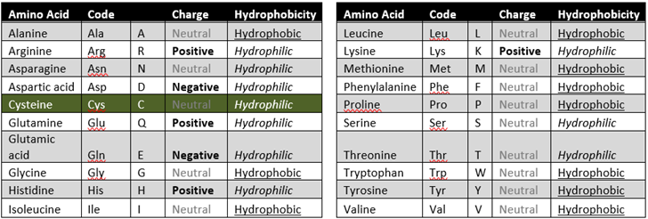

1. **Once you have determined the order of amino acids and the order of colored beads that you will need, you can begin assembling your protein.** 
   1. Your first amino acid (*methionine*) should be represented by a yellow bead (*because methionine is neutral and hydrophobic*). Take a yellow bead and add it to the end of a pipe cleaner. Wrap the pipe cleaner around this yellow bead so that it cannot slip off.
   2. Once you have added and secured your first yellow bead, add a cut up straw to separate this first bead from your next amino acid bead. This straw will represent the bond between amino acids.
   3. If you have an amino acid that has two beads, make sure that these two beads are together. *Do not separate the two beads with a straw if they both represent the same amino acid.*
   4. Continue adding your beads and cut-up straws until every amino acid in your sequence is represented. If you fill up your pipe cleaner, attach a second pipe cleaner.
2. **Finally, you will need to fold your protein using the guidelines below.** 
   1. Start by moving your purple hydrophilic amino acids to the outside and your yellow hydrophobic amino acids to the inside.
   2. Then connect your opposite charges (red and blue amino acids) by wrapping them around each other.
   3. Next, connect your green cysteine amino acids (wrap them around each other using the pipe cleaner).
3. **Your finished protein should have an ‘outer shell’ of hydrophilic and charged amino acids with an inner center of hydrophobic amino acids, with opposite charges connected to each other, and with cysteine amino acids connected to each other in pairs.** 
   1. When finished, your protein should resemble the one in the image below.
4. **When finished, submit your completed protein with your names attached to it (using masking tape or whatever your instructor provides for you) to the location that your instructor has provided.**

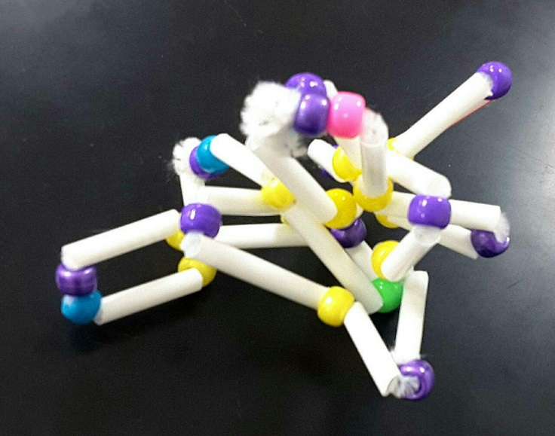

Part 4: Review & Assessment

**Overview:** Rank each Driving Question in Part 2 as a 1 (*completely unsure*), 2 (*somewhat unsure*), or 3 (*completely sure*) based on your comprehension. Then work in teams to review each item and prepare a response. Next, write a final explanation below. You will conclude by completing a formative assessment.

**How does DNA determine protein assembly?**

**How can a new gene be added to an organism where it never existed before?**

Part 5: Life Connections – GMO Debates

**Overview:** For this activity, you will work in teams to debate the benefits and drawbacks of using genetically modified organisms, particularly in regard to food production.

**Directions**:

1. Begin by visiting <https://www.procon.org/headlines/gmos-top-3-pros-and-cons/> (or type “GMOs – Top 3 Pros and Cons” into an internet search engine).
2. Begin by reading the overview section on GMOs at the top of the page. Work with your team to make sure everyone understands the key points of this reading.
3. Complete the table on the next page by summarizing the information on the website.
4. As a group, try to achieve a consensus on GMOs. What is your stance, and what evidence supports your stance? Record your final ideas below.

**What is your stance on GMOs?**

**Why is this your stance? What reasoning or evidence supports this?**



*This page is intentionally blank.*

DNA & Proteins Unit - Week 3 Formative Assessment

Name: Hour Date: Score: /

**Directions**: A 3x5 notecard with handwritten notes can be used to guide your answers. Your instructor may allow you to work in assigned groups. If so, have a different person write each response while others assist.

1. **What primarily determines the function of a protein? How does this relate to DNA?** Include and underline the following terms: *shape, function, amino acids.*   
     
      
     
      
     
      
   *Writer’s Name:*

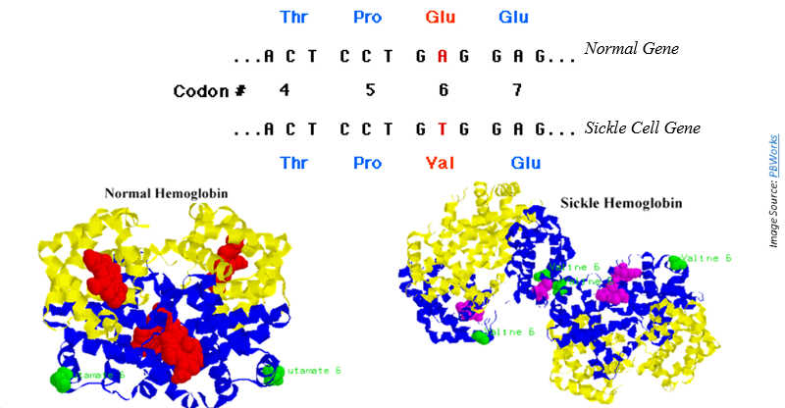

1. The image above shows the genes associated with normal hemoglobin proteins as well as sickle cell hemoglobin. The proteins are shown below these genes. **A) How do the unaffected genes and proteins differ from the genes and proteins in individuals affected by sickle cell anemia? B) How does changing a single base affect hemoglobin proteins, red blood cells, and the entire body?**   
     
      
     
      
     
      
     
      
   *Writer’s Name:*
2. 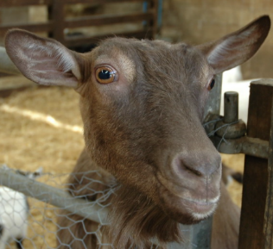Sickle cell anemia occurs when a positively-charged glutamate amino acid is replaced by valine (which is neutral and has no charge) in the hemoglobin protein. There are over 500 amino acids in this protein. **Why would changing a single amino acid affect the entire protein? Begin by explaining how different properties of amino acids (attraction/repulsion to water, chemical charge, and cysteine bonds) determine the shape of a protein.**  
      
     
      
     
      
     
      
     
      
   *Writer’s Name:*

Scientists have created genetically modified goats that produce spider silk proteins in their milk. These proteins can be used to create exceptionally strong materials. To accomplish this, they moved a gene from the spider genome to the goat’s genome.

1. **How did restriction enzymes and “sticky ends” enable scientists to move a gene from the genome of a spider to the genome of a goat?**  
      
     
      
     
      
     
      
   *Writer’s Name:*
2. The behavior and physical appearance of ‘spider goats’ is identical to any other goat. **If these goats have a spider gene added to their genome, why don’t they have eight legs, spin webs, etc.?**  
      
     
      
     
      
     
      
   *Writer’s Name:*