Biodiversity & Extinction Unit – Week 1
Score
□ Above & Beyond
□ Fully Complete
□ Mostly Complete
□ Incomplete – fix the following pages:
Name: Hour Date:
Date Packet is due: after Part 5 Why late?
If your work was late, describe why
Semester Schedule
Traits & Genes
Week 1 - What determines the traits of an organism?
Week 2 - How are traits inherited from parents?
Week 3 – Can we predict traits?
Week 4 - Assessment

DNA & Proteins
Week 1: What is DNA and how does it work?
Week 2: How does DNA affect protein assembly?
Week 3: How does a protein determine traits?
Week 4 - Assessment

Mutations & Change
Week 1: How do mutations change genes & proteins?
Week 2: How can mutations result in new traits?
Week 3: How can mutations lead to new species?
Week 4 - Assessment

Biodiversity & Extinctions
Week 1: How does biodiversity affect ecosystems?
Week 2: Why do some species go extinct?
Week 3: How can human activity cause extinctions?
Week 4 - Assessment

Driving Question: How does biodiversity affect ecosystems?

Anchoring Phenomenon: We have explored how changes from random hereditary mutations can become more prevalent over time if they provide benefits for a particular environment. We will now investigate how the diversity of traits and species supports ecosystem function, and how changes to environments can lead to extinctions.

Deeper Questions
- Why do some species go extinct?
- How does today’s rate of extinction compare to other periods?
- How do extinctions affect ecosystem services & resiliency?

NGSS Standards:
HS-LS2-6 - Changing conditions (e.g., hunting, flooding, volcanoes) may result in a new ecosystem
HS-LS2-7. Design, evaluate, and refine a solution for reducing the impacts of human activities on the environment and biodiversity
HS-LS4-6. Create or revise a simulation to test a solution to mitigate adverse impacts of human activity on biodiversity, especially related to threatened or endangered species.

Weekly Schedule

Part 1: Introduction
- Initial Ideas – Missing Mammoths
- Data Dive – Modern Extinction Rates
- Discussion & Explanations

Part 2: Core Ideas
- Core Ideas
- Revisions of Part 1 Explanations

Part 3: Investigation
- Habitat Threat Scavenger Hunt

Part 4: Review & Assessment
- Ranking Your Readiness
- Assessment

Part 5: Life Connections
- Weekly Recap
- Life Connections

Part 1: Introduction
Overview: In this activity, you will begin by discussing your initial ideas about biodiversity & extinctions.
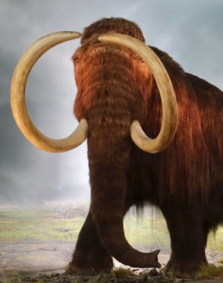
Background: 20,000 years ago, ice sheets covered large portions of the earth and humans lived alongside a species of elephant called mammoths. These animals grazed on plants, using their 15-foot-long tusks to dig under snow for food like shrubs and grasses. Mammoths were the size of today’s African elephants. However, unlike today’s elephants, mammoths were covered in shaggy fur, had a hump on their back filled with extra fat, and had tiny ears to reduce heat loss. Today mammoths are extinct. (Image Source: Flickr)

Initial Ideas:
- Three students shared their ideas about what happened to mammoths. Do you agree or disagree with each student’s claim?
  - Nina: "I think that the mammoth went extinct because their environment changed dramatically when the ice age ended." Agree/ Disagree
  - Marisol: "I disagree. We learned that animals can have mutations that lead to adaptations if their environment changes. Mammoths were probably just hunted to extinction." Agree / Disagree
  - Bristol: “I think that mammoths evolved into the elephants that we have today and became a different species.” Agree / Disagree
- Work in your small groups to discuss your ideas. How are your ideas similar or different? Decide as a group whether each statement is correct (and why). Be prepared to present your ideas to the class.
Data Dive: Species extinctions are still occurring today. Watch the accompanying video to gain more insights. Then use the graph below to answer the accompanying questions. Video: https://youtu.be/cmb5hn2X2ok
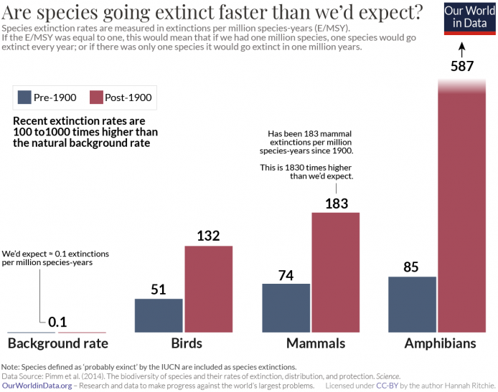
Questions:
- Begin by individually attempting to make sense of this data. What trends or patterns do you notice? How does this relate to any prior knowledge or experience that you have?
- Next, work in your teams to discuss your ideas. Where do you agree? Where do you disagree? Can you use this data to reach agreement? Do others have prior knowledge/experience that could help?
- Based on this data, what is one conclusion that would be supported by this data?
  - How is this conclusion supported by this data?
  - What specifically suggests that your claim is accurate?
- Based on this data, what is a second conclusion that would be supported by this data?
  - How is this conclusion supported by this data?
  - What specifically suggests that your claim is accurate?
- Would you change any of your responses to the first question above? (See Question #1 under Initial Ideas). Discuss as a team.
- As a class, discuss your ideas about this data. What are ideas that most agreed on? Where did your ideas differ as a class? Record your ideas in the spaces below.
We disagreed or are unsure about…
We all agree that…
- Why do some species go extinct? How do extinctions affect ecosystems? Write down your initial explanation in the space below. Don’t worry if you aren’t completely sure about your answer! You will come back and revise this explanation as you gain more information during this unit.

Part 2: Core Ideas
Overview: In this activity, you will begin with a short slideshow presentation. This will provide you with core ideas that will help you clarify your initial ideas. Your instructor will decide on how to implement this portion depending on your previous experience and capabilities with this content.
You will then work in small teams to answer the questions listed below. You should take notes in a notebook, on a dry erase board, or on scratch paper so that you are prepared to deliver your responses during the class discussion that will follow. Note: your instructor may assign specific questions to your group if time is limited.

Intro Video: https://youtu.be/GlWNuzrqe7U

Core Ideas Presentation: https://bit.ly/WUHS-Bio-BiodiversityW1
Driving Questions:
- What is biodiversity? What are three different kinds of biodiversity?
- How can we determine the level of biodiversity in an ecosystem using species richness?
- What are ecosystem services? Summarize the four types of ecosystem services with examples.
- How does biodiversity relate to the amount of ecosystem services that can be provided in an area?
- What is ecosystem resiliency? What does this indicate about a particular ecosystem?
- What is species redundancy? How and why does this relate to biodiversity and ecosystem resiliency?
- How do biodiversity, ecosystem services, and ecosystem resiliency relate to photosynthesis, respiration, biosynthesis, and the 10% Rule?
- How do biodiversity, ecosystem services, and ecosystem resiliency relate to DNA, proteins, mutations, natural selection, and evolution?
- What is extinction? Why/when do extinctions occur?
- Why did the mammoths become extinct? Why didn’t they just adapt to their changing environment?
- How does today’s rate of extinction compare to previous rates of extinction? How could this affect human populations?
- What kinds of disturbances are responsible for the current rate of extinction?
- Revising Explanations: Return to your original explanation that you created at the end of Part 1. Based on this new information, how would you now respond to this question?
Why do some species go extinct?
How do extinctions affect ecosystems?

Part 3 Investigation: Habitat Threat Scavenger Hunt
Overview: In this investigation, you will explore a local habitat to identify potential risks for extinction.
Pre-Investigation Questions: Work as a group to determine the best response to each question. Be prepared to provide verbal responses for these questions for your instructor before you complete the investigation.
- What is biodiversity? What are ecosystem services? How do levels of biodiversity affect ecosystem services?
- How are the concepts of biodiversity, resiliency, and species redundancy similar and how are they different?
- Why do some species go extinct?
- How do today’s rates of extinction compare to the past? What is the cause(s) of this rate of species loss?
When you think you are ready, raise your hand. Your instructor will listen to your verbal responses. Your instructor may decide to postpone these questions until after the investigation.
This activity was successfully completed (instructor signature)

Investigation Overview: In this activity, you will be visiting a habitat near your classroom and performing a risk assessment to determine if your habitat is at risk for extinctions due to habitat loss, invasive species, pollution, and/or overharvesting.
Directions: Prior to visiting an ecosystem, your instructor will provide you with details about how human activity & development in the surrounding area may affect habitat loss or degradation. One option for this information is https://earthengine.google.com/timelapse/. Use this link (or search for Google Earth Engine) and enter an address near the local habitat. Observe how ecosystems, fields, and undeveloped areas have changed.

An internet search can also provide you with information about potential pollutants in your area. The EPA provides interactive maps of air pollution. Do an internet search for EPA AirData Map; then type in the address. Zoom out to see if the area is color-coded as a “nonattainment zone” (i.e., fails to meet minimum standards for air pollution); make sure all layers are turned on; consult the map legend for details. Various maps of water contamination are also available through the USGS, USDA, EWG, and other sources (click links to view maps).

Your instructor may also have information available about hunting and fishing regulations and/or whether there are any threatened or endangered species in the local area. One option is the EPA EcoBox Tools with state-by-state information. For example, WI provides an Endangered & Threatened Species List. Instructors may be able to work in advance to determine if any species in the area are on their state’s list of at-risk species.

While visiting the ecosystem, look for signs of habitat loss or habitat fragmentation. You might also observe evidence of pollutants (such as litter, ash, or algal blooms in water). Your instructor may also be able to provide you with printed photographic guides to determine the prevalence of invasive species; if not, check to see if it would be ok to use a phone or other device in order to find a state department of natural resources website (a good example can be found by searching for WI Field Guide Invasive Plants).

If time is too limited, your instructor may modify this investigation. If you are assigned a specific topic, you only need to complete the sections of the following page that pertain to this focus. If it is not possible to go outside, your instructor may opt to exempt you from some sections on the next page.
Habitat Loss: is this habitat at risk for local extinctions due to habitat loss? Yes / Possibly / No
What evidence supports this conclusion?
Invasive Species: is this habitat at risk for local extinctions due to invasive species? Yes / Possibly / No
What evidence supports this conclusion?
Pollution: is this habitat at risk for local extinctions due to pollution? Yes / Possibly / No
What evidence supports this conclusion?
Overharvesting: is this habitat at risk for local extinctions due to hunting or overharvesting? Yes / Possibly / No
What evidence supports this conclusion?
Summary: are there heightened risks for extinction in this area due to human activity? Yes / Possibly / No
What evidence supports this conclusion?

Part 4: Review & Assessment
Overview: Rank each Driving Question in Part 2 as a 1 (completely unsure), 2 (somewhat unsure), or 3 (completely sure) based on your comprehension. Then work in teams to review each item and prepare a response. Next, write a final explanation below. You will conclude by completing a formative assessment.
Why do some species go extinct?
How do extinctions affect ecosystems?

Part 5: Life Connections
Introduction: writing a letter to your state and federal elected representatives can be an effective way to help influence the policies that affect your community, nation, and world. In this exercise, you will be drafting a letter to send to an elected representative at the state or federal level. If well done, your instructor may actually send your letter to your senator or representative.
How to find your elected representatives: the following website provides detailed information on how to find the contact information for state and federal representatives: https://www.usa.gov/elected-officials

9 Essential Tips for Writing Your Congressperson: Every letter to an elected official should be…
- Direct: State your subject clearly in the first sentence. Stick to just one issue per letter.
- Informative: Identify yourself as a constituent. State your views, support them with your expert knowledge and, when appropriate, cite the bill number of relevant legislation (e.g., S.3456).
- Inquiring: Ask for the policymaker’s point of view and how he or she plans to vote on relevant legislation. Expect an answer to your letter.
- Factual & Courteous: Rely on the facts, but personalize the issue. Explain how the issue affects your life. Avoid personal attacks, threats of political influence or demands.
- Constructive: Be positive about your issue and offer recommendations about how you want the member to address concerns.
- Specific: Always explain the hometown relevance of the issue. Use "I" statements and cite specific times and examples.
- Helpful: Offer to provide additional information if needed, and provide your contact information.
- Appreciative: Remember to thank members for their attention. Follow the issue and thank them later if they vote your way.
- Concise: Keep your letter to one page, or your email to 500 words or less.
Taken from “How to Write a Letter or Email” by the American Psychological Association: http://www.apa.org/advocacy/guide/letter-email.aspx
Sample letter:
June 5th, 2022

The Honorable Senator (last name)
United State Senate
Washington, DC 20510

Dear Senator (last name):

The legislation addressing (briefly describe issue or proposed legislation) is of particular interest to me because I am a (describe your relationship to this issue). This issue directly impacts (describe how this issue specifically affects you and other Americans).

I am primarily concerned about (go into detail about a specific aspect of this issue that is particularly important to you). This particular issue is especially important because (provide evidence, numerical data, and/or personal anecdotes to demonstrate why this issue matters most).

I am writing to you in part to ask for your specific stance on (this issue). (Either follow up by requesting how they will vote on a specific bill, or if this is more general and not about a specific piece of legislation, ask them to clarify their stance on the topic at large). As someone with a background in this issue as well as a personal connection to this topic, I would hope that (summarize how you think they should vote and why).

Thank you for your consideration of my letter and for your attentiveness to this issue. I would be particularly appreciative if you would consider my advice the next time you are asked to vote on (the specific legislation or issue at large). If you would like additional information on this topic, I would be happy to provide more information. You are welcome to contact me using the information below.

Thank you again, and thank you for your service to our (country/state).

Sincerely,
Handwritten signature
Your printed name,
Address
Phone Number
Email Address

Biodiversity & Extinctions - Week 1 Formative Assessment
Name: Hour Date: Score: /
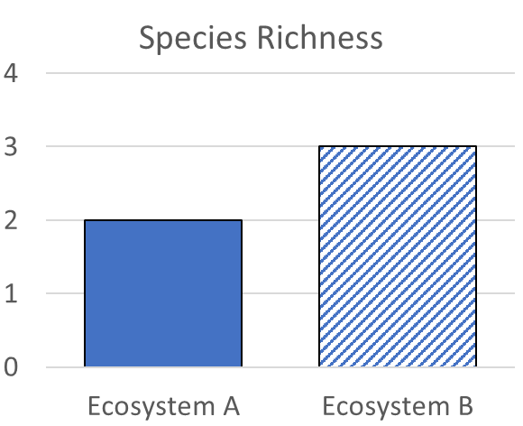
Directions: A 3x5 notecard with handwritten notes can be used to guide your answers. Your instructor may allow you to work in assigned groups. If so, have a different person write each response while others assist.

- Data for two ecosystems is shown here. Based on this data, what can we conclude about the a) ecosystem services, b) species redundancy, and c) ecosystem resiliency in one ecosystem compared to the other? Explain each term in your response.
Writer’s Name:

- Three students shared their ideas about why the mammoth went extinct. Do you agree or disagree with each student’s claim?
  - Nina: "I think that the mammoth went extinct because their environment changed dramatically when the ice age ended." Agree/ Disagree
  - Marisol: "I disagree. We learned that animals can have mutations that lead to adaptations if their environment changes. Mammoths were probably just hunted to extinction." Agree / Disagree
  - Bristol: “I think that mammoths evolved into the elephants that we have today and became a different species.” Agree / Disagree
- Which claim(s) is/are most accurate? Why?
Writer’s Name:

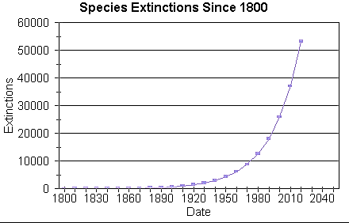
- The data provided here shows how the rate of extinctions are changing over time. In the space below, a) explain how the current rate of biodiversity loss compares to previous rates of extinction; and b) what we can expect to happen in the future if current trends continue. Use the data provided to justify your responses.
Writer’s Name:

- The current rate at which we are losing biodiversity is roughly 300 times faster than the rate at which dinosaurs went extinct. Will this impact human populations? Explain.
Writer’s Name:

