Genetic Modification Mini-Unit Packet

Score

□ Above & Beyond

□ Fully Complete

□ Mostly Complete

□ Incomplete – *fix the following pages*:

Name: Hour Date:

Date Packet is due:after Part 5 Why late?   
 If your work was late, describe why

**Semester Schedule**

**Traits & Genes**

Packet 1 - What determines the traits of an organism?

Packet 2 - How are traits inherited from parents?

Packet 3 – Can we predict traits?

Packet 4 - Assessment

**DNA & Proteins**

Packet 1: What is DNA and how does it work?

Packet 2: How does DNA affect protein assembly?

Packet 3 – Assessment

Packet 4 – How are new genes added to DNA? ***(****Mini-Unit)*

**Mutations & Change**

Packet 1: How does a protein acquire its shape & function?

Packet 2: How do mutations change genes & proteins? Packet 3: How can mutations lead to new traits & species?

Packet 4 – Assessment

Packet 5 – How Does Antibiotic Resistance Occur?

**Biodiversity & Extinctions**

Packet 1: How does biodiversity affect ecosystems?

Packet 2: How and why do extinctions occur?

Packet 3: Final Assessment

**Driving Question**: How are new genes added to an organism’s DNA?

**Anchoring Phenomenon**: We now know that DNA determines what proteins a cell creates, which determines it traits. Today it is increasingly common for researchers to add new genes to organism’s cells. How can a new gene be added to an organism’s cells? And why do the genes from one species work in a different species?

**Weekly Schedule**

**Part 1: Introduction**

* Initial Ideas – Moving genes
* Data Dive – Bt Corn
* Discussion & Developing Explanations

**Part 2: Core Ideas**

* Core Ideas
* Revisions of Part 1 Explanations

**Part 3: Investigation**

* Part 3: GMO Simulation

**Part 4: Review & Assessment**

* Ranking Your Readiness
* Formative Assessment & Mastery Check

**Part 5: Life Connections**

* Weekly Recap
* Life Connections – GMOs Pro/Con

**Deeper Questions**

1. Why would a gene from one species work in the cells of a different species?
2. How are genes removed and inserted into new genomes?
3. What is CRISPR-Cas9? How is it different from earlier versions of genetic modification?

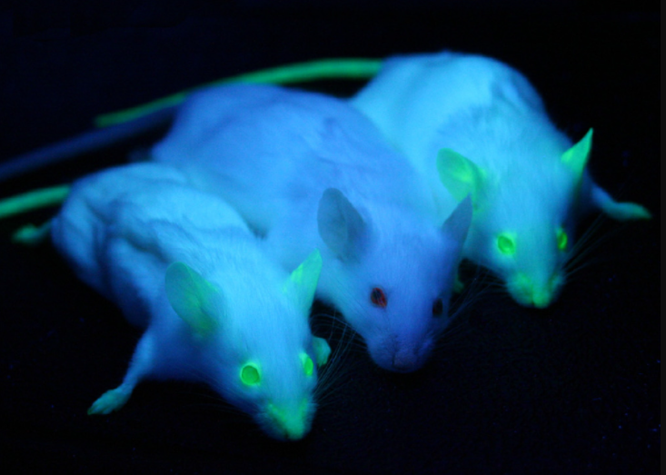

**NGSS Standards**:   
HS-LS1-1 - How the structure of DNA determines the structure of proteins and function.

HS-LS1-2 - How inheritable variations result from 1) changes via meiosis; 2) errors during replication; 3) mutations via environmental factors

HS-LS1-4: How mitosis and differentiation enable complex organisms.



Part 1: Introduction – Bt Corn

**Overview**: In this activity, you will begin by discussing your initial ideas about how genes can be moved to a new species.

**Initial Ideas**: Daryll’s is visiting family that live on a nearby farm. Daryll’s uncle is preparing to plant corn that produces its own insecticide. This reduces his need to spray harmful pesticides on his field that could harm helpful insects (such as pollinators like bees and butterflies). Daryll’s uncle explains that to create this corn, scientists added a gene from bacteria to the corn’s cells. Daryll is uncertain how this could even be possible. He discusses this with his friends at lunch when he returns. They each share their ideas.

1. **Do you agree or disagree with each student’s claim**?
   1. Daryll: "I think he is mistaken. The DNA of bacteria must be very different from the DNA of corn, so how could it work in the cells of corn?" Agree/ Disagree
   2. Avery: "Maybe bacteria and corn make proteins in the same way as each other?" Agree / Disagree
   3. Chandra: “I’ve heard that every organism has the same stuff in their DNA, so it would make sense that DNA from one species would work in another species.” Agree / Disagree
2. **Work in your small groups to discuss your ideas.** How are your ideas similar or different? Decide as a group whether each statement is correct (and why). Be prepared to present your ideas to the class.

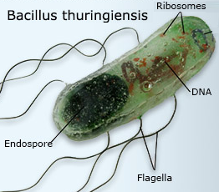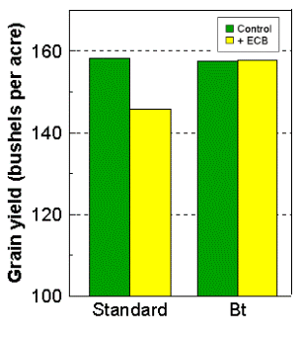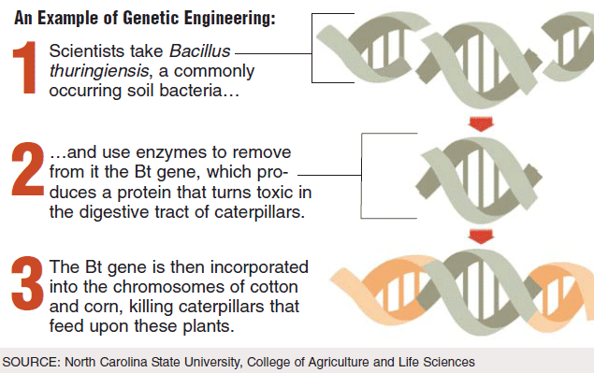**Data Dive**: In this data dive, you will make observations about how Bt corn was created using four images.  
A) This image shows the species of bacteria that naturally produces a protein that works as an *insecticide* (a substance that kills insects).   
B) This image summarizes how Bt corn was created.   
C) This image shows the difference in corn yields between the standard corn and Bt corn under two conditions: control (*no harmful insects*) vs. presence of the European Corn Borer (ECB) caterpillar, a harmful insect.   
D) This image shows a close-up of how genes are cut by enzymes so that they can be inserted into the DNA of a different species. (*Sources:* [*Image 1*](https://www.simply.science/resources/content/imagesv4/apupdate/biology/new+images/bacillus_huringiensis.jpg)*;* [*Image 2*](https://geneticliteracyproject.org/wp-content/uploads/2018/01/gene_splicing-ashz-0903101.gif)*;* [*Image 3*](http://corn.agronomy.wisc.edu/AA/A005.aspx)*;* [*Image 4*](http://www.bbc.co.uk/schools/gcsebitesize/science/triple_edexcel/using_biology/biotechnology/revision/5/))

D

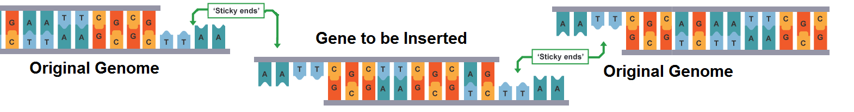

B

A

C

1. **Begin by individually attempting to make sense of these images**. What trends or patterns do you notice? How do they relate? How does this relate to any prior knowledge or experience that you have?
2. **Next, work in your teams to discuss your ideas**. Where do you agree? Where do you disagree? Can you use this data to reach agreement? Do others have prior knowledge/experience that could help?
3. **Based on this information, what is one conclusion you can make about how Bt corn is made?** 
   1. How is this conclusion supported by this data?
   2. What specifically suggests that your claim is accurate?
4. **Based on this information, what is a second conclusion you can make about how Bt corn is made?** 
   1. How is this conclusion supported by this data?
   2. What specifically suggests that your claim is accurate?
5. **How does this data pertain to the three claims from on the previous page?** (See Question #1 under *Initial Ideas*). Discuss as a team.
6. **Discussion & Developing Ideas**: As a class, discuss your ideas about this data. What are the ideas that most agreed on? Where did your ideas differ as a class? Record your ideas in the spaces below

We agree that…

We were unsure or disagreed about…

1. **How can genes be moved to different species?** Write down your initial explanation in the space below. Don’t worry if you aren’t completely sure about your answer! You will come back and revise this explanation as you gain more information during this unit.

Part 2: Core Ideas

**Overview**: In this activity, you will begin with a short slideshow presentation. This will provide you with core ideas that will help you clarify your initial ideas. Your instructor will decide on how to implement this portion depending on your previous experience and capabilities with this content.   
  
You will then work in small teams to answer the questions listed below. You should take notes in a notebook, on a dry erase board, or on scratch paper so that you are prepared to deliver your responses during the class discussion that will follow. *Note: your instructor may assign specific questions to your group if time is limited.*

**Intro Video**: <https://interactive-video-tool.biointeractive.org/activity/b64b2a00-ebc3-4354-b4d3-26ebf0698673>

**Core Ideas Presentation**: Genetic Modification Core Ideas

**Driving Questions**:

1. Explain how the following are similar and different: *genetic engineering, genome, GMO*.
2. How do the cells of a genetically modified organism know how to produce proteins using the new gene?
3. How are most genetically modified organisms created? In your response, include the following: *restriction enzyme, restriction site, sticky ends.*
4. Is it likely that you will encounter GMOs in your day to day life? Explain using examples.
5. How does CRISPR-Cas9 enable genetic modification? How is it different from earlier forms of genetic engineering?
6. Summarize the two main components of CRISRP-Cas9 and describe their function.
7. **Revising Explanations**: Return to your original explanation that you created at the end of Part 1. Based on this new information, how would you now respond to this question?

**How can genes be moved to different species?**

Part 3 Investigation: GMO Simulation

**Overview**: you will use paper models to explore how genes can be moved to new species.

**Background**: Restriction enzymes are proteins that can cut DNA at specific locations. Some restriction enzymes cut DNA in a way that creates fragments with "sticky ends". Sticky ends are single-stranded portions of DNA that ‘stick out’ from the strand. Two sticky ends will bind to each other if they have complementary bases (e.g., AATT will bind to TTAA).

To move a gene from one species to another, scientists cut both the gene and the new species’ DNA with the same restriction enzyme. The gene and the other species’ DNA will have matching sticking ends, enabling the gene to insert itself into the new genome.

You will be simulating this process using the instructions on the next page.

**Directions**

1. 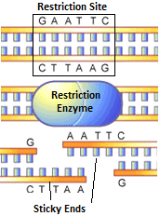First, use a pen or pencil to mark the gene and the genome for   
   how and where the *EcoRI* restriction enzymes would cut DNA.   
   Remember that *EcoRI* cuts DNA any time it encounters   
   the letters GAATTC. Use the image below as a guide.
2. Next, use a scissors to cut out the right side of this page  
   along the dotted line.
3. Third, cut out the gene and the genome.
4. 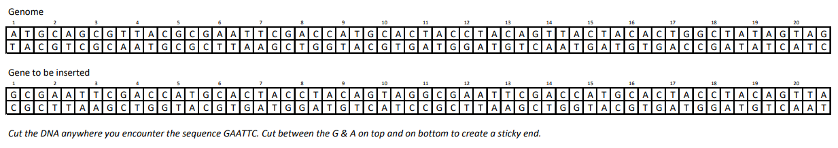Fourth, cut the gene and genome anywhere you find the   
   GAATTC sequence. IMPORTANT: cut the DNA at   
   these sites to produce sticky ends like you see in the   
   image above. You will cut the DNA in three places.
5. Fifth, prepare to use your paper models to demonstrate to   
   your instructor how restriction enzymes and sticky ends   
   enable new genes to be inserted into a species’ DNA.  
   Take time to prepare and rehearse how you will   
   demonstrate this. Consult your class materials if needed.   
   Be prepared to answer the following questions:
   1. *What is a sticky end? Why is it called that?*
   2. *What is a restriction enzyme? What does it do?*
   3. *How do restriction enzymes and sticky ends make   
      genetic engineering possible?*
   4. *How would a cell know how to use the inserted gene to   
      produce a protein? How would this change its traits?*
6. When you think you are ready to explain this process,   
   **raise your hand**. Your instructor will listen to your   
   explanation.   
     
   *This activity was successfully completed*   
   (*instructor signature*)

*This page is intentionally blank.*

Part 4: Review & Assessment

**Overview:** Rank each Driving Question in Part 2 as a 1 (*completely unsure*), 2 (*somewhat unsure*), or 3 (*completely sure*) based on your comprehension. Then work in teams to review each item and prepare a response. Next, write a final explanation below. You will conclude by completing a formative assessment.

**How can genes be moved to different species?**

Part 5: Life Connections – GMO Pro/Con

**Overview:** For this activity, you will work in teams to debate the benefits and drawbacks of using genetically modified organisms, particularly in regard to food production.

**Directions**:

1. Begin by visiting <https://www.procon.org/headlines/gmos-top-3-pros-and-cons/> (or type “GMOs – Top 3 Pros and Cons” into an internet search engine).
2. Begin by reading the overview section on GMOs at the top of the page. Work with your team to make sure everyone understands the key points of this reading.
3. Complete the table on the next page by summarizing the information on the website.
4. As a group, try to achieve a consensus on GMOs. What is your stance, and what evidence supports your stance? Record your final ideas below. Be prepared to discuss your ideas.
5. Determine whether this is a credible source for this topic and justify your stance with evidence and reasoning. Be prepared to discuss your ideas.

**What is your stance on GMOs?**

**Why is this your stance? What reasoning or evidence supports this?**



Genetic Modification Mini-Unit Formative Assessment

Name: Hour Date: Score: /

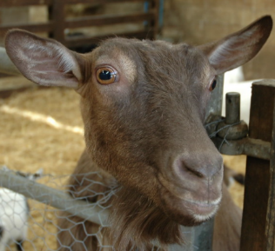  
**Directions**: A 3x5 notecard with handwritten notes can be used to guide your answers. Your instructor may allow you to work in assigned groups. If so, have a different person write each response while others assist.

Scientists have created genetically modified goats that produce spider silk proteins in their milk. These proteins can be used to create exceptionally strong materials. To accomplish this, they moved a gene from the spider genome to the goat’s genome.

1. **What is the difference between genetic engineering and a genetically modified organism (GMO)?** Include the terms *gene* and *genome* in your response.   
      
     
      
     
      
     
      
   *Writer’s Name:*
2. **How did restriction enzymes and “sticky ends” enable scientists to move a gene from the genome of a spider to the genome of a goat?**  
      
     
      
     
      
     
      
   *Writer’s Name:*
3. **How would a goat’s cell know how to read and use a gene from a spider?**  
      
     
      
     
      
     
      
   *Writer’s Name:*
4. The behavior and physical appearance of ‘spider goats’ is identical to any other goat. **If these goats have a spider gene added to their genome, why don’t they have eight legs, spin webs, etc.?**  
      
     
      
     
      
     
      
   *Writer’s Name:*
5. Spider goats were developed prior to the discovery of CRISPR-Cas9. **How does CRISPR-Cas9** **differ from the older forms of genetic engineering?**   
     
      
     
      
     
      
     
      
   *Writer’s Name:*
6. GMOs can be a controversial topic. What is your stance on this issue? **Do you think it is ok to move genes from one species to another? Why or why not? Explain your reasoning.**   
     
      
     
      
     
      
     
      
   *Writer’s Name:*