Traits & Genes Unit – Packet 2
Score
□ Above & Beyond
□ Fully Complete
□ Mostly Complete
□ Incomplete – fix the following pages:
Name: Hour Date:
Date Packet is due: after Part 5 Why late?
If your work was late, describe why
Semester Schedule
Traits & Genes
Packet 1 - What determines the traits of an organism?
Packet 2 - How are traits inherited from parents?
Packet 3 – Can we predict traits?
Packet 4 - Assessment

DNA & Proteins
Packet 1: What is DNA and how does it work?
Packet 2: How does DNA affect protein assembly?
Packet 3: How does a protein acquire its shape & function?
Packet 4 - Assessment

Mutations & Change
Packet 1: How do mutations change genes & proteins?
Packet 2: How can mutations lead to new traits & species?
Packet 3: How do mutations affect natural selection?
Packet 4 - Assessment

Biodiversity & Extinctions
Packet 1: How does biodiversity affect ecosystems?
Packet 2: How and why do extinctions occur?
Packet 3: Assessment

Driving Question: How are traits inherited from parents?

Anchoring Phenomenon: How do traits get passed from parents to offspring? And why are organisms slightly different from their parents and from each other? In this packet, we will focus on a black Labrador retriever named Zola, who gave birth to a wide variety of puppies. How is this possible? And how did her genes get passed on to her puppies?

Schedule

Part 1: Introduction
- Initial Ideas – Zola’s Puppies
- Data Dive – Ideas Over Time
- Discussion & Developing Explanations

Part 2: Core Ideas
- Core Ideas
- Revisions of Part 1 Explanations

Part 3: Investigation
- Meiosis Play-doh Modeling

Part 4: Review & Assessment
- Ranking Your Readiness
- Assessment

Part 5: Life Connections
- Packet Recap
- Life Connections – Sex-Linked Traits

Deeper Questions
- How do organisms of a species reproduce?
- How does reproduction affect diversity and species survival?
- How do reproductive cells (like sperm and egg cells) form?
- Why do offspring look similar but not identical to their parents?

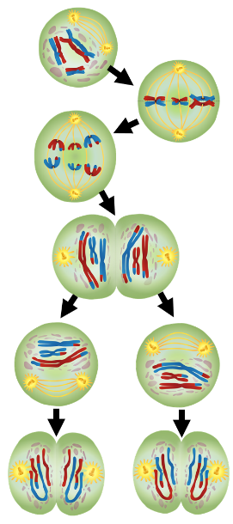
NGSS Standards: HS-LS1-4. Use a model to illustrate the role of cellular division (mitosis) and differentiation in producing and maintaining complex organisms.
HS-LS3-1 - Role of DNA/chromosomes as instructions for traits inherited from parents via meiosis
LS-LS3-3 - Predicting likelihood of different traits in a population/offspring
HS-LS1-4: How does mitosis and differentiation enable complex organisms?

Part 1: Introduction – Zola’s Puppies
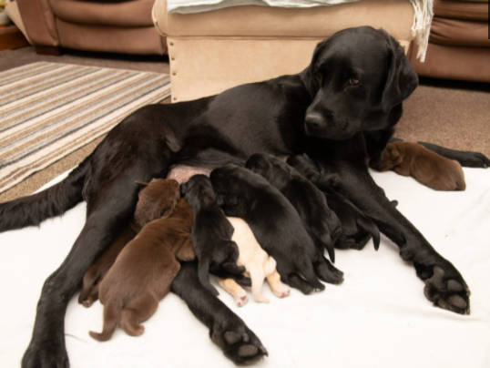
Overview: In this activity, you will begin by discussing ideas about how and why different organisms have different traits, and where the first cell of an organism comes from. You will use an example of a litter of puppies to guide your discussion. You will conclude with an initial explanation to address what determines the wide variety of traits among individuals of a species.

Initial Ideas: A black Labrador retriever named Zola recently gave birth to a litter of puppies. What was surprising was this litter contained black, yellow, and chocolate labs. How could it be possible for a black lab and a yellow lab to produce three different kinds of Labrador puppies?
Figure 1 - Image Source: ICCS.org
Figure 2 Image Source: People Magazine
Video: Next, use this link to view a news article on this story.

Three students shared their ideas about how this one dog could have three different kinds of puppies. Do you agree or disagree with each student’s claim?
  - Avery: " I think that some puppies inherited the mother’s genes, some inherit the father’s genes, and some had mutations." Agree / Disagree
  - Bristol: "I think that both parents had genes for all of these traits but whether or not the genes are used by a cell is completely random." Agree / Disagree
  - Chandra: “I think that maybe some genes skipped a generation but I don’t really understand what that means.” Agree / Disagree
- Work in your small groups to discuss your ideas. How are your ideas similar or different? Decide as a group whether each statement is correct (and why). Be prepared to present your ideas to the class.
Data Dive: In this data dive, you will read the following summary of how our understanding of how organisms inherit their genes and traits has changed over time. You will use this to develop an initial explanation for how organisms within a species acquire their unique characteristics.

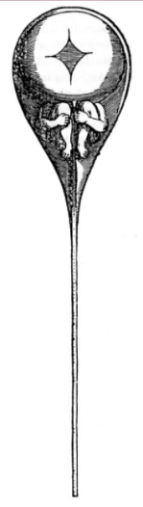
Nearly everyone has observed physical similarities between offspring and their biological parents. However, it took centuries of work to understand exactly how these traits were inherited, and why offspring looked similar but not identical to their parents.

Some thought that individual organisms were already preformed before birth. They thought that sperm cells contained a tiny, fully formed individual (as shown here ). These “preformists” based their beliefs on the observation that offspring have traits similar to their parents. However, this idea also lacked a mechanism to explain how it might work. Where did the tiny, preformed individual come from? And if the individual was already formed in one parent, why do offspring usually exhibit traits from both parents? Eventually, observations under a microscope provided clear evidence that tiny, preformed individuals did not exist inside sperm or egg cells.

The “Pangenesis Theory” argued an individual’s experiences determined their offspring’s traits. This was based on a belief that life experiences altered a body’s cells. A scientist named Galton tested this using blood transfusions in rabbits. He reasoned that if this were true, changing the blood would alter the offspring’s traits. However, the blood transfusions between rabbits did not change the offspring’s traits, disproving this idea.

In the mid-1800s, a monk named Mendel used pea plants to investigate heredity. He observed that some traits were almost always inherited by each generation of plants. Other traits only appeared under specific conditions. For example, fertilizing purple flowers with pollen from white flowers often resulted in offspring with all purple flowers. Sometimes, a cross between two parents would result in offspring that had completely different traits. For example, a cross between plants with purple flowers could result in a few offspring that had white flowers. This disproved the idea that the traits of offspring are simply a blend of both parents.
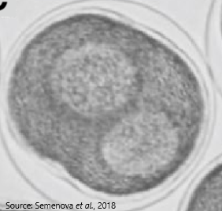
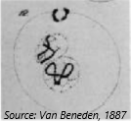
By the late 1800s, microscopes had improved greatly. This allowed scientists to make more accurate observations of the contents of cells. A scientist named Hertwig used a microscope to observe sperm cells as they fertilized egg cells in sea urchins (which had clear transparent cells). Hertwig noticed that the nucleus of the sperm cell fused with the nucleus of the egg cell (as seen here ). He also observed that this fertilized egg gave rise to all the other cells of the body. This suggested that genetic information was found within the cell nucleus.

A few years later, another scientist named Van Beneden used a microscope to observe that the nucleus of a cell sometimes contained “loops” (shown in this image ). When a sperm cell fused with an egg cell, the number of “loops” doubled inside the nucleus. He hypothesized that these loops (or chromosomes) were responsible for the visible traits of an organism.

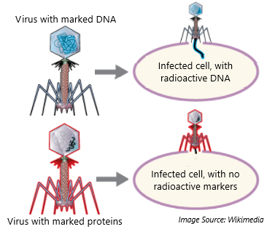
By the mid-1900s, scientists were uncertain whether proteins or a newly discovered substance called DNA provided the genetic information that determined traits. Scientists named Hershey and Chase used viruses to investigate this question further. A virus is a non-living combination of protein and nucleotides (the molecules that make up the DNA macromolecule). Viruses depend on other cells to reproduce. Importantly, they knew that viruses infect cells by injecting their genetic information into the cell. This causes the cell to produce more viruses instead of its normal functions.

To determine whether DNA or proteins were source of genetic information in cells, Hershey and Chase attached radioactive markers to the proteins in some viruses. In other viruses, they attached the radioactive markers to the nucleotides. When the viruses with radioactive proteins infected the cells, nothing changed. However, when the viruses with radioactive nucleotides infected the cell, these radioactive markers moved inside the cell. This confirmed that DNA was the primary source of genetic information.

- For each of the following, summarize their claims, evidence, and reasoning. If there was evidence to disprove this claim, address this as well. Your instructor will determine how to record your ideas.
a. Preformists b. Pangenesis Theory c. Mendel d. Hertwig e. Van Beneden f. Hershey & Chase
- How might these findings help to explain the variety of visible traits in Zola’s puppies? What else do we still need to know to answer this question?
- How do you think that traits are inherited from parents to offspring? Write down your initial explanation in the space below. You will revise this explanation throughout this packet.

Part 2: Core Ideas
Overview: In this activity, you will begin with a short slideshow presentation. This will provide you with core ideas that will help you clarify your initial ideas. Your instructor will decide on how to implement this portion depending on your previous experience and capabilities with this content.
You will then work in small teams to answer the questions listed below. You should take notes in a notebook, on a dry erase board, or on scratch paper so that you are prepared to deliver your responses during the class discussion that will follow. Note: your instructor may assign specific questions to your group if time is limited.

Core Ideas Presentation: https://bit.ly/WUHS-Bio-TraitsGenesW2
Driving Questions:
- What is the difference between sexual and asexual reproduction? What are the advantages and disadvantages of each?
- How was limited genetic diversity a cause of the Irish Potato Famine? How does this relate to asexual reproduction?
- What is a gamete? Why is it important for sexual reproduction?
- What is meiosis? How does it relate to gametes?
- What is the difference between a diploid and haploid cell?
- Why is it necessary for gametes to be haploid? What would occur if a gamete was diploid?
- What is the difference between mitosis and meiosis? How are they similar and how are they different?
- Why does a second round of division occur in meiosis? How does this affect the production of haploid gamete cells like sperm and egg cells?
- What is crossing over? How does it increase the genetic diversity of an organism’s offspring?
- How does crossing over relate to the genetic diversity and likelihood of survival of a species?
- What are linked genes? What determines if genes are linked?
- Summarize how gametes change during fertilization.
- Revising Explanations: Return to your original explanation that you created at the end of Part 1. Based on this new information, how would you now respond to this question?
How are traits inherited from parents to offspring?

Part 3 Investigation: Meiosis Modeling
Investigation Overview: In this investigation, you will be using Playdoh to model different aspects of meiosis, including crossing over.

Materials needed (per group of 4): at least 3 colors of Playdoh; scratch paper or a dry-erase board.

Methods: Check each box as you complete each step.
- ☐ Acquire a piece of scratch paper or a dry erase board as well as a pen, marker, etc.
- ☐ Use your notes to review the process of meiosis. You will need to model the following steps:
  - Duplication of DNA.
  - Condensing DNA into chromosomes.
  - Attaching chromosomes to spindles.
  - Crossing over between similar pairs of duplicated chromosomes.
  - Separation of chromosomes.
  - Initial cell division to create two diploid cells.
  - Second separation of unduplicated chromosomes.
  - Final cell division to create four haploid cells.
- ☐ Work as a team to determine a strategy for showing these steps. You should be able to show all steps simultaneously. Hint: use two Playdoh colors for the chromosomes. Use a third Playdoh color for the spindles. Use the paper or dry erase board to draw circles that depict the cell membranes.
- ☐ Determine which group members will explain each step of meiosis above using your models.
- ☐ When ready, raise your hand and explain your work to your instructor. Be prepared to also address the following questions:
  - What is the difference between mitosis and meiosis? How are they similar?
  - Does meiosis primarily pertain to sexual or asexual reproduction? What is the difference? What are the advantages and drawbacks of each?
  - How does meiosis relate to gametes like sperm and egg cells?
  - What is crossing over? How does it increase the genetic diversity of an organism’s offspring?
- ☐ Return items where needed based on your teacher’s instructions.
This activity was successfully completed (instructor signature)

Part 4: Review & Assessment
Overview: Rank each Driving Question in Part 2 as a 1 (completely unsure), 2 (somewhat unsure), or 3 (completely sure) based on your comprehension. Then work in teams to review each item and prepare a response. Next, write a final explanation below. You will conclude by completing a formative assessment.
How are traits inherited from parents to offspring?

Part 5: Life Connections – Sex-linked Traits
Directions: For this activity, you will consider three claims about color blindness. You will then use a one-page reading to determine if your initial ideas are supported by evidence.

Overview: Oscar recently learned he is color blind. He also learned this condition is more common among men than women. Oscar is uncertain as to how he could become colorblind as neither of his parents are color blind themselves (although his grandfather is also colorblind). Oscar and his friends discuss their ideas:
Oscar: I think that the cells in the eyes of males work differently from females, which results in an increased risk of some problems like color blindness.
Avery: I think that some genes are only inherited from the mother’s side of the family and these sometimes skip a generation somehow; maybe this is one of those traits(?)
Nina: I am pretty sure it has something to do with X and Y chromosomes. However, I thought that this determined a person’s biological sex, so I don’t know how that could also affect their eyes.

Who do you agree with and why? It’s ok to pick more than one person. Explain your thinking. In your
explanation, focus on resources and processes that support plant life and growth.
I most agree with the following: because

Reading: Next, complete this reading and accompanying questions. Be prepared to discuss your ideas.

X & Y Chromosomes
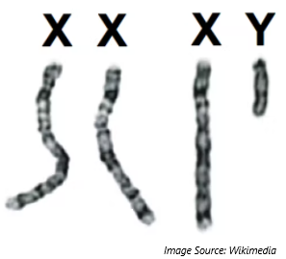
Most human cells contain 46 chromosomes. Half of a cell’s chromosomes (23) come from the male parent and half come from the female parent. Two specific chromosomes generally determine whether an animal is biologically female or male. In mammals, biological females usually have two X chromosomes (XX). Biological males usually have one X chromosome and one Y chromosome (XY). A specific gene on the Y chromosome called SRY turns on genes needed for traits that are biologically male.
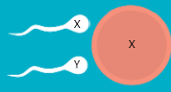
In most cases, individuals who inherit two X chromosomes are biologically female, and those who inherit an X and Y chromosome are biologically male. What primarily determines biological sex is whether a sperm cell carries an X or Y chromosome (the egg cell always contains an X chromosome).
Exceptions to XX & XY. In some instances, an individual could have XY chromosomes but not have an SRY gene due to movement or mutation of that gene. This would result in an individual who was chromosomally male (XY) but genetically female due to the absence of the SRY gene. Vice versa, an individual could have XX chromosomes but have the SRY gene on one X chromosome. This would result in an individual who was chromosomally female but genetically male due to the presence of the SRY gene. Individuals are usually completely unaware if their genetic sex and chromosomal sex are different unless genetically tested.

Similarly, biological sex can be determined by other factors. For example, varying hormonal levels during pregnancy can alter development. A common example of this occurs among male/female twins in cattle. Unlike humans, twins in cattle share a common blood supply. This causes hormones from the male twin to influence the development of the female twin. This changes the female twin’s reproductive tract before and after birth.

In other cases, an organism’s cells may lack functioning receptors for hormonal signals. Finally, in some cases a sperm cell may carry more than two sex chromosomes. For example, some individuals inherit two X chromosomes and a Y chromosome (known as Klinefelter syndrome), resulting in a mixture of what are usually male and female traits. The determination of whether an individual is biologically female or male is complex and due to a range of different factors.

Sex Linked Traits. Unlike other chromosome pairs, the X and Y chromosome share a different number of genes. While the X chromosome contains over 1400 genes, the Y chromosome only contains 158 genes. This means that for individuals with XY chromosomes, some genes (and traits) are only inherited from the mother. These are known as sex-linked genes.

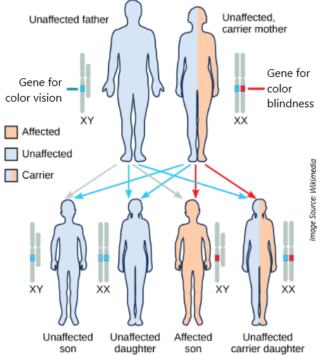
This is why color blindness is far more common among males than females. Individuals with XY chromosomes inherit only one copy of the color vision gene; this comes from their mother. If the mother carries a genetic mutation for color blindness, AND an egg cell receives this gene during meiosis, AND that egg is fertilized by a sperm carrying a Y chromosome, the resulting individual would be color blind. An individual with XX chromosomes would need to inherit a colorblind gene from both parents to be colorblind. The likelihood of this occurring is quite low.

This also means that individuals with XX chromosomes can carry a gene for colorblindness and pass it on to their offspring without being colorblind themselves. For example, if a woman’s father was color blind, he would pass on his X chromosome with the gene for color blindness to her. However, if she received a gene for full color vision from her mother, she would still see full color. This woman then has a 50% chance of passing on the X chromosome with the gene for colorblindness to her offspring. If the woman has a son with XY chromosomes, and if the son inherits the X chromosome with the colorblindness gene, then he will be colorblind even though his mother is not.

Questions (record your ideas using a whiteboard, scratch paper, an online document, or where instructed).
- How do chromosomes determine biological sex in most cases?
- Can other factors besides X and Y chromosomes determine biological sex? Explain?
- How are the X and Y chromosomes different from each other, and how are they different from the other 22 pairs of chromosomes in human cells?
- What is a sex linked trait? How is color blindness an example of a sex linked trait?
- Why is color blindness more common in males than females?
- Oscar’s grandfather on his mother’s side is colorblind, but his mother is not. How is this possible?
- Return to your ideas on the previous page. Based on what you now know, how would you respond to these three claims?

This page is intentionally blank. Use if needed for notes or other purposes.

Traits & Genes Unit - Packet 2 Formative Assessment
Name: Hour Date: Score: /
Directions: A 3x5 notecard with handwritten notes can be used to guide your answers. Your instructor may allow you to work in assigned groups. If so, have a different person write each response while others assist.

- What is the difference between sexual and asexual reproduction? What are the advantages and disadvantages of each?
Writer’s Name:

- Do you agree or disagree with each student’s claim?
  - Bristol: “I think that individuals mostly get either their mother’s or father’s genes.” Agree / Disagree
  - Nina: "I think that the traits of offspring are a mix of the traits of the parents." Agree / Disagree
  - Darryl: "I think that offspring equally receive half of each of their parent’s genes." Agree / Disagree
- Which claim seems most accurate? Why?
Writer’s Name:
- Explain what a gamete is and how it is formed during meiosis. Include and underline the terms diploid and haploid.
Writer’s Name:

- During meiosis, one regular cell will eventually form four haploid cells, each with a different set of DNA. Use the term crossing over to explain how one cell can form four genetically unique cells.
Writer’s Name:
- Domesticated animals with docile temperaments also tend to have floppy ears and short noses (see the images below) compared to similar undomesticated animals. Why does this occur? Include and underline the term linked genes.
Writer’s Name:

