Mutations & Change Unit – Packet 3
Score
□ Above & Beyond
□ Fully Complete
□ Mostly Complete
□ Incomplete – fix the following pages:
Name: Hour Date:
Date Packet is due: after Part 5 Why late?
If your work was late, describe why
Semester Schedule
Traits & Genes
Packet 1 - What determines the traits of an organism?
Packet 2 - How are traits inherited from parents?
Packet 3 – Can we predict traits?
Packet 4 - Assessment

DNA & Proteins
Packet 1: What is DNA and how does it work?
Packet 2: How does DNA affect protein assembly?
Packet 3 – Assessment
Packet 4 – How are new genes added to DNA? (Mini-Unit)

Mutations & Change
Packet 1: How does a protein acquire its shape & function?
Packet 2: How do mutations change genes & proteins? Packet 3: How can mutations lead to new traits & species?
Packet 4 – Assessment
Packet 5 – How Does Antibiotic Resistance Occur?

Biodiversity & Extinctions
Packet 1: How does biodiversity affect ecosystems?
Packet 2: How and why do extinctions occur?
Packet 3: Final Assessment

Driving Question: How can mutations result in new traits?

Anchoring Phenomenon: Last week we investigated how and why mutations occur. This week we will shift our focus to determine how changes from mutations can result in new species in response to competition and environmental pressures. We will explore how these processes result in changes that can result in new species over time.

Deeper Questions
- How do environmental conditions and competition affect whether mutations are helpful, harmful, or neutral?
- How and why do the traits of species sometimes change?
- Why do some species’ traits change faster than others?
- What factors determine whether a species’ traits will change?

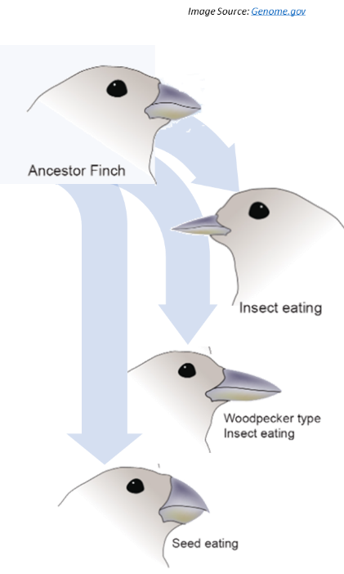
NGSS Standards:
HS-LS1-2 - How inheritable variations result from 1) changes via meiosis; 2) errors during replication; 3) mutations via environmental factors
HS-LS4-3 – How organisms with advantageous traits increase in proportion in their populations.
HS-LS4-4 - How natural selection leads to adaptations of populations.
HS-LS4-2 - Evolution is due to 4 factors: 1) reproduction; 2) heritable mutations; 3) competition; 4) enhanced survival & reproduction in comparison to individuals without beneficial mutations.

Weekly Schedule

Part 1: Introduction
- Initial Ideas – Changing Traits
- Data Dive – Natural Selection Lab
- Discussion & Developing Explanations

Part 2: Core Ideas
- Core Ideas
- Revisions of Part 1 Explanations

Part 3: Investigation
- PhET Natural Selection

Part 4: Review & Assessment
- Ranking Your Readiness
- Formative Assessment & Mastery Check

Part 5: Life Connections
- Antibiotic Resistance Investigation Set-up

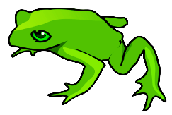
Part 1: Introduction – Natural Selection Lab
Overview: In this activity, you will begin by discussing your initial ideas about how species’ adaptations can emerge as a result of mutations. (Image Source: SVG)

Initial Ideas: Due to differences in their genes, different kinds of tree frogs have different rates of survival & reproduction in some environments compared to others. Green tree frogs are more prevalent in wetlands with lush vegetation. Gray tree frogs are more common among hardwood trees with gray bark.
- Three students shared their ideas about how and why different kinds of tree frogs exist. Do you agree or disagree with each student’s claim?
  - Marisol: "I think that a frog turns green or gray depending on where it is found; for example, tree frogs turn green if they’re born in a wetland or gray if they’re born in a forest." Agree / Disagree
  - Daryll: "I disagree. I think that the frogs are already green or gray when they’re born. Their DNA doesn’t change, just their survival rate." Agree / Disagree
  - Nina: “I don’t agree. DNA can definitely change from mutations. I just think the mutations happen regardless of what environment the frogs live in.” Agree / Disagree
- Work in your small groups to discuss your ideas. How are your ideas similar or different? Decide as a group whether each statement is correct (and why). Be prepared to present your ideas to the class.
Data Dive: you will model how the environment affects survival and reproduction. Your “environment” will be a newspaper. Your “organisms” are colored squares of paper. Students will each act as a “predator” and remove the first squares of paper that they see. You will then compare survival rates among your paper squares and infer how each kind of environment affected these outcomes.
Materials per Group: one large sheet of newspaper; 12 squares of paper (3 black, 3 red, 3 white, 3 newspaper)
- Lay out the sheet of newspaper so that it lies flat on your desk.
- The oldest person in your group will be the first “predator”. Have them turn their back to the newspaper.
- The remaining group members should arrange the squares of paper evenly on the sheet of paper.
  - DO NOT overlap or conceal any of the pieces of paper.
  - One group member must volunteer to be the counter; the other is the starter (they say “GO”)
- On “GO”, the ‘predator’ student turns around and grabs as many pieces of paper as they can with ONE hand while another group member counts to FIVE (e.g., one-one-thousand, two-one-thousand…). The predator should only grab one piece of paper at a time using only their thumb and forefinger.
- Record how many paper squares (black, red, etc.) remained after Round 1 in the table below.
- Return the paper to the pile so that none overlap.
- Repeat these steps three more times. A different person should act as the predator each time.
Color Round 1 Round 2 Round 3 Round 4 Total
Black
Red
White
Newspaper
- Begin by individually attempting to make sense of what happened in this activity. What trends or patterns did you notice? How does this relate to any prior knowledge or experience that you have?
- Next, work in your teams to discuss your ideas. Where do you agree? Where do you disagree? Can you use this data to reach agreement? Do others have prior knowledge/experience that could help?
- Based on this data, what can you conclude about the effects of the environment on the “survival” of the paper square organisms? Why did some colors survive better than others?
  - How is this conclusion supported by evidence and reasoning?
  - What specifically suggests that your claim is accurate?
- If these were real organisms (and not just paper squares), what would explain the differences in their appearance? How would this relate to 1) DNA, 2) proteins, 3) mutations, and 4) traits?
  - What evidence or reasoning supports your explanation?
  - What specifically suggests that your claim is accurate?
- How does this data pertain to the three claims from on the previous page? (See Question #1 under Initial Ideas). Discuss as a team.
- Discussion & Developing Ideas: As a class, discuss your ideas about this data. What are the ideas that most agreed on? Where did your ideas differ as a class? Record your ideas in the spaces below
We agree that…
We were unsure or disagreed about…
How do environmental factors determine whether a mutation is helpful, harmful, or neutral? Write down your initial explanation in the space below. Don’t worry if you aren’t completely sure about your answer! You will come back and revise this explanation as you gain more information during this unit.

Part 2: Core Ideas
Overview: In this activity, you will begin with a short slideshow presentation. This will provide you with core ideas that will help you clarify your initial ideas. Your instructor will decide on how to implement this portion depending on your previous experience and capabilities with this content.
You will then work in small teams to answer the questions listed below. You should take notes in a notebook, on a dry erase board, or on scratch paper so that you are prepared to deliver your responses during the class discussion that will follow. Note: your instructor may assign specific questions to your group if time is limited.

Intro Video: https://www.yout-ube.com/watch?v=M3bROOvWMcM

Core Ideas Presentation: Packet 3 Core Ideas
Driving Questions:
- What determines whether mutations are beneficial, harmful, or neutral?
- What is a silent mutation? What is an adaptation? Why do some mutations result in genetic diseases, while others are silent, while others result in adaptations?
- Why do some birds, like vultures and ostriches, lack some or all of the feathers on their head? How did this change occur, and why is it prevalent in some birds but not others?
- Some species, like sharks and crocodiles, have changed very little since the time of the dinosaurs. Why do some species change extensively over time while others show little evidence of change?
- What is natural selection? How does natural selection relate to changes to traits from mutations?
- How are green and gray tree frogs an example of natural selection?
- What is the difference between natural selection and artificial selection?
- What is evolution? How is evolution similar but different from natural selection?
- Summarize and explain the four factors that are necessary for evolution to occur.
- What is a species? How does evolution by natural selection result in new species?
- “Mutations occur randomly and independently from the environment.” What does this mean?
- What evidence suggests that evolution by natural selection can occur? Address each of the following: homologous structures; analogous structures; vestigial structures; DNA; fossils; and measurable evolution.
- Revising Explanations: Return to your original explanation that you created at the end of Part 1. Based on this new information, how would you now respond to this question?
How do environmental factors determine whether a mutation is helpful, harmful, or neutral?
Summarize how environmental factors affect the pace at which species’ traits change over time.

Part 3 Investigation: PhET Natural Selection
Overview: In this investigation, you will use a computer simulation to investigate how species change in response to natural selection.
Pre-Investigation Questions: Work as a group to determine the best response to each question. Be prepared to provide verbal responses for these questions for your instructor before you complete the investigation.
- What factors most affect whether a mutation is helpful, harmful, or neutral?
- Why do some species change more rapidly than others?
- What is the difference between natural selection and evolution? How they both similar and different?
- What are the four key factors that determine whether species change in response to natural selection?
When you think you are ready, raise your hand. Your instructor will listen to your verbal responses.
This activity was successfully completed (instructor signature)

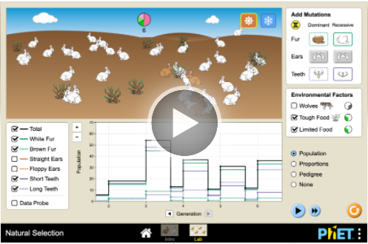
Methods: Check each box as you complete each step.
First Simulation
- ☐ First, use an approved devise and visit https://phet.colorado.edu/en/simulations/natural-selection/ (or use an internet search engine and search “PhET Natural Selection”). Your screen should resemble this
- ☐ Second, click the Play arrow button. Then click “Intro”.
  - In the “Add Mutation” box in the upper right, click the brown fur button under “Dominant”.
  - Click “Limited Food” in the “Environmental Factors” box. Leave “Wolves” unclicked for now.
  - In the box in the bottom left, click “Data Probe”.
  - Click the sun icon in the upper right (next to the snowflake).
  - Complete your predictions on the next page.
- ☐ Next, click the yellow “Add Mate” button. Let the program run until it reaches the 3rd generation.
- Click “Pause” once it reaches Generation 3 (do not go past 3.5). Record your data on the next page.
  - Be sure to drag the gray line to the appropriate generation when recording data; e.g., if the gray line is not between 3 and 4, it will not show the data for the third generation of rabbits.
- ☐ Next, click “Wolves” under “Environmental Factors”. Record your predictions on the next page. Click “Play”. Pause the simulation after Generation 6. Record your data on the next page.
- ☐ Click the “Snow” icon (upper right). Keep the wolves box clicked. Record your predictions on the next page. Click “Play”. Pause the simulation after Generation 10. Record your data on the next page.

Predictions & Data – First Simulation:

- Prediction 1: There are two traits for rabbits in this simulation – brown vs. white fur. Brown fur is dominant to white. Which trait do you think will be more prevalent by the end of the simulation? Why?

- Prediction 2: Do you think that the addition of wolves will affect the percentage of rabbits with brown vs. white fur? Explain.

- Prediction 3: Do you think that the transition from warm to snowy conditions will affect the percentage of rabbits with brown vs. white fur? Explain.

- Use the table below to record your data after each round of the simulation.
 | Total Population of Rabbits | White Fur Total Population | % White Fur (White Fur/Total) | Brown Fur Total Population | % Brown Fur (Brown Fur/Total)
Initial
Start of Generation 3
(limited food)
Start of Generation 6
(wolves added)
Start of Generation 10
(transition to snow)

- Were your predictions accurate? Explain.

Second Simulation
- ☐ Click the “Lab” button at the center bottom of the screen.
  - Click all of the boxes in the white box in the lower left.
  - In the white box in the upper right, click all of the boxes in the “Dominant” column for fur, ears, and teeth. Complete your predictions on the next page.
- ☐ Next, click the yellow “Add Mate” button. Let the program run until it reaches the 3rd generation.
- ☐ Click “Pause” once it reaches Generation 3 (do not go past 3.5). Record your data on the next page.
- ☐ Next, click “Tough Food” under “Environmental Factors” to simulate the transition to more woody plants. Click “Play”. Pause the simulation after Generation 6. Record your data on the next page.
- ☐ Click the “Snow” icon (upper right). Record your predictions on the next page. Click “Play”. Pause the simulation after Generation 9. Record your data on the next page.
- ☐ Click “Wolves” under “Environmental Factors”. Click “Play”. Pause the simulation after Generation 12. Record your data on the next page.
- ☐ Complete the remaining questions. Be prepared to discuss and defend your ideas for the class.
Predictions & Data – Second Simulation:
- Predictions: White fur, straight ears, and short teeth are dominant traits. You will slowly change the environment by adding woody vegetation, snowy conditions, and wolves. For each option, circle the traits you expect to be most prevalent in this population by the final generation and explain why.
Brown / White Fur because …
Straight / Floppy Ears because …
Short / Long Teeth because …

- Use the table below to record your data after each round of the simulation.
 | Total Population of Rabbits | % White Fur (White Fur/Total) | % Brown Fur (Brown Fur/Total) | % Straight Ears (SE/Total) | % Floppy Ears (FE/Total) | % Short Teeth (ST/Total) | % Long Teeth (LT/Total)
Initial
Start of Generation 3
Start of Generation 6
(tough food)
Start of Generation 9
(transition to snow)
Start of Generation 12
(wolves added)

- Based on the data you recorded, which had a greater impact on fur color, a) whether the trait was dominant or recessive, or b) the environmental conditions? Explain and justify with data.

- Did the rabbit color change more drastically when the snow was introduced, or when the wolves were introduced? Why do you think this was the case? Support your argument with data (Gen. 9 vs. 12).

Class Discussion Questions: discuss within your groups; then be prepared to defend your ideas to the class.
- Briefly summarize how changes from mutations affected a) the rabbits’ DNA, b) their proteins & cells, c) the bodies of the rabbits, and d) the rabbit populations.
- Three different mutations resulted in new traits (brown fur, floppy ears, and long teeth). Were these acquired or hereditary mutations? Explain what these terms mean and justify your ideas with evidence.
- The second simulation involved three mutations. Two traits (fur color, teeth size) were directly affected by environmental conditions. One trait (floppy ears) was not. Did this have any impact on the change in prevalence of each trait? How does this relate to the environmental factors that affect evolution by natural selection?
- What affected the rabbit color more, a) whether or not the conditions were snowy, or b) whether or not there were predators? Why? Explain and support your claims and ideas with evidence.
- Did these mutations happen because of changes to environmental conditions, or did these mutations occur independently of environmental conditions?
- Which would result in a faster rate of change, a) an environment with plentiful vegetation and minimal predators, or b) an environment with limited vegetation and more predation? Explain.
- Four factors are necessary for evolution by natural selection to occur: 1) sexual reproduction, 2) heritable genetic variation, 3) competition, and 4) differences in survival & reproduction. Determine whether each of these factors were present in this simulation and justify your claims with evidence.

Part 4: Review & Assessment
Overview: Rank each Driving Question in Part 2 as a 1 (completely unsure), 2 (somewhat unsure), or 3 (completely sure) based on your comprehension. Then work in teams to review each item and prepare a response. Next, write a final explanation below. You will conclude by completing a formative assessment.
How do environmental factors determine whether a mutation is helpful, harmful, or neutral?
Summarize how environmental factors affect the pace at which species’ traits change over time.

Part 5: Life Connections – Antibiotic Resistance
Overview: This activity involves the initial stages of a multi-day investigation. You will be investigating how populations of bacteria change in response to antibiotics. You will use this activity to model and observe how evolution by natural selection occurs among species. You will be starting these steps today because it will take time for bacteria to grow on your petri dishes.

Needed Materials: petri dishes with agar; bacterial samples; sterile cotton swabs; micro-centrifuge tubes; permanent markers; incubator; paper disks (cut from filter paper w/ a hole punch); tweezers; samples of antibiotics (antibacterial soaps and antibiotic creams work well).

Intro Video: https://ed.ted.com/lessons/how-antibiotics-become-resistant-over-time-kevin-wu
Methods:
- At an earlier time, your instructor should acquire laboratory-grown samples of bacteria in test tubes with agar gel. They should also prepare your paper disks and pre-determine which antibiotic/disinfectant samples will go in each quandrant (1-4) of the petri dish.
- Sanitize your lab bench or work area using either a) alcohol wipes or b) by spraying a disinfectant (e.g., Lysol) and wiping with a clean paper towel.
- Sanitize your hands by washing with soap or using hand sanitizer.
- Acquire a petri dish, vial of bacteria, a sterile cotton swab, and samples of antibiotics (such as antibiotic ointment or antibiotic soaps). Do NOT open these items
- Use a permanent marker to divide the bottom of your petri dish into quadrants and number them 1-4.
- Label the bottom of the Petri dish with your last names, class period, and the date (keep the writing very small and only on the very edges of the petri dish).
- Open the cotton swab. Moisten the swab with sterile water
- Use the swab to acquire a sample of bacteria from your test tube.
- Partially open the lid of the petri dish with the opening facing away from you (this will reduce the likelihood of accidental contamination).
- Gently spread the soaked cotton swab across the surface of the agar gel so that it is evenly distributed across the entire surface. Rotate the swab as you do so. Close the lid of the petri dish when finished.
- Acquire four paper disks. Soak three of the disks in different samples of antibiotics provided by your instructor. Soak the fourth disk in sterile water (this will be the control). After you soak each disk, place it on the petri dish – your instructor will determine which quadrant will contain each disk. Make sure to use the tweezers to place each disk into the petri dish.
- Place the plates on their lids and keep in an incubator at 37°C for at least 24 hours (petri dishes should be stored upside down so that the agar nutrient gel is on top and the lid is on the bottom to reduce the risk of accidental contamination).
This page is intentionally blank.

Mutations & Change Unit – Packet 3 Formative Assessment
Adapted from STEM Teaching Tools
Name: Hour Date: Score: /
Directions: A 3x5 notecard with handwritten notes can be used to guide your answers. Your instructor may allow you to work in assigned groups. If so, have a different person write each response while others assist.

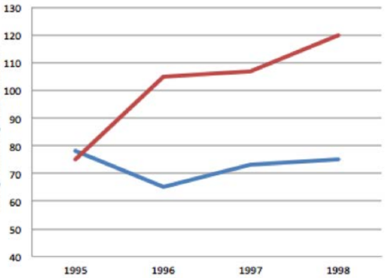
Background Info: Green anoles are a lizard that lives in trees in Florida. A similar species called brown anoles invaded Florida from Cuba. Brown anoles eat similar food as the green anoles. Brown anoles also eat the newly hatched babies of green anoles.
Islands with Brown Anoles

Scientists measured the average height at which green anoles were found in trees (perch height) before and after the invasive brown anoles arrived. This graph shows the data they collected on perch height.
Average Perch Height (cm)
Islands without Brown Anoles

Next, scientists knew that living higher in the trees required larger footpads and more sticky scales on the anoles’ feet. Scientists collected data to investigate whether or not the traits of green anoles changed because of the invasion of the brown anoles. Their data is below.
 | Green Anoles on an Island WITHOUT Brown Anoles | Green Anoles on an Island WITH Brown Anoles
Average Perch Height in Trees | 70 cm | 120 cm
Average Size of the Toe pads | 1.27 cm | 1.33 cm (4.5% increase)
Avg. Number of Sticky Scales on Feet | 51 sticky scales | 54 sticky scales (6.5% increase)

- What was the hypothesis, rationale, and control in this experiment?
Writer’s Name:
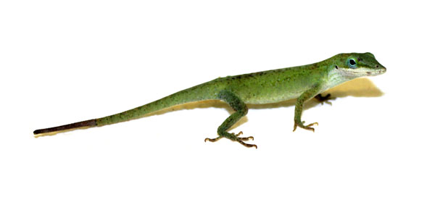
- What patterns do you see in the data above? How do the traits of the green anoles differ between populations on islands with brown anoles compared to islands without brown anoles?
Writer’s Name:
- When the brown anoles invaded, scientists noted that they ate similar food and lived in similar habitats as the green anoles. Why does this matter for the survival of the green anoles? How might this affect the rate of change in the adaptations of this species?
Writer’s Name:
- How did the changes to sticky scales & footpads occur? What caused these changes to these traits?
Writer’s Name:
- Four factors are necessary for evolution to occur. Explain whether or not each of the following four factors are present in the example of the green anoles. Justify your claims with evidence.
Sexual Reproduction:
Heritable Genetic Variation:
Competition:
Repro/Survival Rates:
Writer’s Name:
- If green anoles were affected by a new predator, would the rate of change in their traits increase, decrease, or stay constant? Make a prediction and justify with evidence.

Writer’s Name:

