Mutations & Change Unit - Packet 5
Score
□ Above & Beyond
□ Fully Complete
□ Mostly Complete
□ Incomplete – fix the following pages:
Name: Hour Date:
Date Packet is due: after Part 5 Why late?
If your work was late, describe why
Semester Schedule
Traits & Genes
Packet 1 - What determines the traits of an organism?
Packet 2 - How are traits inherited from parents?
Packet 3 – Can we predict traits?
Packet 4 - Assessment

DNA & Proteins
Packet 1: What is DNA and how does it work?
Packet 2: How does DNA affect protein assembly?
Packet 3 – Assessment
Packet 4 – How are new genes added to DNA? (Mini-Unit)

Mutations & Change
Packet 1: How does a protein acquire its shape & function?
Packet 2: How do mutations change genes & proteins? Packet 3: How can mutations lead to new traits & species?
Packet 4 – Assessment
Packet 5 – How Does Antibiotic Resistance Occur?

Biodiversity & Extinctions
Packet 1: How does biodiversity affect ecosystems?
Packet 2: How and why do extinctions occur?
Packet 3: Final Assessment

Driving Question: How do mutations enable bacteria to evolve resistance to antibiotics?

Anchoring Phenomenon: We have seen how in some cases, mutations can lead to adaptations that increase the ability of an organism to survive and reproduce. In this unit, we will explore this more deeply through the issue of how bacteria can evolve to avoid antibiotics.

Weekly Schedule

Part 0: Lab Set-up (previous week)
- Setting Up Petri Dishes Using Existing Methods

Part 1: Introduction
- Review of Core Ideas
- Planning & Carrying Out Existing Investigations

Part 2: Data Collection & Analysis
- Data Collection
- Reporting Findings

Part 3: Experimental Design
- Planning & Carrying Out A New Investigations

Part 4: Lab Set-up
- Setting Up Petri Dishes Using New Methods

Part 5: Scientific Writing
- Mastery Check – Planning & Carrying Out an Investigation
- Preparing a Report of an Investigation

Part 6-9: Data Collection, Analysis, & Reporting
- Reporting the Results of Your Investigation

Deeper Questions
- How do mutations enable some bacteria to reduce their susceptibility to antibiotics?
- How is antibiotic resistance an example of natural selection?
- Could antibiotic resistance cause the evolution of new bacterial species?
NGSS Standards:
HS-LS1-2 - How inheritable variations result from 1) changes via meiosis; 2) errors during replication; 3) mutations via environmental factors
HS-LS4-3 – How organisms with advantageous traits increase in proportion in their populations.
HS-LS4-4 - How natural selection leads to adaptations of populations.
HS-LS4-2 - Evolution is due to 4 factors: 1) reproduction; 2) heritable mutations; 3) competition; 4) enhanced survival & reproduction in comparison to individuals without beneficial mutations.

Part 1A: Introduction
Overview: In this activity, you will begin with a short reading about bacteria and antibiotic resistance. You will then use this to review core ideas from the Mutations & Change unit.

Initial Ideas: Avery was recently diagnosed with strep throat caused by a bacterial infection. Avery’s physician explained that Avery needed to continue taking the antibiotics even after she felt better to fully treat the infection. Failure to take the full dose of antibiotics could result in antibiotic resistance. Bacteria that are resistant to antibiotics are not killed by these treatments and continue to cause an infection.
- Three students shared their ideas about how and why antibiotic resistance occurs. Do you agree or disagree with each student’s claim?
  - Avery: "I think that antibiotic resistant bacteria know that they are being attacked and learn to evolve adaptations to avoid these attacks (kind of like a zebra running from a lion)." Agree / Disagree
  - Oscar: "I disagree. I don’t think bacteria and viruses are alive. They don’t have DNA. It is really just whether the dose of the chemicals is strong enough to kill all of them." Agree / Disagree
  - Nina: “I’m not sure I agree with that. I think some bacteria are just lucky enough to have a combination of traits that reduce their susceptibility. All other bacteria just die.” Agree / Disagree
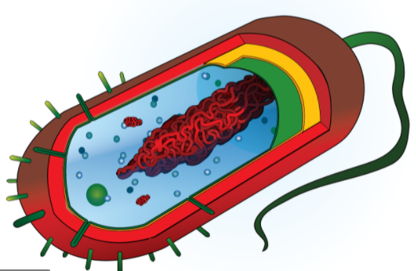
- Work in your small groups to discuss your ideas. How are your ideas similar or different? Decide as a group whether each statement is correct (and why). Be prepared to present your ideas to the class.
Image source: Pixabay
Data Dive: Complete this short reading about bacteria. Then determine how these concepts relate to mutations, natural selection, and evolution.

What are Bacteria? Bacteria are single-celled organisms. Most bacterial cells consist of only a membrane, DNA, and ribosomes (as shown here ). Human bodies are home to many different kinds of bacteria. Most bacteria are not harmful. They often support bodily functions like digestion.

Some bacteria are harmful and cause infections. Fortunately, most bacterial infections can be treated with antibiotics. There are several different ways in which antibiotics work. Some kill bacteria by breaking open their membrane. Some antibiotics interfere with DNA duplication. Some prevent bacteria from assembling proteins. Other antibiotics prevent bacteria from performing cellular respiration.

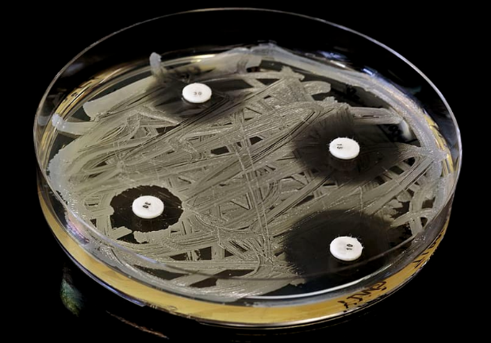
Antibiotics were first discovered by Alexander Fleming in 1928. This discovery happened mostly by accident. Dr. Fleming was growing bacteria in dishes filled with agar (a nutrient-rich gel). Some of the agar became contaminated with mold. Dr. Fleming observed that this mold stopped the growth of bacteria. Fleming’s investigation led to the discovery of the first antibiotic, penicillin.
Image source: Piqsels

What is Antibiotic Resistance? The discovery of antibiotics made it possible to cure diseases that once killed many people. Most or all bacterial cells are killed by a dose of antibiotics. However, overuse of antibiotics has resulted in the growing problem of antibiotic resistance. This occurs when some bacteria are no longer susceptible to antibiotics.
Because of random mutations, some bacteria have developed traits that enable them to avoid the effects of antibiotics. Some bacteria can avoid absorbing the drug through their cell membrane. Others produce extra copies of the cell structure affected by the antibiotic (e.g., extra ribosomes). Some produce enzymes that break down the antibiotic. Finally, some have protein pumps to actively remove the antibiotic from their cells. Bacteria with these new traits are more likely to survive, reproduce, and pass these traits to other bacteria.

Over time, bacteria with these adaptations become increasingly prevalent. This causes antibiotics to become less and less effective. One of the most concerning examples of antibiotic resistance is MRSA. MRSA stands for Methicillin-resistant Staphylococcus aureus (methicillin is a type of antibiotic, and Staphylococcus aureus is a specific type of bacteria). MRSA infections are difficult to treat because these bacteria are resistant to several kinds of antibiotics.
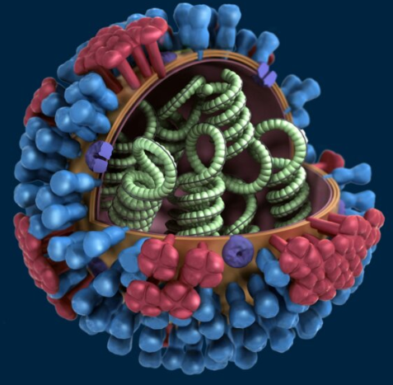
Image source:: Pixnio
How are Viruses Different? Bacteria are very different from viruses, another common cause of disease. Unlike bacteria, viruses are non-living. Viruses are simply a protein shell filled with either DNA or RNA (as shown here ). Viruses do not consume food and cannot reproduce on their own. To reproduce, viruses “hijack” living cells and inject their DNA. This forces the infected cell to produce more viruses. These can then infect other cells.

The most effective way to reduce the risk of a viral infection is through the use of vaccines. Most vaccines consist of a weakened virus or a part of a virus. This enable the body’s immune system to identify the virus shortly after it invades the body and respond more quickly to stop the infection.

Questions: Discuss in small groups. Your instructor will determine how to record your ideas (e.g., whiteboards, scratch paper, online document, etc.). Be prepared to discuss your ideas as a class. Alternatively, your instructor may choose to meet with your group individually when you are ready.
- What are bacteria? How are they different from other organisms? Do all bacteria cause infections?
- What is an antibiotic? What are the different ways in which antibiotics can stop bacterial infections?
- Briefly summarize how and why antibiotic resistance is becoming a growing problem in medicine.
- How might the problem of antibiotic resistance relate to each of the following? A) mutations; B) natural selection; C) evolution.
- Summarize the concerns and causes of MRSA infections. Then work as a team to determine whether or not MRSA is a new species of bacteria. Support your ideas with specific evidence and reasoning.
- Usually the common cold and the flu are caused by viruses. Would antibiotics be effective for treating these diseases? Why or why not?
When you think you are ready, raise your hand. Your instructor will listen to your responses. If you are ready to move on, they will sign below.
This activity was successfully completed (instructor signature)

Part 1B: Planning & Carrying Out Investigations
Overview: In this activity, you will determine how to effectively plan and conduct a systematic scientific investigation. You will contextualize this work using antibiotic resistance as an example.

Instructions: Complete the reading below and use this to answer the accompanying questions. Base your responses on the work you started earlier on antibiotic resistance and on the information provided here.

Reading: In the investigation you started earlier, you are comparing how bacterial growth and reproduction is affected by different treatments of antibiotics and/or disinfectants. In this experiment, a petri dish of agar (a nutrient-rich gel) is coated with a sample of bacteria. Paper disks soaked in either a sample of antibiotic or disinfectant are placed on the agar gel (one paper disk should be soaked in sterile water as a control). Finally, the petri dishes are placed in an incubator for at least 24 hours. Your instructor will determine the different types of antibiotic and/or disinfectant treatments you will test for this portion of the investigation.

Soon you will determine the impact of the antibiotic on bacterial growth by measuring the clear area (called the zone of inhibition) around each paper disc. The greater the size of the zone of inhibition (in millimeters), the greater the impact of the antibiotic on stopping the growth and reproduction of bacteria.

Questions:
- To begin, we need to determine our research question. A research question is what we’re trying to figure out during an investigation. Fill in the blanks below:
We are trying to figure out
- Now develop your hypothesis. A hypothesis is like a guess or a prediction – it is how you would answer your research question based on your existing knowledge. Fill in the blanks below:
We think that
- Now provide a rationale for your hypothesis. A rationale simply states why you think your hypothesis might be right; it provides some evidence and/or logic that supports the validity of your hypothesis.
We think this because:

- Every experiment has two important components – a dependent variable & an independent variable.
An independent variable is the thing you purposely changed to test your hypothesis and answer your research question. Generally speaking, an experiment should only have one independent variable.
What is your independent variable?
A dependent variable is the thing that you measure to determine if your hypothesis is correct. It is the data you collect to answer your research question. You can have more than one dependent variable, but it needs to relate to your hypothesis.
What is your dependent variable(s)?
- A control is a part of your experiment that does not receive any treatment. It is needed so that we have something to compare to. A control helps us to determine the extent to which our independent variable (what we changed) affected our dependent variable (what we measured).
In this experiment, what is your control?
- Sample size and trials affect the validity of your findings. Sample size refers to how many points of data will be collected. Trials refer to the number of times you will repeat the experiment under the same conditions. The larger the sample size and the more trials you perform, the more useful and valid your findings are for answering your research question.
What is your sample size (how many points of data are collected per class)?
How many trials will your class run? How might your sample size and number of
trials affect the validity of your findings?
- Constants are the conditions that are kept the same between each replicate. If possible, an experiment should not be performed under changing conditions. This would make it impossible to determine whether our results were affected by our independent variable or by other changes. This would make our results less useful for answering our research question and for determining if our hypothesis is accurate.
What is being kept constant in this experiment?

- When scientists report their findings, they include a detailed explanation of their methods & materials. This enables other researchers to replicate their work to see if they can obtain the same findings. This also affects the claims a researcher can make about their findings. An experiment with more robust methods enables researchers to make stronger claims about the validity of their findings.
What materials were needed to complete this experiment? List all below:
The methods portion of an experiment should be like a recipe – it should provide all of the steps and materials needed to successfully replicate an experiment (just like a baking recipe provides all of the ingredients and steps needed to create a delicious dessert).
How does this experiment test your hypothesis and answer your research question? Summarize ALL of the steps of our experiment in the space below. Be sure to ask yourself, “Could someone outside my class create the exact same experiment with the same results using this information?”
Step 1:
Step 2:
Step 3:
Step 4:
Step 5:
Step 6:
Step 7:

Part 2: Data Collection & Analysis
Overview: You will be collecting data to answer your research question and determine whether your hypothesis was correct.

Methods:
- Acquire your group’s petri dish from the incubator. Keep the petri dish closed (never open a petri dish after it has been treated with bacteria).
- Use a ruler with millimeter measurements to determine the size of the zone of inhibition around each disk. To do so…
  - Place the ruler above each disk.
  - Measure the distance of each zone of inhibition (the clear area around each disk). If the ZOI is uneven or oval-shaped, measure it at the narrowest and widest points and use the average of the two measurements. If there is no clear area, the distance is 0 mm.
- Record the data for each treatment in the table provided in this section.
- As a class, determine the average size of the zone of inhibition for each treatment. To do so…
  - Add the values for each zone of inhibition for each group for each disk.
  - Divide each sum by the total number of data points.
  - For example, if the values for Disk 1 were: 3, 4, 2, 5, then the sum would be 3 + 4 + 2 + 5 = 14
Then divide this value by the total number of data points 14 ÷ 4 = 3.5
Your average size of the zone of inhibition in this case is 3.5 mm.
- Complete the accompanying questions. Be prepared to discuss your findings as a class.
Data: Record your data using the table below.
Disk | Type of Treatment | Size of Zone of Inhibition for Your Group (mm) | Class Avg Size of Zone of Inhibition (mm)
1
2
3
4
Show your work for class averages:
Disk 1:

Disk 2:
Disk 3:
Disk 4:

Create a graph showing the class averages below. To create a graph…
- First, label each axis.
  - The independent variable (concentration of antibiotic) goes on the x-axis (the horizontal axis).
  - The dependent variable goes on the y-axis (the vertical axis). This would be the average size of the zone of inhibition for each disk.
- Next, determine the type of graph you are making.
  - In this case, we need to compare 4 different concentrations of antibiotics. A bar graph works best for this purpose. Each bar should be labeled with the type of treatment (type or concentration of antibiotic/disinfectant).
- Third, determine the scale you will use on the y-axix (vertical axis).
  - Determine your highest and lowest values for your average data.
  - Your scale should be large enough to encompass all of the values of data but should also be small enough to make it easy to compare the differences in data.
  - Usually your scale starts at zero but does not have to.
  - Values on the y-axis should increase in equal increments (i.e., increase by the same amount).
- Finally, plot your data, add labels, and write a caption.
  - Determine the height of each bar based on the average value for each type of disk. Match this value to where it is found on your y-axis. Draw a bar that matches this value and neatly fill in the bar using pen or pencil.
  - Provide all labels that would be needed to understand all information on the graph.
  - Create a caption that explains what kinds of trends and patterns are in this graph and what these indicate in terms of your research question and hypothesis.

Caption: In this graph, you can see
Questions: Discuss in small groups. Your instructor will determine how to record your ideas (e.g., whiteboards, scratch paper, online document, etc.). Prepare to discuss your ideas for each question. Determine who will serve each of the following roles for each question: info seeker, summarizer, writer, and speaker.
- Summarize your findings. Based on the class averages, what happened? What were the key findings?
- What do these data indicate regarding your research question? Explain.
- Do your findings support or refute your group’s hypothesis? Explain.
- How could these findings be explained using the core ideas from the curriculum? Specifically, how might differences in bacterial growth and reproduction be explained by…
  - The impact of the antibiotic on DNA duplication, transcription, and/or translation.
  - Random mutations (acquired vs. hereditary; substitution vs. frameshift vs. chromosomal).
  - Natural selection and evolution.
  - Any other information from the course.
- How do these findings relate to concerns about antibiotic resistance? How might this expand our understanding of this issue? How might we engineer solutions for this problem using this information?
- How valid are these findings? Do our data answer this question definitively?
- What questions remain unanswered? What is still unclear to you or members of your group? (If a scientist is doing their job effectively, their work will almost always result in new questions).
- What are the next steps? If time and resources allowed, would it make most sense to a) repeat the experiment in exactly the same manner; b) change the experiment to improve the data it can produce; c) develop a new investigation based on these findings; or d) something else?
- Your instructor may choose to meet with individual groups. If so, raise your hand when you are ready. Your instructor will listen to your responses. If you are ready to move on, they will sign below.
This activity was successfully completed (instructor signature)

Part 3: Experimental Design
Overview: In the previous investigation, we compared different concentrations of the same antibiotic to determine how this might affect the issue of antibiotic resistance. Now that we have some data to address this issue, we will design a second investigation to expand our understanding. The following questions will guide you in designing a new experiment. Suggestions are provided for you; you could choose a different option.
Directions:
- As a group, determine which of the following options are most interesting to you:
  - The effect of name brand vs. store brand antibiotic creams on bacterial growth.
  - Comparing effects of antibiotic creams vs. antibacterial soaps on bacterial growth.
  - Comparing effects of antibiotic creams vs. disinfectants on bacterial growth.
  - Alternate option (per instructor’s approval).
- Decide as a class which of these options your class period will pursue. Write your choice below:
- What is your research question?
We are trying to figure out
- What is your hypothesis?
We think that
- Provide a rationale for your hypothesis. We think this because:
- What is your independent variable (the thing that you will change)?
- What is your dependent variable (the thing(s) that you will measure)?
- In this experiment, what is your control (the untreated portion for comparison)?
- What is your sample size (how many points of data are collected per class)?
- How many trials will your class run? How might your sample size and number of
trials affect the validity of your findings?
- What is being kept constant in this experiment?
- What materials were needed to complete this experiment? List all below:
- How will your experiment test your hypothesis and answer your research question? Summarize ALL of the methods for this experiment in the space below. Be sure to ask yourself, “Could someone outside my class create the exact same experiment with the same results using this information?”
Step 1:
Step 2:
Step 3:
Step 4:
Step 5:
Step 6:
Step 7:
Step 8:
- When you think you are ready, raise your hand. Your instructor will listen as you explain how you will conduct this experiment. If you are ready to move on, they will sign below.
This activity was successfully completed (instructor signature)

Part 4: Lab Set-up
Overview: Using the methods you described in the previous pages, you will set up your experiment. You should only do so after you have received instructor approval to do so (see the previous section). Your petri dishes should be in an incubator for at least 24 hours. While waiting, complete Part 5.

Part 5: Scientific Writing
Overview: Communication skills are a critical component of science. A scientist must be able to communicate their results in order for other scientists to build on their work and make further discoveries. Without communication, science cannot advance or progress.

Scientists follow a very rigid style of writing so that all publications are consistent and predictable. If you need to review a lot of material quickly for specific pieces of information, it is very helpful to know where those specific facts will be located. Science writing should include all the following components:
- Title: a title includes the study subject, independent and dependent variables, and the outcome. Authors are usually listed alphabetically by last name below the title. You should also include your school.
- Abstract: a summary of the entire research publication, that conveys all of the key points as succinctly as possible.
- Introduction: this summarizes the study subject, the research question, hypothesis, rationale, and provides and brief summary of the methods.
- Background Information: the concepts, facts, and terminology from other sources related to your experiment so that the average reader can understand your work. All facts should be followed with parenthetical citation indicating the source of that information [(Author, Year) (Smith, 2022)].
- Methods & Materials: this summarizes how the experiment was conducted. It should resemble a cookbook recipe. It should be detailed enough that anyone could replicate your work.
- Results: this section provides all relevant data and observations from your experiment. It should also include at least one graph or table summarizing your data. A caption should describe the trends and patterns in the data and their significance. All axes must be labeled. Your results section could also include observations - what are some things that you observed that aren’t obvious or evident in the data.
- Discussion & Conclusion: this section summarizes the meaning of your data as it relates to your original question and hypothesis. It should include the following:
  - Restate the research question and hypothesis.
  - Explain whether the data support or reject your hypothesis (or if more data is needed).
  - Describe why you think the data supports/refutes/does not affect your hypothesis.
  - Discuss the validity of your findings (i.e., what might limit the ability of your data to address your research question; how might this experiment be improved?).
  - What is the relevance of this investigation and its data? How might this provide insights to questions and provide potential solutions to problems? Why was this work valuable?
- Bibliography/Works Cited: this is the alphabetical list of all the sources you used to create your paper. All sources used for this experiment should be cited using APA citation (Last Name. First Name. (Year). Title. Source.). For example: Kohn, Craig. (2013). What are Stem Cells? www.ted.com/talks/kohn/
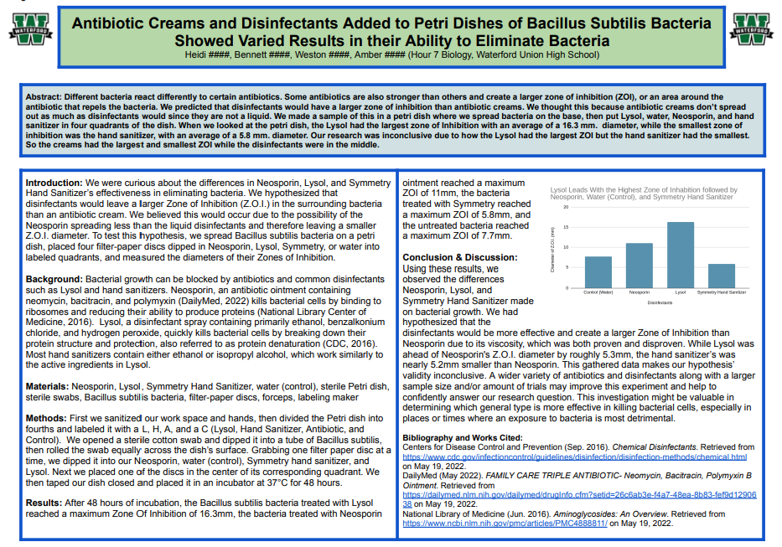

This shows an example of effective science writing from another class. This format is a scientific poster. This format provides a succinct summary of an entire investigation in an organized, systematic manner.

Directions: While your petri dishes are in the incubator, work in your groups to complete the following sections: title, abstract, introduction, background information, and methods & materials.

Your instructor will determine if you should create a poster, paper, or digital presentation. Regardless of format, all of the sections listed on the previous page should be included.

A checklist is provided to guide you as you develop your presentation – use this to make sure you did not miss anything that is needed for your writing! If you are missing items on the checklist, it will affect your grade! Only writing that includes every item on the checklist will be accepted for grading.

After you collect your data, complete the following sections: results, conclusion/discussion, and bibliography.

Part 6: Data Collection & Analysis
Overview: You will be collecting data to answer your research question and determine whether your hypothesis was correct. Record your data using the table below.
Disk | Treatment | Size of Zone of Inhibition for Your Group (mm) | Class Avg Size of Zone of Inhibition (mm)
1
2
3
4
Show your work for class averages:

Create a graph showing the class averages below. Label the x- and y-axis and provide a caption.

Caption: In this graph, you can see

Part 7: Science Writing Checklist
Overview: You will be using your findings from your investigation to prepare a research poster, scientific paper, or digital presentation (as determined by your instructor). Regardless of the format, your work should include all of the following items. Use this page as a checklist to make sure everything needed is included.

Title: this section needs to include…
- The study subject (the topic/question you studied).
- The independent variable and the dependent variable(s).
- The final results.
- Your names, class, hour, and school.

Introduction: this section needs to include…
- The research question (We wondered if…).
- The hypothesis (We hypothesized that…).
- The rationale, or reason for your hypothesis (We thought this would be the case because…).
- Summary of methods (To test this hypothesis, we…).

Background Information: this section needs to include…
- Concepts, facts, and terminology from other sources related to your experiment so that the average reader can understand your work.
- All facts must be followed with parenthetical citation for the source of the information (Author, Year).

Methods & Materials: this section needs to include…
- A materials list of all items used in the investigation.
- A cook-book recipe-style description of how you conducted this experiment.

Results: this section needs to include…
- A written summary of your results, data, and observations.
- A graph/chart/table with…
  - A legend explaining all symbols or abbreviations.
  - Labeled x-axis and y-axis.
  - A caption with a description of all important patterns and trends in the data.

Discussion: this section needs to include…
- The original research question and hypothesis.
- An explanation of whether the data support or reject your hypothesis (or if more data is needed).
- A summary of why you think the data supports/refutes/does not address the validity of your hypothesis.
- A discussion of the validity of your findings (i.e., what might limit the ability of your data to address your research question; how might this experiment be improved?).
- The relevance of this investigation and its data (e.g., how might this provide insights to questions and provide potential solutions to problems? Why was this work valuable?)

Bibliography: this section needs to include…
- All sources used must be listed alphabetically. Each should include: 1) Author’s name (last name, first name); 2) Year of publication; 3) Title of document; and 4) Publication source or website.
- E.g., Badger, Bucky; Wolverine, Wally. (2022). Antibiotic Mechanisms. www.nih.gov/antibiotics

Part 8: Presentation Checklist
Overview: You will be presenting your findings as a group to conclude this project. For your presentation, you will need to break up roles below among the people in your group. If you have less than four people, some individuals may need to do multiple sections. Be sure to address all of the following as you present. You can have speaking notes. However, avoid speaking directly from notes if possible when presenting.

Partner 1: Introduction
- Begin by stating the research question, hypothesis, and rationale.
- Next, summarize background information that your audience will need to understand in order to comprehend and appreciate your work. For example, if you are discussing antibiotic resistance, you should provide information on how antibiotics work and why some bacteria are becoming resistant to these treatments.
Partner 2: Methods
- Begin with a summary of the methods you used to test your hypothesis (To test this hypothesis, we…)
- Then state all the materials used to conduct your experiment (We used the following materials…)
- Address sample size, trial numbers, and constants; explain how these affected your work’s validity.
Partner 3: Results
- Begin with a graph of your data. Summarize the patterns and trends in the data. Be sure to explain how the x-axis and y-axis are labeled to support your audience’s understanding.
- Next, state the significance of these results and how they relate to your research question and hypothesis (do they support it? do they refute it?).
- Conclude by addressing other observations made during the experiment that might not be reflected in this data.
Partner 4: Conclusion
- Begin by restating the research question and hypothesis.
- Next, explain whether your team has decided that your hypothesis is correct or incorrect based on your data (or if you are unable to determine this at this moment). Justify this stance with evidence/reasoning.
- Third, state the confidence you have in your results. Is this enough to answer your research question once and for all? Are your methods able to provide data that fully supports valid conclusions?
- Conclude by stating what would should happen next in order to answer your question. Is more research needed? Should it be the same kind of research and/or should other questions be explored that might have arisen during your work? What are the next steps for addressing your research question?
Questions: You should prepare for follow-up questions from your instructor. Potential examples include:
- How do some antibiotics affect DNA, RNA, proteins, and/or cell division as part of their mechanism?
- In our experiment, bacterial growth was impaired using disks soaked in neomycin, which inactivates bacterial ribosomes. How would this stop or slow the growth and reproduction of bacteria?
- How does antibiotic resistance relate to the following? A) mutations; B) natural selection; C) evolution.
- How do new traits emerge in organisms? How these traits become more prevalent in species? How does this relate to the problem of antibiotic resistance? Is this an example of natural selection and evolution?
- How does your work reflect core principles of scientific investigations? How could it be improved?

Part 9: Peer Review Form
Name: Date: Hour:
Directions: Please evaluate your group as well as yourself on the basis of contributions and effort on a scale of 1 to 5. A group member who makes an outstanding contribution and did their best would receive a score of 5. A group member who did very little might score around a 3, and a group member who did little or nothing might get a one or a two. Provide a reason for your score – why did you give that score? (5’s need no reason)
1. Group Member’s Name: Score: 1 2 3 4 5
Reason:
2. Group Member’s Name: Score: 1 2 3 4 5
Reason:
3. Group Member’s Name: Score: 1 2 3 4 5
Reason:
4. Your Name: Score: 1 2 3 4 5
Reason:
Additional comments or concerns:
Changes you would recommend for this activity:

