Conservation of Matter Unit – Week 1
Score
□ Above & Beyond
□ Fully Complete
□ Mostly Complete
□ Incomplete – fix the following pages:
Name: Hour Date:
Date Packet is due: after Part 5 Why late?
If your work was late, describe why
Semester Schedule
Conservation of Matter
Week 1 - What happens to a substance when it dissolves?
Week 2 – Why do some substances change with heat?
Week 3 – How can we know what is in substances?
Week 4 – Assessment

Atoms & Its Parts
Week 1 - What are atoms?
Week 2 - Electrons & Energy
Week 3 - How do the parts of an atoms determine its properties?
Week 4 - Assessment

Periodic Table
Week 1 - Why do elements have unique properties?
Week 2 - What does the periodic table tell us?
Week 3 - How do atomic properties relate to the PT?
Week 4 - Assessment

Bonding
Week 1 - Why do atoms bond?
Week 2 - How do atoms bond?
Week 3 - How do atomic properties predict formulas?
Week 4 - Assessment

Driving Question: What happens to a substance when it dissolves?

Anchoring Phenomenon: When you mix a drink powder into a glass of water, it seems like it disappears. What actually happens to the powder mix? Does it disappear? Does it turn into something else? In this unit, we will investigate how matter changes when it dissolves in a liquid. We will use this as an introduction to investigations in chemistry.

Weekly Schedule

Part 1: Introduction
- Initial Ideas – Where did the drink mix go?
- Data Dive – Dissolved Powder & Mass?
- Discussion & Developing Explanations

Part 2: Core Ideas
- Core Ideas
- Revisions of Part 1 Explanations

Part 3: Investigation
- Part A: Sugar Water Mass Investigation
- Part B: Measurement Challenge

Part 4: Review & Assessment
- Ranking Your Readiness
- Assessment

Part 5: Life Connections
- Weekly Recap
- Life Connections – Mystery Symptoms

Deeper Questions
- What is matter?
- What are the relationships between matter, mass, volume, and density?
- How can matter be changed?

NGSS Standards:
HS-PS1-7: Use mathematical representations to support the claim that atoms, and therefore mass, are conserved during a chemical reaction.

Part 1: Intro – Where did the drink mix go?
Overview: In this activity, you will begin by discussing your initial ideas about what happens when a substance dissolves in water. Specifically, what happens to the powdered drink mix when you stir it in a glass of water?
Initial Ideas: Marisol is on the cross country team, and she often uses a sports drink to recover from intense workouts. To save money, Marisol’s parents purchase powered sport drink mix in small packets; this mixture consists of sugar as well as minerals such as sodium and potassium. When Marisol adds the powered drink mix to the water, she notices that the volume of water doesn’t seem to change. It almost seems like the drink mix disappears. She mentions this at practice one day and discusses her ideas with her teammates.
- Three students shared their ideas. Do you agree or disagree with each student’s claim?
  - Marisol: “I know that the sugar and minerals dissolve in the water; I think that some of the atoms are eliminated when they get wet, which is why the volume doesn’t change." Agree/ Disagree
  - Bai: "I think the atoms in the sugar and minerals attach to the water molecules." Agree / Disagree
  - Lucia: “I think there is space in between the atoms in water molecules. Maybe the atoms in sugar and the minerals ‘fill up’ these empty spaces.” Agree / Disagree
- Work in your small groups to discuss your ideas. How are your ideas similar or different? Decide as a group whether each statement is correct (and why). Be prepared to present your ideas to the class.
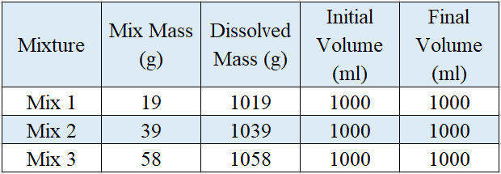
Data Dive: Here you can see data comparing three different drink mixtures. “Mix mass” refers to the mass of the powder in each packet. “Dissolved mass” is the mass of 1000 ml of water plus the drink mixture powder.
- Begin by individually attempting to make sense of this data. What trends or patterns do you notice? How does this relate to any prior knowledge or experience that you have?
- Next, work in your teams to discuss your ideas. Where do you agree? Where do you disagree? Can you use this data to reach agreement? Can others’ prior knowledge/experience help?
- Based on this data, what is one conclusion that would be supported by this data?
  - How is your conclusion supported by data? What specifically suggests your claim is accurate?
- Based on this data, what is a second conclusion that would be supported by this data?
  - How is your conclusion supported by data? What specifically suggests your claim is accurate?
- Would you change any of your responses to the first question above? Discuss as a team.
- What happens to a substance when it dissolves in water? Record your initial explanation in the space below. It’s ok if you aren’t completely sure! You will revise this explanation over time.

Part 2: Core Ideas
Overview: In this activity, you will begin with a short slideshow presentation. This will provide you with core ideas that will help you clarify your initial ideas. Your instructor will decide on how to implement this portion depending on your previous experience and capabilities with this content.
You will then work in small teams to answer the questions listed below. You should take notes in a notebook, on a dry erase board, or on scratch paper so that you are prepared to deliver your responses during the class discussion that will follow. Note: your instructor may assign specific questions to your group if time is limited.

Core Ideas Presentation: https://bit.ly/WUHS-Chem-MatterW1
Driving Questions:
- What is matter?
- How are the following similar and different? Atoms, molecules, elements.
- How many atoms and how many elements are found in a molecule of water?
- What is the relationship between atoms and mass? What is the relationship between mass and weight?
- In space, both an astronaut and a satellite have zero weight; however, the satellite has more mass than the astronaut. Explain how this is possible.
- When sugar dissolves in water, it seems like sugar disappears. What is actually happening to the atoms in the sugar molecules as they dissolve in water? How do you know?
- What is the relationship between a solute, a solvent, and a solution?
- Create a diagram that shows how atoms in a molecule can change when a substance dissolves in water. Make sure that your diagram shows how molecules of that substance interact with water molecules.
- What is the relationship between atoms, volume, and density?
- If we claim that substance A is denser than substance B, what does this mean? In your response, include and explain volume and mass.
- A ship is made from steel, but a steel rod will sink in water. How is it possible for steel ships to float?
- What is energy? How is it different from matter?
- Revising Explanations: Return to your original explanation that you created at the end of Part 1. Based on this new information, how would you now respond to this question?
What happens to a substance when it dissolves in water?

Part 3A Investigation: Sugar Water Mass
Overview: In this investigation, you will investigate what happens to mass and volume as sugar dissolves in water. Before beginning, your instructor should provide you with an overview of the activities you will be doing. After you successfully complete the Pre-Investigation Questions you can begin the investigation.
Pre-Investigation Questions: Work as a group to determine the best response to each question. Be prepared to provide verbal answers for some of these questions for your instructor before you complete the investigation.
- What is the difference between matter and energy?
- What is the difference between atoms, molecules, and elements?
- How are mass, volume, and density related?
- What happens to a substance when it dissolves in water?
- How do you accurately measure volume and mass for a substance?
When you think your group is ready, raise your hand. Your instructor will listen to your verbal responses.
This activity was successfully completed (instructor signature)

Materials: 150 ml beaker; tap water; sugar; weighing paper/dish; digital balance; graduated cylinder.
Methods: Check each box as you complete each step.
- ☐ Record your ideas for the questions below:
How do you think the mass and volume of a beaker of water will change as you dissolve sugar in water?
Mass:
Volume:
Explain your reasoning. Why do you think your predictions are accurate?
- ☐ Acquire the following for each group: 150 ml beaker; sugar; digital balance; weighing paper/dish.
- ☐ Using a graduated cylinder, measure 45 ml of water and add to the beaker. Record volume & mass:
Volume of the water: g Mass* of the water: g
- ☐ Remove the beaker and place weighing paper/dish on the digital balance. Measure 50 g of sugar.
- ☐ Add 5 g of sugar to the water. Observe and record any changes in volume:
Volume:
- ☐ Swirl the cup to completely dissolve the sugar. Record the mass of the sugar water: g
*You are measuring the mass of the water and beaker. How might this affect the accuracy of this experiment? If time allows, discuss within your groups or as a class.
- ☐ Pour the sugar water into the graduated cylinder and record the volume ml.
- ☐ Complete the table below using the data you collected.
Mass of Sugar (g) | Mass of Water (g) | Initial Water Volume (ml) | Mass of Sugar and Water (g) | Final Volume of Sugar & Water (ml)

- ☐ Were your predictions accurate? Explain:
- ☐ Using what you learned so far this week, explain your findings from your investigation. Why did the mass and volume change in the way that they did during your experiment?
- Two images are shown here. (Image source: Stanford Univ)
  - Which best represents the water before the sugar was added? a. Left b. Right
  - Which best represents the sugar before the it was added? a. Left b. Right
Explain your reasoning for the questions above.

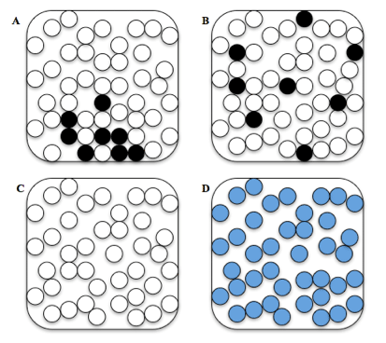
- Which of these pictures best represents the water and sugar particles after they have been thoroughly mixed together? (Image source: Stanford Univ)
Image ____ because:
- Three students shared their ideas. Do you agree or disagree with each student’s claim?
  - Marisol: “I know that the sugar and minerals dissolve in the water; I think that some of the atoms are eliminated when they get wet, which is why the volume doesn’t change." Agree/ Disagree
  - Bai: "I think the atoms in the sugar and minerals attach to the water molecules." Agree / Disagree
  - Lucia: “I think there is space in between the atoms in water molecules. Maybe the atoms in sugar and the minerals ‘fill up’ these empty spaces.” Agree / Disagree
- Explain why you agreed or disagreed with each of the following:
Marisol:
Bai:
Lucia:
- What happens to a substance when it dissolves in water?
Be prepared to discuss and defend your ideas in small groups and as a class.

Part 3B Investigation: Measurement Challenge
Overview: You will use your understanding of density to predict the mass of unknown objects.

Materials: Flinn Measurement Challenge kit

Methods: Check each box as you complete each step.
- ☐ Obtain a plastic block from your teacher. Record the block number and color of the sample.
Block Number: Color of Block:

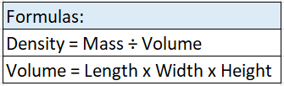
- ☐ The densities for each type of block are provided below. Work in your assigned groups to predict the mass of the plastic sample. Use the provided formulas to determine how to calculate your prediction; show the calculations you use to determine this mass.
Block Color | White | Black | Milky White | Clear | Gray
Density | 0.541 g/cm³ | 0.985 g/cm³ | 0.908 g/cm³ | 1.18 g/cm³ | 1.42 g/cm³

Predicted Mass of Block: Show the work you used to make this prediction below.

- ☐ When the mass of the plastic block has been calculated and a prediction has been made, bring the block up to your instructor. Your instructor will measure the actual mass of the block using a laboratory balance and record this value in the space below.
Actual Mass of Block: Teacher Initials:
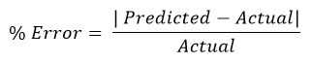
- ☐ Calculate the percent error for your prediction. (i.e., how far “off” was your predicted mass compared to the actual mass?) Show your work.
- Imagine one group gets 97% accuracy, while another gets 30% accuracy. What is a potential explanation that might explain these differences in their level of accuracy? Why might this matter in chemistry?

Part 4: Review & Assessment
Overview: Rank each Driving Question in Part 2 as a 1 (completely unsure), 2 (somewhat unsure), or 3 (completely sure) based on your comprehension. Then work in teams to review each item and prepare a response. Next, write a final explanation below. You will conclude by completing a formative assessment.
What happens to a substance when it dissolves in water? (When finished, compare to your first response in Part 1).

Part 5: Life Connections – Mystery Symptoms
Directions: For this activity, you will consider a real-world scenario related to our topics this week. You will use your understanding of this week’s content to develop an explanation based on the evidence provided.

Background: A teenage patient is brought to the emergency room with severe abdominal pain, nausea, and a fever. The ER physicians determine that the symptoms and conditions are consistent with acute pancreatitis, or an inflammation of the pancreas. The pancreas is the organ that produces digestive enzymes and hormones. Nurses asked the parents of the patient whether they were on any medications. The parents stated that they were. They also noted that because the pills were large, they had sometimes broken the medication into smaller pieces to make them easier to swallow. All other factors, including diet and activity, were unchanged.

Initial Questions: work in your assigned groups to answer the questions below. Record your group’s ideas using scratch paper, a dry erase board, a digital document, or another option.
- Based on the information provided, what do you think caused the pancreatitis?
- What evidence and reasoning support your claims?
- What additional information would you need to confirm your ideas?
- How might your ideas be inaccurate? What assumptions are making that might be inaccurate?
Going Deeper: Next, read the excerpts below. These are challenge texts that will generally be above your capacities as a high school student. As you read the texts, underline any words that are challenging or unfamiliar. Complete an initial read-through, and check with your group to reach an initial consensus about the key points of the excerpt. Then use an internet search engine to look up unfamiliar terms and/or find additional information to help you make sense of these readings.

The dissolution test is a globally required test for most of all pharmaceutical products that are not true solutions. Dissolution, or in vitro release, of the drug substance from the product into a typically aqueous-based medium, is linked to the release of the drug into the body, making it available for absorption, and then efficacy or clinical outcome. Dissolution testing is primarily used in industry as a quality control tool to monitor the formulation and manufacturing processes of the dosage form. The regulatory agencies use the dissolution test to provide a quality connection from a pivotal biobatch to the commercialized product. For this reason, the dissolution test development and validation are critical factors in insuring that the test is robust and clinically relevant. Development and validation of a dissolution method requires a good understanding of the theory of dissolution and the roles of the key parameters of a dissolution test. (Source: Vivian A. Gray, Thomas W. Rosanske, in Specification of Drug Substances and Products (Second Edition), 2020).
Deeper Questions: work in your assigned groups to answer the questions below. Record your group’s ideas using scratch paper, a dry erase board, a digital document, or another option.
- Summarize this excerpt. What are the key points?
- How might this information relate to the teenage patient with pacreatitis?
- How could you use this information to improve your hyoptheses about this case?
- How might your ideas be inaccurate? What assumptions are making that might be inaccurate?

Conservation of Matter - Week 1 Formative Assessment
Name: Hour Date: Score: /
Directions: A 3x5 notecard with handwritten notes can be used to guide your answers. Your instructor may allow you to work in assigned groups. If so, have a different person write each response while others assist.

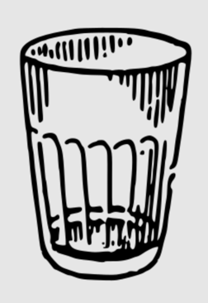
- A glass cup is washed, completely dried, and placed on a shelf. Is there any matter that remains within the glass? Include and underline the following terms: matter, atoms, solid, liquid, gas.
Writer’s Name:

- When salt is added to water, it seems like it disappears. Three students share their ideas. Do you agree or disagree with each student’s claim?
  - Marisol: “I know that salt dissolves in the water; I think that some of the atoms in salt molecules are eliminated by the water, which is why the water’s volume doesn’t change." Agree/ Disagree
  - Bai: "I think the atoms in the salt molecules attach to the water molecules." Agree / Disagree
  - Lucia: “I think there is space in between the atoms in water molecules. Maybe the atoms in the salt molecules ‘fill up’ these empty spaces.” Agree / Disagree
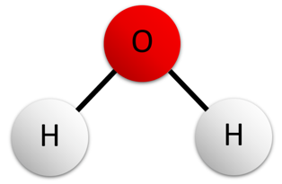
Which claim(s) is/are most accurate? Why?
Writer’s Name:
- A molecule of water is shown here. How many atoms and how many elements are found in this molecule? Explain each term in your response.
Writer’s Name:
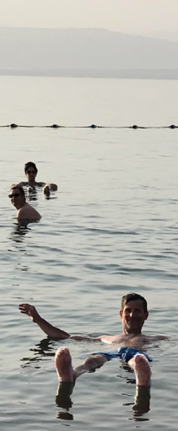
- In space, both an astronaut and a satellite have zero weight; however, the satellite has more mass than the astronaut. Explain how this is possible. Include and underline the following terms: mass, atoms, weight.
Writer’s Name:
- The Great Salt Lake in Utah has high salinity (28%). This enables people to float on the surface of the water without swimming. Explain how this is possible; include and underline the following terms: density, atoms, volume.
Writer’s Name:
- This data compares changes in response to the addition of three different drink mixtures to 1000 ml of water. “Mix mass” refers to the mass of the powder in each packet. “Dissolved mass” is the mass of 1000 ml of water plus the drink mixture powder. Use this info to answer the questions below.
What is the solute? What is the solvent?
How did the addition of each drink mix affect the mass of each solution?
How did the addition of each drink mix affect the density of each solution?

