Animals Unit – Packet 4
Score
□ Above & Beyond
□ Fully Complete
□ Mostly Complete
□ Incomplete – fix the following pages:
Name: Hour Date:
Date Packet is due: after Part 5 Why late?
If your work was late, describe why
Semester Schedule
Matter & Energy
Week 1: What happens when something burns?
Week 2: What happens to molecules during combustion?
Week 3: Unit Assessment
Animals
Week 1: What are animal cells made from?
Week 2: What happens to food when it is consumed?
Week 3: What happens inside animal cells?
Week 4: Unit Assessment

Plants
Week 1: How do plant cells differ from animal cells?
Week 2: How do plants get their food and gain mass?
Week 3: How do plants get other needed molecules?
Week 4: Unit Assessment

Ecosystems
Week 1: Why do some places have more species than others?
Week 2: How does human activity affect living species?
Week 3: Unit Assessment

Driving Question: How do animals grow and function? What happens to the matter and energy contained in food that animals consume?

Anchoring Phenomenon: Throughout this unit, we have explored how the food consumed by animals affects their cells. In this final week, we will put all the pieces together to develop sophisticated explanations for the phenomena we have encountered in this unit.

Weekly Schedule

Part 1: Introduction
- Comparative Data Dives.

Part 2: Critiquing Responses
- Evaluating Sample Responses
- Writing a “Level 3” Response

Part 3: Investigation
- Life Connections

Part 4: Review
- Jeopardy Review Game

Part 5: Final Review
- Review of Driving Questions
- Final Q&A

Deeper Questions
- What happens to food molecules during digestion, cellular respiration, and biosynthesis?
- What are animal cells made from and how do they function?
- How do the functions of animal cells affect the animals’ bodies?

NGSS Standards:
HS-PS1-4. Develop a model to illustrate that the release or absorption of energy from a chemical reaction system depends upon the changes in total bond energy.
HS-PS1-7. Use mathematical representations to support the claim that atoms, and therefore mass, are conserved during a chemical reaction.

Part 1: Introduction – Comparative Data Dives
Directions: The following address phenomena we encountered throughout this unit. Construct explanations for each phenomenon and driving questions using the provided terms.
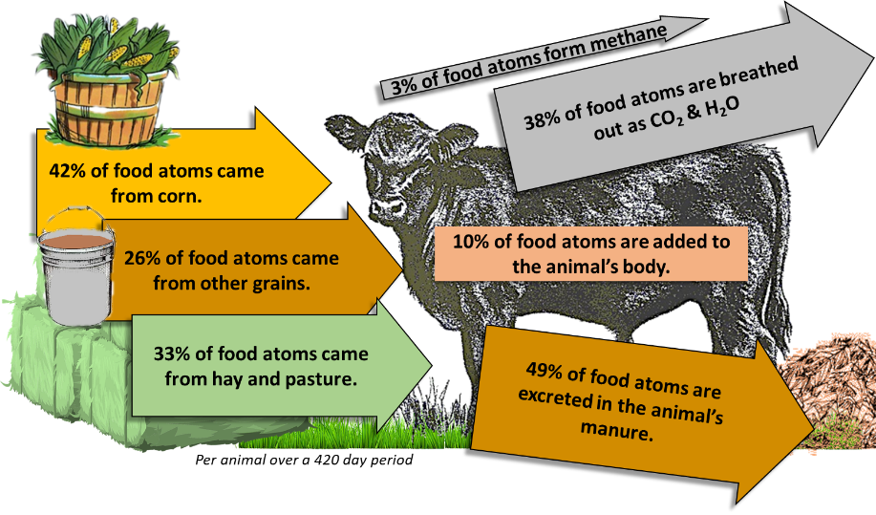
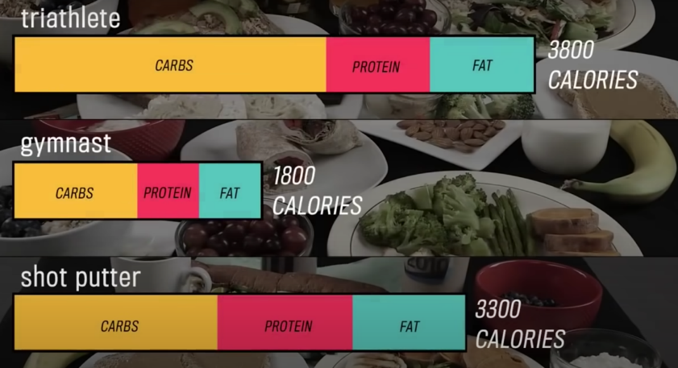
Olympic Diets: This shows the different diets of Olympic athletes. To effectively compete in their sports, athletes must consume differing levels of calories and have different proportions of carbohydrates, protein, and fat in their diets.
A cow gains roughly 1.5 lbs. per day but consumes 15 lbs. of food. Why are only 10% of consumed food atoms added to the cow’s body? Use the following in your response: cell respiration, glucose, CO₂, H₂O, ATP, biosynthesis.
Score this (1,2,3) - Complete: Accurate: Precise: Overall:

Why do different athletes need differing amounts of carbohydrates, fats, and protein? Use the following in your response: macromolecules, carbohydrates, fats, protein, energy, matter.
Score this (1,2,3) - Complete: Accurate: Precise: Overall:

Cattle Diets: this shows the inputs (left) and outputs (right) for atoms in food molecules as they pass through a cow while it is growing.
Mealworm Mass: This shows the average gain in mass in the mealworms and the average mass lost from a potato as it was eaten by mealworms. Note: in this experiment, CO₂ and water vapor concentrations increased in the air inside the container.
 | Worm Mass Gain (g) | Potato Mass Loss  (g)
Group 1 | 2.0 | 4.8
Group 2 | 2.4 | 6.3
Group 3 | 4.4 | 5.2
Group 4 | 2.8 | 5.2
Group 5 | 3.1 | 5.7
AVERAGE | 2.9 | 5.4
Roughly 0.5 grams of potato were added to the worms’ cells. Summarize how this occurred. Use the following in your response: digestion; enzymes; blood; biosynthesis; amino acids; fatty acids; protein; fat.
Score this (1,2,3) - Complete: Accurate: Precise: Overall:

The worms consumed 5.4 grams of potatoes. However, only 2.9 grams of atoms were added to the worms’ bodies and feces. What happened to the other 2.5 grams of atoms from the potato? Use the following in your response: cellular respiration, glucose, O₂, mitochondria, ATP, CO₂, H₂O.
Score this (1,2,3) - Complete: Accurate: Precise: Overall:

Part 2: Critiquing Responses
Directions: Rate each of the following responses and provide a brief written justification for why you think they earned a 1 (still learning), 2 (acceptable), or 3 (sophisticated). If time allows, repeat this same process with your responses on the previous page.

Q: Why do animals only gain 10% of the mass of the food they consume?
Bristol: Most atoms in the food are turned into energy in cell respiration; energy leaves the body as heat.
3 2 1 Complete: Do they fully address the entire question and explain all changes to matter & energy?
3 2 1 Accurate: Is every aspect of the written response factually correct?
3 2 1 Precise: Are they effectively using terms from the course in a clear and specific manner?

Overall Score: /3 Comments:
Nina: The cells turn glucose into CO₂ and H₂O during cell respiration and they breathe it out.

3 2 1 Complete: Do they fully address the entire question and explain all changes to matter & energy?
3 2 1 Accurate: Is every aspect of the written response factually correct?
3 2 1 Precise: Are they effectively using terms from the course in a clear and specific manner?

Overall Score: /3 Comments:
Avery: Food is mostly glucose molecules, which provides chemical energy to recharge ATP. During cellular respiration, glucose & oxygen rearrange into CO₂ & H₂O, which is breathed out. Food also has amino acids & fatty acids which form proteins and fat during biosynthesis; this is the 10% that is added to the animal’s body.
3 2 1 Complete: Do they fully address the entire question and explain all changes to matter & energy?
3 2 1 Accurate: Is every aspect of the written response is factually correct?
3 2 1 Precise: Are they effectively using terms from the course in a clear and specific manner?

Overall Score: /3 Comments:
Chandra: The animal doesn’t use all the atoms in its food or it would get too big and too heavy.
3 2 1 Complete: Do they fully address the entire question and explain all changes to matter & energy?
3 2 1 Accurate: Is every aspect of the written response factually correct?
3 2 1 Precise: Are they effectively using terms from the course in a clear and specific manner?

Overall Score: /3 Comments:

Part 3: Life Connections
Directions: In this activity, you will watch a documentary about the human body. This will provide an opportunity to connect what you have learned in this unit to real-world considerations.

Movie URL: Inside the Living Body

Questions: Work individually and in small groups to record your answers using scratch paper, a dry erase board, or a digital document. Be prepared to discuss your ideas as a class.
- Using specific examples from the movie, explain how this movie addressed the following topics:
  - Organelles, Cells, Tissues, Organs, and Systems
  - Macromolecules
  - Digestion
  - Cellular Respiration
  - Biosynthesis
  - Mitosis
- A baby gains mass as it grows older. How? Where do these atoms come from? How do these atoms become a part of the cells of a person?
- How does a cell acquire chemical energy from the food a person consumes?
- Summarize something you have learned from this movie that you did not know before.

Part 4: Jeopardy Review
Overview: In this activity, you will be playing a Jeopardy-style game to review key concepts from the course. This presentation can be accessed by clicking here. The full URL is below. The rules for this review game are posted within the presentation. You can also use this presentation outside of class to help prepare you for the unit test. Your instructor may decide to use an alternative option (like Gimkit or Kahoot).

Animals Jeopardy URL: https://docs.google.com/presentation/d/1U0V-v7LwJbxaIEOx-PHHTABiCs-fEswS/edit?usp=sharing&ouid=112804783999504456798&rtpof=true&sd=true

Part 5: Review
Overview: For each objective, rank it as a 1 (completely unsure), 2 (somewhat unsure), or 3 (completely sure) based on your comfort with that objective. Pay special attention to bold items.

- What is a cell? Why are cells important to animals?
- How are cells different from molecules? How are they similar?
- What is a macromolecule? How is it similar and different compared to molecules?
- What is fat? What are fats made from? How do cells use fat?
- What is a protein? What are proteins made from? How do cells use proteins?
- What is a carbohydrate? What are carbohydrates made from? How do cells use carbohydrates?
- What is an organelle? How do organelles enable a cell to function?
- How are the following related but different? Cells, Organelles, Tissues, Organs, Systems.
- What are the two primary purposes of consumed food?
- What do each of the following macromolecules provide to cells? Fat, Protein, Carbohydrates.
- What is digestion? How does digestion change macromolecules?
- What are enzymes? What is the primary function of enzymes during digestion?
- What happens to food molecules after enzymes break apart macromolecules?
- What are examples of molecules that the blood transports to and from cells?
- What happens to most glucose molecules after being absorbed by cells?
- Where does cell respiration occur? What happens to glucose & oxygen during cell respiration?
- How are the CO₂ & H₂O that an organism breathes out related to the food and oxygen it consumes?
- What is ATP? What does ATP do for the cell?
- What molecule(s) besides glucose is frequently used for cellular respiration?
- When you see your breath on a cold day, where are these atoms in the water vapor coming from?
- Why do animals only gain 10% of the mass of their food? What happens to the other 90%?
- What is biosynthesis? How does biosynthesis relate to the fat and protein found in cells?
- Which macromolecules are primarily used for cellular respiration? Which are used for biosynthesis?
- Where does protein biosynthesis occur? What happens during protein biosynthesis?
- Where does fat biosynthesis occur? What happens during fat biosynthesis?
- True or false: all fat molecules are formed from fatty acids consumed in the diet. Explain.
- If an animal consumes more chemical energy in food than is needed by their cells, what happens to some of the matter and energy in this food?
- As cells assemble more proteins and fat from food molecules, what happens to the size of the cell?
- What is mitosis? Why is mitosis important for the bodies of animals?
- A baby calf will grow from 100 lbs. to over 1000 lbs. in less than two years. As it does so, it increases in mass and gains more and more cells. Where do these additional atoms and additional cells come from?

