Plants Unit – Packet 4
Score
□ Above & Beyond
□ Fully Complete
□ Mostly Complete
□ Incomplete – fix the following pages:
Name: Hour Date:
Date Packet is due: after Part 5 Why late?
If your work was late, describe why
Semester Schedule
Matter & Energy
Week 1: What happens when something burns?
Week 2: What happens to molecules during combustion?
Week 3: Unit Assessment
Animals
Week 1: What are animal cells made from?
Week 2: What happens to food when it is consumed?
Week 3: What happens inside animal cells?
Week 4: Unit Assessment

Plants
Week 1: How do plant cells differ from animal cells?
Week 2: How do plants get their food and gain mass?
Week 3: How do plants get other needed molecules?
Week 4: Unit Assessment

Ecosystems
Week 1: Why do some places have more species than others?
Week 2: How does human activity affect living species?
Week 3: Unit Assessment

Driving Question: How do plants grow and function? How do plants acquire the macromolecules their cells need to function?

Anchoring Phenomenon: Throughout this unit, we have explored how plant cells function and how they acquire needed macromolecules. We will conclude by putting all the pieces together to develop sophisticated explanations for the phenomena we have encountered in this unit.

Weekly Schedule

Part 1: Introduction
- Comparative Data Dives.

Part 2: Critiquing Responses
- Evaluating Sample Responses
- Writing a “Level 3” Response

Part 3: Investigation
- Life Connections

Part 4: Review
- Jeopardy Review Game

Part 5: Final Review
- Review of Driving Questions
- Final Q&A

Deeper Questions
- How do plant cells differ from animal cells in terms of structures and functions? How are they similar?
- How do plants acquire mass and grow in size?
- How do plants acquire carbohydrates, fats, and proteins?

NGSS Standards: HS-LS1-2. Organization of interacting systems in multicellular organisms.
HS-LS1-6. How carbon, hydrogen, and oxygen from sugar molecules may combine with other elements to form amino acids and/or other large carbon-based molecules.
HS-LS1-5. How photosynthesis transforms light energy into stored chemical energy.
HS-LS1-7. Cellular respiration is a chemical process whereby food molecules and oxygen molecules form new compounds resulting in a net transfer of energy.

Part 1: Introduction – Comparative Data Dives
Directions: The following address phenomena we encountered throughout this unit. Construct explanations for each phenomenon and driving questions using the provided terms.

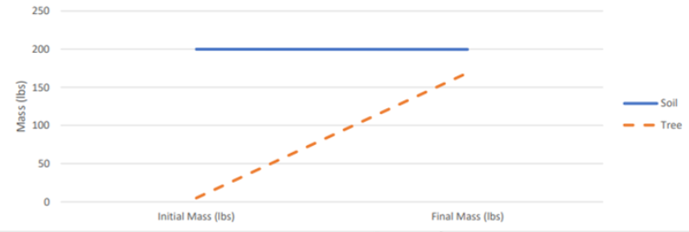
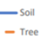
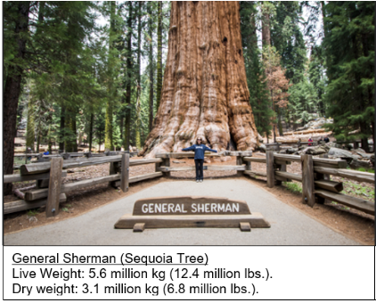
van Helmont (1577-1644) recorded the initial mass of a tree and soil. After 5 years, he recorded the final mass of each item (above). How did the tree gain mass if the soil’s mass did not change much? Use the following in your response: water, carbon dioxide, soil minerals.
Score this (1,2,3) - Complete: Accurate: Precise: Overall:

This shows data about the General Sherman. How did this tree get so big? Where did the atoms in this tree come from? Use the following in your response: photosynthesis, glucose, cellulose.
Score this (1,2,3) - Complete: Accurate: Precise: Overall:

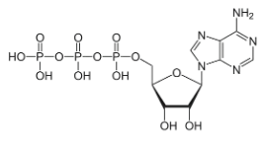
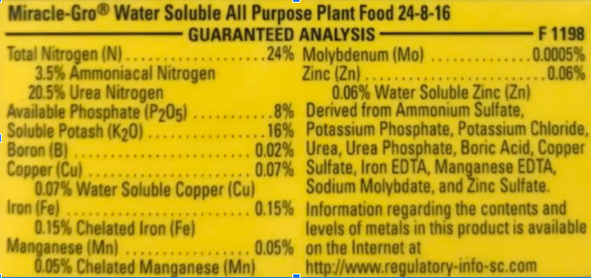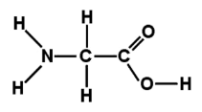
Planning Investigations: (1) Some students are unsure whether egg shells improve radish growth. (2) They predict that adding eggshells will result in larger radishes with more mass. (3) They think this because eggshells contain minerals, and they know plants need minerals to make some molecules. (4) To test this, they grow six plants in standard potting soil; (5) another six plants will be grown in soil with crumbled eggshells. (6) They will measure the average height and mass to determine whether eggshells made an impact on radish growth.
1. What sentence contains the hypothesis? 2. What sentence contains the research question?
3. What sentence contains the rationale?
4. What is/are the independent variable(s)?
5. What is/are the dependent variable(s)?
6. Would it be ok if they tried both eggshells AND fertilizer as their independent variables? Explain.
8. Why did some radishes only get regular potting soil?
9. How do their sample sizes and number of trials affect the validity and reliability of their experiment?
The image on the left shows the ingredients in fertilizer. On the right you can see two important molecules for plant cells. The top right shows an ATP molecule and the bottom right shows an amino acid. Why do plants need fertilizer? How do the ingredients in fertilizer relate to these molecules?
Score this (1,2,3) - Complete: Accurate: Precise: Overall:

Part 2: Critiquing Responses
Directions: Rate each of the following responses and provide a brief written justification for why you think they earned a 1 (still learning), 2 (acceptable), or 3 (sophisticated). If time allows, repeat this same process with your responses on the previous page.

Q: A 50-foot maple tree will gain about 60 kg (132 lbs.) of atoms per year. A full-grown maple tree can weigh as much as 9000 kg (10 tons). Where does the mass of a tree come from?
Dasher: The tree absorbs heavy minerals from the soil, which make up most of the mass of the tree.
3 2 1 Complete: Do they fully address the entire question and explain all changes to matter & energy?
3 2 1 Accurate: Is every aspect of the written response factually correct?
3 2 1 Precise: Are they effectively using terms from the course in a clear and specific manner?

Overall Score: /3 Comments:
Dancer: After plant cells go through cell respiration, they use the glucose to form cellulose which makes the skeleton of the tree.

3 2 1 Complete: Do they fully address the entire question and explain all changes to matter & energy?
3 2 1 Accurate: Is every aspect of the written response factually correct?
3 2 1 Precise: Are they effectively using terms from the course in a clear and specific manner?

Overall Score: /3 Comments:
Donner: Plant cells absorb water and CO₂ and rearrange these to form glucose and oxygen during photosynthesis. Some glucose is used to make cellulose, which makes up most of the mass of the tree. Atoms in glucose can also be rearranged with soil minerals to make other molecules like amino acids, ATP, etc.
3 2 1 Complete: Do they fully address the entire question and explain all changes to matter & energy?
3 2 1 Accurate: Is every aspect of the written response is factually correct?
3 2 1 Precise: Are they effectively using terms from the course in a clear and specific manner?

Overall Score: /3 Comments:
Blitzen: The tree’s leaves convert sunlight into glucose, which can be made into cellulose.
3 2 1 Complete: Do they fully address the entire question and explain all changes to matter & energy?
3 2 1 Accurate: Is every aspect of the written response factually correct?
3 2 1 Precise: Are they effectively using terms from the course in a clear and specific manner?

Overall Score: /3 Comments:

Part 3: Explaining Carnivorous Plants
Directions: Begin by watching the short video. Then read the information below before answering the subsequent questions. Video: https://www.youtube.com/watch?v=O7eQKSf0LmY
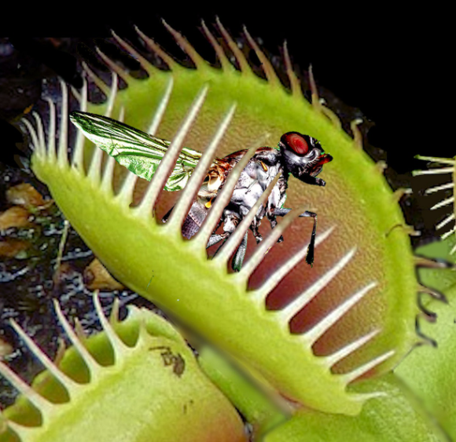
“There are over 600 known species of carnivorous plants, the majority of which thrive in bogs, marshes and rocky outcrops, or other nitrogen-poor areas where sunlight and water are abundant. These plants have evolved the ability to trap and digest insects, which are an excellent source of nitrogen as they contain around 10% nitrogen by mass. Carnivorous plants are able to obtain between 10% and 80% of their total nitrogen from insects, depending on environment and type of trap employed.”
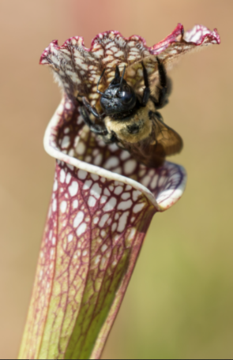
“The most famous of these prey capture mechanisms are the snap traps found in Venus flytraps and waterwheel plants. These traps consist of two lobed leaves that are able to close around insect prey when the plant senses movement of one of its trigger hairs. One of the most remarkable aspects of the snap trap is that it employs simple memory to ensure it does not close on precipitation or debris.”
“Pitcher plants are able to attract foraging, flying or crawling insects to their liquid-filled pits; once inside the pit, the insect is enzymatically digested. The lip of the pit fall trap is coated with a slippery mucous-like substance secreted by the plant; when an insect lands there, it is unable to escape … the end result is that plants are able to acquire nitrogen from trapped insects. Carnivorous plants are able to thrive in areas of extremely low nitrogen, a fact that speaks to the enormous potential of insects as a source of nitrogen.”
Source: Behie, S. W., & Bidochka, M. J. (2013). Insects as a Nitrogen Source for Plants. Insects, 4(3), 413–424. https://doi.org/10.3390/insects4030413. Image Sources: Pixabay (top) Deviant Art (bottom)
Questions: Work individually and in small groups to record your answers using scratch paper, a dry erase board, or a digital document. Be prepared to discuss your ideas as a class.
- True or false: carnivorous plants consume insects instead of photosynthesizing. Explain.
- Carnivorous plants are typically found in soils with low levels of nitrogen. How does this relate to their adapations as carnivorous plants?
- How do carnivorous plants use the insects that they trap? What cellular function (cellular respiration, photosynthesis, or biosynthesis) does this affect?
- How are enzymes used by carnivorous plants? Predict what happens to the molecules inside the insect after it is enzymatically digested using what you know about macromolecules, enzymes, polymers, and monomers.
- Explain how a carnivorous plant acquires each of the following molecules or macromolecules needed by the cell: glucose, cellulose, amino acids, proteins, fatty acids, fatty membranes.

Part 4: Jeopardy Review
Overview: In this activity, you will be playing a Jeopardy-style game to review key concepts from the course. This presentation can be accessed by clicking here. The full URL is below. You can also use this presentation to help prepare you for the unit test. Your instructor may decide to use a different option (e.g. Gimkit or Kahoot).

Plants Jeopardy URL: https://docs.google.com/presentation/d/1hszyGnSlzUQ84XCLV1CQGGEc7VtQvElh4T2ssntr1t0/edit?usp=sharing

Part 5: Review
Overview: For each objective, rank it as a 1 (completely unsure), 2 (somewhat unsure), or 3 (completely sure) based on your comfort with that objective. Pay special attention to bold items.

- True or false: animal cells & plant cells contain similar organelles and function in similar ways. Explain.
- Do plant cells have mitochondria? How does this relate to the functions of a plant cell?
- What are three organelles found in plant cells that are not found in animal cells?
- What is a cell wall? What is cellulose? How do these affect the function of plants & plant cells?
- What is a vacuole? What is its purpose and function in a plant cell?
- What process occurs in chloroplasts? How does this affect the function of plants and plant cells?
- Most of the glucose produced during photosynthesis is used for what purposes?
- True or false: just like animal cells, plant cells are organized into tissues, organs, and systems.
- What is xylem and phloem? What is their purpose and function?
- How do plants move molecules like glucose and water if they lack a heart to pump fluids?
- How do root cells acquire the glucose they need for cell respiration and for other purposes?
- Both animal cells and plant cells need carbs, fat, and protein to function. How do plants acquire these molecules if they cannot consume other organisms?
- How do the atoms in glucose and soil minerals relate to all the molecules found within a plant cell?
- What are enzymes and what do enzymes do inside cells?
- How do some enzymes assemble macromolecules from individual molecules?
- How do some enzymes disassemble macromolecules into individual molecules?
- How do enzymes enable species to interact with each other?
- What are decomposers? What are examples of decomposers? Why are decomposers important for species interactions?
- Define each of the following: research question; hypothesis; rationale.
- What is the difference between an independent variable and a dependent variable? How can these components affect the validity and reliability of a research experiment?
- What is a control? How does it affect the validity and reliability of a research experiment?
- What are constants? How do they affect the validity and reliability of a research experiment?
- Define trials and sample size, and explain how they affect the validity & reliability of an experiment.
- Summarize how you would identify key components of a research experiment. Explain how these affect the validity and reliability of data and conclusions that result from that experiment.

