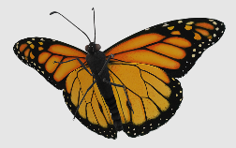
Traits & Genes Unit Summary

There is a seemingly endless variety of living organisms on the planet. While roughly a million species have been identified, millions more exist that are still undiscovered. Each species has a unique set of observable traits, or characteristics. In this unit, we investigated what factors determine the observable traits of living organisms.

Traits, Proteins, and Genes
An organism’s traits are determined by proteins assembled within its cells. Proteins are macromolecules made from chains of molecules called amino acids. The order in which different kinds of amino acids are assembled determines the type of protein that is produced. Different kinds of proteins result in different kinds of traits.
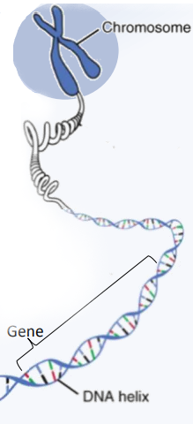
The instructions for assembling proteins are found within an organism’s DNA. DNA is a macromolecule made of long twisting chains of molecules called nucleotides. DNA is stored in the nucleus of the cell. A gene is a section of DNA that contains the instructions for the assembly of a particular protein. Cells contain tens of thousands of different kinds of proteins. Each protein is associated with a specific gene. For an organism to have a trait, they need a protein and gene specific to that trait.

Every cell needs its own copy of DNA to produce the proteins needed for cellular functions. Mitosis is a process of cellular division. During mitosis, cells duplicate their DNA. As a cell divides in half to form two new cells, the duplicated DNA is divided evenly between the two cells. This results in two genetically identical cells.

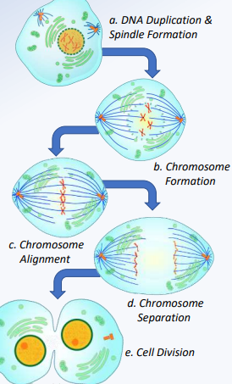
Chromosomes are tightly coiled ‘packages’ of DNA and are important for ensuring the DNA is evenly distributed between the two cells. Just as you might pack your clothes into a suitcase if you are traveling, DNA is packed into chromosomes during mitosis. This ensures that duplicated DNA is evenly distributed as one cell divides into two cells.

Mitosis
Mitosis begins with the process of duplicating DNA and cellular organelles. The cell then uses proteins called histones to pack DNA into chromosomes (similar to how fishing reels wind up fishing line). Another protein called spindles line up and evenly divide the chromosomes. Spindles resemble ‘spiders’ on either side of the cell. The spindle’s ‘spider legs’ line up and pull apart the chromosome copies.

Once a copy of each chromosome is on the opposite side of the cell, the cell divides in half. This forms two genetically identical cells, each with their own complete copy of the organism’s DNA. After mitosis is completed, each cell has the instructions it needs to assemble all the proteins needed for functioning.

Mitosis enables one cell to become the trillions of cells in our body in a short amount of time. When mitosis occurs, one cell becomes two cells. After forty rounds of doubling through mitosis, one cell can become a trillion cells. This is known as exponential growth because the rate at which cells multiply occurs more rapidly with each round of division.

As cells divide, they selectively ‘turn off’ some genes. This is known as cellular differentiation. Turning off some genes allows for cells to become specialized, resulting in a wide variety of cells (skin, muscle, nerves, etc.).

Reproduction
The steps of mitosis ensure that each cell receives a full copy of an organism’s DNA. However, organisms must also have a mechanism to pass on their DNA to their offspring as well. Some organisms produce genetically identical copies of themselves in a manner similar to mitosis. This is known as asexual reproduction. While asexual reproduction tends to be more rapid, it reduces genetic diversity. This makes a species more susceptible to disturbances like disease.

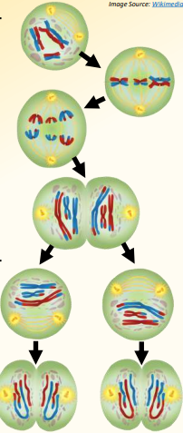
The Irish Potato Famine provides a cautionary example of the risks of limited genetic diversity. The lumper variety of potato provided a much-needed source of food to 1800s Ireland. Lumpers could reproduce rapidly through asexual reproduction. However, the lack of genetic diversity made lumpers equally susceptible to a pathogen that spread rapidly in the 1840s. In a period of three years, a million people starved and millions more left the country.

Sexual reproduction results in offspring that are genetically unique. Sexual reproduction results in offspring with a unique combination of both parents’ genes. Sexual reproduction depends on gametes, or sperm and egg cells. Gametes are haploid; these cells have half the amount of DNA compared to other bodily cells. This is necessary to ensure that each generation has the same amount of genetic material. For example, most human cells have 46 chromosomes; these cells are known as diploid because they have two copies of each chromosome. Sperm and egg cells each have 23 chromosomes; they are haploid (one copy of each chromosome). When sperm and egg cells fuse during fertilization, they produce a single diploid cell with 46 chromosomes (23 from each parent).

Meiosis
Meiosis is a form of cell division that produces haploid gamete cells (sperm and egg cells with half the usual amount of chromosomes). Meiosis and mitosis are similar in that both involve cell division. Both processes begin by duplicating DNA, forming chromosomes, aligning and separating the chromosomes, and splitting into two cells. Meiosis then involves a second round of cell division, resulting in four cells. Each of these four cells has one copy of each chromosome. These cells eventually become sperm or egg cells.

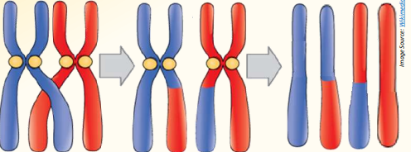
Unlike mitosis, meiosis also involves a process called crossing over where duplicated chromosomes can exchange segments of DNA. Because of crossing over, each haploid gamete cell (sperm or egg cells) will have a unique combination of genes. This means that genes on the same chromosome may not always be inherited together. During crossing over, genes from one chromosome will be mixed with genes from a different copy of that same chromosome.

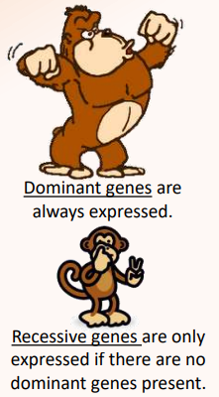
The closer that two genes are to each other, the more likely it is that they will be inherited together. This is known as gene linkage. Gene linkage explains why some traits are often found together. For example, certain combinations of hair and eye color occur more frequently because the genes for these traits are located near each other on the same chromosome. If crossing over occurs, these genes are likely to be moved together than genes that are further apart.

When a sperm and egg cell fuse, the resulting cell randomly receives two copies of each gene (one gene from each parent). The genes that an organism inherits, and how these genes interact with each other determines the traits of that newly formed organism.

Dominant vs. Recessive Genes
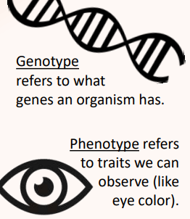
Some genes are dominant, and some are recessive. Dominant genes are always expressed if present. Recessive genes are only expressed if there are no dominant genes present for that trait. If an organism inherits both a dominant gene and a recessive gene, only the dominant gene will be expressed. For example, if someone had genes for both brown eyes and blue eyes, only the dominant brown eyed gene would be expressed. The combination of genes (e.g., one dominant, one recessive), would refer to the genotype. The trait that results from this combination (e.g., brown eyes) would be the phenotype.

Because organisms generally have two copies of each gene, we can use specific terms to describe the possible combinations of genes. If an organism only has dominant genes for a trait, they are homozygous dominant for that trait. These individuals exhibit the dominant trait. If an organism only has recessive genes, they are homozygous recessive for that trait. These individuals exhibit the recessive trait. If an organism has a dominant allele and a recessive allele, they are heterozygous for that trait. These individuals exhibit the dominant trait.
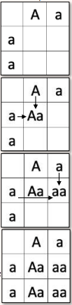
Punnett Squares
Punnett squares show all the possible combinations of genotypes and phenotypes that could exist in offspring. Punnett squares use letters to represent dominant and recessive alleles. An uppercase letter represents a gene that is dominant. A lowercase letter represents a gene that is recessive. Punnett squares indicate the probability of different possible outcomes. However, it cannot exactly predict the traits (or exact ratios of traits) that will occur among offspring.

To set up a Punnett square, you must first separate the letters that represent the genotype of each parent (because each sperm and egg cell will randomly receive one copy of these two genes). These letters are written in the top and left-side boxes. Then match each letter from each parent (e.g., left letter & top letter; right letter & top letter; left letter & bottom letter; right letter & bottom letter). Then determine the ratio of genotypes and phenotypes (remember, if they have even one uppercase letter, they will express the dominant phenotype).

For example, imagine a cross between a parent that is heterozygous (Aa) for a trait with a parent that is homozygous recessive (aa). These parents could only have two kinds of genotypes for this trait among their offspring - Aa or aa. This means that there is a 50% chance that offspring would exhibit the dominant phenotype. There is also a 50% chance that offspring will exhibit a recessive phenotype.

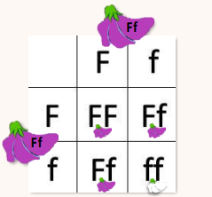
If both parents are heterozygous (Ff), there is a 1/4 (25%) chance that their offspring will be homozygous dominant (FF) for that trait. There is a 2/4 (50%) chance that their offspring will heterozygous (Ff) for that trait. And there is a 1/4 (25%) chance that the offspring will be homozygous recessive (ff) for a trait.

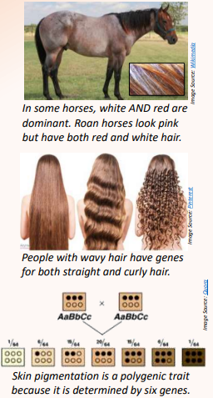
Remember - these numbers are probabilities, not guarantees. For example, it is possible that heterozygous (Aa) parents could have all homozygous recessive (aa) offspring. However, that outcome is less likely than a mixture of genotypes. This is similar to how you could flip a coin and get heads four times in a row, but you are more likely to get a mixture of heads and tails.

Codominance, Incomplete Dominance, and Polygenic Traits
While most genes are either dominant or recessive, there are exceptions. Some genes are codominant - both genes are expressed because each gene is dominant (e.g., roan horses). In some cases, neither of two genes are dominant (incompletely dominant). Individuals with both genes will have traits that are a blend or mixture of the two traits (e.g., wavy hair).

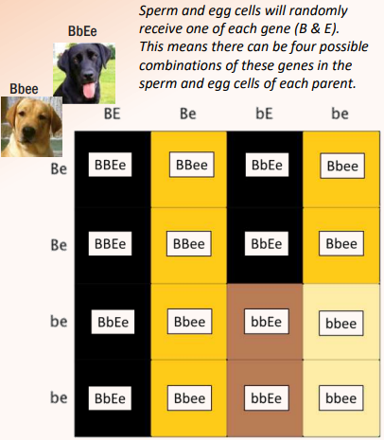
Some traits are determined by more than two genes; these are known as polygenic traits. For example, skin color is determined by six genes. The more dominant pigment genes an individual inherits, the darker their skin pigmentation. Finally, some genes affect the expression of other genes. For example, two genes determine the hair color of Labrador retrievers. The E gene determines whether a dark (black/brown) or light (yellow/white) pigment is expressed. The B gene determines how intensely that pigment is expressed. Four colors of Labrador retrievers are possible because of the interactions between these two genes.

Heritability
While genes provide the instructions for assembling proteins, genes are not the only factors that affect the expression of traits. The environment in which an organism exists also has a significant influence on whether a trait is expressed and to what extent. For example, malnourished organisms will be smaller than those that are properly fed even if they share identical genes.

Heritability refers to the extent to which genetic factors affect the expression of a trait. Some traits, like eye color, are almost entirely affected by genes, with little or no impact from environmental factors. These are highly heritable traits. Other traits, like growth or personality, are strongly affected by environmental factors. These traits have low heritability.

